Article Transparent Fuel Capcule after Richard2 2 13 17

Transparent Fuel Capsule for Fusion Reactor
Alexander Bolonkin
C&R, abolonkin@gmail.com
Abstract
For more 60 years scientists havewanted to reach confined, stable thermonuclear reaction state. They are using two main methods: ICF – Inertial Confinement Fusion and MCF – Magnetic Confinement Fusion. In ICF they have tried to heat a frozen thermonuclear fuel by highly compressing the reactive force of the fuel’s vaporized cover and tohold (confine) it by inertial forces of the fuel used. In MCF they heatrarefied plasma by electric current and hold it a relative long time by enshrouding magnetic field. In ICF, only 10-20% the laser energy is used for compression and significantly less for further fuel heating.
The author is offering a significantly new design the fuel pellet (capsule) for laser ICF reactor which allows using about 90% the laser energy for pellet heating and compression work. The second advantage of the author’s innovative suggested method is significantly increasing (by a hundred-fold) the time of nuclear reaction (reactivity) as well as the possibility to use the compressed gas fuel at room temperature,instead of the frozen fuel held at absolute Kelvin zero. The suggested pellet (capsule) design requires few collimated light beams (maximum 6, not 192 as with NIF) because it is using offered multi-reflect capsule(pellet). That greatly simplifies the design laser system.Possible of getting conditions will be enough for using the D-D nuclear fuel, which is monetarily less costly by 30,000 times than T-D fuel.
----------------------------------------------------
Keywords: Inertial Confinement Fusion, Thermonuclear reactor, inertialthermonuclear reactor, fuel pellet of thermonuclear reactor, transparent fuel capsule for fusion reactor.

Introduction
Brief Information about Thermonuclear Reactors
Fusion power is useful energy generated by nuclear fusion reactions. In this kind of reaction, two light atomic nuclei fuse together to form a heavier nucleus, releasing energy that may be confined and harnessed for various human purposes. In order for a reactor to be viable it must be able to reach ignition stage, that is, when the heating of the plasma by the products of the fusion reactions is sufficient to maintain the temperature of the plasma against all losses without external power input. The conditions needed for a nuclear fusion reactor to reach ignition stage are the "triple product" of density, confinement time, and plasma temperature T. In order to create the required conditions, the fuel must be heated to temperatures beyond mere ordinary workshop plasmas, and/or compressed to immense pressures. The key to practical fusion power is to select a fuel that requires the minimum amount of energy to fuse, that is, the lowest barrier energy. The best-known fuel from this standpoint is a one-to-one mix of deuterium and tritium; both are heavy isotopes of hydrogen. The T-Dmix has a low barrier. For the T-D reaction, the physical value is about L= nTτ> (10²⁰– 10 ²¹) in CI units, where T is temperature, [KeV], 1 eV = 1.16×10⁴ K; n is matter density, [1/m³]; τ is time, [s]. The thermonuclear reaction of ³H + ²D realizes if L >10²⁰ in CI (meter, kilogram, second) units. This number has not yet been achieved in any fusion reactor.
At present, T-D is used by two main methods of fusion: inertial confinement fusion (ICF) and magnetic confinement fusion (MCF)--for example, tokomak device.
In inertial confinement laser fusion (ICF), nuclear fusion reactions are initiated by compressing and heating a target. The target is a pellet that most often contains T –D (often only micro or milligrams). Intense focused laser or ion beams are used for compression of the pellets. The beams explosively detonate the outer superficial material layers of the target pellet. That accelerates the underlying target layers inward, sending a shockwave into the center of each pellet mass. If the shockwave is powerful enough, and if high enough density at the center is achieved, some of the fuel will be heated enough to cause fusion reactions. In a target, which has been heated and compressed to the point of thermonuclear ignition, energy can then heat surrounding fuel to cause it to fuse as well, potentially releasing tremendous amounts of energy.
Magnetic confinement fusion (MCF). Since plasmas are very good electrical conductors, magnetic fields can also be configured to safely confine fusion fuel. A variety of magnetic configurations can be used, the basic distinction being between magnetic mirror confinement and toroidal confinement, the most popular designs being tokomaks and stellarators.
Short history of ICF thermonuclear fusion.Serious attempts at an ICF design was Shiva, a 20-armed neodymium laser system built at the Lawrence Livermore National Laboratory (LLNL) in California that started operation in 1978. Shiva was a "proof of concept" design, followed by the NOVA design with 10 times the power. Although net energy can be released even without ignition (the breakeven point), ignition is considered necessary for a practical power system. The resulting design, the National Ignition Facility (NIF), commenced construction at LLNL in the early 1990s, was six years behind schedule and over-budget by some $3.5 billion. Like earlier experiments, NIF failed to reach ignition and was, as of 2015, reportedly generating only about 1/3rd of the required energy levels needed to reach full fusion stage of operation.
Laser physicists in Europe have put forward plans to build a £500m facility, called HiPER, to study a new approach to laser fusion: a "fast ignition" laser facility would consist of a long-pulse laser with energy of 200 kJ to compress the fuel and a short-pulse laser with energy of 70 kJ to heat it.
Basic data on a few of the current inertial laser installations:
1. NOVA uses laser NIF (USA), has 192 beams, impulse energy up 120 kJ. Can reach density of 20
g/cm³, speed of cover is over 300 km/s. NIF has failed to reach ignition and is, as of 2013,
generating about 1/3rd of the required energy levels. NIF cost is about $3.5B.
2. HiPER (EU) has impulse energy of 70 kJ.
2. OMEGA (USA) has impulse energy of 60 kJ.
3. Gekko-XII (Japan) has impulse energy of 20 kJ. Can reach density of 120 g/cm³.
4. Febus (France) has impulse energy of 20 kJ.
5. Iskra-5 (Russia) has impulse energy of 30 kJ.
The largest current nuclear fusion experiment, JET, has resulted in fusion power production some larger than the power put into the plasma, maintained for a few seconds.
The most well-known project of magnetic fusion is ITER. ITER (International Thermonuclear Experimental Reactor) is an international nuclear fusion research and engineering mega project, which will be the world's largest magnetic confinement plasma physics experiment. Construction of the ITER Tokomak complex started in 2013 and the reported building costs exceeded US$14 billion by June 2015. ITER began in 1985 as a Reagan–Gorbachev initiative and expected completion is in 2027. ITER reactor alone requires about one billion USD annually to operate.
Similar projects. Other planned and proposed fusion reactors include DEMO, Wendelstein 7-X, NIF, HiPER, and MAST, as well as CFETR (China Fusion Engineering Test Reactor), a 200 MW tokamak.
Innovations in offered fuel capsule
Beforeconsideration the offered transparent capsule, let us show the work of the current capsule (Fig.1a). Current capsule contains pellet 1 having the frizzed T-D (≈ 2 mm)and cover plastic ablators 2,(≈ 5 mm) typically polystyrene (CH). Many power laser beams 3 (up 192) irradiate the capsule from all sides. In result the material (ablator) is heated by the absorbed laser energy and evaporates or sublimates (4). If process acts a very short time (ns), one produces the shock-wave (5). The shock-wave cumulative the high pressure in a center of fuel pellet 1. If pressure and temperature of fuel is enough the nuclear reaction occurs. If reactivity is enough, the fuel is ignited.
This method has many difficult technical problems not easily overcome successfully. One requests many identical light beams acting simultaneously for uniform radiation bathing. The shock wave acts very short time and does not produce enough heat. Only10-20% of the laser energy is actually used for pressurization of the fuel pellet. The pellet 1 after sublimation is “naked”and cannot steadily hold the pressure for enough time for any useful nuclear reaction result.
The author herein offers two versions of his more efficient capsule design (1b, 1c).
Both pellets have a compressed (up 200 ÷ 600 atm) gas fuel (or frozen fuel).
In first version (fig.1b) the cover 6 is made from a good transparence material not heated by focused laser beam. The frequency of laser beam or fuel (or in the fuel additive)is taken such that fuel well absorbs the imposed laser radiation. The result is that the fuel absorbs 90% (or more) of the laser energy and has enough heating for sustainedignition all available fusion reaction fuel (not only small region in center pellet as in conventional method).
The massive transparencecover from heavy nuclei reflects the lightnuclei of fuel (and reaction products) and significantly increases the duration time of a desired reaction.
It is difficult to select absorption frequency or absorption additive matter, the capsule is covering the strong mirror 8 (having the small holes for laser beams). It is better if mirror has the high reflectivity Fresnel cells. The mirror multiple reflects the laser beams back to the pellet and good increases the pressure to fuel.
Fig.1. The current ICF capsule for laser driver (a); the offered transparency ICF capsule (b); the offered transparency-reflective capsule for laser drive. Notations: 1 – pellet having the thermonuclear fuel; 2 – cover which is vaporized by laser beam and produced the shock wave; 3 – laser beam; 4 – cover gas; 5 – repulsive force (pressure); 6 - high transparence cover; 7 – laser beam through the transparency cover; 8 – high efficiency light (laser beam) reflector(possible Fresnel cells); 9 - issueand reflected laser beam; 10 – fuel pellet (absorption additives are possible in version “b” and “c”).
Advantages of the offered design
1
2
3
4
5
6
6
TC-F1
7
8
9
a
b
c
10
The herein offered method and design has workability advantages, especially in comparison the conventional fuel capsule:
- Сconsiderably increasesthe necessary high temperature (in 10 – 20 times and more). In conventional capsule only 10 ÷ 20% the beam energy converts to pressure. The part of the residual energy converts to energy the shock wave, the part of remaining wave energy converts again in pressure at centerpellet, the part of last energy produces the high temperature at small central volume at a very short time. As result, very few nucleuses have the nuclear reaction and cannot to heat to needed temperature the rest fuel (cannot ignite the nuclear reaction).
In suggested capsule, no studies pressure cover, producing shock-wave, again compressing the fuel by shock wave, producing the temperature by shock wave. The 90% and more the laser energy become directly converted into the fuel temperature. The temperature influences to nuclear reactivity significantly more than pressure.
- Greatly increase the reaction time (up hundred and more times). Ithappens because the mass of the cover 6 (Fig.1b) resists an expansion the hot fuel gas. The mass of the cover may be in hundreds times more than mass of fuel (mass of fuel is 0.01 – 0.1 mg). Besides the nuclear number of cover is ten times more than fuel and reaction fragments (cover has N = 50 – 200, fuel and reaction fragment has N = 2 – 6). This means the cover nucleus will be reflect the light hot fuel and fragment nucleus. The increasing reaction time greatly produces the full combustion of fuel and improves the efficiency coefficient.
- The offered design my uses the compressed gas fuel pellets (up 800 atmospheres). That is more comfortable then the very coldcapsules (about absolute zero Kelvin) used standardly at the present time.
- For testing the offered design may be applied any current ICF laser system, having the laser beam more 20 kJ.
- It is possible for herein offered design the laser beam energy 50 kJ will be enough for ignition fuel D+D. In this case we solve the very important problem – final cost of the nuclear energy produced. At present, cost of T+D nuclear energy in 10 times more than cost the energy of commercial electricity generation infrastructure facilities usingnatural gas and oil as fuels. Change fuel T+D by D+D decreases the fuel cost in 30,000 times the cost of the nuclear energy [14](see estimation below).
Estimations and Computations
Brief Information about Plasmas and Nuclear Reactions
Below aresome equation useful for computation:
2. The Deep of Penetration of outer radiation into plasma is
. [cm] | (1)
For plasma density n_{e} = 10²² 1/cm³ d_{p} = 5.31×10⁻⁶ cm.

3. The Gas (Plasma) Dynamic Pressure,p_{k}, is
, | (2)
where k = 1.38×10⁻²³ is Boltzmann constant; T_{e} is temperature of electrons, ºK; T_{i} is temperature of ions,ºK. These temperatures may be different; n is plasma density, 1/m³; p_{k} is plasma pressure, N/m².

4. The gas (plasma) ion pressure, p, is
, | (3)
Here n is plasma density in 1/m³.

5. The magnetic p_{m} and electrostatic pressure, p_{s},are
, | (4)
where B is electromagnetic induction, tesla; μ₀ = 4π×10⁻⁷ electromagnetic constant; ε₀ = 8.85×10⁻¹² , F/m,is electrostatic constant; E_{S} is electrostatic intensity, V/m.

6. Ion thermal velocity is
, | (5)
where μ = m_{i} /m_{p}, m_{i} is mass of ion, kg; m_{p} = 1.67×10⁻²⁷is mass of proton, kg.

7. Transverse Spitzer plasma resistivity
, | (6)
where ln Λ = 5 ÷ 15 ≈ 10 is Coulomb logarithm, Z is charge state.
8. Reaction rates <σv> (in cm³ s⁻¹) averaged over Maxwellian distributions for low energy (T<25
keV) may be represent by
(7)
where T is measured in keV.

9. The power density released in the form of charged particles is
(8)
Here in P_{DD} equation it is included D+T reaction.

10. Reaction rates are presented in Table 1 below:
Table 1. Reaction rates <σv> (in cm⁻³ s⁻¹) averaged over Maxwellian distributions
Tempera-ture, keV | D+D,  (2a + 2b) | D+T ,  (1) | D+³He,  (3) | T+T,  (4) | T+³He,  (6a-c)
1.0 | 1.5×10⁻²² | 5.5×10⁻²¹ | 10⁻²⁶ | 3.3×10⁻²² | 10⁻²⁸
2.0 | 5.4×10⁻²¹ | 2.6×10⁻¹⁹ | 1.4×10⁻²³ | 7.1×10⁻²¹ | 10⁻²⁵
5.0 | 1.8×10⁻¹⁹ | 1.3×10⁻¹⁷ | 6.7×10⁻²¹ | 1.4×10⁻¹⁹ | 2.1×10⁻²²
10.0 | 1.2×10⁻¹⁸ | 1.1×10⁻¹⁶ | 2.3×10⁻¹⁹ | 7.2×10⁻¹⁹ | 1.2×10⁻²⁰
20.0 | 5.2×10⁻¹⁸ | 4.2×10⁻¹⁶ | 3.8×10⁻¹⁸ | 2.5×10⁻¹⁸ | 2.6×10⁻¹⁹
50.0 | 2.1×10⁻¹⁷ | 8.7×10⁻¹⁶ | 5.4×10⁻¹⁷ | 8.7×10⁻¹⁸ | 5.3×10⁻¹⁸
100.0 | 4.5×10⁻¹⁷ | 8.5×10⁻¹⁶ | 1.6×10⁻¹⁶ | 1.9×10⁻¹⁷ | 7.7×10⁻¹⁷
200.0 | 8.8×10⁻¹⁷ | 6.3×10⁻¹⁶ | 2.4×10⁻¹⁶ | 4.2×10⁻¹⁷ | 9.2×10⁻¹⁷
500.0 | 1.8×10⁻¹⁶ | 3.7×10⁻¹⁶ | 2.3×10⁻¹⁶ | 8.4×10⁻¹⁷ | 2.9 ×10⁻¹⁶
1000.0 | 2.2×10⁻¹⁶ | 2.7×10⁻¹⁶ | 1.8×10⁻¹⁶ | 8.0×10⁻¹⁷ | 5.2×10⁻¹⁶
Source: AIP, Desk Reference, Third Edition, p.644.
Theory, computation and estimation of nuclear reactors and comparison one with current laser ICF.
Estimation of Laser method (ICF).
For comparison the laser and offer methods, we estimate the current ICF laser method.
Typical laser installation for ICF has the power 5 MJ and deliver to pellet about 20÷50 kJ energy. The pullet has the 1 – 10 mg liquid (frozen) fuel T+D (density 200 kg/m³), diameter of the spherical fuel pullet about1- 2 mm, diameter of an evaporative coating 4 – 10 mm.
Let us take the delivered energy E = 50 kJ, volume of the coating v = 50 mm³,Specific weight of coating γ = 400 kg/m³ (molar weight µ = 10).
For these data and instant delivery of laser energy the maximum pressure in cover is
$p=\frac{E}{v}=\frac{5×{10}^{4}}{{50·10}^{-9}}={10}^{12}\frac{N}{m^{2}}={10}^{7}\text{atm}$ (9)
But we don’t know what part this pressure transfer to the fuel pellet.
Number of nuclear in 1 m³ of covering is
(10)
Here m_{p}=1.67.10⁻²⁷ is mass of nucleon (proton) [kg].
Temperature of evaporating cover is
(11)
Here k = 1.38×10⁻²³ Boltzmann constant, J/K.
Speed of evaporated covering is
(12)
Time of evaporating for thickness of covering l = 2.10⁻³ m is
(13)
Let us to consider now the process into pellet.
The density of T+D fuel particles is
(14)
where µ = 2.5 is average molar mass of fuel T+D.
The frozen (liquid) fuel, after converting in gas, has a temperature of about T = 20 K.
The pressure average speed V_{n}of particles afterconversion of the fuel into gas (plasma) and sound speed V_{f}to fuel gas at temperature 20K are:
(15)
The laser beam is very short – some picoseconds(10⁻¹² s) in duration. That way the laser pressure can produced only shock-wave. The pellet cover protects the pellet from laser heating.
Additional fuel pressure in center of pellet from two opposing sound wave bump-up is
. (16)
Fuel temperature in center of small mass pellet where two opposing sound (shock) wave bump-up happens is
(17)
In reality, the full pressure and temperature in center of capsule is much more, but not enough for the full nuclear reaction. The author herein computes ONLY the sound wave. Any shock-wave becomes fast at short distance than the sound wave. However, in our case this computation is very complex.
Current inertial reactors have the maximal rate of fuel compressing in center of pellet about
.
Criterion of ignition (for radius of pullet R_{o} = 0.02 cm and solid or liquid fuel ρ_{o}= 0.2 g/cm³) is
(18)
where ρ in g/cm³, R in cm. This value is insufficient (0.28 < 1).
You can imagine – with just a small effort and we will fulfill the criterion of ignition! Look your attention in very low temperature of fuel (17). For this temperature, the criterion may be wrong, or area of the ignition located into center of pullet may be very small, that energy is very few for ignition of all fuel?
Estimation of some parameters the nuclear reactor and pellet.
Below is not mega-project. Instead, below, are the estimations of the typical parameters of nuclear reactors.
1. Suitable thermonuclear reactions.
The corresponding reactions are
D + T →⁴He (3.5MeV) + n (14.1MeV);
D + D →T (1.01MeV) + p (3.02MeV) 50%, (19)
D + D →³He(0.82MeV) + n (2.45MeV) 50% .
The deuterium cannot be used in the laser reactor because one requests in 100 times more ignition criterion then T + D. But D+D may be used in AB reactors with an additional heating by electric field [3 = 14].
The ³He is received in deuterium reaction may be used in next reactions:
D + ³He →⁴He (3.6MeV) + p (14.7MeV);
³He + ³He →⁴He +2p (12.9MeV). (20)
They produce only high-energy protons, which can be directly converted in electric energy. Last reactions do not produce radio isotopic matters (no neutrons). But ³He is very expensive (30,000 $/g) as T.
Reaction D + D has the other distinct advantages:
1. One produces the protons which energy theoreticallycan be converted directly to electric energy.
2. One produces the tritium, which is expensive and may be used for thermonuclear reaction.
3. One produces less and low energy neutrons, which create radioactive matters.
The other important advantage is using the pellets with compression gas fuel. Let us take a micro-balloon (pellet) having fuel gas with p_{o}˃200 atm., radius 0.05 cm., temperature 300K. The mass fuel will be less 1 mg.The thickness of pellet having pressure 500 atmospheres is about 0.05÷0.1 mm.
Compressed gas micro-balloon (pellet) is more comfortable for working because it is unnecessary to store the fuel at lower (frozen)temperature (<10 K).
Next, we will consider mainly the fuel mass of M = 0.1 µg (10⁻⁷ kg), fuels T + D, D + D and the pellet volumev₁ = 2 mm³and v₂ = 4.19 mm³ (diameter of pellet is d = 2 mm).

2. Number of nucleus N in given volume v = 2 mm³ and density n of fuel until the nuclear reaction
is:
(22)
For volume v = 4 mm³ the pressure will be in two time less (for T+D: p =237 atm, for D+D p = 296 atm). Temperature of gas fuel before the laser heating is T = 300ºC.
3. Temperature and pressure of gas fuel in pellet after heating by laser beam having energy E = 50 kJ, coefficient efficiency η = 1 is:
Temperature:
(23)
Pressure is (for volume of pellet v = 2.10⁻⁹ m³):
. (24)
4. . Temperature and pressure of gas fuel in pellet after full Thermonuclear reaction, coefficient efficiency η = 1 is (for volume of pellet v = 2.10⁻⁹ m³, without neutron energy):
. ( 25) (26)
5. The plasma confinement time.
From the equations of uniformly accelerated motion, we can derive an equation for the assessment of the plasma conformation time:
, (27)
where E is kinetic energy, J; m is mass of fuel + pellet cover, kg; V_{a} is average speed, m/s; V is final speed of fuel product, m/s; r is radius of pellet, m; t is conformation time, s.
Estimation are (for r = 1mm = 10⁻³ m):
For pellet without cover, m = 10⁻⁴ g = 10⁻⁷ kg, heating only the laser beamE= 5.10⁴ J):
. (28)
For pellet with cover, m = 10⁻³ kg, heating only the laser beam:
. (29)
For pellet without cover, m = 10⁻⁷ kg, heating by nuclear reaction T+D E = 6.72.10⁶ J.:
. (30)
For pellet with cover, m = 10⁻³ kg, heating by nuclear reaction T+D E = 6.72.10⁶ J.:
. (31)
As you see the transparent cover increases the conformation time by a hundred times!
For reaction D+D having E = 5.71 MJ the comformation time is closed.
Duration of laser impulse is some very few pico-seconds (10⁻¹²).
6. Radiation absorption by the pellettransparency cover.
Radiation absorption by the pellet transparency cover is very important for offered method.If cover hot has enough transparency and the cover begin to active absorb (blocked) the laser radiation, the cover will evaporate and we return to current old method, which is not efficiency as a practice shows.
Author offers to use for coverthe very efficiency material used in fiber optic for the transferring the light signal (fig.2).
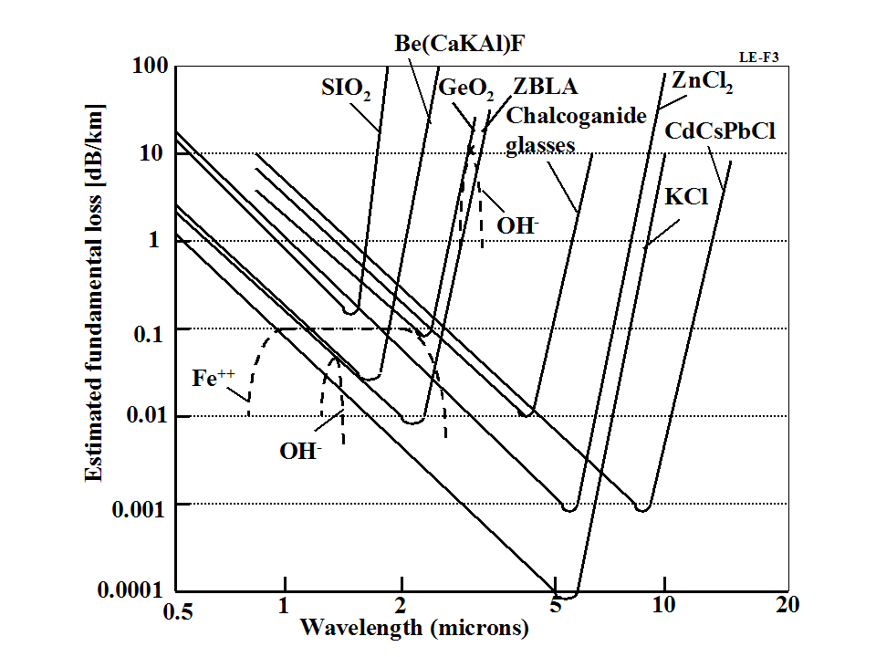
Fig. 2.Estimation of basic attenuation of some possible very low-loss materials [2], p.376.

The conventional optical matter widely produced currently in industry has an attenuation coefficient equal to a = 2 dB/km.
Let us estimate the loss of beam energy in the transparence cover. Coefficient a loss for thickness of cover δ = 2 mm is
. (32)
For the laser beam energy equalsE = 5.10⁴ J, the loss energy is
(33)
Assume the pellet cover is from a quartz having the heat capability 880 J/kg.K and permissible temperature 300ºC. For heating of cover to this temperature is necessary 7.7 J. That is significantly more 4.4.10⁻² J. That means no problem with heating of pellet cover (no loss the energy into good transparency cover).
7. Heating, absorption, reflection and transparency the laser beam by fuel.
Heating, absorption, reflection and transparency of the fuel by the laser beam is important problem in offered method. The fuel must absorb most of the beam energy. If fuel is plasma, then the absorptionx [cm] the radiation by gas fuel may be estimated by next equation:
, (34)
wheren is density of fuel, 1/cm³; σ is cross section area of photon into plasma, cm².
The crosssection of photons is presented in fig.3 [18].As you see the elements having nuclear mass 2 ÷ 6 have σ = 100 ÷ 10,000 cm². The pellet having the density n = 1.2.10²²1/cm³ and σ = 2.10³barns has
. (35)
That is enough for transmitted beam energy to the receiving fuel.
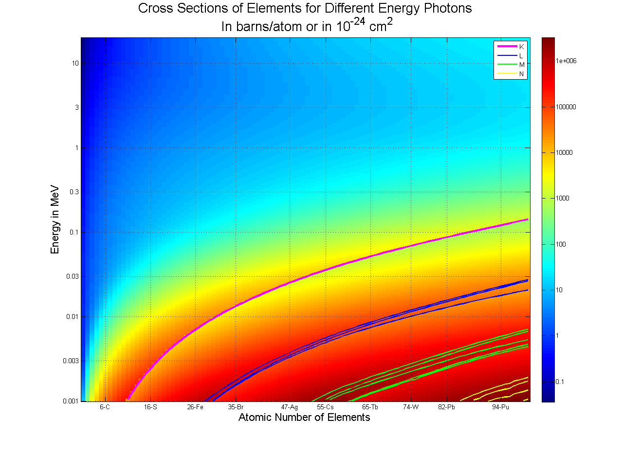
Fig.3. Cross Section of Elements for Different Energy Photon.
If fuel pellet will be reflects or passes radiation, you must use the pellet design fig.1c, having the reflector over pellet cover.
The beam pressure is
. (36)
Here ρ is coefficient reflectivity, < 1; E is energy of beam, J; c = 3.10⁸ m/s is light speed; s is surface area of spherical pellet (d = 2 mm); t is beam time , sec.
The beam pressure is gigantic. In case multi reflectivity the pressure will increases in some times. But time is very short and this pressure can only create the shock wave.
For increasing the beam energy absorption we can add in fuel the matter which active absorbs the need light, for example, polystyrene (OH), or Fe (see fig.2). NIF used the wave λ = 0.351.10⁻⁶, 1.053.10⁻⁶ m.
8. Lawson’s criterion.
Lawson’s criterion of nuclear reaction is
(37)
where n is density of plasma, 1/m³; T is temperature, keV; τ is time, sec.
After heating the pellet v = 2 mm³ by laser beam E = 50 kJ the fuel T+D we have n = 1.2.10²⁸ 1/m³, temperature T = 10⁸K = 10^{8.}0.86.10⁻⁴ eV =8.6 keV, τ = 2.10⁻⁷ s, (see above). Substitute these values into (37) we have:
For fuel D+D after heating the pellet v = 2 mm³ by laser beam E = 50 kJ we have n = 1.5.10²⁸ 1/m³, temperature T = 0.8.10⁸K = 0.8.10^{8.}0.86.10⁻⁴ eV =6.9 keV, τ = 2.10⁻⁷ s. Substitute this values into (37) we have:
Lawson criterion is fulfilling.
For conventional pellet WITHOUT transparency cover having fuel T+D, v = 2 mm³, n = 1.2.10²⁸ 1/m³, temperature T = 0.15.10⁸K = 10^{8.}0.15.0.86.10⁻⁴ eV =1.29keV (here 0.15 is part of beam energy used for heating the fuel by current method), τ = 2.10⁻⁹ s, (see above), we have:
Lawson criterion is not fulfilling.
9. The mean free path of the nuclear reaction particles.
For transferringenergy,the mean free path of the nuclear reaction particles must be into the fuel i.e. less then the radius of the fuel pellet. Otherwise, the particles leave the fuel without transfer the full its energy to nuclear fuel. Thatway all neutrons having the big free path (great penetrating power) leavethe fuel without heating the fuel. They heat only the reactor body and produce the radioactive isotopes in body matter. The heating the fuel can only the charged particles.
Let us to estimate the mean free path the charge particles the reaction (19). Author has only the mean free path the α-particles (⁴He)having mass m = 4 and charge Z=2 [15] p.955, Fig.44.8 versus energy for air (m = 14) and pressure 1 atm. He recalculated them to other particles mass (m =1, 3) other pressure (p = 300 atm), other charges (Z = 1) and other fuel mass (m = 2, 2.5). The results of estimation are shown in Table 2 immediately following:
Table 2. Estimation of the mean free path of the nuclear reaction particles
Particles.  Free path as α,  (energy, MeV) | Free  pathas α, mm, in air at  1 atm | Free  path as α,mm, in air at  300atm | Correct.  coeffic.  on mass  particle | Free  path as α, mm,  correct.  in mass | Correct.  coeffic.  of charge  particle  2/Z | Free  path as α, mm,  correct.  in Z | Correct.  coeffic.  of invar.  mass  (m air/  m fuel) | Final Free  path ,mm, in fuel at  300atm
⁴He (3.5 MeV) | 20 | 0.067 | 1 | 0.067 | 1 (Z=2) | 0.067 | 14/2.5 | 0.375
T=³H (1 MeV) | 5 | 0.017 | 3/4 | 0.0127 | 2 (Z=1) | 0.0254 | 14/2 | 0.178
³He (0.8 MeV) | 4 | 0.013 | 3/4 | 0.0097 | 1 (Z=2) | 0.0097 | 14/2 | 0.068
p (3 MeV) | 18 | 0.067 | 1/4 | 0.0167 | 2 (Z=1) | 0.0334 | 14/2 | 0.234

The free pass of reaction particles limits the minimal radius (mass) of fuel. The result of computation shows the direct efficiency using the electric energy of the charged particles is very difficult because the most part of their energy will absorb the fuel for pellet heating.
10. Cost of the thermonuclear fuel.
Deuterium. The sea water contains deuterium about 1.55.10⁻⁴ %. The World produces about tens
thousand tons in year. Cost 1 $/g.
Tritium. The special nuclear reactors can produced it. Now the cost is 30,000 $/g. In future an
expected cost will be from 100K÷200K $/g.
Helium-3. Very rare isotope. The Helium-4 contains 1.3.10⁻⁶/1 of the Helium-3. Cost is 30K $/g.
One project offers to extract it on Moon and delivery to Earth.
Lithium 6 -7. Nature mixture cost 270 $/kg.
Barium. Cost 11140 $/kg.
Uranium-238 contains 0.7% of Uranium-235. It cost 90÷250 $/kg.
Plutonium-239. Cost 5600 $/g.
As you see the thermonuclear fuel D+D is the cheapest, but T+D has the lowest temperature for thermonuclear reaction. All the current experimental thermonuclear installations are using the T+D.
Look your attention, the offered method allows to get very high thermonuclear temperature. We take U = 15 ÷ 50 kV [3-14], but no limit take U = 100, 200, 500 kV. The 200 kV produce the temperature T = 200.10^{3.}1.18.10⁴ = 2.36.10⁹ K (two billions!). As you see in fig. 4 and estimations over [12], that significantly increase the probability of thermonuclear reaction and produce a fuel for the other reactor. We canuse the cheap fuel produced few neutrons, many protons, expensive elements, which can be to made a fuel for thermonuclear reactors.
Discussion
About sixty years ago, scientists conducted Research and Development of a thermonuclear reactor that promised then a true revolution in the energy industry and, especially, in humankind’s aerospace activities. Using such reactor, aircraft could undertake flights of very long distance and for extended periods and that, of course, decreases a significant cost of aerial transportation, allowing the saving of ever-more expensive imported oil-based fuels. The pressure, time and temperature required for any particular fuel to fuse is known as the Lawson criterion L. Lawson criterion relates to plasma production plasma density,temperature and time.
The thermonuclear reaction is realized when L is more certain magnitude. There are two main methods of nuclear fusion: inertial confinement fusion (ICF) and magnetic confinement fusion (MCF).
Existing thermonuclear reactors are very complex, expensive, large, and heavy. They cost many billions of US dollars and require many years for their design, construction and prototype testing. They cannot stably achieve the nuclear ignition and the Lawson criterion. In future, they will have many difficulties with acceptable cost of nuclear energy, with converting the nuclear energy to conventional energy, with small thermonuclear installation suitable for transportation or space exploration. Scientists promise an industrial application of thermonuclear energy after 10 – 15 years additional researches and new billions of US dollars in the future. However, old methods do not allow us to reach an industrial or transport engine in nearest future.
In inertial confinement many scientists thought that short pressure (10⁻⁹ – 10⁻¹² s), which they can reach by laser beam, compress the fuel capsule, but this short pressure only create the shock wave which produced the not large pressure and temperature in a limited range area in center of fuel capsule. The scientists try to reach it by increasing NIF, but plasma from initial vaporization the cover of fuel capsule does not allow to delivery big energy. After laser beam, the fuel capsule is “naked” capsule. Capsule cannot to keep the high-energy particles of the nuclear ignition and loss them. Producing the power laser beam is very expensive and has very low efficiency (1 - 3.5%).
The offered method EIF (Electric Impulse Fusion) does not have these disadvantages [3-14]. One uses the primary high pressed gas fuel ampoules and directly heats them to need high temperature by special electric impulse in special cartridge. The shell of capsuleprotects the fuel by the heavy elements (µ = 200) having high number of nucleons A and charges Z. They reflect the light protons, D, T, repels high-energy reacted particles (D, T, ³He, ⁴He, p) back to fuel and significantly increasing the pressure and conformation time.
The laser ICF, MCF ideas cannot be used for thermonuclear reaction in its classical form. Produced temperature and pressure by laser ICF and magnetic MCF are not enough for thermonuclear reaction. In given article the author offers the new design of ICF pellet. That design allows more full using the beam energy for heating the pellet andto reach the need temperature (up 100 MeV) and using the primary compressing the gas fuel (up 700 atm) in special ampoules and increase the time of reaction in 100 times by heaver pullet cover. That increases the intensity of nuclear reaction (and temperature) in hundreds times.
The important innovations are the compressed the fuel gas into fuel cartridge at room temperature and using laser beam for directheating of fuel up the thermonuclear temperatures. The current ICF uses the frozen fuel about absolute zero. That is not acceptable for practice. Author also suggested the transport nuclear engine and nuclear rocket [3-14].
The method possible allows to use reaction D+D (instead T+D) with cheap nuclear fuel D (Tritium is very expensive – about 30,000 USD per 1 g, deuterium costs 1 $/g). One also allows using the compressed fuel-gas at room temperature. We can use the nuclear reactions, which do not produce many neutrons and gamma radiation. They are dangerousfor people.
Conclusion

The author offers a new design the fuel pellet for the laserimpulse thermonuclear reactors, which increases the temperature of a primary compressed nuclear fuel in hundreds times, reaches the ignition and full thermonuclear reaction. New design of the nuclear pellet offered by its originator contains several innovations and inventions.
Main of them is using a high transparence cover of pellet, which allows to use the laser beam for direct high efficiency heating of fuel bylaser beam to high temperature the hundredmilliondegrees.The second innovation is using the heavytransparent pullet cover used for increasing the compressing fuel state (reaction time).Important innovation is compressed gas fuel at room temperature and using efficiency cover reflector (fig.3c) for increasing the temperature, pressure fuel and nuclear reactivity.
The offered method is cheap and easy for testing. For its testing may be used the most currentICF installations. Closed ideas are in [3]-[14].
Acknowledgement
The author wishes to acknowledge R.B. Cathcart for correcting the author’s English and offering useful advices and suggestions.

References
(Reader can find part of these articles in WEBs:

https://archive.org/details/List5OfBolonkinPublications,http://Bolonkin.narod.ru/p65.htm, http://arxiv.org/find/all/1/au:+Bolonkin/0/1/0/all/0/1, http://vixra.org).
[1]Bolonkin, A.A., Light Pressure Engine. Patent (Auther Certificate) #1183421, USSR (priority on 5
January, 1983), 1985 (in Russian).
[2] Bolonkin A.A., Non-Rocket Space Launch and Flight.Elsevier, 2005. Or Journal of British Interplanetary
Society, Vol. 57, No.11/12, 2004; pp. 379-390, p.376.
https://archive.org/details/Non-rocketSpaceLaunchAndFlightv.3
[3] Bolonkin,A.A., “Inexpensive Mini Thermonuclear Reactor”. International Journal of Advanced
Engineering Applications, Vol.1, Iss.6, pp.62-77 (2012). http://viXra.org/abs/1305.0046
http://archive.org/details/InexpensiveMiniThermonuclearReactor,
[4] Bolonkin A.A. , Cumulative Thermonuclear AB-Reactor.. Vixra 7/ 8/2015,
http://viXra.org/abs/1507.0053 ,
https://archive.org/details/ArticleCumulativeReactorFinalAfterCathAndOlga7716
[5] Bolonkin A.A., Ultra-Cold Thermonuclear Synthesis: Criterion of Cold Fusion. 7 18 2015.
http://viXra.org/abs/1507.0158, GSJournal: http://gsjournal.net/Science-
Journals/%7B$cat_name%7D/View/6140 .
[6] Bolonkin A.A., Cumulative and Impulse Mini Thermonuclear Reactors. 3 30 16,
http://viXra.org/abs/1605.0309, https://archive.org/download/ImpulseMiniThermonuclearReactors ,
[7] Bolonkin A.A.,Electric Cumulative Thermonuclear Reactors.
https://archive.org/download/abolonkin_gmail_201610, http://vixra.org/abs/1610.0208 .
[8] Bolonkin, A.A., “Non Rocket Space Launch and Flight”. Elsevier, 2005. 488 pgs. ISBN-13:
978-0-08044-731-5, ISBN-10: 0-080-44731-7 . http://vixra.org/abs/1504.0011 v4,
Journal of BritishInterplanetary Society, Vol. 57,No.11/12, 2004; pp. 379-390.
https://archive.org/details/Non-rocketSpaceLaunchAndFlightv.3.
[9] Bolonkin, A.A., “New Concepts, Ideas, Innovations in Aerospace, Technology and the Human
Sciences”, NOVA, 2006, 510 pgs. ISBN-13: 978-1-60021-787-6. http://viXra.org/abs/1309.0193,
[10] Bolonkin, A.A., Femtotechnologies and Revolutionary Projects. Lambert, USA, 2011. 538 p. 16 Mb.
ISBN:978-3-8473-0839-0, http://viXra.org/abs/1309.0191.
[11] Bolonkin, A.A., Innovations and New Technologies (v.2).Lulu, 2014. 465 pgs. 10.5 Mb, ISBN:
978-1-312-62280-7. https://archive.org/details/Book5InnovationsAndNewTechnologiesv2102014/
[12] Bolonkin, A.A.,Small, Non-Expensive Electric Impulse Thermonuclear Reactor with Colliding Jets.
7 11 16, Preprint http://viXra.org/abs/1611.0276 .
[13] Bolonkin,A.A., “Inexpensive Mini Thermonuclear Reactor”. International Journal of Advanced
Engineering Applications, Vol.1, Iss.6, pp.62-77 (2012). http://viXra.org/abs/1305.0046
http://archive.org/details/InexpensiveMiniThermonuclearReactor.
[14] Bolonkin, A.A., Neumann Z., Cost of a nuclear fuel energy. In press.
[15] Kikoin I.K., Tables of Physical Values, Moscow, Atomizdat, 1975 (Russian).
[16] Koshkin N.I., Shirkevich M.G., Handbook of Elementary Physics, Moscow, Nauka, 1982 (Russian).
[17] AIP, Physics Desk Reference, 3-rd Edition. Springer, AIP PRESS.
[18] Wikipedia. Absorption of radiation. https://en.wikipedia.org/wiki/Absorption_cross_section .

3 February 2017

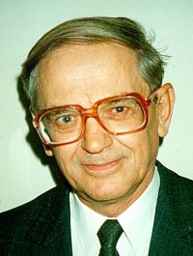
Capsule biography of Bolonkin, Alexander Alexandrovich
Alexander A. Bolonkin was born in the former USSR. He holds doctoral degree in aviation engineering from Moscow Aviation Institute and a post-doctoral degree in aerospace engineering from Leningrad Polytechnic University. He has held the positions of senior engineer in the Antonov Aircraft Design Company and Chairman of the Reliability Department in the Clushko Rocket Design Company. He has also lectured at the Moscow Aviation Universities. Following his arrival in the United States in 1988, he lectured at the New Jersey Institute of Technology and worked as a Senior Scientist at NASA and the US Air Force Research Laboratories.
Bolonkin is the author of more than 250 scientific articles and books and has 17 inventions to his credit. His most notable books include The Development of Soviet Rocket Engines (Delphic Ass., Inc., Washington , 1991); Non-Rocket Space Launch and Flight (Elsevier, 2006); New Concepts, Ideas, Innovation in Aerospace, Technology and Human Life (USA, NOVA, 2007); Macro-Projects: Environment and Technology (NOVA, 2008); Human Immortality and Electronic Civilization, 3-rd Edition, (Lulu, 2007; Publish America, 2010):Life and Science. Lambert Academic Publishing, Germany, 2011, 205 pgs. ISBN: 978-3-8473-0839-3.
http://www.archive.org/details/Life.Science.Future.biographyNotesResearchesAndInnovations; Femtotechnology and Revolutionary {projects, Lambert, 2011, p.530; New Methods of Optimization and their Application, Moscow High Technical University named Bauman (in Russian: Новыеметодыоптимизациииихприменение. МВТУим. Баумана, 1972г., 220 стр). List and linksof Bolonkin’s publication: http://viXra.org/abs/1604.0304.Homepage: http://Bolonkin.narod.ru.

