Article English after RC Ion Air Rocket Propulsion 6 26 20
Ion Air Rocket Propulsion
C&R, Alexander Bolonkin
abolonkin@gmail.com
Abstract
Modern cosmonautics and Earthly aviation, based on liquid and turbo-air engines, have nearly exhausted the range of their technical capabilities. There is little significant present-day and future progress in monetary cost reduction of trips and flights into outer space. Passenger planes can hardly exceed the speed of sound, and the cost of launching into space is still more than 15-25 thousand US dollars per kilogram. Progress on pricing can only be based on fundamentally new technologies that can improve these indicators tenfold. For example, the inter-continental flight-time will be reduced to 30 – 40 minutes, and the cost of a flight to outer space will be reduced to the current cost of a long-distance airline ticket.
The author offers a fundamentally new electric air-jet engine that can operate at cosmic speeds up to Mach 25 and higher and be ten times more economical than liquid-jet engines.
---------------------------------------
Key Words: Ion air electric propulsion
Introduction
A modern aircraft engine should ensure that the aircraft starts from the ground and operates efficiently at all reachable speeds. Everything was sufficient as long as the speeds were subsonic. When trying to create supersonic aircraft, engineers were faced with the fact that the efficiency of turbojet engines fell and especially strongly when the speed achieved or exceed Mach 5 -7. The fact is that at high speeds, the air becomes hot by friction, but for much better flight engine efficiency air must be additionally heated, and the turbine blades do not allow this, because additional heating weakens them structurally. And they are already under a huge strain of centrifugal forces and it is technically very difficult to cool them. Therefore, it is almost impossible to use turbojet engines at speeds of more than 10 Mach. This difficulty was circumvented by the use of ramjet engines. But ramjet engines do not create thrust at low speeds, and at high speeds they have the problem of burning fuel continuously in supersonic air flows.
Liquid rocket engines used for flights to outer space do not have these inherent disadvantages. But their fuel consumption is enormous. This is due to the fact that they have to take the oxidizer with them, which normally requires large storage tanks, a huge weight of the rocket and the cost of launching and the rocket.
The idea of the author is to use oxygen in the air during a space launch, and for compressing and accelerating the air, he uses electric fields, i.e. he offers not only an unusual engine, but also an electric ion air compressor and generator.
Description of the proposed engine
The proposed engine is shown in Fig. 1A, 1B. Fig. 1A shows the ion electric compressor and generator, and Fig.1B shows an independent ion-electric ramjet engine that uses electricity generated by this generator.
The Upper part (Fig. 1A, electric generator) consists of three sections: the compressor ion-electric section 2, the combustion chamber 3 and the ion-electric generator 4. This can be converted into an electric generator "normal" air-jet or gas-turbine engine.
An ion-electric rocket engine consists of an electric generator that serves to generate electricity (Fig.1A) and a ramjet engine - a tube for creating rocket-like jet thrust (Fig.1B). Their ratio depends on the purpose for which this installation will be used: like an electric generator, or like a rocket engine, or both at the same time, a unique mode of operation.
The air compressor 2 consists of a tube at the ends of which are ring electrodes connected to a capacitor 8, which creates an accelerating high-voltage electric field in the compressor. In addition, ion injectors 5 are located in the front of the compressor.
The annular combustion chamber 3 has fuel injectors 6. Their purpose is to increase the temperature of the air passing through the engine.
The ion generator 4 (Fig.1A) converts the pressure of hot air coming from the combustion chamber into electricity. The device of the generator 4 is back to the device of the ion-electric compressor. It has two ring electrodes that create a strong braking electric field with the help of a capacitor 9. At the input, the generator has positive ion injectors 5, and at the output electronic injectors 7, creating a difference in electrical potentials and current through the consumer 10 (Fig. 1A).
The pipe-ramjet engine (Fig.1B) accelerates the air flow passing through it by an electric field and creates thrust. Inside it has a strong electric field created by a capacitor 11. There is a positive ion injector 5 at the inlet. The output is an electron injector 7. The injectors are connected to source 12 (in this case, 10).
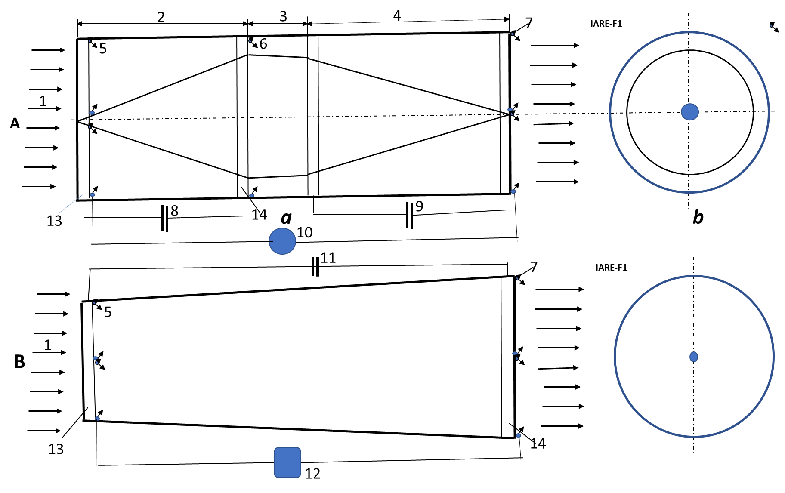
Fig.1A.(upper). Ion-Air Rocket Engine, using the conventional fuel. Notations: 1 - air; 2 – ion-air compressor; 3 – combustion camera; 4 – electric generator; 5 – ion injector; 6 – fuel injector; 7 – electron injector; 8 – condenser for creating the electrostatic field of compressor; 9 - condenser for creating the electrostatic field of electric generator; 10 - consumer of electricity. 13-14 – electrodes of high voltage.
Fig.1B.(lower). Ion-Air Rocket Engine, using the electricity. Notations: 1 - air; 5 – ion injector; 7 – electron injector; 11 – condenser for creating the electrostatic field into engine; 12 - issue of electricity; 13-14 – electrodes of high voltage.
Operation of Vehicle Installation
The proposed installation functions thusly;
The compressor receives air 1 through the inlet (Fig.1A). The air enters a strong electric field and positive ions are injected into it. Under the influence of a strong electric field, these ions are accelerated and, colliding with air molecules, transmit their kinetic energy to them and create a pressure that compresses the air. Compressed air then enters the combustion chamber 2. Here, an appropriate fuel is injected into the air. Fuel ignites and burns, increasing the temperature and volume of air. Subsequently, the compressed air enters the generator 4, where the electric field tends to slow it down, but it overcomes this resistance due to high pressure and speed and creates a high electrical voltage. The exhaust air leaves the installation, where electronic injectors 7 inject electrons into it. The electrical circuit closes and the entire installation is neutralized.
From the thermodynamic point of view, the proposed installation is completely identical to a conventional air jet-engine with a cycle at constant pressure (Fig. 2) or an electric turbo generator. But it has important fundamental differences: instead of a mechanical compressor, turbo generator and dynamo, a strong electric field is used. This immediately saves its operators from needing complex, expensive, massive turbines and magnetic dynamos and restrictions on the operational temperature and tensile strength of the turbine blades. This also greatly simplifies, reduces the cost of factory construction, reduces the weight of the engine. This can be seen from Fig.1. The design has only a pipe and a pair of cones.
The electrical circuit is simple (Fig. 1A). It consists of: charge injectors 5, → compressor 2 (internal energy consumer), → combustion chamber 3 (energy injection), → electric generator 4, → electronic injector 7, external current (energy) consumer 10, → charge injector 5. The mass of charge (ionizer) in a rocket engine is usually lost. But it is small (about 11 gr/hour). At the ground generator, it can be collected in a special device.
Note that the energy of capacitors 8, 9, 11 is not consumed when the unit is running.
Good capacitors can stay charged for days, weeks and months. Their charging energy is low. Charging is possible during flight.
The resulting electricity can be easily converted into traction. Such a Converter (engine) is shown in Fig.1B. It consists of a tube at the ends of which are reinforced electrodes 13-14 and injectors of ions 5 and electrons 7. The engine works as a compressor-accelerator of Earth’s air molecules. It consumes electricity from a source 12. Unlike conventional ramjet engines, the proposed ion engine can generate thrust at almost any speed (including zero). And in airless outer space, it throws off only ions, turning into an effective powerful ion rocket engine.
Advantages of the proposed ion engine and generator
The proposed jet engine has important advantages over existing turbine air-jet engines and liquid-propellant rocket engines. This is a giant leap in aviation and outer space mobility. These advantages are as follows:
Compared to the Air-Jet Engine and Ramjet Engine:
1. Extreme simplicity and cheapness. It is only a tube with ion and electronic injectors.
2. Low specific-weight. 3-4 times less than that of the usual Air-Jet Engine.
3. Unlimited maximum flight speed (up to 20-30 Mach).
4. Ability to work at high-altitude (up to 70 km in Earth’s atmosphere).
5. Can create greater thrust at zero speed, unlike the Ramjet.
7. It can work as a powerful starter during takeoff, using a ground-based electrical resource
and sliding contacts, i.e. it can work as a hypersonic gun. Or simply forcing the engine,
because the maximum power it has is not limited.
8. Can be used as a helicopter propeller for vehicular vertical takeoff and landing.
9. Can be used for landcraft and watercraft transport.
10. Can be used for ground-based electric power production plants.
Advantages over liquid-propellant and ion engines:
1. It can be used as acceleration boosters, reducing fuel consumption and the cost of
launching aircraft into space and into high orbits by tens of times.
2. It can be Used to increase the life of satellites in near-earth orbits several times and in
space (as a powerful ion engine with an appropriate electrical source).
Theory and example of estimation.
Thermodynamic calculation [5].
Calculation of a cycle with heat input at p = const. The heat capacity is assumed to be constant. The working medium is air with a gas constant R =287 J/ kg. degree. Parameters of the starting point: p₁ = 1 bar, T₁ = 320 K, compression ratio ε =18, pre-expansion degree ρ = 2, adiabatic index k = 1.4. The calculation is based on the mass of 1 kg air (Fig. 2). This is comfortable for recalculation into other parameters.
The _{initial} volume of the working body is
v₁ = RT₁/p₁ = 287×320/10⁵ = 0.92 m³/kg
Parameters of the second point (Fig. 2):
v₁/v₂ = ε, v₂ = v₁/ε = 0.82/18 = 0.05 m³/kg,
p₂/p₁ = (v₁/v₂)^{k} = ε^{k}, p₂ = pε^{k} = 1×10^{1.4} = 57.4 bar
T₂ = p₂ v₂/R = 57.4×10⁵×0.05/287 = 1023 K.
Parameters of the third point (Fig. 2):
v₃/v₂ = T₃/T₂ = ρ, T₃ = T₂ ρ = 1023.2 = 2046 K; p₃ = 57.4 bar,
v₃ = v₂ρ = 0.05.2 = 0.10 m³/kg .
Parameters of the fourth point:
v₄ = 0.92 m³/kg, T₄/T₃ = (v₃/v₄)^{k-1}, T₄ = 2046.(0.10/0.92)^{0.4} = 848 K,
p₄ = RT₄/v₄ = 287.843/(0.92.10⁵) = 2.65 bar.
The compression operation is equal to
l₁ = (p₁v₁ - p₂v₂)/(k-1) = (1.0.92 – 57.4.0.05)10⁵/0.4 = - 505000 =-505 kJ/kg .
The extension works as follows
L₃ = p₂(v₃ – v₂) + (p₃v₃ – p₄v₄)/(k-1) = 57.4.10⁵(0.10 – 0.05) +
+ (10⁵/0.4)(57.4.0.10 – 2.65.0.92) = 1161 kJ/kg .
Useful work
l = l₂ + l₁ = 1161 – 505 = 656 kJ/kg .
The amount of heat supplied
q₁ = C_{p} (T₃ – T₂) = (29.09/28.85)(2046 – 1023) = 1032 kJ/kg .
Allocated amount of heat
q₂ = C_{v} (T₄ – T₁) = (20.78/28.85)(848-320) = 381 kJ/kg.
Useful heat used
q = q₁ – q₂ = 1032 – 381 = 651 kJ/kg
Thermal cycle CPU
η_{t} = l/q₁ = 656/1032 = 0.636 .
Thermal efficiency of the Carnot cycle
η_{i} = 1 + T₁/T₃ = 1 – 320/2046 = 0.844 .
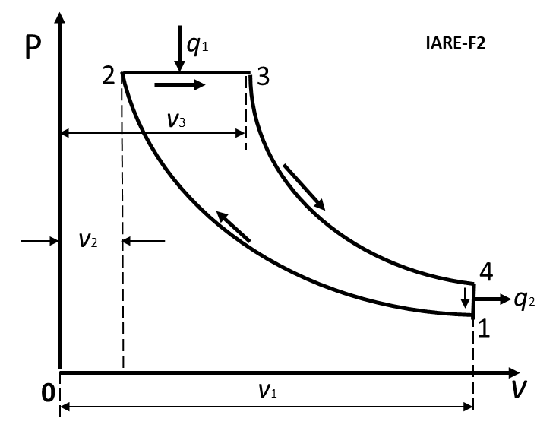
Fig.2. Thermodynamic cycle of the proposed Ion-Air Rocket Engine in the coordinates pressure – specific volume. Notation: 1-2 - compression adiabat, 2-3 - fuel heating at constant pressure, 3-4 -expansion adiabat, 4-1 - exhaust.
Electric estimation and calculation
Estimation of parameters of the electric compressor and generator.
Electric compressor. Let's estimate the amount of electric charge, current, and voltage required to create the desired pressure in the compressor. Let us take, for simplicity, that 1 kg of air has a volume of 1 m³. It is known that a spatial charge Q =1 C placed in a uniform electric field with a strength E = 1 V/m creates a force equal to 1 N. If we take a cylinder with a cross section of 1 m² with a volume charge of 1 Coulomb in 1 m³ and place it in a uniform electric field with a strength of E = 1 MV, the pressure at one end of the cylinder will be p₁ = 10⁶/10⁵ =10 Atm (bar).
Our compressor creates a pressure of 57.4 bar. Therefore, the electric charge in 1 m³ of air must be 57.4/10 = 5.74 C/m³, the current for compressing 1 kg of air i = 5.74 A, and the required voltage obtained from the electric generator
U_{c} = P_{c}/i = -505.10³/5.74 = - 88 kV,
here U_{c} – voltage consumed by the compressor, V; Pc-power consumed by the compressor, W.
Similarly, the electric generator must produce a voltage
U_{g} = P_{g}/i = 1164.10³/5.74 = 209 kV,
here U_{g} is the voltage generated by the generator, V; P_{g} is the power generated by 1 kg of hot air passing through the generator, W.
The payload will have a voltage of
U_{u} = P_{u}/i = 656.10³/5.74 = 114.3 kV,
here U_{u} is the voltage consumed by the field, V; P_{u} is the power generated by 1 kg of hot air
passing through the generator, W.
This was all for an air consumption of 1 kg, i.e. for an engine with a power of P₁ = 656 kW.
The engine power P = 5000 kW.
This is the power of today’s average aircraft engine. For such an engine, the air consumption will be
G_{a} = P/P₁ = 5000/656 = 7.62 kg/s .
And the current strength I should be increased by 7.62 times.
I = i.G_{a} = 5.74.7.62 = 43.74 A.
And the voltage on the compressor, generator and load will be the same.
Note that the air consumption of our electric motor is much less than that of a conventional mechanical Air-Jet Engine. This is due to the fact that the mechanical air jet engine must compress excess air to cool the turbine blades.
Estimation of flow of mass and energy of the ionizer.
Ion mass. Let's take Lithium-7 as an ionizer. Consumption of number N₁ ions per 1 kg of air
N₁ = Q/q = 5.74/1.6.10⁻¹⁹ = 3.59.10¹⁹, 1/s ,
here Q-charge of 1 kg of air, C; q = 1.6.10⁻¹⁹C charge of 1 ion, C.
Mass of ions in 1 kg of air is
M₁ = N₁nm_{p} = 3.59.10^{19.}7.1.67.10⁻²⁷ = 4.19.10⁻⁷ kg/kg,air.
Therefore, for a power of 5 MW, the ionizer consumption will be
G_{i} = G_{a}M₁ = 7.62.4.19.10⁻⁷ = 3.15.10⁻⁶ kg/s = 11.4 gr/hour .
The fuel consumption of 5 MV engine is equal to
G_{f} = P/q = 5.10⁶/40.10⁶ = 0.125 kg/s = 450 kg/hour.
Here q = 40 MJ/kg is specific energy of 1 kg aviation kerosene.
As the reader notes, the consumption of ion mass is very small in comparison with fuel.
Energy of ionization. The ionization energy is v = 5 eV. For an engine with a power of 5MV, i.e. current I = 43.74 A energy of ionization is
P_{i} = Iv = 43.74.5 = 219 W.
Therefore, the influence of the mass and energy consumption of the ionizer on the flight characteristics of the engine can be ignored. Many elements can be ionizers.
Subsonic flight. Evaluation of engine thrust during flight and fixed in place. Acceleration of air flow.
Engine thrust in flight. Using mechanical formulas
T = P/∆V, E = m∆V²/2, ∆V = (2E/m)^{0.5}, (2P/m_{s})^{0.5}, m_{s} = ρSV, ∆V = (2P/ρSV)^{0.5},
where P is power, W; ∆V is flow rate increment, m/s; E is energy of acceleration, J; m is mass, kg; m_{s} is mass in second, kg/s; S is cross section of air flow, m²; ρ is air density, kg/m³.
We get the final formulas in flight
T = (0.5ρSVP)^{0.5},
where T is trust in flight, N.
From equations of mechanic
P = m_{s}∆V²/2, m_{s} = ρSV, P = 0.5ρSV³,
We get the formulas for thrust, when flight speed is zero
T_{o} = (0.5ρSP²)^{1/3}.
Let us to estimate trust of the engine P = 5 MW having S = 2 m² on subsonic speed:
If V = 0, H = 0 km, T_{o} = (0.5ρSP²)^{1/3} = (0.5.1.225.2.25.10¹²)^{1/3} = 3.06.10⁴ N = 3.06 tons.
If V = 200 v/s, H = 10 km, T = (0.5ρSVP)^{0.5} = (0.5.0.414.2.200.5.10⁶)^{0.5} = 2.03 tons.
Note that a conventional mechanical aircraft engine is in dire need of increased power during takeoff and ascent to altitude. Therefore, by reducing its resource and safety for a limited time, it is allowed to increase capacity by 10-30%. This is the take-off mode for 1-2 minutes and the nominal mode for 30-60 minutes.
The proposed electric rocket engine has almost no restrictions on the maximum power. Increasing its power affects only the fuel consumption and ionizer. And it is possible to use a combustion chamber cooler. The top temperature may be only limited by the air molecule dissociation and ionization.
Supersonic and hypersonic flights.
Estimates of the velocity head at high altitudes show that the pressure and air density of ρ= 1 kg/m³ at the engine inlet can be maintained up to an altitude of approximately 30 km and a speed of >1000 m/s. This means that to simplify estimates, we can assume that the proposed engine retains its power. Let us estimate how much thrust the engine develops in this case
H = 30 km, V = 1000 m/s, T = (0.5ρSVP)^{0.5} = (0.5.1.22.2.1000.5.10⁶)^{0.5} = 7.83 tons.
H = 30 km, V = 3000 m/s, T = (0.5ρSVP)^{0.5} = (0.5.1.22.2.3000.5.10⁶)^{0.5} = 13.6 tons.
H = 30 km, V = 6000 m/s, T = (0.5ρSVP)^{0.5} = (0.5.1.22.2.6000.5.10⁶)^{0.5} = 19.2 tons.
H = 30 km, V = 8000 m/s, T = (0.5ρSVP)^{0.5} = (0.5.1.22.2.8000.5.10⁶)^{0.5} = 22.1 tons.
Let us evaluate the parameters of the launch trajectory (acceleration) of a passenger spacecraft. The acceleration of a comfortable tourist spacecraft ought not exceed 3g ≈ a = 30 m/s². The acceleration distance to the speed V = 6000 m/s is equal to (for ballistic flight in distance 10,000 km)
L = V²/(2a) = (6.10³)²/2.30 = 600 km.
Acceleration time
t = V/a = 6000/30 = 200 sec.
Full time is about 29-30 minutes.
For speed V = 8000 m/s the ассeleration distance is L = 1067 km and time t = 267 sec.
Cost of launch 1 metric ton into Earth orbit H = 150 km.
Energy need for acceleration for V = 8000 m/s:
E_{a} = mV²/2 = 1000.(8.10³)² = 6.4.10¹⁰ J.
Energy need for lifting G = 1000 kg on H = 150 km
E_{H} = GgH =10⁴150.10³=1.5.10⁹ J.
Total energy is
E = E_{a} + E_{H} = 6.55.10¹⁰ J.
Amount of fuel (say, kerosene) needed for offered launcher is
G_{f} = E/q = 6.55.10¹⁰ /4.10⁷ = 1.64 ton.
The average retail cost of kerosene in 2020 year was about 0.64 US$/liter. 1.64 ton cost about $1000. The flight of one tourist (100 kg) cost 30-40 million dollars ten years ago. Seven rich tourists have already visited space. By now, the price has risen to 2020 US$ 100 million, but the queue is only lengthening!
Note: Now, to launch 1 ton of cargo, at least 16 – 20 tons of expensive, toxic and explosive fuel is required. The cost of launching 1 ton of cargo into outer space costs 15 -25 million US dollars.
Even if Mr. Elon Mask reduces the cost of a regular launch by 2-3 times – this is not the solution to the problem, because by the old method to drastically reduce the cost of launching, for example, by 100 times is simply impossible.
Private-sector space travel companies are developing new services: flying around the moon, going into outer space briefly, relaxation in an luxurious inflated space hotel, flying around the Earth for sight-seeing, etc. In addition, the proposed method allows launches and the operation of spacecraft for almost years, unlike airplanes.
High-speed cheap inter-continental flights. The proposed engine can be used for flights to any long distances near the Earth, for example, New York – London, Paris, Moscow, Beijing, travel around the Earth, etc. The flight is performed in the same way as the spacewalk. The aircraft accelerates in the atmosphere to a high speed (for example, up to 6 km/s. In the final section the trajectory due to the wings and thrust is deflected up to 30º and the device goes on a ballistic trajectory.
Other applications of the proposed ion engine. The engine (more precisely, the second part of Fig. 1B) can be made in the form of a large thin ring of a large diameter comparable to the diameter of the helicopter, with a double grid. Then the device can land and take off like a helicopter. The advantage over the helicopter will be that the device can develop high speeds. In addition, the advantage is in the mechanical simplicity and fabrication cheapness of the screw installation.
The engine can be used as an engine for vehicular land and water transport and as a stationary ground-based electric generator {see [8]-[18]}. It can foster a revolution in hypersonic missiles.

Discussion
The proposed ion engine, if successfully built, tested and employed, means a huge economic and strategic conceptual breakthrough in outer space operations, rocket technology, transport and energy. It reduces the cost of delivering cargo and people to space by tens or hundreds of times, reduces the cost of long-distance flights, and provides new opportunities for aerospace-planes, helicopters, hovercrafts, land, sea and underwater transport, and for generating electric energy. The study and verification of the theoretical foundations of the proposed method is not difficult and can be carried out on desktop computational models.
Acknowledgement.
The author is grateful Richard B. Cathcart for editing English and useful tips.
Reference:
1. Bolonkin A.A., Wind Energy – Electron Jet Generators and Propulsions. USA, Lulu,
ISBN 978-1-386-84732-5, 142 p.
2. Габович М.Д., Пучки ионов и атомов для управляемого термоядерного синтеза и
технологических целей. М. Мир, 1992, 354 с. (Russian).
3. Forrester T.A., Large Ion Beam. Fundamental of Generation and Propagation. Wiley.
Форрестор Т.А., Интенсивные ионные пучки. М., Мир,1992, 354 с. (Translation in Russian).
4. Kikoin I.K., Table of Physics Values. Moscow, Atomizdat, 1976. (in Russian).
5. Нащекин В.В., Техническая термодинамика и теплопередача. М. Высшая школа,
1969. (Russian). Naschekin V. V., Technical thermodynamics and heat transfer.
6. Гришин С.Д., Лесков Л.В., Электрические ракетные двигатели летательных аппаратов. М.
Машиностроение. 1989, 216 стр.(Russian). Grishin S. D., Leskov L. V., Electric rocket engines of
aircraft.
7. Wikipedia. Wind energy. Ionization energy.
Additional articles:
8) Bolonkin A.A., Electron Air Hypersonic Propulsion. International Journal of Advanced
Engineering Applications, Vol.1, Iss.6, pp.42-47 (2012). http://viXra.org/abs/1306.0003,
9) Bolonkin A.A., Electronic Wind Generator.
Electrical and Power Engineering Frontier Sep. 2013, Vol. 2 Iss. 3, pp. 64-71.
http://www.academicpub.org/epef/Issue.aspx?Volume=2&Number=3&Abstr=false
http://viXra.org/abs/1306.0046.
10) Bolonkin A.A., Electron Hydro Electric Generator. International Journal of Advanced
Engineering Applications. ISSN: 2321-7723 (Online), Special Issue I, 2013.
http://fragrancejournals.com/?page_id=18, http://viXra.org/abs/1306.0196,
http://www.scribd.com/doc/149489902/Electron-Hydro-Electric-Generator , #1089
http://archive.org/details/ElectronHydroElectricGenerator_532,
http://intellectualarchive.com,
11) Bolonkin A.A., Electron Super Speed Hydro Propulsion.
International Journal of Advanced Engineering Applications, Special Issue 1, pp.15-19
(2013), http://viXra.org/abs/1306.0195,
http://archive.org/details/ElectronSuperSpeedHydroPropulsion.
12) Bolonkin A.A., Electric Hypersonic Space Aircraft. http://intellectualarchive.com,
#1288; http://vixra.org/abs/1407.0011 , 1 July 2014; http://www.scibd/doc/232209230,
http://archive.org/details/ElectricHypersonicaircraft, http://gsjournal.net/Science-Journals-Papers/Author/1481/Alexander,%20Bolonkin .
13) Bolonkin A.A., Electrostatic Generator and Electric Transformer,
http://Vixra.org/abs/1407.0016, http://GSJournal.net, 2 July 2014;
http://intellectualarchive.com, #1289.
14) Bolonkin A.A., Jet generator. http://Vixra.org/abs/1407.0180 ,
https://archive.org/details/, http://gsjournal.net/Science-Journals-Papers/Author/1481/Alexander,%20Bolonkin
15) Bolonkin A.A., Electrostatic Gunnon. http://www.gsjournal.net , sent 11 13 19. https://archive.org/details/articleelectrostaticguneng101219, www.IntellectualArchive.com#2217, http://viXra.org/abs/1911.0232 http://viXra.org #10913270.
16) Bolonkin A.A., Electric Ion Wind Generator. 6 9 20. http://viXra.org/abs/2006.0067
Archive: https://archive.org/details/article-after-r-electro-ione-wind-generator-6-6-20.
GSJournal, 6 8 20. "Electric Ion Wind Generator",
https://www.gsjournal.net/Science-Journals/Research%20Papers/View/8276.
17) Bolonkin A.A., Thermonuclear Micro-Projectile and Methods for its Use in Defensive
Protection from Space Rockets, Peaceful Energy and Transport. 9 22 19.
https://archive.org/details/ articleafterrcstrategicdefthermonuclearmicro-projectileandmethodsforitsuseindefe, www.IntellectualArchive.com #2192, http://viXra.org/abs/1909.0475, http://www.gsjournal.net
18) Bolonkin A.A., Cheap, Small Electric Space Propulsion (Launcher).
https://archive.org/details/articleelectriceng3spacelauncher111819 .

