Article Thermoforming of planets for arch 8 10 14

Terraforming of planets and Space Objects
Alexander Bolonkin
C&R, USA abolonkin@juno.com

Abstract
The current physics believes that vacuum can produce energy and Universes. The basis of any Universe is energy. Author assumes: energy may be positive or negative. Positive energy produces our positive matter, negative energy produces negative matter. Using this effect the author offers the formatting the current planets of Solar system, making them suitable for people, for humanity. That include: the production of Earth atmosphere, water, magnetic field in planets and natural satellites, change their angle speed, and transportation them to Earth orbit.
Negative matter repels our (positive) matter. Using this effect the author offers a space propulsion system which allows reaching by space ship a speed close to light speed and to enable massive retrieval of extraterrestrial materials to construct works in space. That may be the best method colonization the space, Solar System and Universe.
Concept of negative energy also allows solving the many very important problems of humanity. For example, humanity can create any artificial material, food, travel to other stars and possible (in future) create a new Universe.
------------------------------------------------------------
Key words: Thermoforming planets, Space Flight, Space propulsion, negative energy, negative matter.
Introduction
In works [1]-[4] author showed the basis of the Universe: Time, Matter, Charge, Distance (dimensions), Volume, is energy. Energy may be positive and negative. All particles are only different forms; collections of energy units. Author offered new artificial forms of matter having gigantic strength, heat resistance (millions times more than steel) and other awesome properties [5]-[6]. He also offered method for conversion any matters in energy and using than in aerospace [6]-[10].
The concept of negative energy explains the main riddle of the Universe: From where did the vacuum take a huge amount of energy for creation of our Universe? If we include the equal virtual pair positive and negative energy in vacuum, the total (sum) energy in vacuum equals zero.
It may help to explain the dark energy and dark matter in the current model of the Universe. If there exist two Universes (positive and negative), embedded one (positive) Universe into the other (negative) Universe. As shown in [11] the negative Universe is full identical to our positive Universe because the choice of sign is arbitrary.
Negative energy generates negative matter. But the relationship of negative matter to positive matter is different. Positive matter attracts positive matter but repels negative matter and the negative matter attracts the negative matter but powerfully repels the positive matter. They fly away one from other with a speed close to light speed. If they are connected, the positive and negative matters are annihilated (the sum of energy became zero).
Solar System.
The Solar System comprises the Sun and the objects that orbit it, whether they orbit it directly or by orbiting other objects that orbit it directly. The four smaller inner planets, Mercury, Venus, Earth and Mars, also called the terrestrial planets, are primarily composed of rock and metal. The two largest, Jupiter and Saturn, are composed mainly of hydrogen and helium; the two outermost planets, Uranus and Neptune, are composed largely of substances with relatively high melting points (compared with hydrogen and helium), called ices, such as water, ammonia and methane, and are often referred to separately as "ice giants". All planets have almost circular orbits that lie within a nearly flat disc called the ecliptic plane.
The Solar System also contains regions populated by smaller objects. The asteroid belt, which lies between Mars and Jupiter, mostly contains objects composed, like the terrestrial planets, of rock and metal. Within these populations are several dozen to more than ten thousand objects that may be large enough to have been rounded by their own gravity. Such objects are referred to as dwarf planets.
Six of the planets, at least three of the dwarf planets, and many of the smaller bodies are orbited by natural satellites
All the planets and most other objects orbit the Sun in the same direction that the Sun is rotating (counter-clockwise, as viewed from a long way above Earth's north pole).
Most of the planets in the Solar System possess secondary systems of their own, being orbited by planetary objects called natural satellites, or moons (two of which are larger than the planet Mercury), and, in the case of the four gas giants,
Most of the largest natural satellites are in synchronous rotation, with one face permanently turned toward their parent.
Kepler's laws of planetary motion describe the orbits of objects about the Sun. Following Kepler's laws, each object travels along an ellipse with the Sun at one focus.
On an elliptical orbit, a body's distance from the Sun varies over the course of its year. A body's closest approach to the Sun is called its perihelion, whereas its most distant point from the Sun is called its aphelion. The orbits of the planets are nearly circular,
The boundary in the Solar System beyond which those volatile substances could condense is known as the frost line, and it lies at roughly 5 AU from the Sun.
The objects of the inner Solar System are composed mostly of rock, the collective name for compounds with high melting points, such assilicates, iron or nickel, that remained solid under almost all conditions in the protoplanetary nebula. Jupiter and Saturn are composed mainly of gases, the astronomical term for materials with extremely low melting points and high vapour pressure, such as molecular hydrogen, helium, and neon, which were always in the gaseous phase in the nebula. Ices, like water, methane, ammonia, hydrogen sulfide and carbon dioxide, have melting points up to a few hundred kelvins. They can be found as ices, liquids, or gases in various places in the Solar System, whereas in the nebula they were either in the solid or gaseous phase. Icy substances comprise the majority of the satellites of the giant planets, as well as most of Uranus and Neptune (the so-called "ice giants") and the numerous small objects that lie beyond Neptune's orbit. Together, gases and ices are referred to as volatiles.
The Solar System formed 4.568 billion years ago from the gravitational collapse of a region within a large molecular cloud.
Due to their higher boiling points, only metals and silicates could exist in solid form in the warm inner Solar System close to the Sun, and these would eventually form the rocky planets of Mercury, Venus, Earth, and Mars. Because metallic elements only comprised a very small fraction of the solar nebula, the terrestrial planets could not grow very large. The giant planets (Jupiter, Saturn, Uranus, and Neptune) formed further out, beyond the frost line,
Within 50 million years, the pressure and density of hydrogen in the centre of the protostar became great enough for it to begin thermonuclear fusion. The temperature, reaction rate, pressure, and density increased until hydrostatic equilibrium was achieved: the thermal pressure equalled the force of gravity
The Solar System will remain roughly as we know it today until the hydrogen in the core of the Sun has been entirely converted to helium, which will occur roughly 5.4 billion years from now. This will mark the end of the Sun's main-sequence life. At this time, the core of the Sun will collapse, and the energy output will be much greater than at present. The outer layers of the Sun will expand to roughly 260 times its current diameter, and the Sun will become a red giant.
The expanding Sun is expected to vaporize Mercury and Venus and render Earth uninhabitable as the habitable zone moves out to the orbit of Mars.
Sun.
The Sun is the Solar System's star, and by far its chief component. Its large mass (332,900 Earth masses)^{[47]} produces temperatures and densities in its core high enough to sustain nuclear fusion, which releases enormous amounts of energy, mostly radiated into space as electromagnetic radiation, peaking in the 400–700 nm band of visible light.
The vast majority of the Solar System consists of a near-vacuum known as the interplanetary medium. Along with light, the Sun radiates a continuous stream of charged particles (a plasma) known as the solar wind.
Inner Planets (Planets of Earth group).
The four inner or terrestrial planets have dense, rocky compositions, They are composed largely of refractory minerals, such as the silicates, which form their crusts and mantles, and metals, such as iron and nickel, which form their cores. Three of the four inner planets (Venus, Earth and Mars) have atmospheres substantial enough to generate weather; all have impact cratersand tectonic surface features, such as rift valleys and volcanoes.

Mercury
Mercury (0.4 AU from the Sun) is the closest planet to the Sun and the smallest planet in the Solar System (0.055 Earth masses). Mercury has no natural satellites; besides impact craters, its only known geological features are lobed ridges or rupes, Mercury's almost negligible atmosphere consists of atoms blasted off its surface by the solar wind. Its relatively large iron core and thin mantle have not yet been adequately explained.

Venus
Venus (0.7 AU from the Sun) is close in size to Earth (0.815 Earth masses) and, like Earth, has a thick silicate mantle around an iron core, a substantial atmosphere, and evidence of internal geological activity. It is much drier than Earth, and its atmosphere is ninety times as dense. Venus has no natural satellites. It is the hottest planet, with surface temperatures over 400 °C (752°F), most likely due to the amount of greenhouse gases in the atmosphere.^{[71]} No definitive evidence of current geological activity has been detected on Venus, but it has no magnetic field that would prevent depletion of its substantial atmosphere, which suggests that its atmosphere is frequently replenished by volcanic eruptions.

Earth
Earth (1 AU from the Sun) is the largest and densest of the inner planets, the only one known to have current geological activity, and the only place where life is known to exist. Its liquid hydrosphere is unique among the terrestrial planets, and it is the only planet where plate tectonics has been observed. Earth's atmosphere is radically different from those of the other planets, having been altered by the presence of life to contain 21% free oxygen.^{[74]} It has one natural satellite, the Moon, the only large satellite of a terrestrial planet in the Solar System.

Mars
Mars (1.5 AU from the Sun) is smaller than Earth and Venus (0.107 Earth masses). It possesses an atmosphere of mostly carbon dioxide with a surface pressure of 6.1 millibars (roughly 0.6% of that of Earth). Its surface, peppered with vast volcanoes, such as Olympus Mons, and rift valleys, such as Valles Marineris, shows geological activity that may have persisted until as recently as 2 million years ago. Its red colour comes from iron oxide (rust) in its soil. Mars has two tiny natural satellites (Deimos and Phobos) thought to be captured asteroids.

Ceres
Ceres (2.77 AU) is the largest asteroid, a protoplanet, and a dwarf planet.^{[d]} It has a diameter of slightly under 1,000 km, and a mass large enough for its own gravity to pull it into a spherical shape. Ceres was considered a planet when it was discovered in 1801, and was reclassified to asteroid in the 1850s as further observations revealed additional asteroids.^{[84]} It was classified as a dwarf planet in 2006.

Outer Solar System
The outer region of the Solar System is home to the gas giants and their large moons.
Due to their greater distance from the Sun, the solid objects in the outer Solar System contain a higher proportion of volatiles, such as water, ammonia and methane. They have a lot of satellites which may be useful for our research.
Jupiter. Jupiter has 67 known satellites. The four largest, Ganymede, Callisto, Io, and Europa, show similarities to the terrestrial planets, such as volcanism and internal heating. Ganymede, the largest satellite in the Solar System, is larger than Mercury.
Saturn has 62 confirmed satellites; two of which, Titan and Enceladus, show signs of geological activity, though they are largely made of ice. Titan, the second-largest moon in the Solar System, is larger than Mercury and the only satellite in the Solar System with a substantial atmosphere.
Uranus has 27 known satellites, the largest ones being Titania, Oberon, Umbriel, Ariel, and Miranda.
Neptune has 14 known satellites. The largest, Triton, is geologically active, with geysers of liquid nitrogen.^{[94]} Triton is the only large satellite with a retrograde orbit. Neptune is accompanied in its orbit by several minor planets, termed Neptune trojans, that are in 1:1 resonance with it.
Pluto. The dwarf planet Pluto (39 AU average) is the largest known object in the Kuiper belt. Charon, Pluto's largest moon, is sometimes described as part of a binary system with Pluto, as the two bodies orbit a barycentre of gravity above their surfaces (i.e. they appear to "orbit each other"). Beyond Charon, four much smaller moons, Styx, Nix, Kerberos, and Hydra, are known to orbit within the system.
Centaur (minor planet).
The centaurs are icy comet-like bodies whose orbits have semi-major axes greater than Jupiter's (5.5 AU) and less than Neptune's (30 AU). The largest known centaur, 10199 Chariklo, has a diameter of about 250 km.^{[95]} The first centaur discovered, 2060 Chiron, has also been classified as comet (95P) because it develops a coma just as comets do when they approach the Sun.
List of natural satellites of the Solar System
There are 19 natural satellites in the Solar System that are known to be massive enough to be close to hydrostatic equilibrium, which Alan Stern calls satellite planets. However, several of these were once in equilibrium but are no longer: these include all of the moons listed for Saturn apart from Titan and Rhea. Other moons that were once in equilibrium but are no longer very round, such as Saturn's Phoebe, are not included. Satellites are listed first in order from the Sun, and second in order from their parent body.

Main idea. Positive and negative Energy. Positive and negative matter.
Vacuum energy is an underlying background energy that exists in space throughout the entire Universe. One contribution to the vacuum energy may be from virtual particles which are thought to be particle pairs that blink into existence and then annihilate in a timespan too short to observe. They are expected to do this everywhere, throughout the Universe. Their behavior is codified in Heisenberg's energy–time uncertainty principle. Still, the exact effect of such fleeting bits of energy is difficult to quantify.
The effects of vacuum energy can be experimentally observed in various phenomena such as spontaneous emission, the Casimir effect and the Lamb shift, and are thought to influence the behavior of the Universe on cosmological scales. Using the upper limit of the cosmological constant, the vacuum energy in a cubic meter of free space has been estimated to be 10⁻⁹ joules (10⁻² ergs).^{[1]} However, in both Quantum Electrodynamics (QED) and Stochastic Electrodynamics (SED), consistency with the principle of Lorentz covariance and with the magnitude of the Planck constant requires it to have a much larger value of 10¹¹³ joules per cubic meter. This huge discrepancy is known as the vacuum catastrophe.
Vacuum energy can also be thought of in terms of virtual particles (also known as vacuum fluctuations) which are created and destroyed out of the vacuum. These particles are always created out of the vacuum in particle-antiparticle pairs, which in most cases shortly annihilate each other and disappear. However, these particles and antiparticles may interact with others before disappearing, a process which can be mapped using Feynman diagrams. Note that this method of computing vacuum energy is mathematically equivalent to having a quantum harmonic oscillator at each point and, therefore, suffers the same renormalization problems.
Additional contributions to the vacuum energy come from spontaneous symmetry breaking in quantum field theory.
Other predictions are harder to verify. Vacuum fluctuations are always created as particle–antiparticle pairs. The creation of these virtual particles near the event horizon of a black hole has been hypothesized by physicist Stephen Hawking to be a mechanism for the eventual "evaporation" of black holes. The net energy of the Universe remains zero so long as the particle pairs annihilate each other within Planck time. If one of the pair is pulled into the black hole before this, then the other particle becomes "real" and energy/mass is essentially radiated into space from the black hole.
In 1973, Edward Tryon proposed the zero-energy universe hypothesis: that the Universe may be a large-scale quantum-mechanical vacuum fluctuation where positive mass-energy is balanced by negative gravitational potential energy. During the 1980s, there were many attempts to relate the fields that generate the vacuum energy to specific fields that were predicted by attempts at a S.Hawking Grand unification theory (2010) and to use observations of the Universe to confirm one or another version. However, the exact nature of the particles (or fields) that generate vacuum energy, with a density such as that required by inflation theory, remains a mystery. Main problem Edward Tryon and Crand unification theory is gigantic difference an energy between the positive mass-energy and negative gravitational potential energy.
In difference of Edward Tryou and Hawking theory the author believes the vacuum has the zero energy and produces simultaneously in equal amount the positive and negative energy. The positive and negative matter repel one other and the part of the negative matter may to fly with light speed in space or in the negative Universe. That also means in the same time with our (positive) Universe was created the same negative Universe which does not have interaction with our Universe. We cannot view the negative Universe. Contact between positive and negative matter requests the high speed (returning the energy was received in removing) and produces full annihilation with zero-point energy. The zero-annihilation is opposed the conventional annihilation of a positive particle-antiparticle which produces the maximum of energy.
Ratio between positive and negative energies and positive and negative matters are described equations:
(1)
where E₊ is positive energy, J; E₋ is negative energy, J; m₊ is positive matter, kg; m₋ is negative matter, kg; c = 3×10⁸ m/s is the light speed.
This assumption about the existing of negative energy may to give the huge possibilities in human technology. We can produce a need matter in a need amount (include the new planet atmosphere) in need place, annihilate the positive matter (for example, bad atmosphere in Venue), free travel in space, relocate of small planets, create a large space colonization and so on. Some of them possibilities are considered below.
Creating the earth atmosphere in other planets
For colonization the Mercury, Venue, Mars, Moon and other planets it is desirable the planet has the atmosphere similar to Earth's atmosphere (pressure and composition). In this case we can wait the climate closed to Earth. It cannot be widely colonization of planet if people will live into special hermetic settlement and walk out of them only into a special space suite. It will be possible only if men can be in space without special space suit [11] or the biological civilization will be changed by E-exists [12] (electronic civilization).
We can compute the need positive mass and energy for creating of new atmosphere. The need equations are:
(2)
where p is surface pressure of atmosphere, N/m²; m is specific mass of atmosphere on 1 m², kg/m²; S is planet surface, m²; R is radius of planet, m; M is total mass of planet atmosphere, kg; g is gravity of planets, m/s²; E is energy need for creating the planet atmosphere, J.
Result of computation is presented in Table 1.
Table 1. Mass and energy is needed for creating the artificial
Earth atmosphere on nearest planets and Moon.
Planets  and Moon | Planet  gravity  g , m/s² | Planet  Radius  R ×10⁶ m. | Mass of  atmosphere,  M ×10¹⁸ kg, | Desire  energy  E ×10¹⁸ J
Mercury | 3.72 | 2.43 | 2.69 | 2.42
Venue | 8.69 | 6.05 | 5.3 | 4.77
Mars | 3.72 | 3.38 | 3.87 | 3.48
Moon | 1.62 | 1.737 | 2.35 | 2.11
Earth | 9.81 | 6.378 | 5.11 | 4.60
If planet has a bad atmosphere (as Venue) the old atmosphere may be annihilated by a negative matter and the Earth atmosphere will be created. The excess of positive matter may be used for getting an agriculture soil and as construction material.
Creating the water in other planets
For comfortable living conditions the humanity needs in ponds, lakes, small rivers and (possible) small sea. Assume the water surface cover k relative part of a planet surface S and has an average deep h meters. The need mass of water may be estimated by equations:
(2a)
where M is planet mass of water, kg; γ = 1000 kg/m³ is specific mass of water, kg/m³; k is relative part of a planet surface covered by water, k < 1; h is average deep of water ponds, m.
Result of estimations for k = 0.1 and h = 5 m is presented in Table 2.
Table 2. Mass of water and energy is needed for creating
the artificial ponds in planets for k = 01 and h = 5 m.
Planets  and Moon | Mass of water,  M ×10¹⁴ kg | Need energy  E ×10¹⁸ J
Mercury | 0.74 | 0.733
Venue | 4.6 | 5.94
Mars | 1.44 | 1.3
Moon | 0.38 | 0.342

Creating the day time (angle rotary of planet)
For people is important usual alternation the duration of a day and night (24 hours). If we will have not limited the energy, we can change the angle speed of planets and natural satellites.
For computation of the desire energy we use the following equations:
(3)
where ω is desire angle speed of planet, rad/sec; T is time of one revolution, sec; J is angle inertial moment, kg.m²; m is mass of planet, kg; R is radius planet, m; E is rotation energy of planet, J; ΔE is energy requested for change the angle speed of planet or satellite, J; ω_{p} is angle speed of planet, rad/sec.
Results of computation of need energy are presented in Table 3.
Table 3. Desire energy for change the angle speed.
Planet | Planet  radius  R_{p}, 10⁶ m | Mass,  10²⁴ kg | Angle  inertia J,  10³⁶ kg.m² | Period,  Earth  days | Need  energy  E, 10²⁵ J | ΔE
Mercury | 2.43 | 0.33 | 0.773 | 59 | 0.1314 | ≈ E
Venus | 6.05 | 4.87 | 71.3 | 247 | 12.12 | ≈ E
Earth | 6.378 | 5.976 | 97.2 | 1 | 0 | 0
Mars | 3.39 | 0.645 | 2.94 | ≈ 1 | ≈ 0 | ≈ 0
Moon | 1.737 | 0.0735 | 0.09 | 27 | 0.015 | ≈ E

Creating of Magnetic field
Earth's magnetic field, also known as the geomagnetic field, is the magnetic field that extends from the Earth's interior to where it meets the solar wind, a stream of charged particles emanating from the Sun. Its magnitude at the Earth's surface ranges from 25 to 65 microtesla (0.25 to 0.65 gauss).
The magnetosphere is the region above the ionosphere and extends several tens of thousands of kilometers into space, protecting the Earth from the charged particles of the solar wind and cosmic rays that would otherwise strip away the upper atmosphere, including the ozone layer that protects the Earth from harmful ultraviolet radiation.
Earth's magnetic field serves to deflect most of the solar wind, whose charged particles would otherwise strip away the ozone layer that protects the Earth from harmful ultraviolet radiation. One stripping mechanism is for gas to be caught in bubbles of magnetic field, which are ripped off by solar winds. Calculations of the loss of carbon dioxide from the atmosphere of Mars, resulting from scavenging of ions by the solar wind, indicate that the dissipation of the magnetic field of Mars caused a near-total loss of its atmosphere.
Earth's magnetic field, predominantly dipolar at its surface, is distorted further out by the solar wind. This is a stream of charged particles leaving the Sun's corona and accelerating to a speed of 200 to 1000 kilometres per second. They carry with them a magnetic field, the interplanetary magnetic field(IMF).
As well as deflecting the solar wind, the Earth's magnetic field deflects cosmic rays, high-energy charged particles that are mostly from outside the Solar system. (Many cosmic rays are kept out of the Solar system by the Sun's magnetosphere, or heliosphere.) By contrast, astronauts on the Moon risk exposure to radiation. Anyone who had been on the Moon's surface during a particularly violent solar eruption in 2005 would have received a lethal dose.
Magnetic field is important for humanity planets. One protects the humanity from ultraviolet radiation and decreasing the leak atmosphere in space.
The magnetic field is about 25 ÷ 65 A/m near the Earth surface. The energy of outer Earth magnetic field is about 4 ÷ 8×10¹⁸ J. The similar magnetic field must have any human planet located near the Earth orbit.
The creation the artificial magnetic field is described and computed in author article [10].
Relocation the planets or they satellites in Earth and Earth Solar Orbit
The planets are located in different orbits. All orbits (except Earth) have an excess or a lack of solar energy. We have only one the best (Earth’s) orbit. The offer concept of negative energy theoretically gives the possibility to receive a gigantic energy needed for the planet relocation. Let us to estimate the energy needed for planet relocation to Earth’s orbit.
Table 4. Data on Solar System planets
Space  body | Distance  from Sun, 10¹⁰ m | Mass,  10²⁴ kg | Gravitation  constant  μ m³/s² | Circular  speed,  V₀ km/s | Escape  speed,  V_{e} km/s | Orbital  speed,  V_{or} km/s | Gravity  Constant.  g, m/s² | Planet  radius  R_{p}, 10⁶ m
Sun | - | 1.99·10⁶ | 1.3276·10²⁰ | 437 | 617.7 | - | 274 | 696
Mercury | 5.79 | 0.33 | 2.2·10¹³ | 3 | 4.25 | 47.87 | 3.72 | 2.43
Venus | 10.8 | 4.87 | 3.2·10¹⁴ | 7.25 | 10.36 | 35.02 | 8.69 | 6.05
Earth | 14.96 | 5.976 | 4·10¹⁴ | 7.9 | 11.18 | 29.78 | 9.78 | 6.378
Mars | 22.8 | 0.645 | 4.3·10¹³ | 3.55 | 5.02 | 24.13 | 3.72 | 3.39
Jupiter | 77.8 | 1899.3 | 1.268·10¹⁷ | 40.4 | 59.54 | 13.07 | 23.01 | 70.85
Saturn | 142.7 | 568.4 | 3.79·10¹⁶ | 25.8 | 35.49 | 9.672 | 9.44 | 60.1
Uranus | 287.1 | 86.3 | 5.76·10¹⁵ | 15.4 | 21.29 | 6.835 | 9.67 | 24.6
Neptune | 449.8 | 103 | 6.87·10¹⁵ | 18.8 | 23.71 | 5.4778 | 15.0 | 23.5
Moon | 0.03841  From Earth | 0.0735 | 0.19·10¹³ | 1.68 | 2.37 | 1.09 | 1.62 | 1.737
For planet relocations from one circle to other circle by Hohmann transfer we need two impulses. Desired Delta Speeds, time of transfer and specific energy may be computed by equations:
(4)
where a is average distance (average radius of planet orbits), m; r₁ is radius of the first orbit, m; r₂ is the radius of the second orbit, m; ΔV₁ is delta speed of the first impulse, m/s; ΔV₂ is delta speed of the second impulse, m/s; ΔV is total delta speed, m/s; μ = 1.328×10²⁰ is solar constant, t is transfer time, sec (or days or years); E₁ is energy of 1 kg planet mass in given orbit, J; M is mass of planet, kg; E is full energy of planet in given orbit, J; ΔE is relocation energy, J; E_{1,I} is energy of planet in desire position, J.
Result of computations for Mercury, Venus, Mars are present in Table 5 and figs.1 – 4.
Table 5. Delta Speeds, time of transfer, specific energy and total energy of planets.
Planet | r ×10¹⁰ m | a ×10¹⁰ m | ΔV₁×10³  m /s | ΔV₂×10³  m/s | ΔV×10³  m/s | t, day | E₁×10⁸  J/kg | M×10¹⁸  kg | E×10²⁷  J
Mercury | 5.79 | 10.37 | 7.5 | 9.5 | 17 | 105.5 | 6.4 | 2.69 | 1.72
Venue | 10.5 | 12.88 | 2.86 | 2,74 | 5.6 | 145.8 | 5.15 | 5.3 | 2.73
Earth | 15. | 15. | 0 | 0 | 0 | 182 | 4.4 | 5.11 | 0
Mars | 22.8 | 18.88 | 2.65 | 2.94 | 5.59 | 259 | 3.52 | 3.87 | 1.36

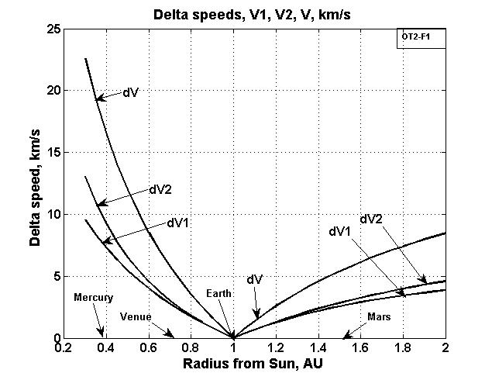
Fig.1. Desire delta speeds for relocation of planets the Earth’s group (Mercury, Venus, Earth, Mars) via radius from Sun in astronomical units, AU = 150 million km; dV1 is the first impulse, dV2 is the second impulse, dV = dV1 + dV2, km/s .
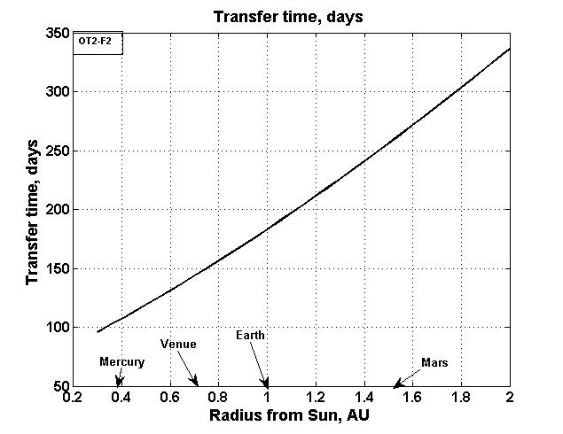
Fig.2. Transfer time (in days) for relocation of planets the Earth’s group (Mercury, Venus, Mars) via planet radius from Sun in astronomical units, AU = 150 million km.
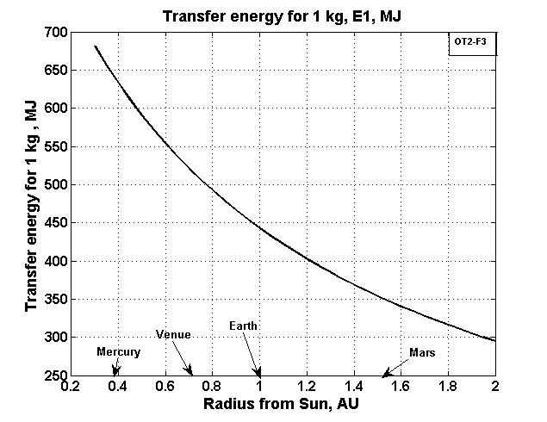
Fig.3. Energy (in million J) 1 kg planet the Earth’s group (Mercury, Venus, Mars) via radius of planet orbit from Sun in astronomical units, AU = 150 million km.

Example. Let us to estimate the desire energy for relocation 1 kg from Mercury orbit to Earth orbit (or back). In Mercury’s orbit 1 kg mass has E_{1,1} = 6.4×10⁸ J, in Earth’s orbit one has E_{1,2} = 4.4×10⁸ J (see also Fig.3). Consequently, the transfer energy is ΔE = E_{1,1} - E_{1,2} = 2×10⁸ J .
The far planets as Jupiter, Saturn, Uranus and Neptune have a lot of satellites, which can be relocated in Earth and Earth Sun orbits and used as settlement by Humanity. Computations of desired delta speed, time and energy for relocation are presented in figs. 4 – 6.
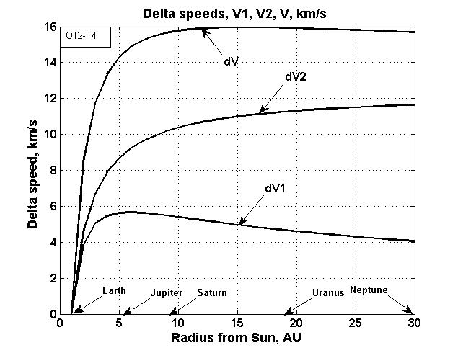
Fig.4. Desire delta speeds for relocation (or flight) the planet or their satellites via radius from Sun in astronomical units, AU = 150 million km; dV1 is the first impulse, dV2 is the second impulse, dV = |dV1| + |dV2|, km/s .

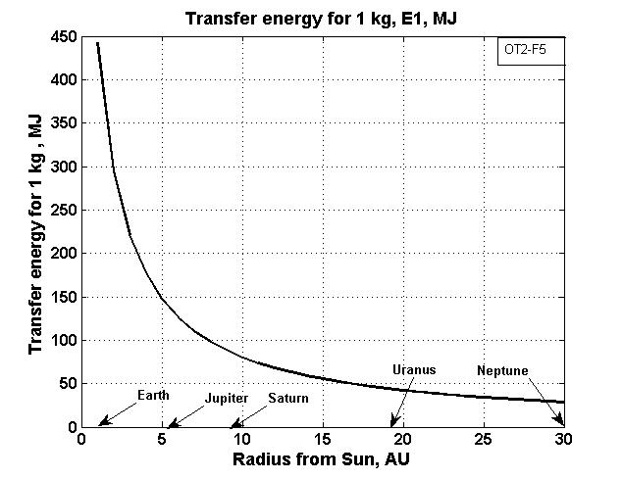
Fig.5. Energy (in million J) 1 kg of far planet or their satellites the via planet orbit from Sun in astronomical units,
AU = 150 million km.
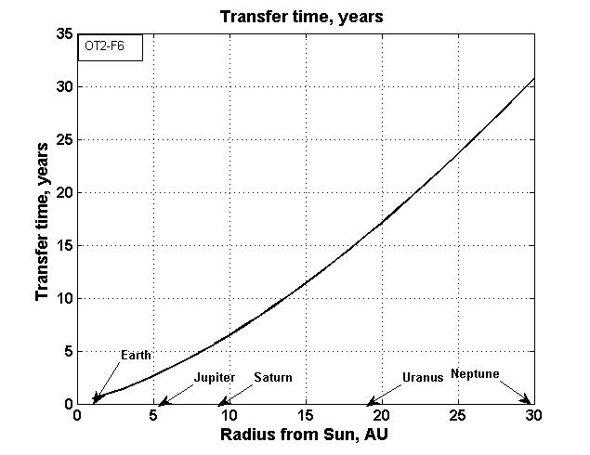
Fig.6. Transfer time (in years) for relocation of planets or their satellites via a planet orbit radius from Sun in astronomical units, AU = 150 million km.
More detail data about space bodies and planet satellites suitable for relocation a presented in Table 6.
Table 6. Data of the some natural satellites
 |  | Moon | Io | Europa | Ganymede | Callisto[ | Mimas | Enceladus | Tethys | Dione | Rhea
Mean  radius | km  :E^{[f]} | 1,737.1  0.273 | 1,815  0.286 | 1,569  0.245 | 2,634.1  0.413 | 2,410.3  0.378 | 198.30  0.031 | 252.1  0.04 | 533  0.083 | 561.7  0.088 | 764.3  0.12
Surface area^{[a]} | km²  :E^{[f]} | 37,930,000  0.074 | 41.91×10⁶  0.082 | 30/9×10⁶  0.061 | 87. ×10⁶  0.171 | 73×10⁶  0.143 | 490,000  0.001 | 799,000  0.0016 | 3,570,000  0.007 | 3,965,000  0.0078 | 7,337,000  0.0144
Volume[b] | km³  :E[f] | 2.2×10¹⁰  0.02 | 2.53×10¹⁰  0.02 | 1.59×10¹⁰  0.07 | 7.6×10¹⁰  0.15 | 5.9×10¹⁰  0.05 | 3.3×10⁷  0.00003 | 6.7×10⁷  0.00006 | 6.3×10⁸  0.0006 | 7.4×10⁸  0.0007 | 1.9 ×10⁹  0.0017
Mass | kg  :E[f] | 7.348×10²²  0.0123 | 8.94×10²²  0.015 | 4.80×10²²  0.008 | 1.48×10²³  0.025 | 1.0758×10²³  0.018 | 3.75×10¹⁹  0.000006 | 1.08×10²⁰  0.000018 | 6.174×10²⁰  0.00132 | 1.095×10²¹  0.0003 | 2.306×10²¹  0.0004
Density[c] | g/cm³ | 3.3464 | 3.528 | 3.01 | 1.936 | 1.83 | 1.15 | 1.61 | 0.98 | 1.48 | 1.23
Equatorial  gravity[d] | m/s² | 1.622 | 1.796 | 1.314 | 1.428 | 1.235 | 0.0636 | 0.111 | 0.145 | 0.231 | 0.264
Escape  velocity[e] | km/s | 2.38 | 2.56 | 2.025 | 2.741 | 2.440 | 0.159 | 0.239 | 0.393 | 0.510 | 0.635
Rotation  period | days[g] | 27.321582  (sync)[m] | 1.7691378  (sync) | 3.551181  (sync) | 7.154553  (sync) | 16.68902  (sync) | 0.94242  (sync) | 1.37022  (sync) | 1.88780  (sync) | 2.73691  (sync) | 4.518212  (sync)
Mean orbital speed[o] | km/s | 1.022 | 17.34 | 13.740 | 10.880 | 8.204 | 14.32 | 12.63 | 11.35 | 10.03 | 8.48
Atmospheric  composition | H He Na⁺ K⁺ Ar | SO₂ | O₂ | O₂ | O₂ CO₂ |  | H₂O, N₂, CO₂,CH₄

Colonization of space
Space colonization (also called space settlement or extraterrestrial colonization) is permanent human habitation that is not on Earth.
Many arguments have been made for space colonization. The two most common are survival of human civilization and the biosphere from possible disasters (natural or man-made), and the huge resources in space for expansion of human society.
As of right now the building of space colonies present a number of huge challenges, both technological and economic. Space settlements would have to provide for all the material needs of hundreds or thousands of humans in an environment out in space that is very hostile to human life. They would involve technologies, such as controlled ecological life support systems, that have yet to be developed in any meaningful way. They would also have to deal with the as yet unknown issue of how humans would behave and thrive in such places long-term. Because of the huge cost of sending anything from the surface of the Earth into orbit (roughly $20,000 USD per kilogram) a space colony would be a massively expensive proposition.
No space colonies have built so far, nor are there any timetables for building one by any large-scale organization (either government or private). However, there have been many proposals, speculations, and designs for space settlements that have been made, and there are a considerable number of space colonization advocates and groups. And several famous scientists, such as Freeman Dyson, have come out in favor of space settlement.
Also on the technological front, there is ongoing progress in making access to space cheaper, and in creating automated manufacturing and construction techniques. This could in the future lead to widespread space tourism, which could be a stepping stone to space colonization.
Negative Matter Engine. Theory and Estimations. Interstellar relocation.
Negative matter propulsion system may be used for space flight into Sun system and relocation the Earth to other Stars.
In the author’s works [4]-[5] the author showed: how an artificial micro black hole can create new positive and negative energy (matter), separate positive and negative energy (matter) and how this engine may be used for producing a thrust. Typical photon engine is shown in fig. 1.

Fig.7. Interstellar space propulsion on vacuum energy. Notations: 1 – micro black hole, 2 – reflector, 3 – radiation.

We consider three cases:
- The obtained positive matter accretes on the space ship; the negative matter leaves (flies away) with a speed close to light speed.
- The obtained positive matter is discarded in space with zero speed (relative to space ship).
- The obtained positive matter is fully converted into thrust by rocket (or photon) engine.
If the ship crew using a local watch and measuring the self-acceleration computes time, speed and distance of the space ship, their readings will be different from measurements of an Earthbound observer.

Estimations and computations flight data by a ship crew (without relativistic effect)
1. The obtained positive matter accretes on the space ship.
From impulse theory we can compute the speed of our space ship by equation
(5)
where V is non-relativistic final speed, m/s; M is ship mass, kg; m is mass (module |m|) spent in flight, kg; m/M is relative consumption of vacuum mass, kg.
2. The obtained positive matter is discarded in space with zero speed (relative to space ship).
In this case the final speed is computed by equation
(6)
In this case as you see the final speed is significantly more than in case 1. One may be more that the light
speed (from computation only impulsive acceleration without relativistic effect).
3. The obtained positive matter is full converted into thrust by rocket (or photon) engine.
In this case the ship speed is (m_{s} and w are const):
(7)
where m_{s} is second consumption of the obtained positive matter, kg/s; w is the exhaust speed from engine,
m/s; T is time of engine work, sec.
If we use the photon engine, w = c.
The results of computation of equations (5)-(7) are presented in fig. 8.
Fig.8. Final ship speed in three cases:
1) The obtained positive matter accretes on the space ship, the negative matter leaves (flies away) with a speed close to
light speed.
2) The obtained positive matter is discarded in space with zero speed (relative to space ship). Exhaust speed w = 0.
3) The obtained positive matter is full converted into thrust by rocket (or photon) engine: w = 0.2, 0.4, 0.6, 0.8, 1.
The ship speed V and distance S of non relativistic acceleration flight is
(8)
where V is speed, m/s; a acceleration, m/s²; t is acceleration time, sec.
Results of computations are in figs. 9 – 10 (1 year = 364·24·60·60 ≈ 31.45·10⁶ sec.).

Fig.9. Ship speed via internal time of flight (years) for different accelerations g.

Fig.10. Distance (millions km) via the internal flight time (years) for different accelerations g.

Theory, computations and estimation of a flight the space ship with relativistic
effects.
1. Common relations. The relativistic theory [8] asserts the measurement of time t, speed v and distance S of moving object made an immobile observer (on Earth) and observer located in object (astronaut of space ship) gives the different result. The theory gives the following relations between them
where c = 3∙108 m/s is light speed; v is speed of the moving object measured by immobile observer, m/s; ve is speed measured by astronaut by calculation the acceleration and self time, m/s; t is time, sec; s is length, m. The subscript ‘e’ means the value is measured by astronaut. The other values are measured by Earth observer. The th, ch, sh are hyperbolic tangent, cosine and sine. Note the speed ve calculated by astronaut may be any, in particular, ve > c. The hyperbolic th x ≤ 1.
The hyperbolic th, ch, sh may be computed through conventional function ex
For small ve /c <<1 the v ≈ ve , t ≈ te, s ≈ se . The computations of magnitudes (9) are presented in fig. 11.
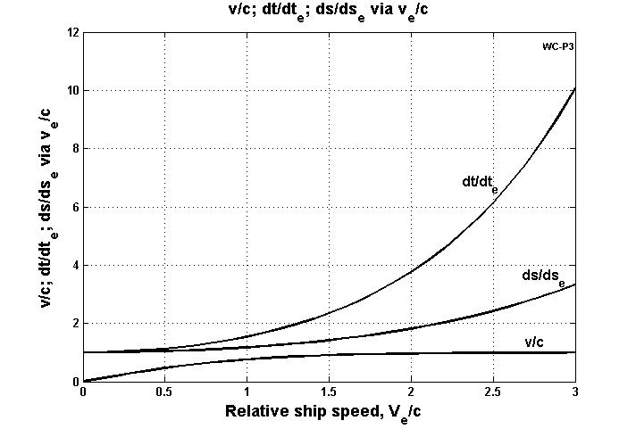
Fig.11. Ratio speeds, times and lengths measured by astronaut and Earth observer.
2. Case of constant acceleration a. In this case the relativistic equations may be integrated and we
get the next relations between the time, speed and distance measured by Earth observer and
astronaut:
where a = const acceleration of space ship measured by astronaut, m/s². S is distance, m.
The speed and distance are (in t_{e} = t = 0, values v(0) = S(0) = 0):
where is the rest of the relative mass of ship moved by the photon engine.
Let us consider the hypothetic flight to star system Alfa-Centaur (Alpha Centauri) located at a distance 4.3 light years from Earth with constant Earth acceleration a = 10 m/s. The first half of distance the ship accelerates, the second it brakes. Then the maximum speed of ship will be v/c = 0.95, the astronaut time of flight will be 7.3 years, the Earth time will be 12 years. The radioed (beamed) information sent by astronauts about Alfa-Centaur (Alpha Centauri) will reached the Earth after 4.3 years.
3. Relative consumption of mass by rocket engine is
(13)
where is relative ship speed; is relative speed of an exhaust mass (gas, photons, protons) measured by astronaut; ; M₀ –initial mass of rocket, kg.
The photon engine having = 1 spends about 40% of rocket mass for reaching relative speed = 0.5c = 150 000 km/s.
For v/c << 1 the equation (13) became as the well-known equation . Computations of the equation (13) are presented in fig.12.
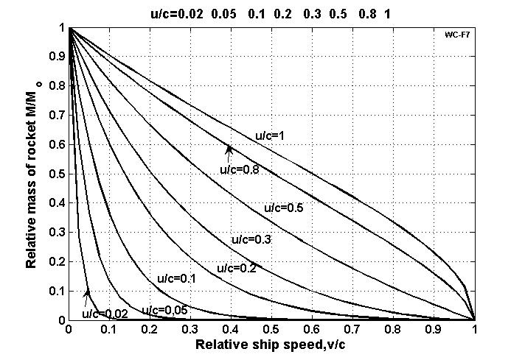
Fig.12. Relative mass of rocket via relative speed of rocket and relative speed of exhaust mass.
4. Drag of ship body.
The dynamic pressure (drag) of space ship equals
where p_{e} is dynamic pressure, N/m²; ρ_{e} is density of space medium, kg/m³ (mass of proton is m_{p}=1,67∙10⁻²⁷ kg). The computation of equation (14) are presented in fig.13.
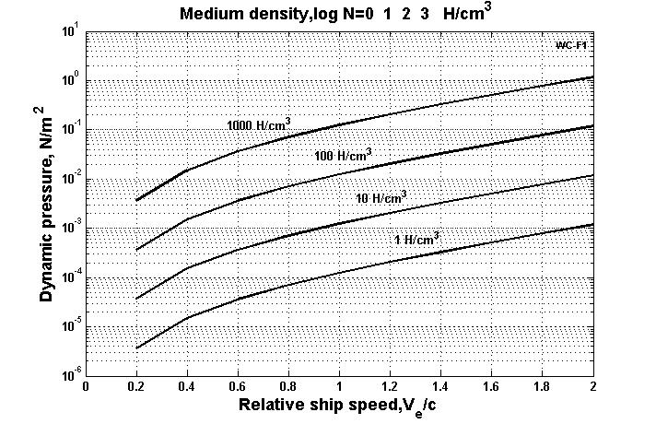
Fig.13. Dynamic pressure (drag) via relative space ship and media density.

Discussion
The reader can ask: where is guaranty that the negative energy and negative matter exist? That can show only future. The author gives examples when scientists made the assumption which received weak proof after long time. Some of them did not any proof up a recent time however their theories are widely used now.
Examples: In 1974 S. Hawking assumed the black hole has radiation. All attempts (40 years!) find this radiation was not successful. But most scientists believe in this radiation exist and research it. In 2014 S. Hawking received 3 millions prime for his assume.
In 1927 was offered hypotheses about creating the Universe from Big Bang about 14 billion years ago. No strong proofs this theory. But many scientists believe and development it.
Perturbation theory believes the vacuum has virtual particles (Dirac sea). This theory assumes the Casimir force supports this theory. But other scientists explain the Casimor forces the other factors.
Some theories contain conditions which cannot be check up never. For example, quark. Theory believes: if we will try to separate two quarks, they convert to other particles.
Theory Strings believe: there are many other space dimensions, which is impossible to see. Thousands scientists received Ph. Degrees, but no any results for technology.
Any theory may be useful if one simplify current theory, explain the obscure pheromones, prompt the new experiments.
Assumption of positive and negative energy allows to develop not only the theory positive and negative matter, but to build the simple Universe from simplest units of energy.
Let us shortly consider the propulsion system uses the positive and negative matter.
Ever since Newton first formulated his theory of gravity, there have been at least three conceptually distinct quantities called mass: inertial mass, "active" gravitational mass (that is, the source of the gravitational field), and "passive" gravitational mass (that is, the mass that is evident from the force produced in a gravitational field).
In 1957, Hermann Bondi suggested in a paper in Reviews of Modern Physics that mass might be negative as well as positive [19].
Although no particles are known to have negative mass, physicists (primarily Hermann Bondi and Robert L. Forward) [20] have been able to describe some of the anticipated properties such particles may have. Assuming that all three concepts of mass are equivalent the gravitational interactions between masses of arbitrary sign can be explored.
For two positive masses, nothing changes and there is a pull on each other causing an attraction. Two negative masses would produce a pull on one another, but would repel because of their negative inertial masses. For different signs there is a push that repels the positive mass but attracts the negative mass.
Bondi pointed out that two objects of equal and opposite mass would produce a constant acceleration of the system towards the positive-mass object.
Forward used the properties of negative-mass matter to create the diametric drive, a design for spacecraft propulsion using negative mass that requires no energy input and no reaction mass to achieve arbitrarily high acceleration.
The diametric drive was a speculative proposal for an "engine" which would create a non-conservative gravitational field with non-zero curl. It was argued that in such circumstances, the side of the field which creates more force on the spacecraft will accelerate the spacecraft in the direction of the force.
One idea for realizing this concept involved hypothetical particles with negative mass, originally proposed by Robert Forward and Jamie Woodward. If one were to construct a block of negative mass, and then attach it to a normal "positive" mass, the negative mass would fall towards the positive as does any mass toward any other. On the other hand, the negative mass would generate "negative gravity", and thus the positive mass (the spaceship itself generally) would fall away from the negative mass. If arranged properly, the distance between the two would not change, while they continued to accelerate forever.

The negative mass propulsion offered in this article is in principal different from Forward’s engine.
Forward believed that inertial, “active” and “passive” masses have different properties (an assumption not so far not supported by experiments).
He designs from them a rigid structure which produces a thrust despite the rigid linkage between them. His engine is a reactionless drive.
A reactionless drive (also known by many other names, including as an inertial propulsion engine, a reactionless thruster, a reactionless engine, a bootstrap drive or an inertia drive) is a fictional or theorized method of propulsion wherein thrust is generated without any need for an outside force or net momentum exchange to produce linear motion. The name comes from Newton's Third Law of Motion, which is usually expressed as, "[f]or every action, there is an equal and opposite reaction". Such a drive would necessarily violate laws of classical physics, the conservation of momentum and the conservation of energy. In spite of their physical impossibility, devices are a staple of science fiction, particularly for space propulsion. Devices and methods are still being proposed as working technologies only now they are based on the real or imagined principles from modern physics.
The author’s theory believes the inertial, active and passive positive matter are one positive matter (supported by experiments) and inertial, active and passive negative matter are also one (same) negative matter, which has but a single difference in properties (other than sign): that negative matter repels positive matter.
The Forward drive violates Newton’s Third Law of Motion, violates laws of classical physics, the conservation of momentum and the conservation of energy. The suggested engine does not do this (the total energy and mass are zero!). The Forward engine is a reactionless drive, the offered engine works as a conventional reactive engine, sending away the negative mass with speed close to light speed.
The Forward drive has constant mass in during the entire flight. The offered drive increases its’ positive mass in the flight and can use it for further increasing the speed, decreasing the flight time or creating an artificial space body i.e. tapping the matter influx for space construction.

Conclusion
The current physics believes that vacuum can produce energy and Universes. Author assumes: The basis of any Universe is energy. Energy may be positive or negative. Positive energy produces our positive matter, negative energy produces negative matter. Using this effect the author offers the formatting the current planets of Solar system, making them suitable for people, for humanity. That include: the production of Earth atmosphere, water, magnetic field in planets and natural satellites, change their angle speed, and relocation them to Earth orbit.
Negative matter repels our (positive) matter. Using this effect the author offers a space propulsion system which allows reaching by space ship a speed close to light speed and to enable massive retrieval of extraterrestrial materials to construct works in space. That may be the best method colonization the space, Solar System and Universe.
Concept of negative energy also allows solving the many very important problems of humanity. For example, humanity can create any artificial material, food, travel to other stars and possible (in future) create a new Universe.
If author assumption about existing of the negative energy is tried, the probability of negative matter existing and exhibiting repulsion from our positive matter is very high. In this case many problems of space flights (including interstellar), and obtaining matter for artificial space bodies will be in principle solved.
ACKNOWLEDGEMENT
The author wishes to acknowledge Richard Cathcart for correcting the English and offering useful advice and suggestions.
References
1. Bolonkin A.A., Universe (part 1). Relations between Time, Matter, Volume, Distance, and
Energy. JOURNAL OF ENERGY STORAGE AND CONVERSION, JESC : July-December 2012,
Volume 3, #2, pp. 141-154. http://viXra.org/abs/1207.0075, http://www.scribd.com/doc/100541327/,
http://archive.org/details/Universe.RelationsBetweenTimeMatterVolumeDistanceAndEnergy
2. Bolonkin A.A., Universe (Part 2): Rolling of Space (Volume, Distance), Time, and Matter
into a Point. http://www.scribd.com/doc/120693979 .
3. Bolonkin A.A., “Remarks about Universe” (part 1-2), International Journal of Advanced
Engineering Applications, IJAEA. Vol.1, Iss.3, pp.62-67 (2012) .
http://viXra.org/abs/1309.0196 , http://fragrancejournals.com/wp-content/uploads/2013/03/IJAEA-1-3-10.pdf
4. Bolonkin A.A., Article Universe (Part 3). Relations between Charge, Time, Matter, Volume,
Distance, and Energy. General Science Journal, 9 January 2014. http://www.gsjournal.net/Science-Journals/Research%20Papers-Mechanics%20/%20Electrodynamics/Download/5245 .
http://www.scribd.com/doc/225550770/, http://viXra.org/abs/1401.0075,
https://archive.org/details/ArticleUniverse3AfterFriedlander010914 .
5. Bolonkin A.A., Femtotechnology. AB-matter. Properties, Stability, Possibility Production
and Applications. Global Science Journal 24 March 2014, http://www.gsjournal.net/Science-Journals/Research%20Papers-Quantum%20Theory%20/%20Particle%20Physics/Download/5244 ,
http://www.scribd.com/doc/214245731/, http://viXra.org/abs/1309.0201; http://intellectualarchive.com
#1245, 24 March 2014;.
6. Bolonkin A.A., Femtotechnologies and Revolutionary Projects. Lambert, USA, 2011. 538 p.
16 Mb. ISBN: 978-3-8473-0839-0. http://www.scribd.com/doc/75519828/, http://viXra.org/abs/1309.0191,
http://www.archive.org/details/FemtotechnologiesAndRevolutionaryProjects
7. Bolonkin A.A., Converting of any Matter to Nuclear Energy by AB-Generator and Aerospace
Journal of Energy Storige and Conversion, Vol.3, #1, January-June 2012, p. 43-69.
http://www.archive.org/details/ConvertingOfAnyMatterToNuclearEnergyByAb-generatorAndAerospace,
http://www.scribd.com/doc/57419950/Converting-of-Matter-to-Nuclear-Energy-by-AB-Generator-and-its-Application
8. Bolonkin A.A., Method for Interstellar Flight. GSJ, 9 August 2014.
http://www.gsjournal.net/Science-Journals/Research%20Papers-Engineering%20(Applied)/Download/5642 ,
http://viXra.org/abs/1408.0055, https://archive.org/details/ArticleInterstellarFlight72014AfterJoseph,
9. Bolonkin A.A., Space Wing Electro Relativistic AB-Ship.
I J N N A, 4(2) January-June 2012, pp. 13-19 • ISSN: 0974-6048, Collection “Femto”. www.Vixro.org .
Collection: “Interstellar Medium: New Research”. NOVA, 2011.
https://www.novapublishers.com/catalog/product_info.php?products_id=22357 ;
http://www.scribd.com/doc/56874853/Space-Wing-Electro-Relativistic-AB-Ship ;
http://www.archive.org/details/SpaceWingElectroRelativisticAb-ship .
10. Bolonkin A.A., Artificial Magnetic Field for Venus and other Planets. Collection: Inner Solar System.
Prospective Energy and Material Resources , Ch.20. Elsevier, 2014.
11. Bolonkin A.A., Man in Outer Space without a Special Space Suit.
American Journal of Engineering and Applied Science 2(4), 573-579, 2009, ISSN 1991-7020.
http://www.scribd.com/doc/24050793/, http://viXra.org/abs/1309.0199,
http://www.archive.org/details/LiveOfHumanityInOuterSpaceWithoutSpaceSuite .
12. Bolonkin A.A., Universe, Human Immortality and Future Human Evaluation. Scribd. 2010г., 124 pages,
4.8 Mb. ISBN-10: 0124158013, ISBN-13: 978-0124158016
http://www.archive.org/details/UniverseHumanImmortalityAndFutureHumanEvaluation,
http://viXra.org/abs/1207.0020 , http://intellectualarchive.com/?link=find#detail
13. Шацкий А.А., Новиков И.Д., Кардашев И.С., Задача Кеплера и столкновение тел с отрицательной
массой. УФН, Том 181, №4, Апрель 2011г. (in Russian). Shatskiy A.A., I.D. Novikov, N.S. Kardashev ,
The Kepler problem and collisions of negative masses. Uspekhi Fizicheskikh Nauk 181 (4) 399 ± 403
(2011).
14. Зингер Е., (1968). К механике фотонных ракет, Москва, Издательство ИЛ, 1968. (Russian).
Translation from the German: Sanger E., Zur mechanik der photonen-stranlantriebe, Verlag Munchen, 1966.
15. Anonymous (2007). "Basic Facts on Cosmos 1 and Solar Sailing". The Planetary Society.
http://www.planetary.org/programs/projects/innovative_technologies/solar_sailing/facts.html.
Retrieved 2007-07-26.
16. Rahls, Chuck (December 7, 2005). "Interstellar Spaceflight: Is It Possible?". Physorg.com.
http://www.physorg.com/news8817.html. Retrieved 2007-07-31.
17. Zobel, Edward A. (2006). "Summary of Introductory Momentum Equations". Zona Land.
http://id.mind.net/~zona/mstm/physics/mechanics/momentum/introductoryProblems/momentumSummary2.html. Retrieved 2007-08-02.
18. Anonymous (2006). "The Sabre Engine". Reaction Engines Ltd..
http://www.reactionengines.co.uk/sabre.html. Retrieved 2007-07-26.
19. Bondi, H. (July 1957). "Negative Mass in General Relativity". Rev. Mod. Phys. 29 (3):
423. Bibcode:1957RvMP...29..423B.doi:10.1103/RevModPhys.29.423.
20. Landis, G. (1991). "Comments on Negative Mass Propulsion". J. Propulsion and Power 7 (2): 304.
doi:10.2514/3.23327.
10 August, 2014
 Alexander Bolonkin
Alexander A. Bolonkin was born in the former Soviet Union. He holds a doctoral degree in aviation engineering from Moscow Aviation Institute and post-doctoral degree in aerospace engineering from Leningrad Polytechnic University. He has held the positions of senior engineering at the Antonov Aircraft Design Company and chairman of the Reliability Department at the Glushko Rocket design Company. He has also lectured at the Moscow Aviation Universities. Following his arrival in the United States in 1988, he lectured at the New Jersey Institute of Technology and worked as a senior researcher at NASA and the US Air Force Research Laboratories.
Professor A.A. Bolonkin is the author of more than 200 scientific articles and books, and has 17 inventions to his credit. His most notable books include: Non-Rocket Space Launch and Flight (Elsevier, 2006) http://viXra.org/abs/1407.0174 ; New Concepts, Ideas, and Innovations in Aerospace, Technology and Human Life (NOVA, 2008); Human Immortality and Electronic Civilization (Lulu, 1994); Femtotechnologies and Revolutionary Projects. Lambert Academic Publishing, Germany, 2011, 538 p. http://www.scribd.com/doc/75519828/ , Life and Science. Lambert, 2011, 205 pgs.

