Author: Andrey Amand
Title: The World of Virtual Racing and Innovations. Kart VR Evolution
Subtitle: Creating VR Karting: Business model, technologies, and safety issues

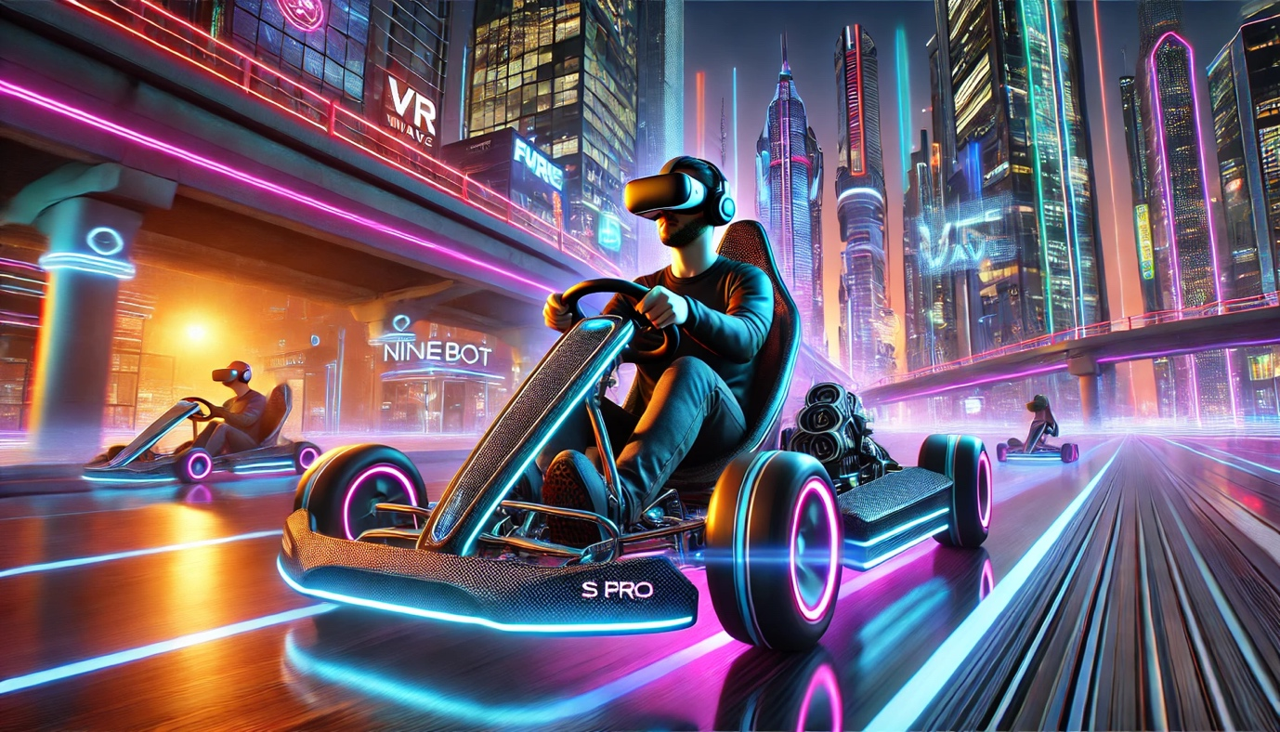
Annotation
Virtual reality (VR) is a powerful tool for education, training, and developing new forms of entertainment. In this monograph, I examine the world of virtual karting through the lens of the Kart VR Evolution attraction, which transports the player into a dynamic racing world of the future. Kart VR is a synthesis of cutting-edge technologies, from self-balancing scooters to virtual reality headsets.
I will explore the technological aspects of the project, its innovative solutions, competitive advantages, and prospects for market development. Particular attention will be paid to the socio-ethical aspects of using this technology. This monograph is addressed to developers, engineers, researchers, and anyone interested in modern technologies and their application in various fields. I share the deep knowledge and practical experience gained while creating this unique project in the field of virtual reality.

Keywords:
- Virtual reality (VR)
- Augmented reality (AR)
- Mixed reality (MR)
- VR karting
- Virtual racing
- VR driving simulators
- Kart VR evolution
- Innovative technologies
- Immersive technologies
- Training simulators
- Racing simulators
- Self-balancing scooters
- VR headsets
- Apple vision pro
- Team racing
- VR attractions

Table of contents
Introduction
Chapter 1. Kart VR Evolution - The heart of the attraction: from real racing to virtual
1.1. Synthesis of physics and virtuality
1.2. VR Equipment: Immersing in the virtual world of karting
1.3. Taking care of health and safety
Chapter 2. Birth of the attraction: From first steps to a proprietary solution
2.1. Assembling the high-tech puzzle
2.2. Unexpected challenge: HTC Vive tracker sensors and the search for an alternative
2.3. Lessons in perseverance
Chapter 3. Overtaking reality - New facets of racing sensations
3.1. Deep immersion: Sensations beyond time
3.2. Not just entertainment, but also training
3.3. In the competitive race: Advantages and prospects
3.4. From entertainment to business
3.5. Looking to the future: New horizons of realism
Chapter 4. Virtual tracks and game modes
4.1. A racing world without borders: Karting tracks
4.2. Kart VR Evolution game modes: Choose your style
4.3. A virtual playground for real skills
4.4. Races that unite
Chapter 5. Success strategy and business prospects
5.1. Competitive advantages
5.2. Looking to the future
5.3. From start to finish - Business prospects
Chapter 6. Marketing strategy and positioning
6.1. Target audience: Who craves virtual speed?
6.2. Promotion strategy: At full speed to success
6.3. Creating the Kart VR Evolution brand: The face of speed
6.4. In the world of games and entertainment: Market conqueror
Chapter 7. Speed without harming the planet - Environmental responsibility
7.1. Minimizing environmental impact
7.2. Ecology and the future
Chapter 8. Kart VR Evolution and Apple Vision Pro: A new dimension of reality
8.1. Revolution in mixed reality
8.2. Apple Vision Pro technical specifications
8.3. Apple Vision Pro in virtual reality
8.4. Apple Vision Pro in augmented reality
8.5. Prospects for integrating Apple Vision Pro with Kart VR Evolution
Conclusion
List of references

Introduction
Virtual Reality opens up new horizons for learning, training, and entertainment. In this monograph, I offer readers a detailed overview of the Kart VR Evolution attraction, which represents a symbiosis of cutting-edge technologies and unique innovations, transforming an enclosed space into an exhilarating racing track of the future. The project combines advancements in self-balancing scooters and virtual reality headsets, creating an unparalleled experience of complete immersion.
This book is a deep dive into the world of the Kart VR Evolution VR attraction, blurring the lines between the real and virtual world of racing. Here you will find not only a detailed analysis of the technological solutions, innovations, and competitive advantages of the project but also an examination of its business prospects, as well as important socio-ethical and environmental aspects.
This book is addressed to a wide range of readers: developers, engineers, researchers, entrepreneurs, and anyone interested in modern technologies and their application in various fields. I share with you my practical experience and knowledge gained during the creation of this unique VR attraction and invite you on a fascinating journey into the world of virtual racing!

Chapter 1. Kart VR Evolution - The Heart of the attraction: From real racing to virtual
Observing a race at one of Moscow's karting tracks, I couldn't tear my gaze away from the swift karts speeding along the track. There was something captivating about the scene: the speed, the excitement, the thirst for victory, all making my heart beat faster. But at the same time, I clearly saw the other side of the coin: the limitations, the risks, and the inaccessibility of this pleasure for many. The weather could interrupt the race at any moment, danger lurked at every turn, and the high cost of equipment and kart rental made karting inaccessible to a wide audience.
Being an expert in the field of VR/AR and AI, I constantly think about how new technologies can change our world and make it better. And at that moment, at the karting track, an idea struck me: what if we could transfer all the dynamics and excitement of racing into virtual reality? To create an attraction that would give people an unforgettable racing experience, free from all the limitations and dangers of the real world?

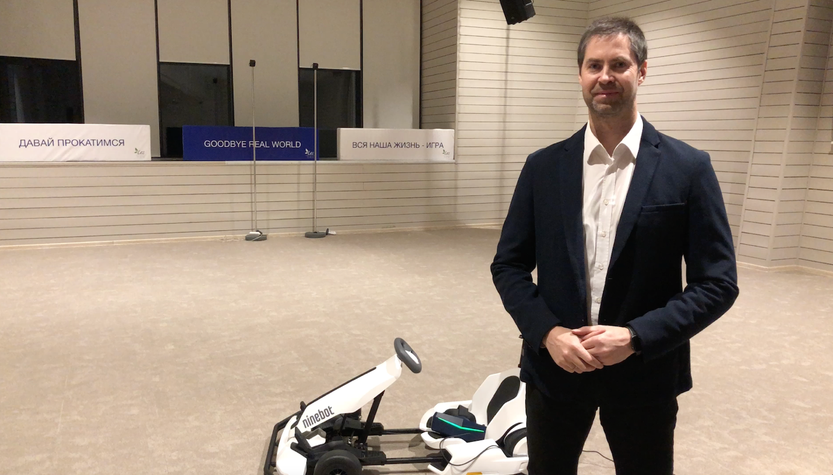

Thus was born the Kart VR Evolution project - a real breakthrough in the world of virtual entertainment, created to give you the feeling of freedom and excitement of real racing, but without the limitations of the real world. In Kart VR, you can race at any speed, without fear of accidents and regardless of the weather. It's a unique combination of cutting-edge technologies, such as self-balancing scooters transformed into racing karts, VR headsets with stunning resolution, and powerful servers united by innovative software. Kart VR Evolution is the result of many years of work aimed at creating an unparalleled virtual racing experience that will change your perception of this type of entertainment.
However, the path to realizing this dream was not easy. We faced unexpected obstacles, technical challenges, doubts, and risks. I will talk about this exciting journey - from the initial idea to the launch of the attraction - in my book.
But before diving into the world of virtual speed, let's stay grounded for a bit and talk about what conditions are necessary to implement this exciting project. VR karting is not only about advanced technologies but also about a carefully thought-out infrastructure that ensures safety, comfort, and an unforgettable experience for every player.
  - A Space for virtual races
The heart of Kart VR Evolution is the playing area - a space measuring at least 20x20 meters, where players can fully immerse themselves in the world of virtual racing. However, beyond the racing arena itself, the attraction requires additional space for seamless operation:
- Charging zone: Here, gyro scooters, VR glasses and other equipment will “rest and gain strength” to always be ready for new racing battles.
- Administrative zone: This space serves as the control center for the attraction. From here, the operator will monitor the virtual races, provide assistance to players, and manage the overall system, guaranteeing a smooth and enjoyable experience.
- Waiting and rest area: This zone provides a comfortable space for visitors to relax, share their experiences, and eagerly await their turn on the attraction.
In total, a minimum floor space of 400 m2 is recommended to accommodate Kart VR Evolution comfortably.
Important details:
In addition to the overall area, several crucial factors contribute to a successful and enjoyable experience:
- Floor covering: The playing area's floor must be level, smooth, and non-slip to ensure the safe and comfortable movement of the karts.
- Lighting: The zone requires adequate, uniform artificial lighting, minimizing glare and avoiding direct sunlight to ensure optimal visibility and immersion for players.
- Power supply: A stable 220 Volt power supply with sufficient capacity is essential for the uninterrupted operation of the attraction, preventing disruptions and ensuring a seamless experience.
Kart VR Evolution is not just about pushing the boundaries of speed and technology; it is, above all, about prioritizing the safety and comfort of our players. We are committed to ensuring that virtual racing is not only exhilarating but also conducted in a secure and controlled environment.

1.2. Playing by the rules
Before taking the wheel of a virtual kart, every player undergoes a mandatory briefing where they are introduced to the safety regulations and guidelines for using the attraction. After all, even in the virtual world, it's crucial to observe certain norms and limitations.
Here are a few key rules to help you get the most out of your Kart VR Evolution experience without any risks:
- Age restrictions: We care about the well-being of our young racers, so the use of Kart VR Evolution is only permitted in accordance with the age restrictions set by the manufacturers of the VR headsets used.
- Protective gear: Helmets, knee pads, and elbow pads are your faithful companions in the world of virtual racing. They will help prevent injuries in case of unexpected collisions or falls.
- Health restrictions: Unfortunately, virtual reality is not accessible to everyone. If you have health problems, such as epilepsy, cardiovascular disease, or problems with the vestibular system, it is best to refrain from playing Kart VR Evolution. The attraction is also not intended for pregnant women or people weighing over 120 kg or taller than 200 cm.
- Attentive operator: The safety and comfort of the players are monitored by an experienced operator who is always ready to assist and answer any questions.

1.3. Synthesis of physics and virtuality
VR karting is an attraction where physics is inextricably linked with virtuality. At its core are Ninebot S Pro self-balancing scooters, transformed into controllable karts through a series of special modifications. It's important to note that different versions of the attraction may utilize other scooter models that meet the requirements for reliability and performance.
So, what modifications transform an ordinary self-balancing scooter into a Kart VR Evolution racing kart?
- Additional mounts: We have added special mounts to the Ninebot S Pro frame for installing the system unit, acoustic system, and a higher-capacity battery, creating an ergonomic design reminiscent of a real racing kart. A seat with lateral support ensures a comfortable and stable seating position so that the player feels confident even during sharp maneuvers.
- Increased strength: The safety of the players is paramount for Kart VR Evolution. That's why we've reinforced the standard frame of the scooter to withstand the high loads and accelerations that are inevitable during exciting virtual races. In doing so, we use only high-strength materials that guarantee reliability, high maneuverability of the attraction, and structural safety.
- Length adjustment: The seat is easily adjustable in length, adapting to heights of up to two meters, to provide maximum comfort and control over the kart.
- Control system: A special control system is connected to the kart's steering wheel, which transmits movement data to the VR system in real time, creating the full feeling of driving a real kart.

Characteristic | Value
Speed | Up to 20 km/h
Range | Up to 30 km
Maximum user weight | Up to 120 kg
Battery | High-capacity Li-ion batteries
Additional features | Built-in sensors for stability and motion control

When choosing a self-balancing scooter model for Kart VR Evolution, I was guided by several important criteria: reliability, maneuverability, power, as well as availability and cost. After analyzing the market, we opted for the Ninebot S Pro from Segway-Ninebot.
The Ninebot S Pro stands out for its high build quality and use of durable materials, guaranteeing its reliability and longevity. It offers excellent maneuverability and a smooth ride thanks to powerful electric motors and an intelligent balancing system. The maximum speed of 20 km/h is optimal for karting, allowing players to experience the speed and excitement of racing without creating safety risks within the limited space of the attraction. A range of up to 30 km on a single charge ensures long and engaging gaming sessions.
The Ninebot S Pro represents an optimal combination of quality, reliability, performance, and cost, making it the ideal foundation for our attraction.
1.4. VR Equipment: Immersion in the virtual world
Kart VR Evolution utilizes the most advanced VR technologies to create the most realistic and immersive experience possible.
VR Headsets: In the first versions of the attraction, we relied on Oculus Quest - standalone virtual reality headsets from Facebook, known for their high image quality and ease of use. However, Kart VR Evolution is a flexible platform, and we have since acquired more advanced VR headset models, such as the Pimax 8K+. The Pimax 8K+ VR headset acts as a portal to a dynamic virtual racing world, transforming an ordinary space into a realistic track.
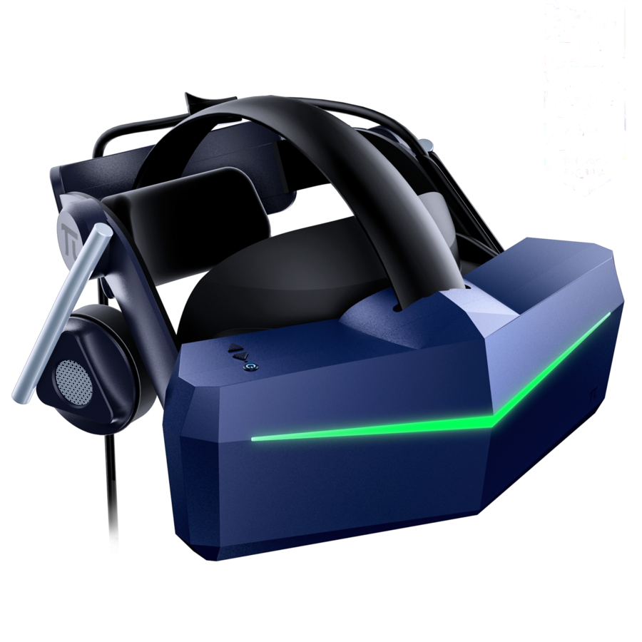
Specifications of Pimax 8K+:
Characteristic | Value
Resolution | 8K+ (5120 x 2720 pixels per eye)
Field of View | 200°
Audio | Built-in speakers with spatial audio
Tracking | Built-in sensors for precise head tracking

The Pimax 8K+ virtual reality headset represents the pinnacle of modern VR technology. Its ultra-high 8K+ resolution, surpassing most counterparts on the market, delivers stunning clarity and image detail. This allows you to discern even the smallest details within the virtual environment: material textures appear incredibly realistic, and the "screen door effect" is practically imperceptible.
The wide 200° field of view guarantees complete immersion, creating a panoramic vision effect. You won't feel the boundaries of the screen - virtual reality will surround you from all sides. Built-in speakers with spatial audio enhance the sense of presence, allowing you to not only see but also hear the world of Kart VR Evolution as if you were truly there. The Pimax 8K+ also boasts low latency, ensuring smooth visuals and minimizing the risk of discomfort and dizziness during gameplay.
External tracking system: To ensure that your virtual kart's movements accurately replicate your actions in the real world, we have developed a unique external tracking system. This system is highly accurate and stable, allowing you to fully immerse yourself in the race without being distracted by technical limitations.

Parameter | Description
Model | Utilizes a proprietary external tracking system based on motion tracking technologies using sensors and cameras.
Manufacturer | Developed in-house as part of the project.
Advantages | High tracking accuracy, ability to track both player and kart movement, low latency.
Disadvantages | Complexity in setup and calibration, can be sensitive to external factors such as lighting and interference.
Description and Analysis | The external tracking system is the crucial link between the real and virtual worlds in Kart VR Evolution. It precisely tracks the movements of both the kart and the player in real-time, creating a truly immersive experience. This high level of accuracy ensures that physical actions translate seamlessly into the virtual environment, making the game feel incredibly realistic and engaging. Moreover, the system's high data refresh rate guarantees smooth motion and minimal latency – a critical factor in delivering a responsive and exhilarating racing experience.

In addition to our proprietary system, we also utilize the proven HTC VIVE external tracking system, renowned for its high accuracy and stability. This system ensures precise tracking of user movements, which is especially crucial in dynamic and demanding applications like virtual reality karting. The HTC VIVE system offers a wide range of customization options and scalability, making it ideal for diverse VR projects.
Server: A powerful and reliable server forms the heart of the attraction, responsible for the smooth and uninterrupted operation of the entire system.

Parameter | Description
Model | Custom-built server utilizing components from leading global manufacturers like Intel, Nvidia, and Samsung.
Advantages | High performance, stability, ability to process data from multiple players simultaneously, storage of game data and analytics capabilities.
Disadvantages | High cost, requires specific operating conditions (ventilation, power supply, protection from interference).
Description & analysis | The server processes all data from the kart sensors, VR headsets, and the attraction's control system. It synchronizes players' movements in real-time with their actions in the virtual world, ensures smooth and realistic graphics, and supports network interaction between racers. It also stores user information, achievements, and race results, enabling progress tracking and player rankings.
The game environment is built using Unreal Engine, a powerful and professional game engine that allows us to create high-quality graphics, realistic physics, and sophisticated gameplay mechanics. Unreal Engine is widely used in the gaming industry for developing AAA titles and is renowned for its flexibility, extensive capabilities, and high performance.

1.3. Caring for health and safety
While we strive to create exhilarating virtual racing experiences, the health and safety of each player are our top priorities. We understand that everyone is different and reacts to virtual reality in their own way. Therefore, we strongly recommend listening to your body and taking breaks every 30 minutes or more frequently if needed. Kart VR Evolution provides a comfortable rest area where you can take a break from the virtual races and regain your strength.
Important! Using the VR attraction has certain limitations. Virtual karting is not recommended for people with:
- Epilepsy
- Cardiovascular diseases
- Vestibular system problems
- Other serious medical conditions
The attraction is also not intended for:
- Pregnant women
- People weighing over 120 kg
- People taller than 200 cm
Children can use the attraction only in accordance with the age restrictions set by the manufacturers of the VR headsets used.

Chapter 2. From first steps to a proprietary solution
From the very beginning, we understood that creating virtual karting was no easy feat. Combining the physical sensations of driving a kart with the complete immersion of virtual reality was a challenge that required careful planning and the selection of the most advanced technologies available.

2.1. Assembling the High-Tech puzzle
Creating Kart VR was akin to assembling a complex technological puzzle. Each attraction is the result of integrating components from various manufacturers, carefully selected to achieve the most immersive effect possible.
So, what does Kart VR Evolution consist of?
First and foremost, it includes four identical sets of equipment - the "combat units" of our virtual championship, each comprising:
Kart: The means of transportation: Depending on the version of the attraction and the specific supply contract, this can be a self-balancing scooter of a certain model equipped with a hoverkart - a special accessory that transforms it into a kart.
Virtual Reality (VR) Headset: Provides the immersive visual and audio experience of the virtual racing world.
Additional Equipment: For the comfort and safety of the players, each set includes a helmet, protective gear (knee pads, elbow pads), an external tracking system (which also serves as an additional battery for the VR headset), and other necessary accessories.
At the heart of the entire system lies a powerful server, responsible for:
Storing, synchronizing, and running games: It allows all four players to simultaneously inhabit the virtual world and interact with each other.
Attraction maintenance and diagnostics: It enables us to quickly identify and resolve any issues, ensuring smooth and uninterrupted operation.
The server comprises the following components:
Component details
Processor AMD Ryzen 5 3600X OEM (100-000000022)
CPU cooler PCcooler GI-X5R
Motherboard ASRock B450M STEEL LEGEND
RAM DDR4 G.SKILL AEGIS 2x8 GB 3200MHz (F4-3200C16D-16GIS)
Graphics card GIGABYTE (GV-N207SGAMING OC-8GD) GeForce RTX 2070 SUPER 1815MHz PCI-E 3.0 8192MB 14000MHz 256 bit 3xDisplayPort HDMI HDCP GAMING OC X3
SSD ADATA M.2 2280 512GB XPG GAMMIX S5 AGAMMIXS5-512GT-C
Power supply zalman 600W ZM600-LX I
Case 1STPLAYER FIREBASEX2
Operating system WINDOWS 10 Professional 64bit DVD (FQC-08909-L) oem
Router XIAOMI Mi WiFi Router 4A Gigabit
Keyboard and mouse LOGITECH MK220, USB
Tablet SAMSUNG Galaxy Tab A 10.1 (2019) SM-T515N, 2GB, 32GB, 3G, 4G, Android 9.0 [sm-t515nzddser]
Base station SteamVR 2.0 (99-H12170-00)
Tracker HTC VIVE 2.0 (99HANLO10-00)
Controller controller for VIVE Pro 2.0
System unit (Backpack PC) Zotac ZBOX-VR7N73 ZOTAC VR GO 3.0 Backpack 17-9750H, Geforce RTX2070, 240G SSD, 16GB DDR4, Windows 10 PRO N 64-bit, Wi-Fi, BT, GB-Lan, 2x HDMI, DP, charging dock, 2x battery, EU+UK PLUG
Assembling the kart from these high-tech components was only the first step in creating the finished attraction. We still had to conduct numerous tests, configure the software, ensure the safety and comfort of the players, and consider all operational nuances.
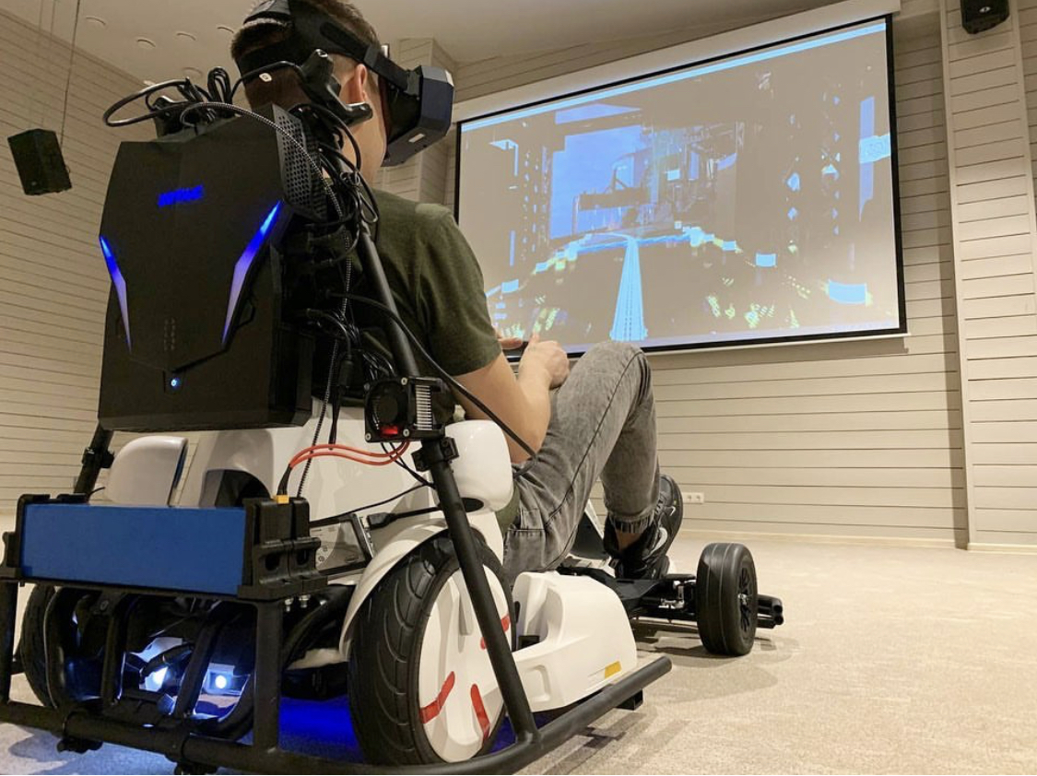
One crucial aspect was ensuring the operational autonomy of Kart VR. We strived to enable the attraction to function for as long as possible without interruptions for recharging. Ultimately, we achieved a runtime of about three hours on a single charge, allowing for multiple exhilarating racing sessions back-to-back. A full recharge of all components takes approximately two hours.
For those who wish to guarantee maximum uptime without any pauses, we offer the option to purchase additional self-balancing scooters and batteries. This enables quick swapping of depleted components for charged ones, ensuring continuous racing action without downtime.

2.2. The unexpected challenge: HTC Vive tracker sensors and the search for an alternative
It seemed like nothing could go wrong. All the components were carefully chosen, the equipment was set up, and the software was ready to go. But reality, as it often does, had other plans. During the very first tests, we encountered a problem that threatened to derail the entire project.
The HTC Vive tracker sensors, responsible for tracking the position of the karts in space, began to malfunction. They would periodically lose connection with the base stations and transmit incorrect location data, leading to unpredictable behavior in the virtual karts. Instead of smoothly gliding along the virtual track, the karts would "teleport," suddenly changing position, even "crashing" into invisible walls. This posed a real safety risk to the players: a kart, physically located in the center of the arena, could suddenly find itself dangerously close to a wall or even collide with another kart in the virtual world.
The malfunctioning sensors also caused software crashes. The system stopped processing data correctly, and we couldn't continue configuration and debugging. We faced a difficult choice. We could either accept the limitations imposed by the unstable sensors, creating a simplified version of the attraction with small tracks and low speeds to minimize the risk of collisions, or we could find another solution. But that would be a betrayal of our idea – abandoning the boundless freedom and thrilling experience we wanted to offer our players.
The solution didn't come immediately. We spent countless hours discussing the situation. The tension grew; people were expecting results, and we found ourselves at an impasse. But it's in such moments that the boldest and most unexpected solutions arise. Instead of trying to "tame" the capricious sensors, we decided to create our own solution: to develop a unique algorithm for kart movement that wouldn't rely on the HTC Vive tracker.
We challenged ourselves and everyone who said it couldn't be done. Our engineers and programmers enthusiastically got to work. This was a task that required not only deep knowledge of programming and robotics but also a creative approach, a willingness to experiment, and the courage to forge new paths.
Of course, developing a unique algorithm required additional investment. To ensure that the new system worked flawlessly, we needed to increase the computing power of the server. We made the decision to invest in more powerful equipment, understanding that it was a necessary step towards creating a truly revolutionary VR attraction.

2.3. Lessons in perseverance

The HTC Vive tracker sensor saga taught us a valuable lesson. It taught us to not be afraid of difficulties, to be flexible, to seek unconventional solutions, and to always believe in our dream. The development of Kart VR became more than just a project; it became a true adventure where we tested our strength, demonstrated resourcefulness, and proved that nothing is impossible when a team of like-minded individuals united by a common goal sets their minds to it.
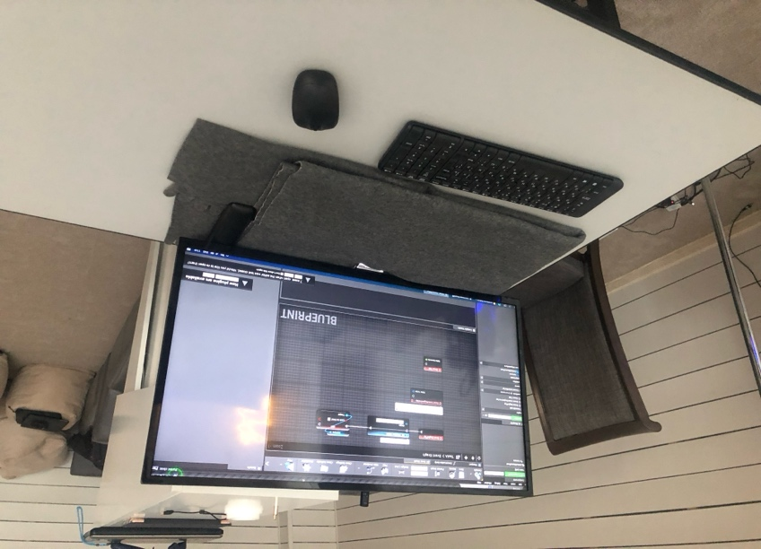

Chapter 3. Outpacing reality - new dimensions of racing experience
VR Karting is an attraction and a new dimension of entertainment where the lines between virtual and real blur, making exhilarating racing sensations accessible to everyone. This project challenges conventional notions of racing by combining the best aspects of both real and virtual worlds.
Imagine: you are behind the wheel of a racing kart, feeling the vibration of the engine, the acceleration that pushes you into your seat, the sharp jerk of the steering wheel as you enter a turn... In virtual karting, these sensations are not just simulated—they are absolutely real! You are not just pressing the gas pedal; you physically feel the kart’s movement and the oncoming airflow responding instantly to your actions. The high-resolution VR headset allows you to see every crack in the asphalt, every gleam on the chrome details of the race cars.
What sets this attraction apart from computer racing simulators, even those using VR headsets? Firstly, it is the depth of immersion achieved through the synchronization of physical sensations and virtual reality:
- Dynamic motion: You are not just pressing pedals and turning a virtual steering wheel - you are truly sitting in a kart that dynamically responds to your actions. Physical movement on the track combined with a realistic virtual world creates an unparalleled sense of being on a racing track.
- Visual feast: Pimax 8K+ VR headsets with ultra-high 8K+ resolution and a 200° panoramic view do not just show a virtual world - they immerse you in it. You will notice the smallest details of the surroundings: the texture of the asphalt, the sunlight gleaming on opponents' race cars, even the dust rising from the wheels.
- Sounds of speed: Built-in speakers with spatial sound enhance the sense of presence, accurately conveying all the nuances of the race’s soundscape: the roar of engines, the screech of brakes, the hum of tires on asphalt, the noise of the grandstands.
Virtual karting is not just a game; it is a full sensory experience that allows you to not only watch the race but feel it with every fiber of your body.

Our karting is both an exhilarating entertainment and an opportunity to hone your driving skills, prepare for real races, or simply better understand the nuances of kart control. The integrated training system offers a variety of exercises and tasks that will help you become a more experienced racer.
What can you learn in the virtual racing world?
- Proper cornering: The attraction analyzes your speed, trajectory, steering angle, and instantly provides recommendations to improve your technique. The system will tell you when to start braking, how to choose the correct trajectory, and how to exit the turn most effectively while maintaining speed.
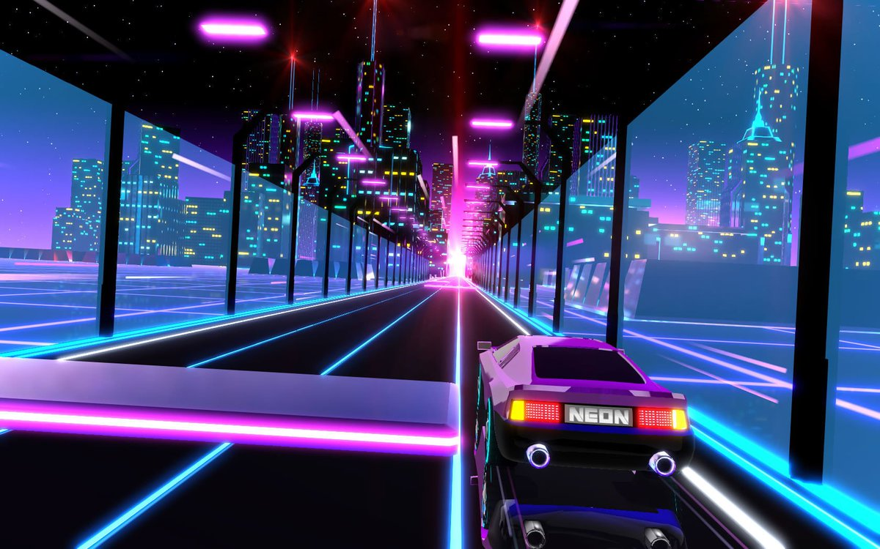
- Optimal braking and acceleration: Master the art of smooth and precise braking to reduce lap times and avoid errors. Learn how to make the most of acceleration on straight sections to outpace your competitors.
- Developing your own racing strategy: Virtual karting allows you to experiment with different driving styles and track tactics. Try various approaches, analyze your results, and discover your unique style that will lead you to victory!
The karting training technology acts as your personal virtual instructor, helping you become the best racer. The system provides feedback on your actions, analyzes mistakes, and helps correct them, making learning both effective and enjoyable.
A glimpse into the future:
Virtual karting is not just a fleeting amusement; it is a platform for the future. Its potential extends far beyond racing. In the next chapter, we will explore how Kart VR Evolution can reshape the world of racing and entertainment.

Chapter 4. Virtual tracks and game modes
Kart VR Evolution is an incredibly realistic attraction and an exhilarating game that opens up a limitless world of virtual racing. Here, you'll find tracks for every taste, test your skills in various game modes, and challenge your friends to thrilling competitions.
4.1. A racing world without borders: Virtual karting tracks
Forget the limitations of real-world racetracks! In virtual reality, a whole universe of racing circuits awaits, where the only limit to your speed is your imagination! Race through futuristic megacities, soar over canyons, defy gravity on loops and corkscrews – anything is possible in the virtual realm! There are no dangerous corners, unpredictable weather, or strict rules, only pure excitement and the adrenaline rush of speed.

In the "Race" mode, for example, you'll start from virtual starting lines. In reality, there are no markings on the physical space, allowing for the most efficient use of the area.
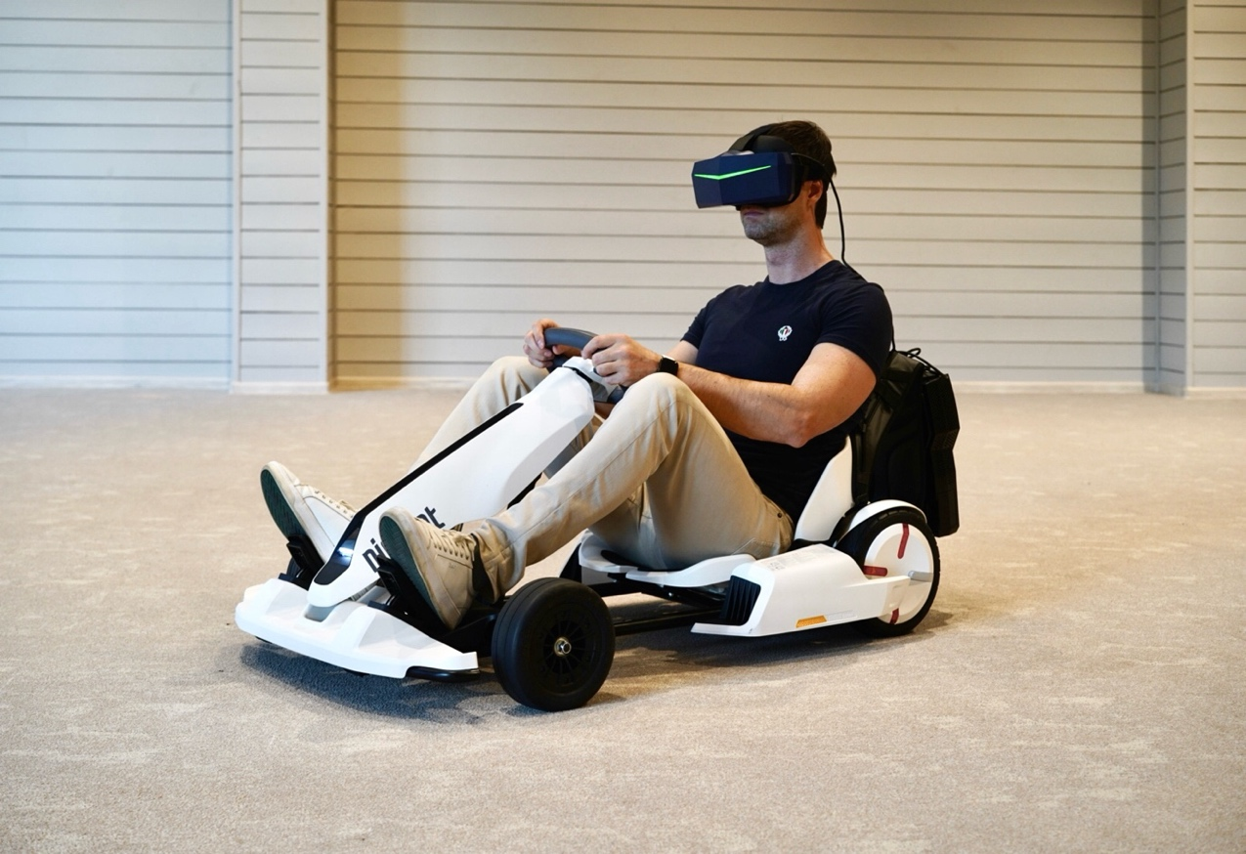
However, if desired, the attraction operator can add markings to the floor to help players orient themselves before the start. I offer tracks of various types, each presenting unique challenges and unforgettable experiences:
Track | Description
Short Track | Perfect for beginners and those looking for a quick dive into the world of virtual racing. This track features a simple layout, smooth turns, and no challenging sections. It winds through a vibrant and dynamic futuristic city, with neon-lit skyscrapers and flying cars whizzing overhead.
Medium Track | Ready for a more serious challenge? This track awaits you with sharp turns, steep elevation changes, and other elements that will test your driving skills and reaction time. It twists and turns along a winding mountain pass, with breathtaking views of the surrounding peaks and deep chasms. Be careful on the winding sections: one wrong move and you could "fly off" the track!
Long Track | This track is a true challenge for experienced racers! It combines all the elements of the previous tracks, but in a much more complex and unpredictable format. You'll race through futuristic cities, mountain roads, and underground tunnels, overcoming obstacles and competing against the strongest virtual opponents.
And that's not all! The virtual world is constantly expanding: new tracks with thrilling turns and unexpected obstacles await you.
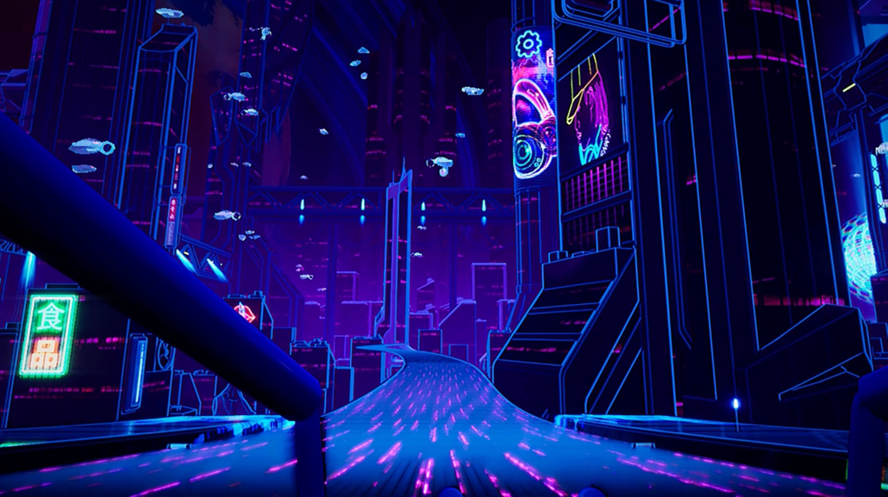
4.2. Game modes: Choose your style
Kart VR Evolution isn't just about racing; it's about choosing your own play style. Whether you want to test your limits and set a new record or crave the thrill of competition and dream of crossing the finish line first, this platform has a game mode for everyone!
- Time trials: Here, your main opponent is the clock. Choose your track, focus your concentration, and try to beat the lap record! This mode is ideal for those striving for self-improvement and who love to challenge themselves.
- Racing against opponents: Ready for the real excitement of competition? In this mode, you can battle against friends or AI-controlled virtual racers. The winner is the first to cross the finish line, overcoming all obstacles and leaving the competition in the dust!
- Team races: This mode emphasizes not only individual skill but also teamwork. Team up with friends, develop a common strategy, coordinate your actions on the track, and strive for victory together!
- Combat racing: This is more than just racing; it's full-blown action! In "Combat Racing" mode, you'll need to demonstrate your accuracy and reaction time, dodging enemy fire and hitting them with maximum precision. The action takes place on the virtual streets of a ruined city, where danger lurks around every corner.
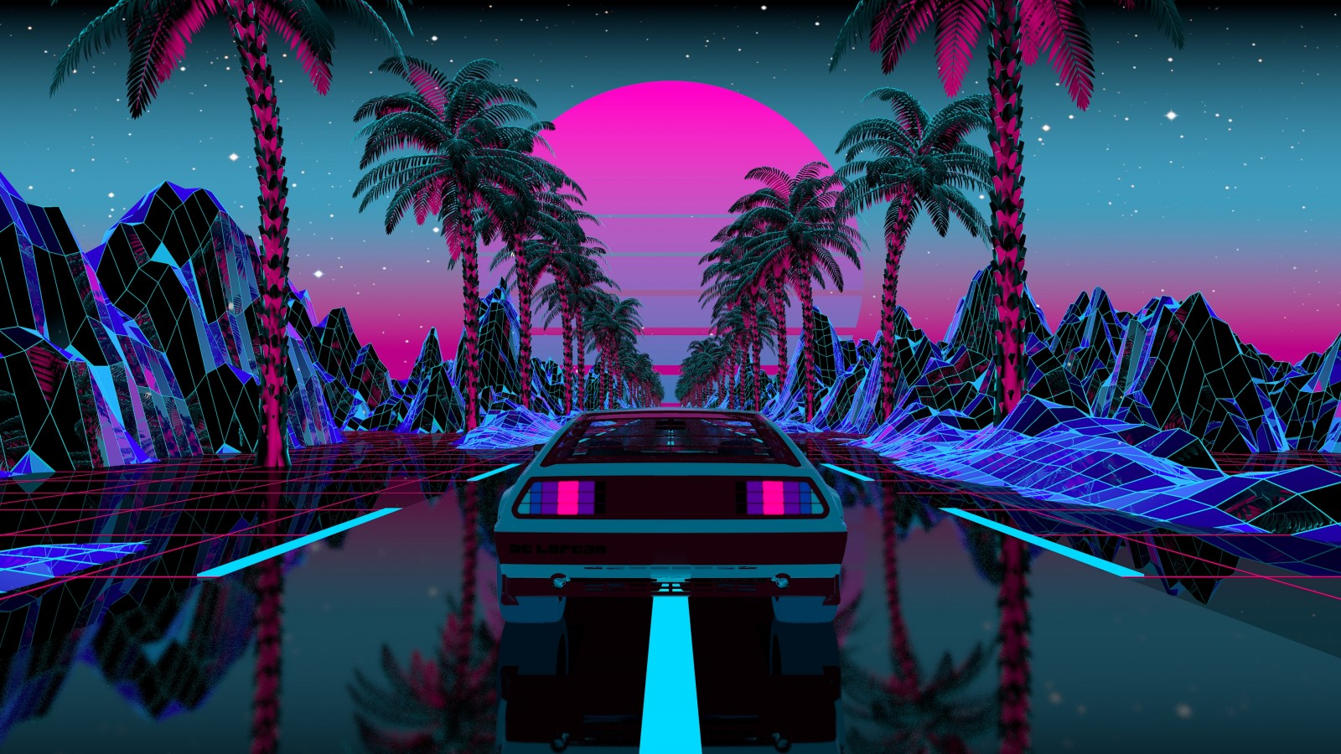
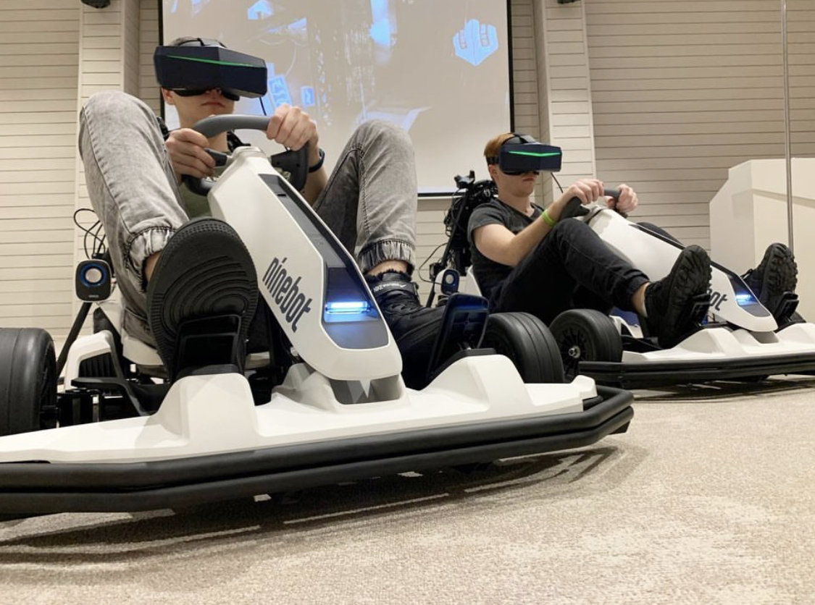
4.3. A Virtual playground for real skills
The virtual racing world is not only about entertainment, but also about the opportunity to hone your driving skills in a completely safe environment.

Thanks to the realistic physics of control and kart behavior in the virtual environment, you can develop qualities essential for any driver:
- Enhanced reaction time: You'll have to react instantly to changing situations on the track, dodging obstacles, accelerating, and overtaking opponents. This helps sharpen your reflexes and teaches you to make quick decisions in any situation – both virtual and real.
- Improved coordination: Controlling a kart requires coordinated work from your entire body. You need to simultaneously steer, operate the pedals, and monitor the track, synchronizing your actions with the movements of your virtual avatar. Regular practice helps develop coordination and dexterity; skills that undoubtedly come in handy behind the wheel of a real car.
- Better speed and distance perception: Kart VR Evolution allows you to experience real speed without putting yourself at risk. In the virtual environment, you'll learn to better judge distances, anticipate the behavior of other racers, and feel more confident at high speeds.

4.4. Races that unite
A visit to the virtual karting arena is a fantastic opportunity to spend time with friends, share the thrill of racing, and simply have fun!
- Competitions with friends: Organize a real tournament amongst yourselves and see who will become the champion! Choose from a variety of tracks and game modes, challenge yourselves and each other, and get a boost of positive energy from the competition!
- Team spirit: Join forces in teams to compete against others in exhilarating virtual races! Mutual assistance, coordinated actions, and a shared strategy are the keys to your triumphant success!
- New acquaintances: Virtual karting is a great place to meet new people who share your passion for racing and virtual reality. Chat, share your experiences, create your own teams, and conquer the virtual tracks together!

Chapter 5: Strategies for success and business prospects
The VR karting arena is an extremely exciting attraction capable of delivering vivid and unforgettable emotions, as well as a promising business project with enormous potential for development and monetization.

5.1. Competitive advantages
In the world of VR, there are many diverse attractions that offer a unique immersive experience in virtual reality. Here are some popular types of VR attractions:

- VR flight simulators: Allow users to experience the sensation of flying an airplane or spaceship.
- VR roller coasters: Combine physical chair movement with virtual visuals to create thrilling sensations.
- VR shooting galleries: Offer a shooting experience in a virtual world using controllers that mimic weapons.
- VR quests and escape rooms: Players solve puzzles and complete tasks in virtual space.
- VR arenas for multiplayer games: Large spaces where multiple players can interact in a virtual world.
- VR cinemas: Offer fully immersive movie-watching experiences.
- VR extreme sports simulators: Allow users to experience sensations of snowboarding, surfing, rock climbing, etc.
- VR travel: Provide opportunities to "visit" famous cities, countries, landmarks, and exotic places.
- VR educational attractions: Offer interactive lessons in history, science, or art.
- VR driving simulators: Allow practicing driving skills in a safe virtual environment.
- Virtual karting indeed occupies a unique niche as it combines the physical experience of driving a real kart with visual and audio immersion in virtual reality. This creates a deeper and more realistic sensation than purely virtual simulators, while also providing greater variability and safety than traditional karting.
- This combination of physical and virtual experience opens up new possibilities for entertainment and training. It allows for the creation of diverse virtual tracks and scenarios unavailable in the real world, while maintaining the tactile sensations of driving a real kart. This is a unique offering in the entertainment market that can attract both traditional karting enthusiasts and virtual reality enthusiasts.

Here are the key advantages that make this project so attractive:
- Total immersion: The ultra-high resolution and wide field of view of the Pimax 8K+ VR headsets, combined with the dynamics of the moving karts, blur the line between the virtual and real. The player doesn't just watch the race; they become an active participant, feeling the vibration of the engine, the acceleration, the scent of burning rubber, and the roar of the crowd.
- Safety: In the virtual world, the thrill of racing comes without any risk to health. An intelligent collision avoidance system ensures that you won't collide with another kart or crash into a barrier, even if you forget to brake in the heat of the competition.
- Accessibility: Virtual karting doesn't require a large, open track. The attraction can be housed in a specially equipped room, making it ideal for shopping malls, entertainment complexes, and other indoor venues.
- Flexibility and variety: The project isn't limited to a single track and vehicle type. In the virtual world, you can create racing tracks for every taste, from futuristic megacities to winding mountain passes. Players can race in classic karts, hovering bikes, or even fantastical machines of the future.
- Eco-friendliness: Virtual karting is an environmentally friendly attraction. It utilizes electric karts that produce no harmful emissions.
- Social aspect: It's not just individual entertainment but also an opportunity to share unforgettable experiences with friends. You can race together, compete for the best time, or join forces in teams.
- Potential for development: Kart VR Evolution is a platform for the future. We're constantly working to make it even more realistic and engaging by integrating new VR technologies and creating new gameplay opportunities.

5.2 A look to the future
Kart VR Evolution is a fully realized product and a platform that will continue to evolve and improve. We see enormous potential in this technology and firmly believe it has the power to revolutionize the worlds of racing and entertainment.
Here are our plans for the future:
- New tracks: We will create new, even more realistic and exciting tracks that transport players to incredible virtual worlds.
- New game modes: We will develop new game modes, adding new features and challenges to the virtual karting experience.
- New technologies: We will integrate cutting-edge technologies, such as haptic feedback, to further enhance the sense of presence in the virtual world.
- Esports: We plan to develop virtual karting into a full-fledged esports discipline, hosting tournaments and championships for players from around the globe.
- Professional training tool: We see the potential for Kart VR Evolution as a training tool for professional racers, allowing them to hone their skills in a safe and controlled environment.

5.3. From start to finish – Business prospects
The uniqueness and appeal of the Kart VR Evolution project open up a wide range of monetization opportunities. Here are a few:
- Ticket sales: The primary revenue stream will be through the sale of tickets for gaming sessions. A flexible pricing system will allow us to cater to different customer segments.
- Event rentals: The attraction can be rented out for various events, from corporate parties to children's birthdays. We will develop special service packages for corporate clients.
- Franchising: We plan to create a franchise that will allow us to expand Kart VR Evolution globally. Franchisees will receive access to our technology, software, and comprehensive support at all stages of business development.
- Advertising and sponsorship: Kart VR Evolution is an excellent platform for advertising. We can place advertising banners on virtual tracks, brand the karts, and offer sponsorship packages for tournaments and championships.
Choosing the right location for virtual racing
The success of any VR attraction largely depends on choosing the right location. It's crucial to consider several factors: foot traffic, target audience, competition, rental costs, and more.
Due to its mobility and versatility, Kart VR is suitable for various locations. Here are some promising options:
- Shopping and entertainment centers: shopping malls attract a wide range of visitors, from families with children to teenagers and adults. High foot traffic and existing entertainment infrastructure make them an ideal location for VR attractions. However, it's important to consider the high competition and rental costs in popular malls.
- Entertainment complexes: Cinemas, bowling alleys, and children's play centers already draw in people seeking entertainment. Placing Kart VR Evolution in such complexes expands the entertainment options and attracts a new audience.
- Amusement parks and water parks: Kart VR Evolution would be a vibrant addition to existing attractions, appealing to thrill-seekers and fans of new technologies.
- Hotels and resorts: A VR attraction can be an excellent entertainment option for guests, offering an alternative to traditional leisure activities. This is especially relevant for hotels in locations with unpredictable weather.
- Corporate events: Kart VR Evolution can be rented for team-building events, corporate parties, presentations, and other gatherings. It's a fantastic way to surprise employees and partners, while also creating an informal atmosphere for networking.

When choosing a location for Kart VR Evolution, it's essential to consider the following:
- Target audience: Who are your potential customers? Where do they spend their free time?
- Competition: Are there other VR attractions or entertainment options in the area that could pose competition?
- Rental costs and other expenses: Ensure you can recoup your investment and generate a profit.
- Technical feasibility: Is there enough space in the venue for the playing area, charging zone, and other necessary zones? Is there a stable power supply and internet connection?
A well-chosen location is crucial to the success of any VR attraction. Carefully analyze all factors and make an informed decision to ensure that your Kart VR venture becomes a popular and profitable business!
VR karting is more than just an attraction; it's a glimpse into the future of entertainment. We are confident that it is destined for success and will become one of the most popular virtual attractions in the world.

Chapter 6: Marketing strategy and positioning
We've created a VR attraction capable of captivating the hearts of millions. But every journey to the top begins with a single step. How do we make sure the whole world knows about our project?
6.1 Target audience: Who craves virtual speed?
Kart VR appeals to a wide audience united by a love for racing, new technologies, and thrilling experiences.
- Gamers: Always on the lookout for the next level of gaming experience, Kart VR is ready to deliver. Unparalleled immersion, realistic physics, and exciting online competitions will attract players of all ages and nationalities.
- Karting Enthusiasts: Those who live for the roar of engines and the thrill of racing will appreciate the opportunity to hone their driving skills in the safe environment of Kart VR, without any risk to themselves or the environment.
- Families: VR karting is an excellent entertainment option for the whole family, where parents and children can compete against each other and create lasting memories.
- Youth: Visiting a virtual karting arena is trendy, modern, and cool. It allows young people to immerse themselves in the world of high technology and spend time with friends, gaining unforgettable experiences.
6.2 Promotion strategy: At full speed to success
To make your VR attraction known worldwide, it's essential to develop an effective promotion strategy that captures the attention of your target audience and sets your project apart from the competition.
Here are a few tips to help you achieve success:
Online marketing:
- Create a captivating website: Showcase all the features of your attraction with stunning photos, engaging videos, and compelling customer testimonials.
- Launch social media campaigns: Target your ideal customer profiles – gamers, racing enthusiasts, families with children.
- Utilize targeted and contextual advertising: Reach those already interested in VR technology and entertainment.
- Run online contests and giveaways: Generate excitement and attract new audiences.
Public relations:
- Engage with the media: Reach out to leading publications covering VR, gaming, and entertainment.
- Organize test drives for journalists and bloggers: Let them experience the thrill firsthand and share their impressions with a wider audience.
- Appear on TV programs: Seek opportunities to feature your attraction on shows focusing on new technologies and entertainment.
Influencer marketing:
- Collaborate with bloggers and influencers: Partner with popular gamers, tech bloggers, and opinion leaders who hold sway with your target audience.
Industry events:
- Attend exhibitions and conferences: Make a memorable impression at industry events, showcasing your attraction's capabilities to potential customers, investors, and partners.
Keep in mind:
- Create a strong brand identity: Develop a unique and memorable brand for your attraction, one that evokes dynamism, the thrill of racing, and unforgettable emotions.
- Focus on your target audience: Always tailor your message and marketing channels to resonate with your ideal customers.
- Continuous improvement: Don't rest on your laurels! Continuously explore new promotional avenues and refine your strategy to stay ahead of the competition.
6.3 Creating the brand: The face of speed
For the successful promotion of Kart VR, it's crucial to create a vibrant and memorable brand associated with a world of speed, high technology, and unforgettable experiences.
- Logo: Dynamic and futuristic, reflecting the essence of the attraction.
- Slogan: Short, catchy, and memorable, evoking a desire to dive into the world of Kart VR Evolution.
- Brand Identity: Modern, energetic, and appealing to the target audience.
Kart VR Evolution has the potential to become synonymous with a new generation of virtual racing.
6.4 In the world of games and entertainment: Conquering the market
Kart VR offers an unparalleled level of immersion that traditional video games and simulators simply cannot match. It's not just individual entertainment; it's a platform for social interaction where players can compete, connect, and share experiences. Kart VR is also a platform for growth, capable of expanding with new game modes, tracks, features, and technologies.
I am confident that virtual reality karting will become one of the most popular forms of entertainment worldwide, attracting millions of players and setting new standards in the VR attraction industry.

Chapter 7: Speed without harming the planet - Environmental responsibility
In a world where environmental concerns are increasingly urgent, it's essential that new technologies not only entertain but also demonstrate responsibility towards our planet. Kart VR strives to be an example of an environmentally friendly and sustainable project.
7.1 Minimizing environmental impact
We are committed to minimizing our environmental footprint and have taken several steps to reduce our impact:
- Electric Self-Balancing Scooters: Unlike traditional karts that use gasoline engines, Kart VR is powered by electricity. Our karts are equipped with eco-friendly electric scooters that produce no harmful emissions and don't pollute the air.
- Energy-Efficient Technologies: We strive to minimize energy consumption. The attraction uses energy-efficient equipment, and the software is optimized to reduce the load on the server and computers.
7.2 Ecology and the future
We're not stopping there! We plan to implement even more eco-friendly solutions:
- Renewable Energy Sources: We are exploring the possibility of using solar panels to partially power the attraction with clean energy.
- Recycled Materials: We aim to use recycled materials in the construction of the karts and attraction equipment, reducing our environmental impact and supporting the recycling industry.
- Environmental Education: We want Kart VR Evolution to be more than just entertainment; we want it to be a platform for promoting environmental awareness. We'll educate our guests about the importance of protecting our planet and how virtual technologies can help create a more sustainable future.
Kart VR Evolution is not only an exhilarating entertainment experience, but it's also a project created with a deep respect for our planet. We believe the future belongs to technologies that align with the principles of sustainability and help preserve our shared home - planet Earth.

Chapter 8: Kart VR Evolution and Apple Vision Pro: A new dimension of reality
The release of the Apple Vision Pro headset presents us with a unique opportunity to upgrade our virtual karting system and utilize this device for both virtual reality (VR) and augmented reality (AR) experiences. Apple Vision Pro promises to be a revolutionary device that merges the best of both VR and AR, opening up entirely new horizons for users in interactive technologies.
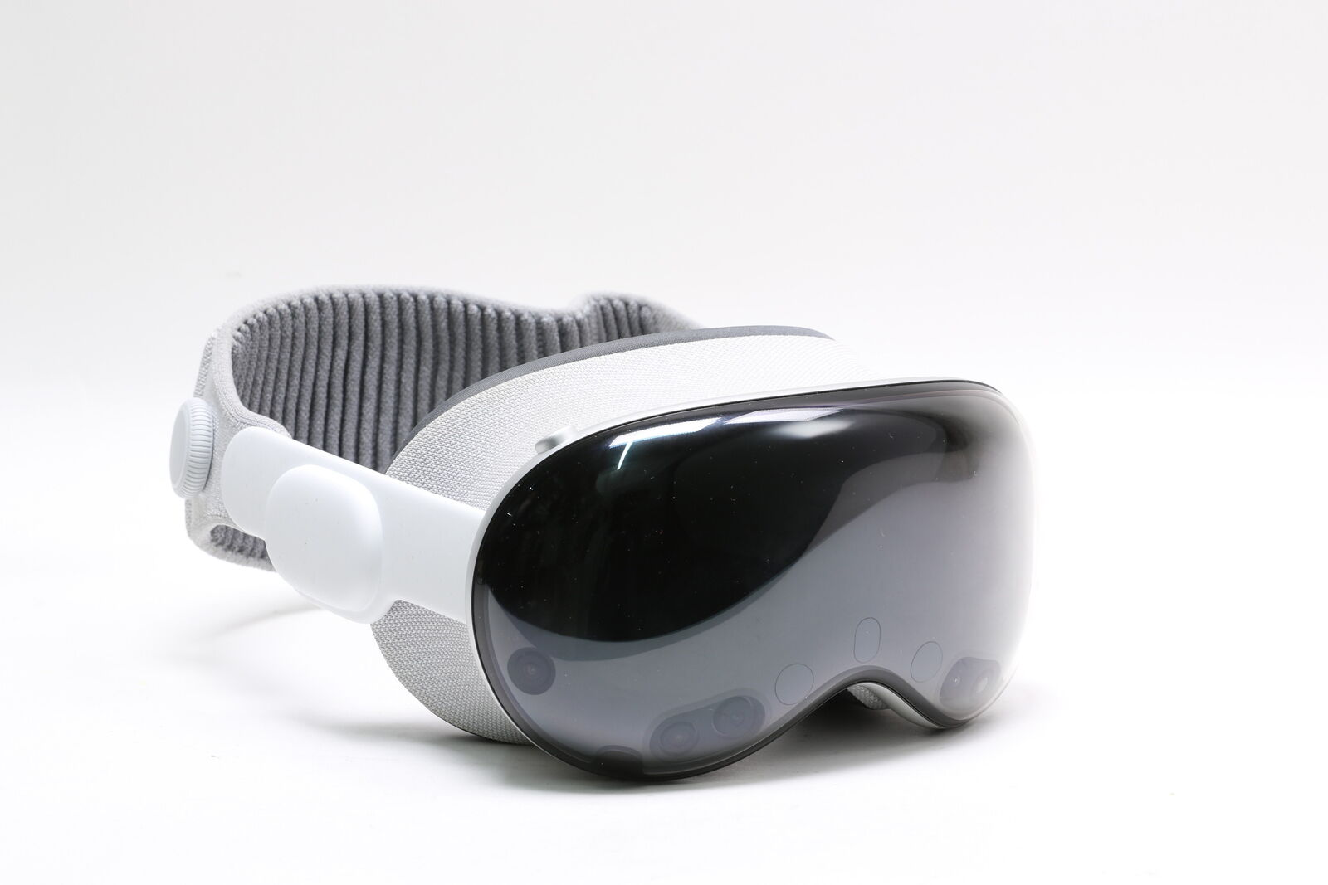

8.1 Revolution in mixed reality
Apple Vision Pro is a mixed reality (MR) headset that combines elements of both virtual reality (VR) and augmented reality (AR). It allows users to interact with virtual objects in the real world and immerse themselves in captivating virtual environments.
8.2 Apple Vision Pro technical specifications
Apple Vision Pro is packed with cutting-edge technology, including:
- High-quality display: Delivers vibrant and sharp visuals, crucial for a comfortable and realistic VR and AR experience.
- Spatial audio: Creates a sense of presence in the virtual environment, enabling the user to pinpoint the direction of sounds and further immerse themselves in the experience.
- Motion tracking Sensors: Ensure precise tracking of head and hand movements, making interaction with virtual objects more intuitive and natural.
- Powerful processor: Apple Vision Pro is equipped with a powerful processor capable of running even the most demanding VR and AR applications smoothly and responsively.
8.3 Apple Vision Pro in Virtual Reality

Apple Vision Pro unlocks new possibilities for creating extraordinary VR experiences:

- Gaming: VR games utilizing Apple Vision Pro will become even more realistic and immersive thanks to the high-quality visuals, spatial audio, and precise motion tracking.
- Training: VR simulations with Apple Vision Pro can help people learn new skills in a safe and controlled environment, leading to more effective training outcomes.
- Entertainment: VR films, concerts, and other forms of entertainment will become even more immersive and impressive, transporting viewers to new worlds and experiences.

8.4 Apple Vision Pro in augmented reality

Apple Vision Pro also pushes the boundaries of augmented reality:

- Navigation: AR applications combined with Apple Vision Pro will make it easier for people to navigate unfamiliar places by overlaying directions, points of interest, and other useful information directly onto the real world.
- Design: AR tools working in tandem with Apple Vision Pro will empower designers to create and visualize their projects in the real world, interacting with 3D models as if they were physical objects.
- Gaming: AR games will transform the real world into an engaging playground, adding virtual objects and characters to the player's surroundings.
8.5 Integration prospects of Apple Vision Pro with Kart VR

Apple Vision Pro has the potential to be the perfect complement to Kart VR, taking the attraction to new levels of realism and immersion.

- Enhanced Graphics and Sound: With Apple Vision Pro's high-quality display and spatial audio, we can make the visuals and sounds in Kart VR Evolution even more realistic and captivating, further blurring the lines between the virtual and real.
- AR Elements: Integrating AR capabilities through Apple Vision Pro allows us to add exciting new features and possibilities to Kart VR. For example, virtual objects like flags, power-ups, or even competitors could appear in the real world, interacting with players and creating a more engaging and interactive experience.

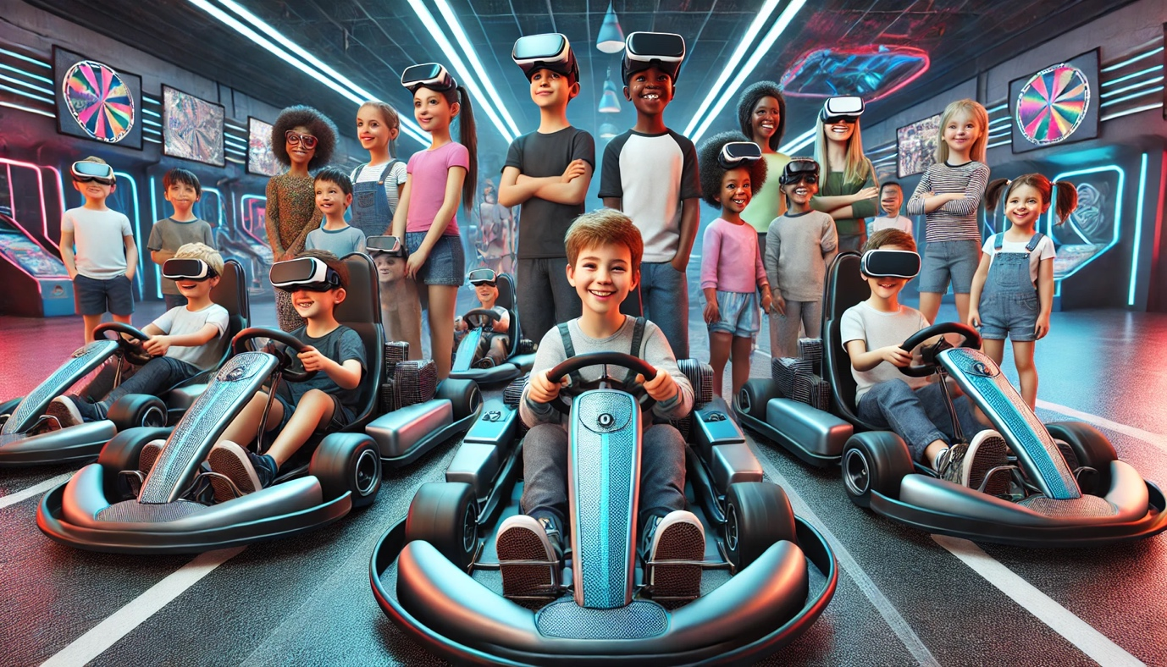

Conclusion:
Kart VR Evolution is not just another project; it's a glimpse into the future of entertainment, a future where the lines between reality and virtuality blur, and technology serves the betterment of humanity. We are confident that Kart VR Evolution will revolutionize the worlds of racing and virtual reality, providing people with unforgettable experiences and lasting memories.

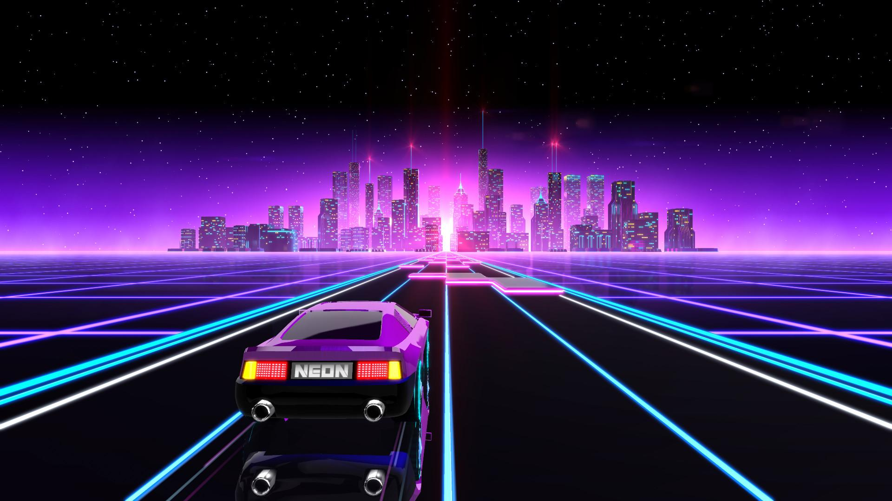

Bibliography:
- Virtual Reality: A new Era of entertainment and education. / Edited by A.A. Petrov. - Moscow: Technosphere publishing house, 2022. - 350 p. (In Russian)
- Artificial intelligence in games: From simulation to reality. / D.A. Sidorov. - Moscow: Binom publishing house, 2021. - 400 p. (In Russian)
- Technologies of the future: Virtual reality, augmented reality and mixed reality. / edited by N.N. Kozlov. - Moscow: Lan publishing house, 2023. - 500 p. (In Russian)
- Karting: History, technology, races. / S.V. Ivanov. - Moscow: Avtosport publishing house, 2018. - 280 p. (In Russian)
- Smirnov A.V. Virtual reality in sports: New opportunities for training and entertainment. // Technologies and innovations journal, 2023, No. 2, pp. 45-52. (In Russian)
- Kuznetsova E.I. Development of virtual reality attractions: Trends and prospects. // Innovations in the entertainment industry journal, 2022, No. 3, pp. 25-31. (In Russian)
- Lee, E. A., & Park, N. (2018). Ethical considerations for virtual reality in education. Educational technology research and development, 66(4), 761-780. DOI: 10.1007/s11423-018-9593-x
- Madary, M., & Metzinger, T. (2016). Real virtuality: A code of ethical conduct. Recommendations for good scientific practice and the consumers of VR technology. Frontiers in robotics and AI, 3, 3. DOI: 10.3389/frobt.2016.00003
- Themed entertainment association (TEA). https://teaconnect.org/
- VRScout. https://vrscout.com/
- Road to zero emission leisure. https://zeroleisure.org/
- Information about Ninebot S Pro on the official Segway website. https://www.segway.com/products/pt/ninebot-s-pro/
- Official page of Pimax 8K+ on the manufacturer's website. https://www.pimax.com/products/pimax-vision-8k-plus
- Apple Vision Pro page on the official Apple website. https://www.apple.com/apple-vision-pro/
- Apple Vision Pro review. CNET. https://www.cnet.com/tech/computing/apple-vision-pro-hands-on-a-spectacular-and-spendy-new-reality/
- Unreal engine official website. https://www.unrealengine.com/
- VR/AR/MR 2023 Exhibition materials. https://www.vrar-expo.com/
- "Virtual reality and the future of entertainment" conference materials. https://vr-conf.ru/ (In Russian)

