Maksim Strelchenko
POWER CONTROL FOR WATER TREATMENT APPARATUS
Part 2

CONTENT
Summary of the invention 3
Brief description of the drawings 4
Detailed description of the invention 30
Brief Product Description 30
Exemplary “Actual” Practice and Applications, and Analysis of Results Obtained Therefrom 31
Estimate of Operating Efficiency of The W2W Water Treatment/ Purification/ Regeneration System for an Input of Water Containing a Measured Amount of Various Metals 31
Test of the Effectiveness of Operation of the W2W Electrochemical Reactor and System 34
Use of the W2W Water Treatment/Purification/Regeneration System for Reducing Water Hardness 36
Detailed Description of How the Power Control of the Present Invention Synchronizes the Power Supply to a W2W Electrochemical Reactor 38
Synchronized Operation of the Electrochemical Reactor (ECR) and the Energy Source Mechanism (ESM) 38
Hydrodynamic Synchronization 41
Electro-hydrodynamic Synchronization 42
Example 43
Water Treatment Capacity 44
Hydraulics of the Casing (Housing) of the Electrochemical Reactor (ECR) 44
Detailed Description of Electro-hydrodynamic Synchronization 45
CLAIMS 52
REFERENCES, PATENT AND LICENSE INFORMATION 53

Summary of the invention
The invention provides a complete electrochemical water purification system. The complete configuration of this system, including alternative embodiments, is described at length.
One embodiment of this system includes a power control for an electrically powered water treatment apparatus having electrode cells. The power control comprises:
- a master power supply unit having a control input;
- a slave power supply unit having a control input;
- a current sensor adapted to measure the electrical current flowing through the cells of the water treatment apparatus;
- a voltage sensor adapted to measure the voltage applied to the cells of the
- water treatment apparatus;
- a PLC having inputs from said current sensor and said voltage sensor and outputs for said master and slave power supply units; and wherein, said PLC is programmed so as to be able to maximize the electrical power applied to the cells without overheating.
Other aspects and advantages of the present invention will be apparent from reading the detailed description that follows.

Brief description of the drawings
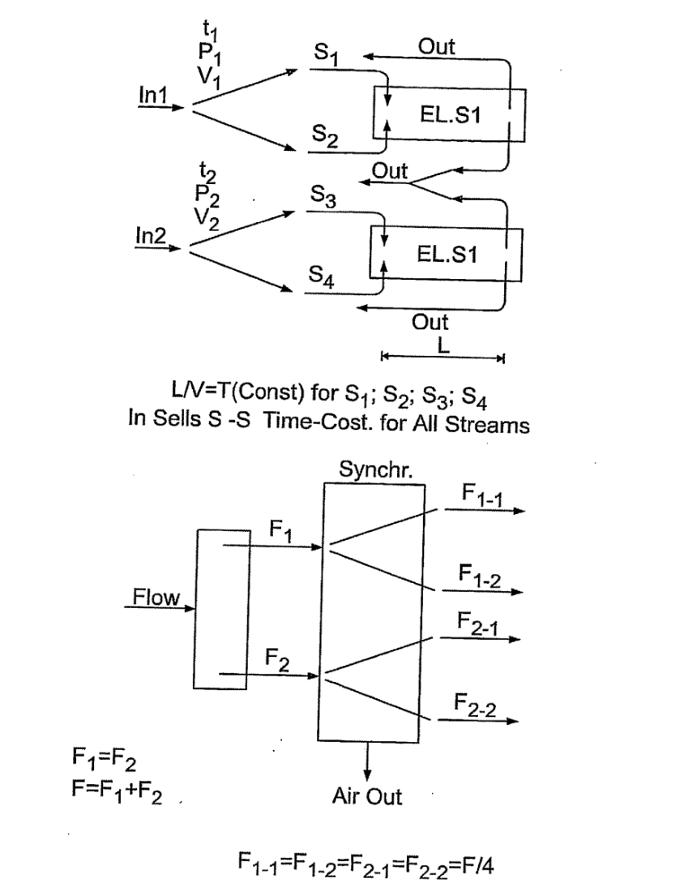

Fig. 1. A schematic representation of the motion of streams of impure water and their synchronization.

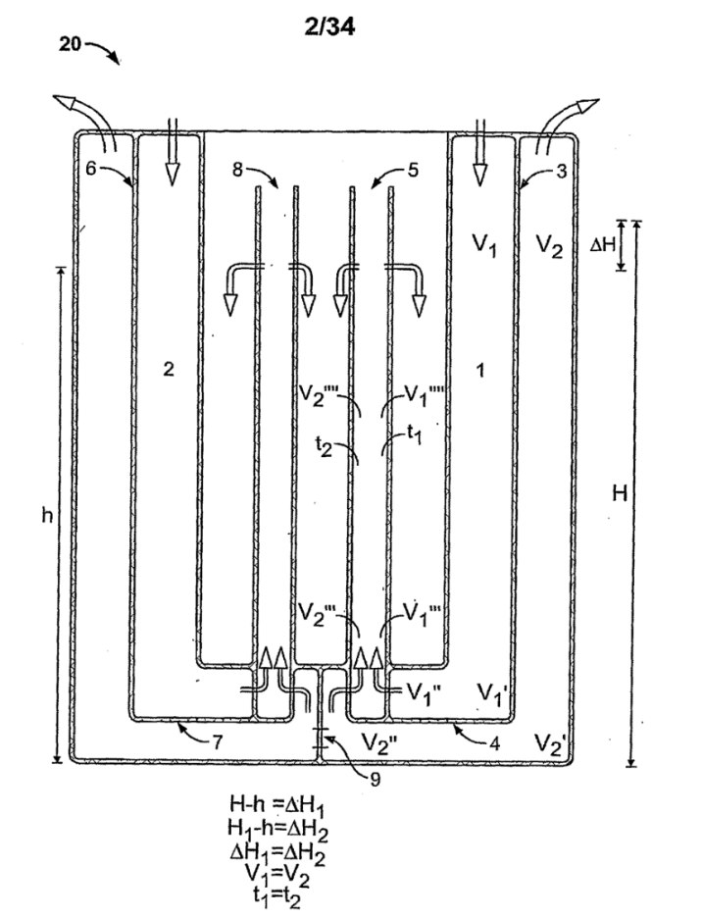
Fig. 2 A schematic cross-section view of a W2W electrochemical reactor body of the present invention.
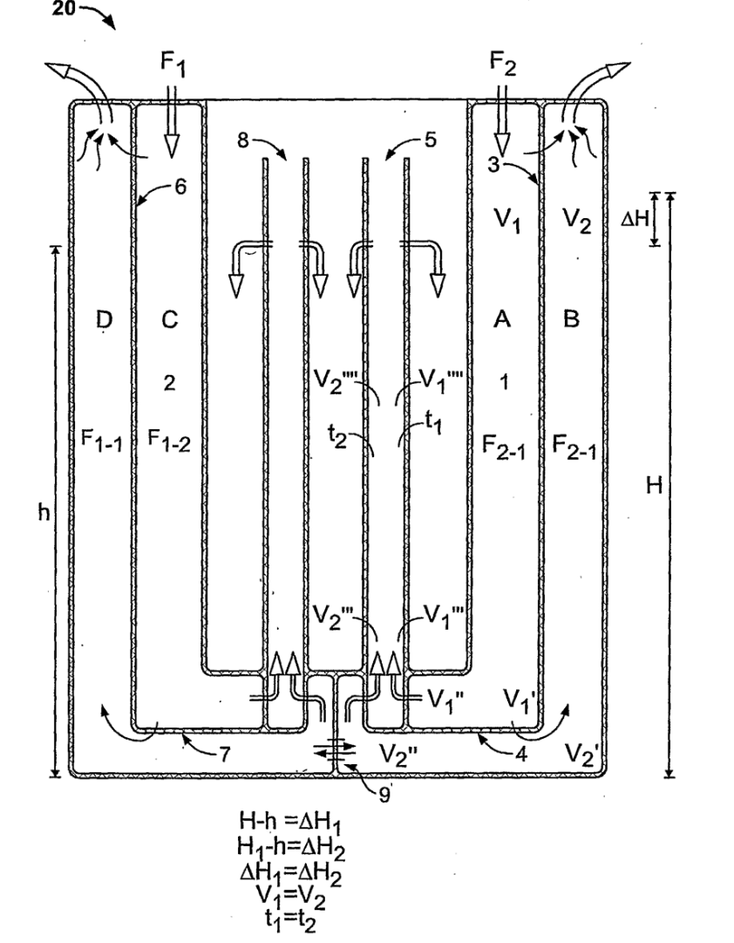
Fig. 2’ A slight revision of Fig. 2.

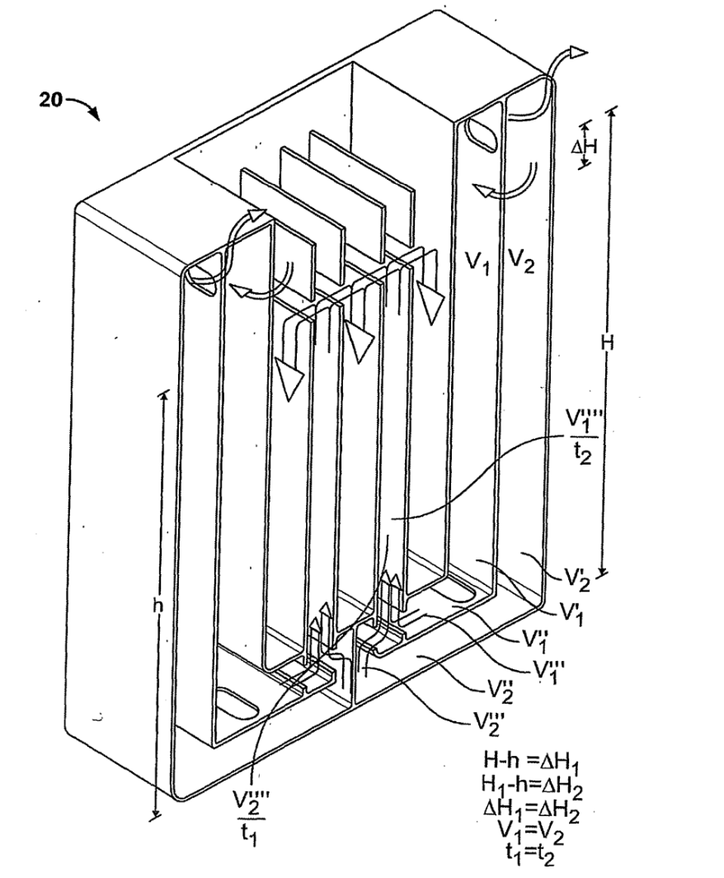
Fig. 3 A perspective schematic sectional view of a W2W electrochemical reactor body of the present invention.
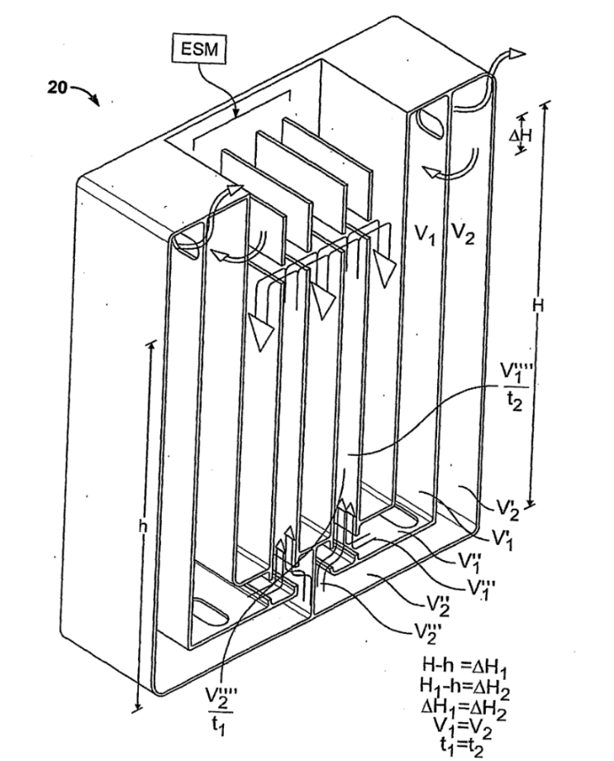
Fig. 3’ A slight revision of Fig. 3.
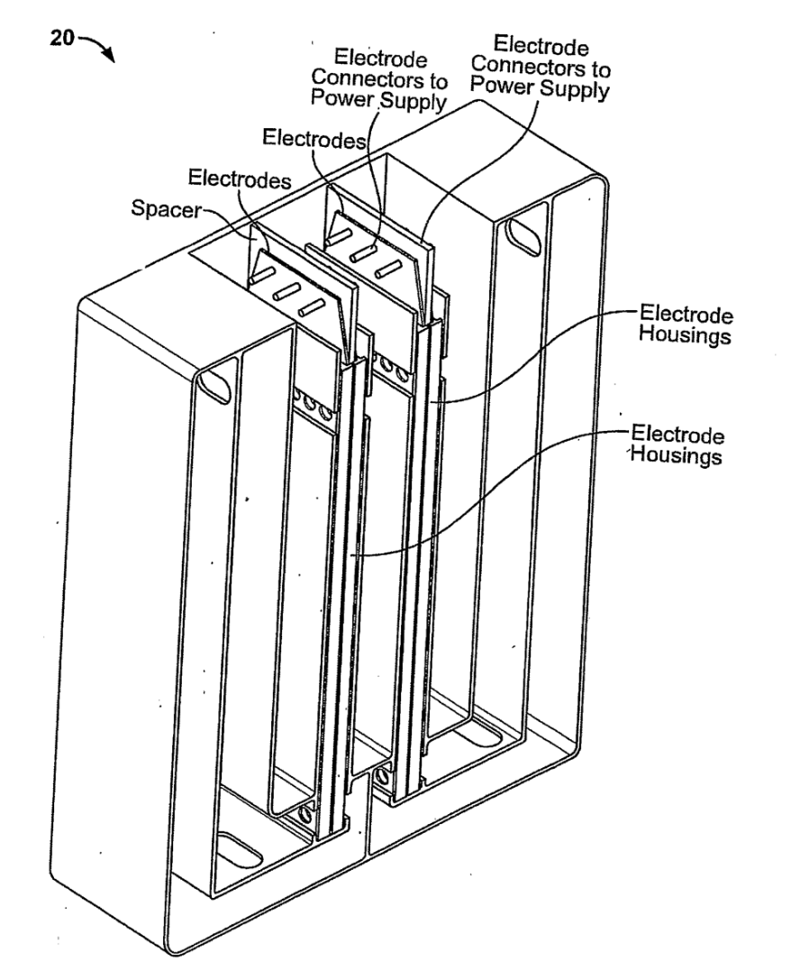
Fig. 4 A perspective view of a W2W electrochemical reactor with two electrode cell cassettes and the associated electrodes.
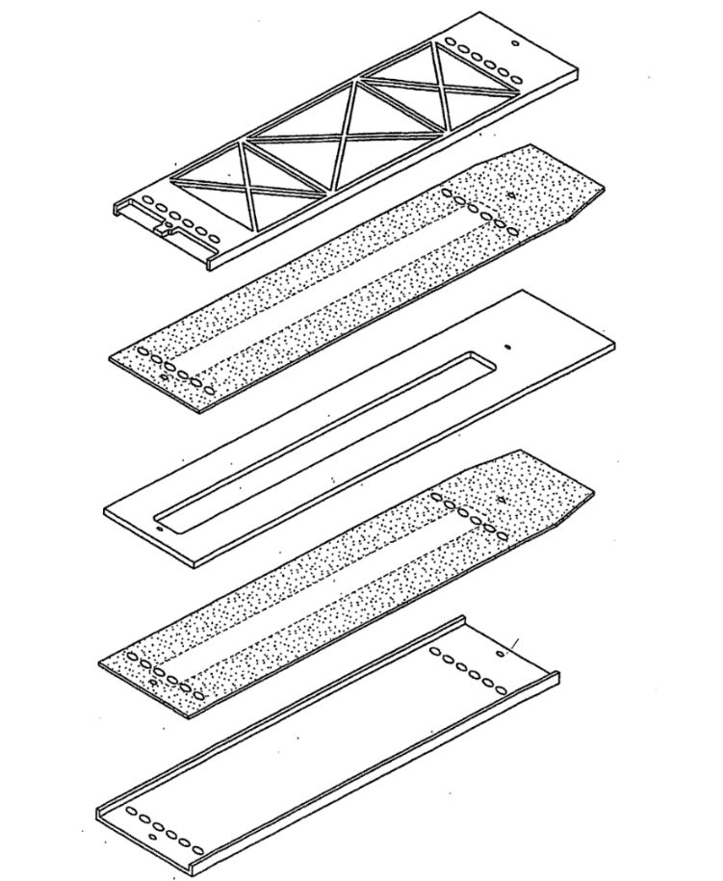
Fig. 5 An exploded view of one embodiment of electrode cell cassette and the associate electrodes of the present invention.
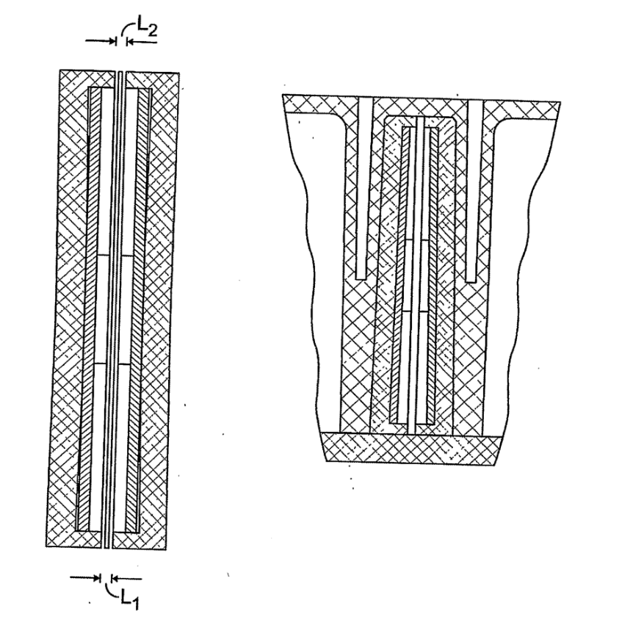
Fig. 6 The self-sealing construction of electrode cells of the present invention in two cross-section views.
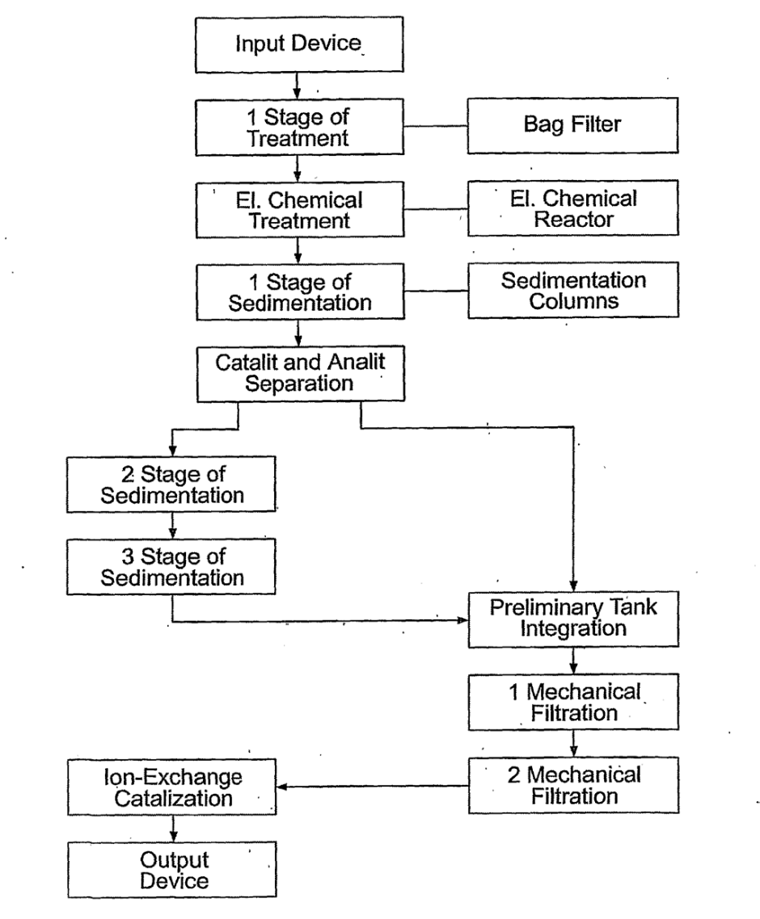
Fig. 7 A basic water flow chart of a W2W system.

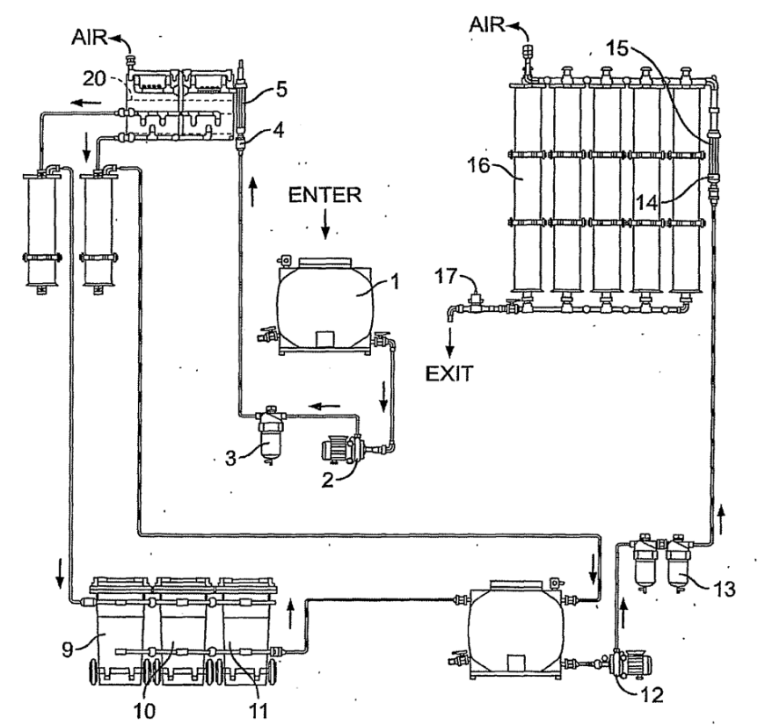
Fig. 8 A general scheme of one embodiment of a W2W system of the present invention.

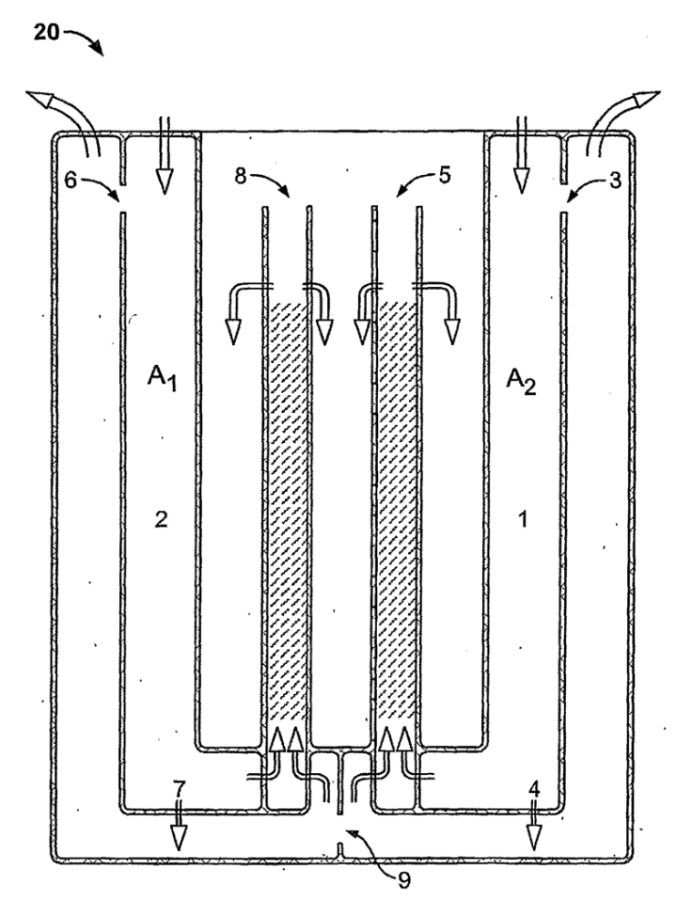
Fig. 9 A schematic cross-section view of one embodiment of a W2W electrochemical reactor of the present invention.

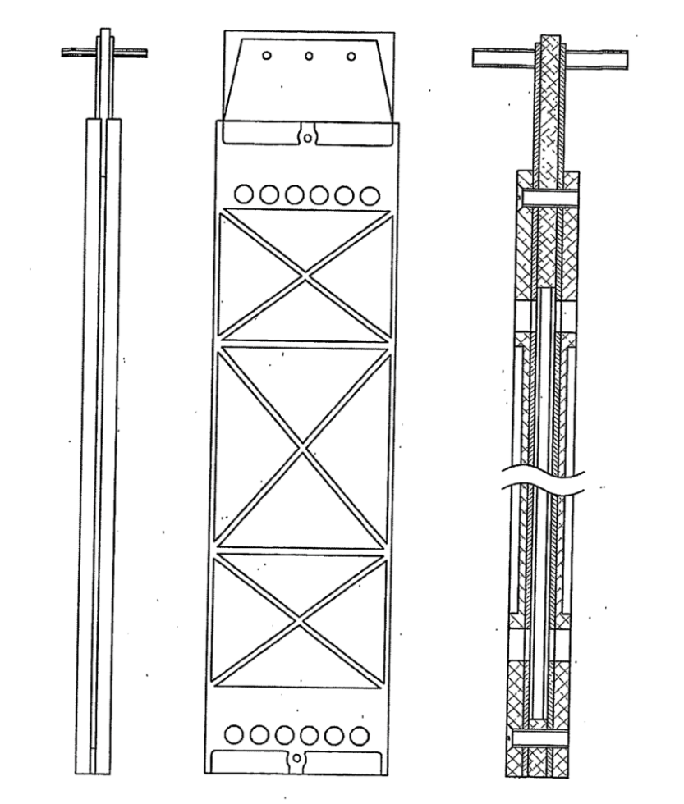
Fig. 10 An electrode cell cassette and its associated pair of oppositely charged electrodes of the present invention in three different views.
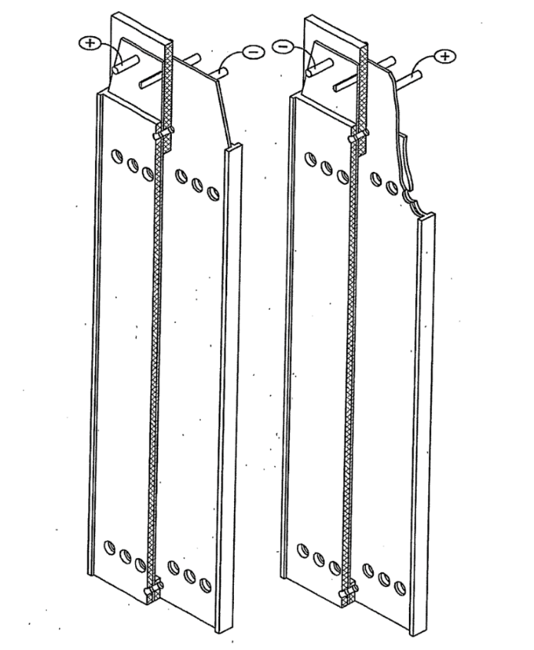
Fig. 11 is A perspective view of two electrode cell cassettes and their associated pair of oppositely charged electrodes of the present invention.
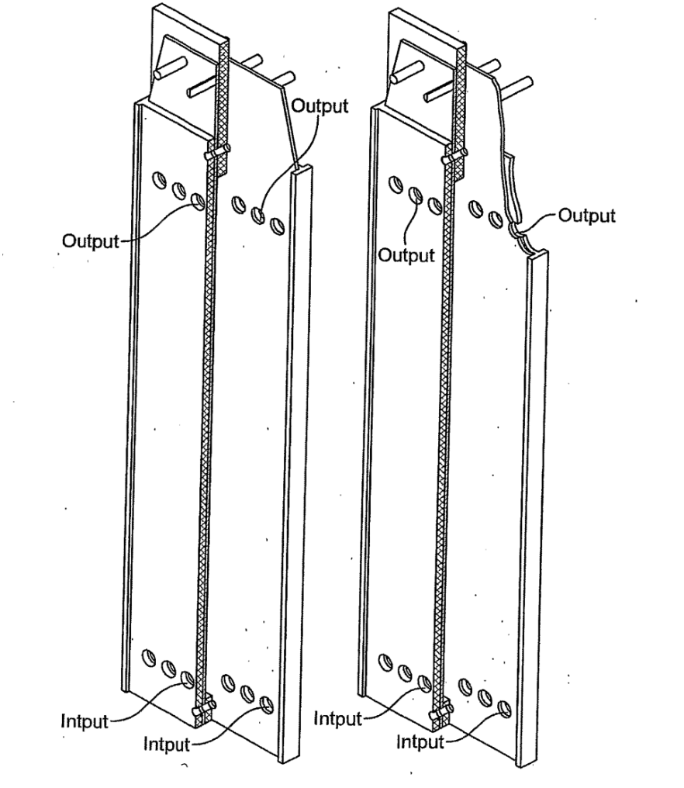
Fig. 12 Another perspective view of two electrode cell cassettes and their associated pair of oppositely charged electrodes of the present invention.
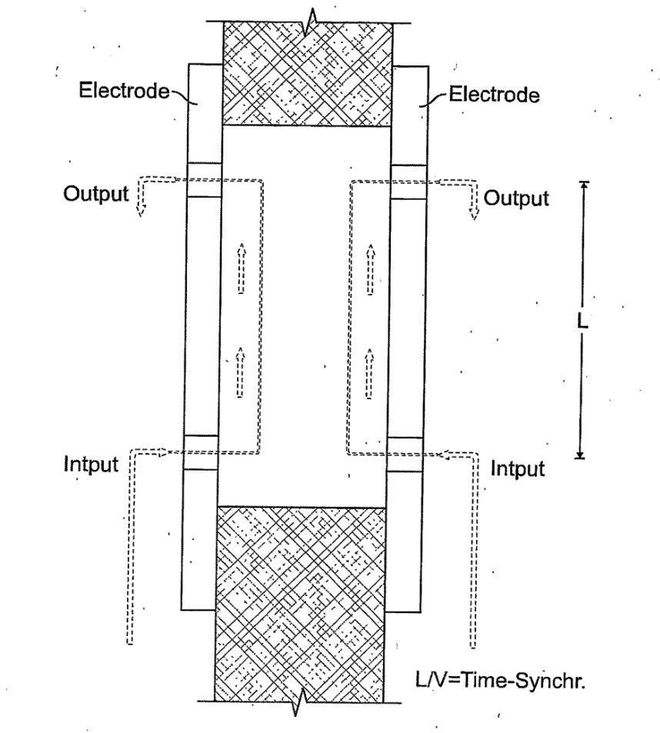
Fig. 13 A schematic diagram showing how the water flows through electrodes of the present invention.
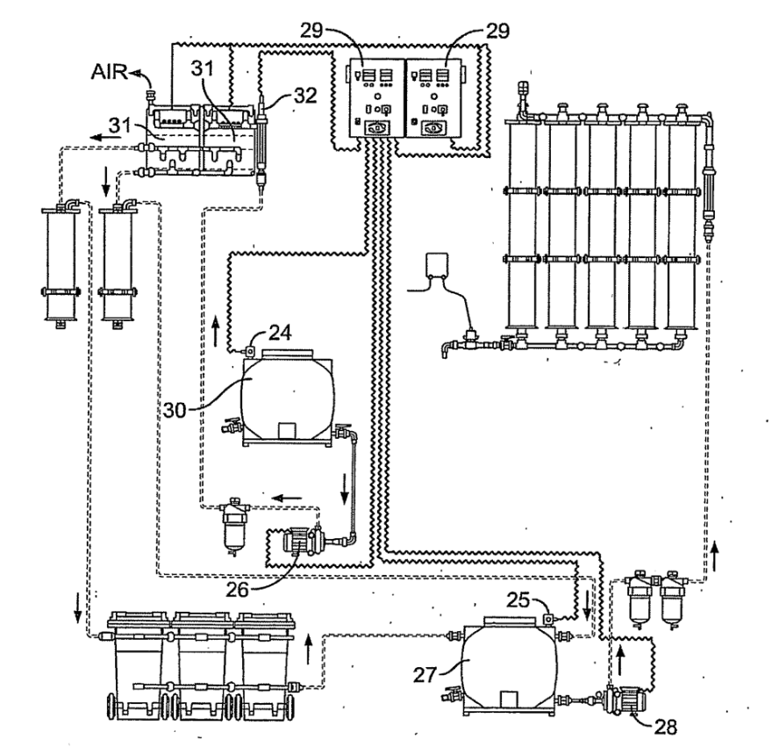
Fig. 14 A general scheme of one embodiment of a W2W system with automatically controllable power supplies.
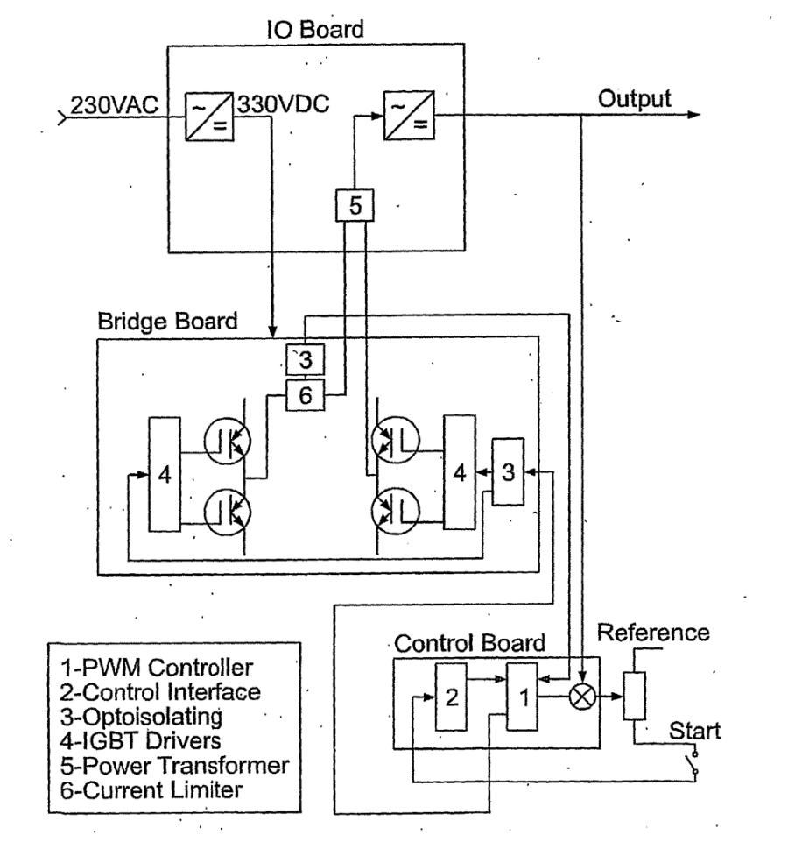
Fig. 15 A schematic diagram of the automatically controllable power supplies in Fig. 14.
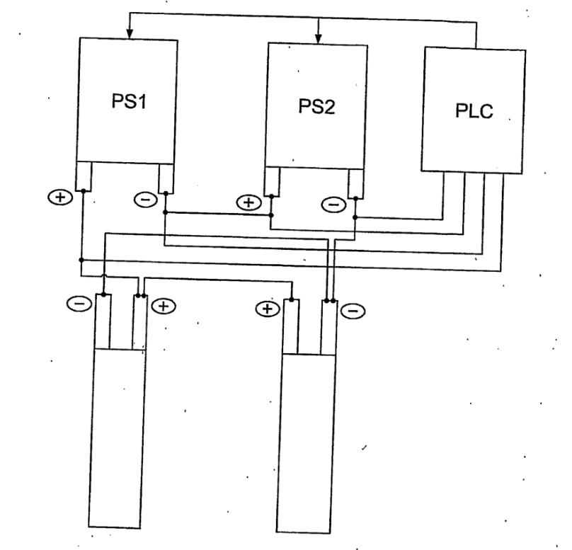
Fig. 16 A schematic diagram of power supplies connected in series and their connections to a PLC.
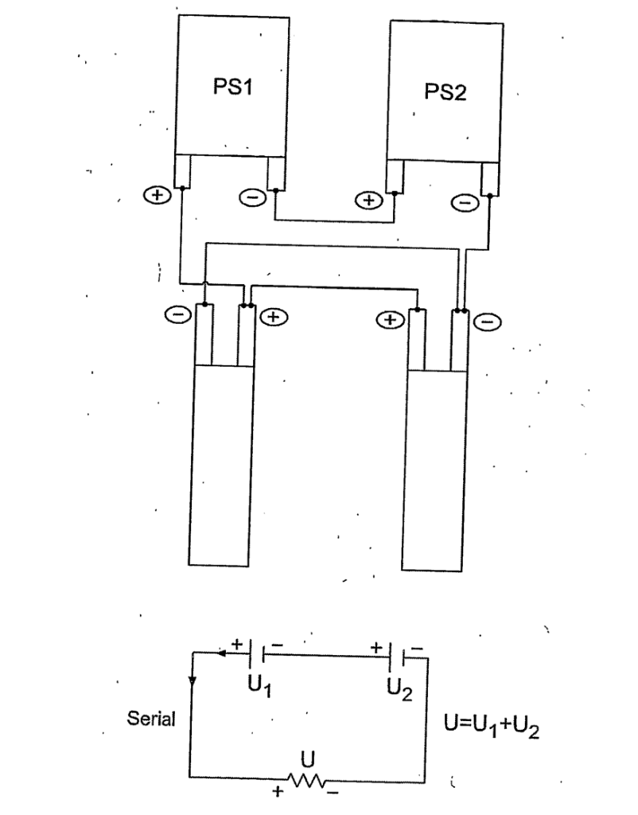
Fig. 17 Another schematic diagram of power supplies connected in series.

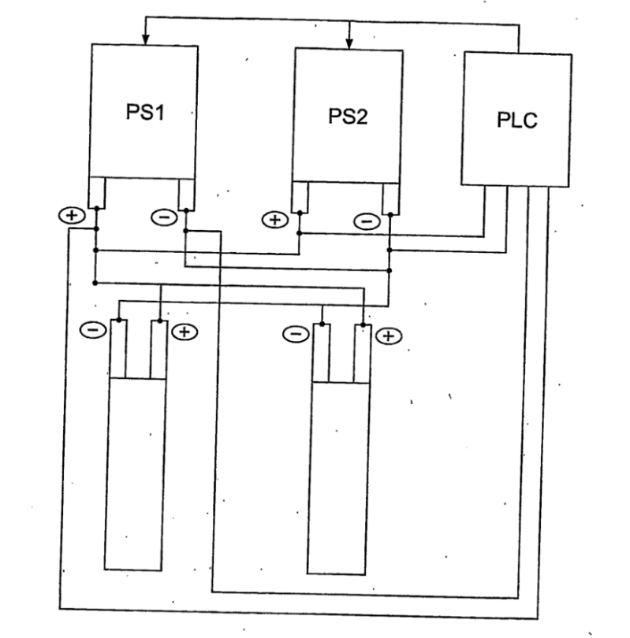
Fig. 18 is a schematic diagram of power supplies connected in parallel and
their connections to a PLC.

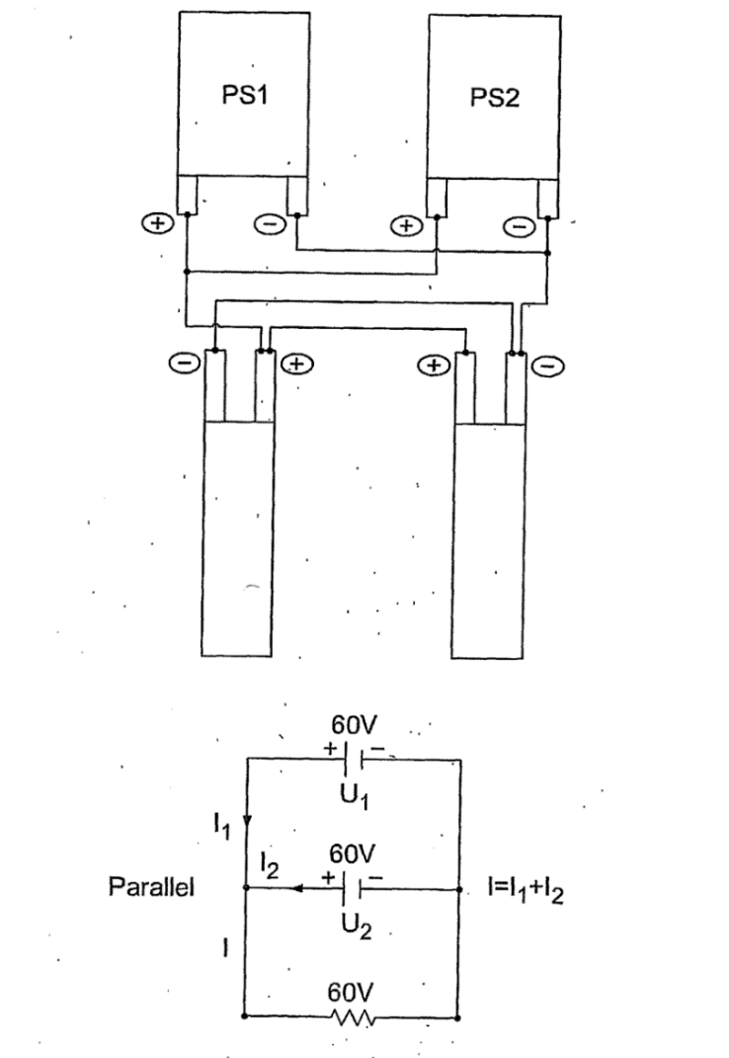
Fig. 19 Another schematic diagram of power supplies connected in parallel.

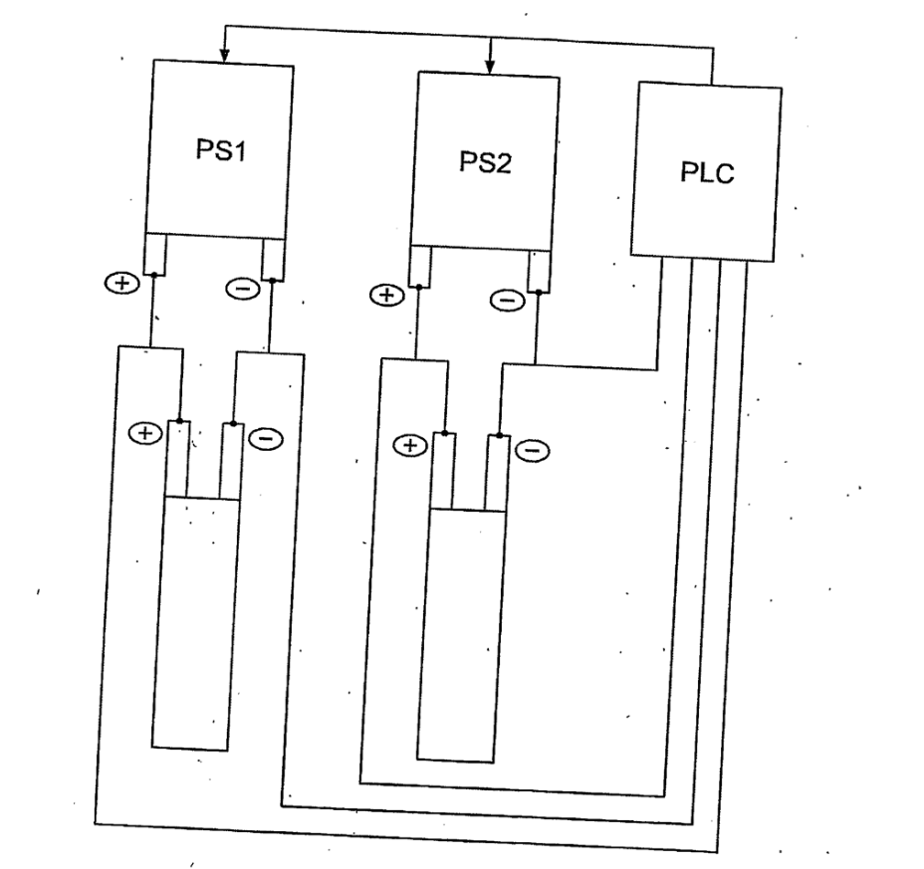
Fig. 20 A schematic diagram of power supplies connected in pseudo parallel and their connections to a PLC.

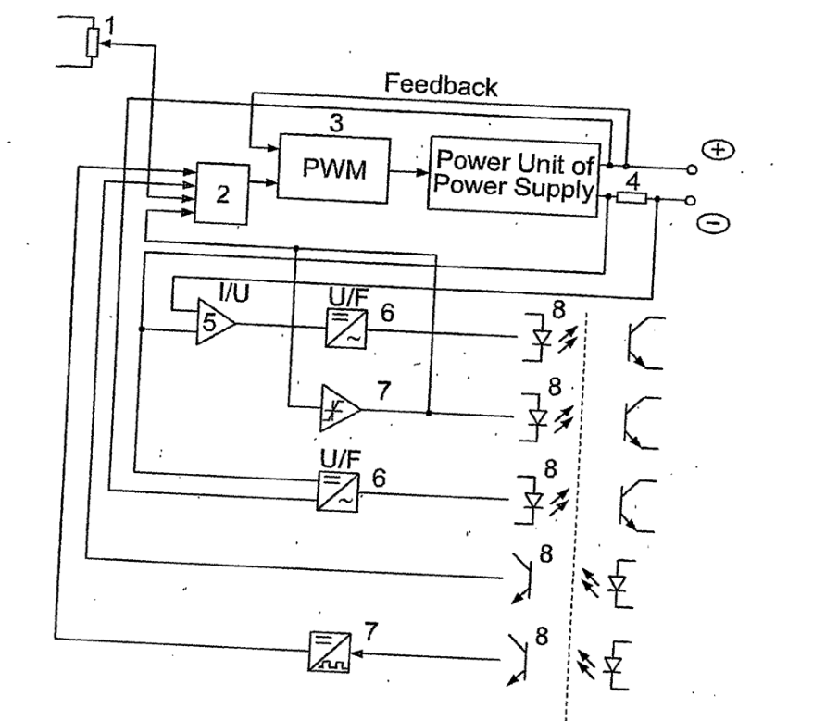
Fig. 21 A schematic diagram of a control board interface of the present invention.

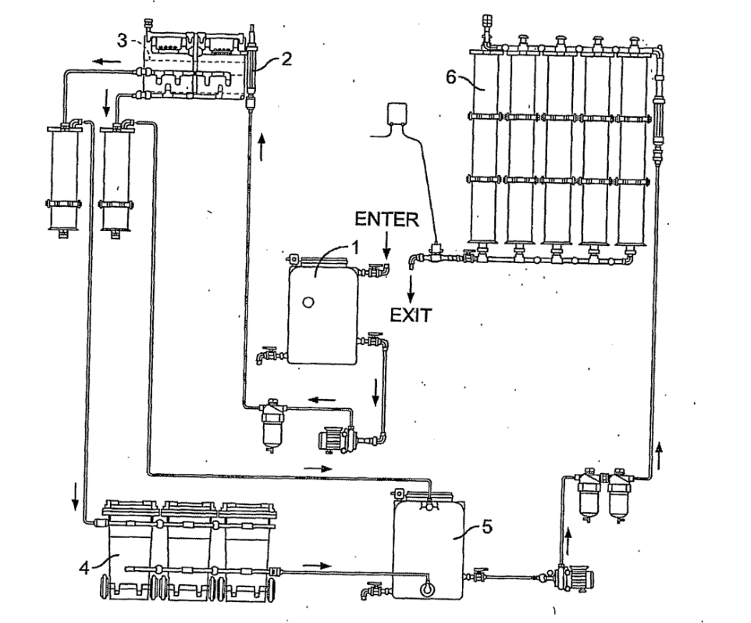
Fig. 22 A schematic diagram of a W2W system of the present invention.

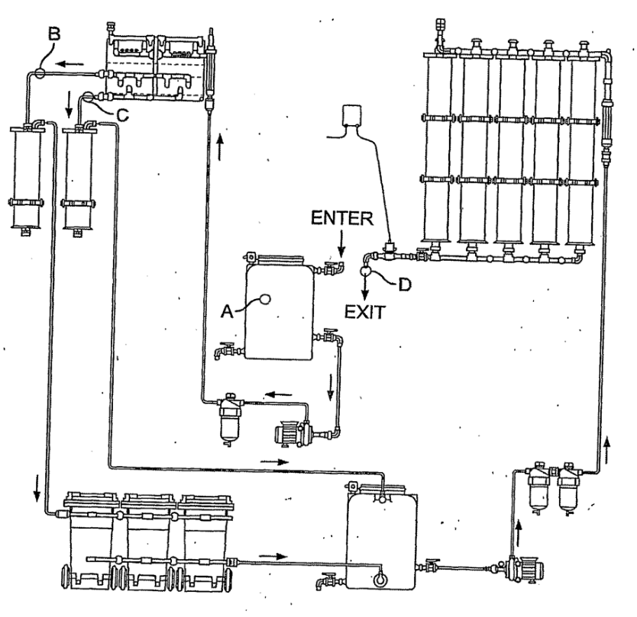
Fig. 23 A schematic diagram of a W2W system with a water sampling plan, in which A refers to a tapping point for inspection of water included in the W2W system, B refers to a tapping point for inspection of water coming out of the reactor (katholyte), C refers to a tapping point for inspection of water coming out of the reactor (anolyte), and D refers to a tapping point for inspection of water coming out of the W2W system.

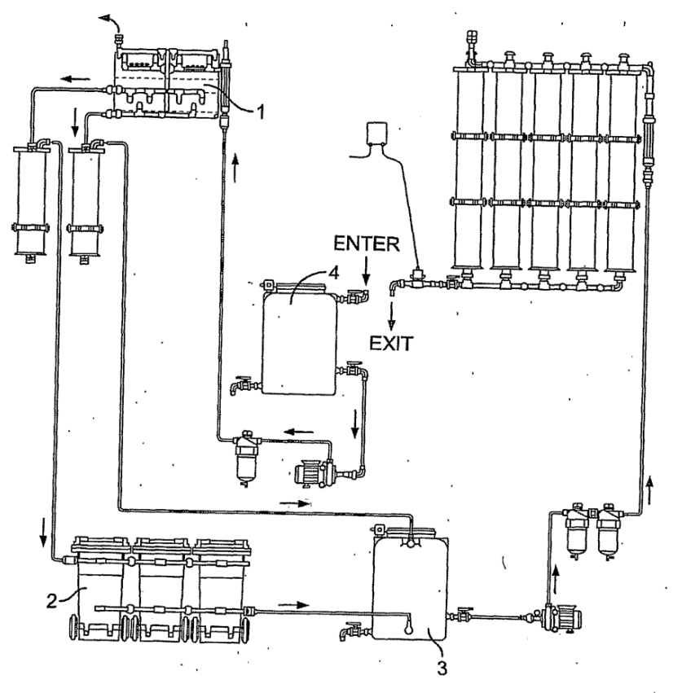
Fig. 24 is a schematic diagram of a W2W system with a water flow path indicated, in which 1 refers to an electrochemical reactor, 2 refers to sedimentation containers, 3 refers to a buffer tank, and 4 refers to a preliminary tank.

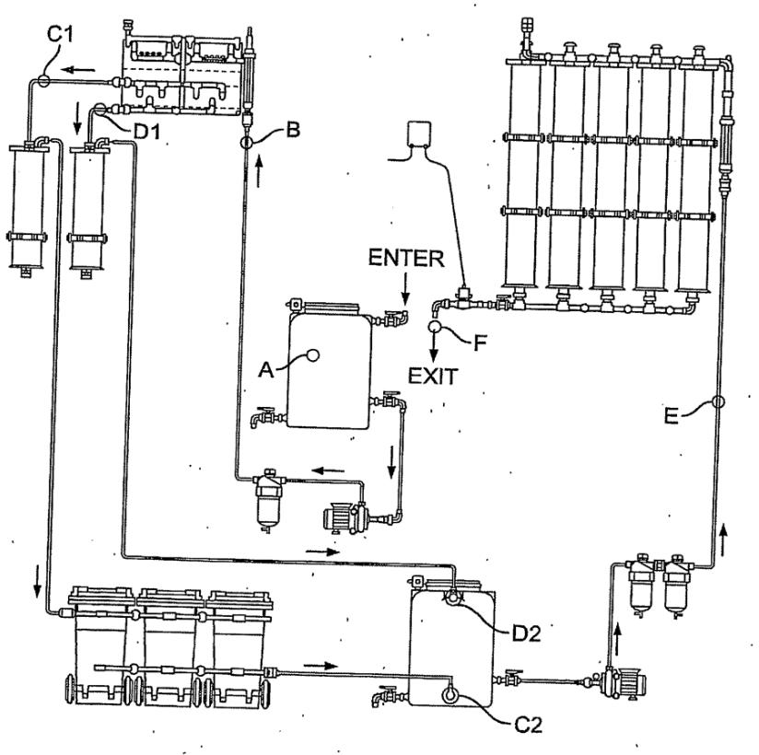

Fig. 25 is a schematic diagram of a W2W system with another water sampling plan, in which A refers to a tapping point for inspection of water included in the W2W system, B refers to a tapping point for inspection of water included in the reactor, Cl refers to a tapping point for inspection of water coming out of the reactor (katholyte), C2 refers to a tapping point for inspection of water coming out of the 3 filters in 50 micron and sedimentation containers, DI refers to a tapping point for inspection of water coming out of the reactor (anolyte), D2 refers to a tapping point for inspection of water coming out of the reactor (anolyte) on an input in intermediate container after filter in 50 micron, E refers to a tapping point for inspection of water flowing through the columns with ionic-exchange resin, and F refers to a tapping point for inspection of water coming out of the W2W system.

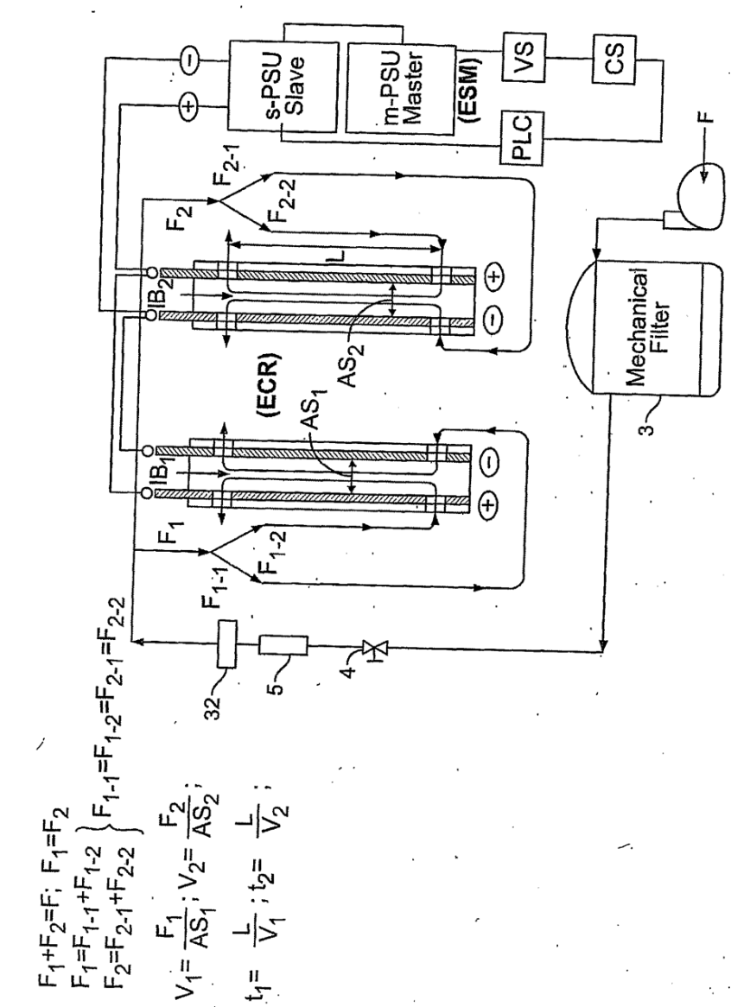
Fig. 26 is a schematic diagram of a W2W electrochemical reactor and its connections to power supplies and a mechanical filter, in which VS stands for voltage senor, and CS stands for current senor.
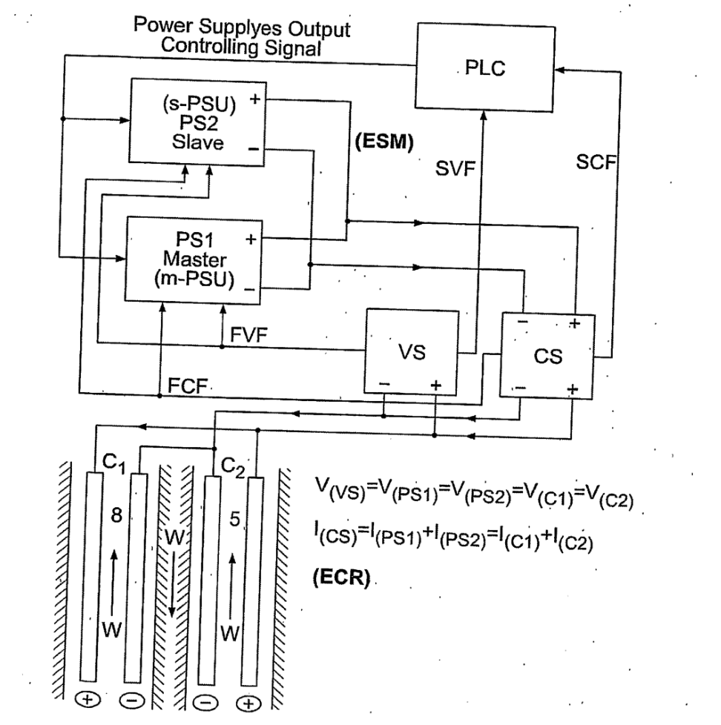
Fig. 27 is a schematic diagram showing power supplies connected in parallel and electrodes connected in parallel.

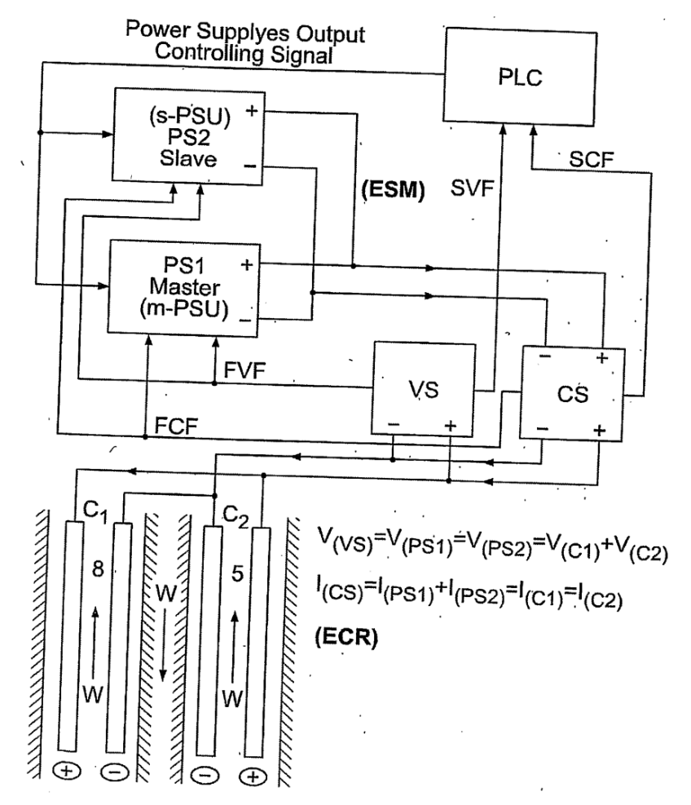
Fig. 28 is a schematic diagram showing power supplies connected in parallel and electrodes connected in series.

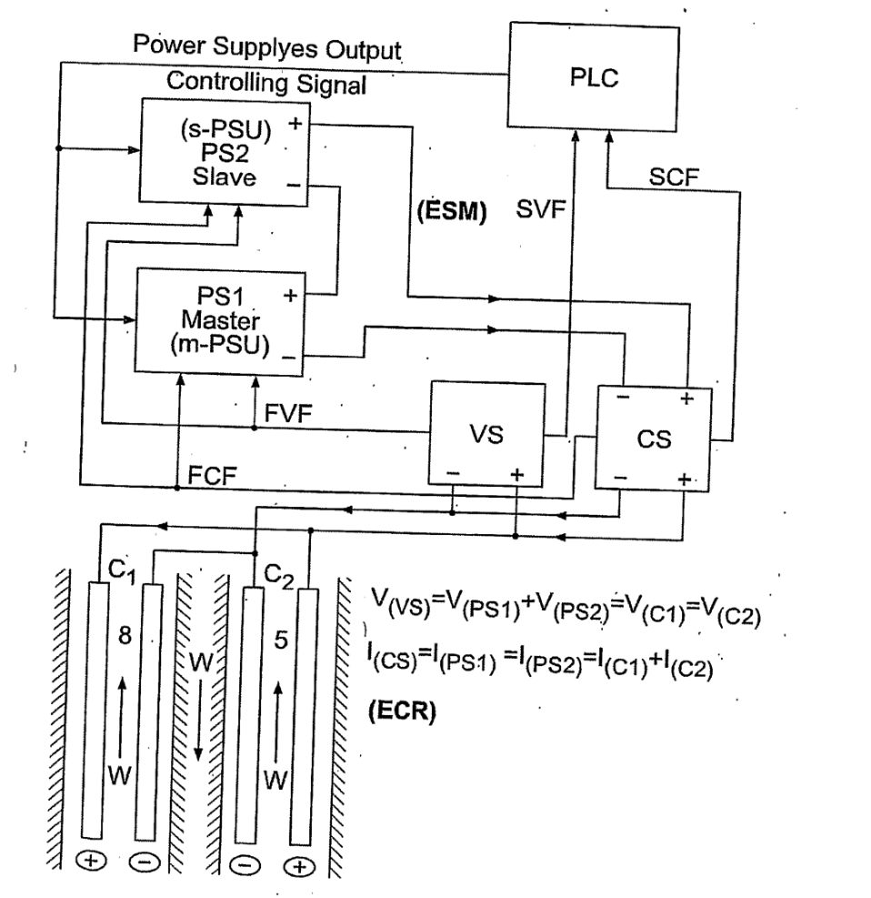
Fig. 29 is a schematic diagram showing power supplies connected in series and electrodes connected in parallel.

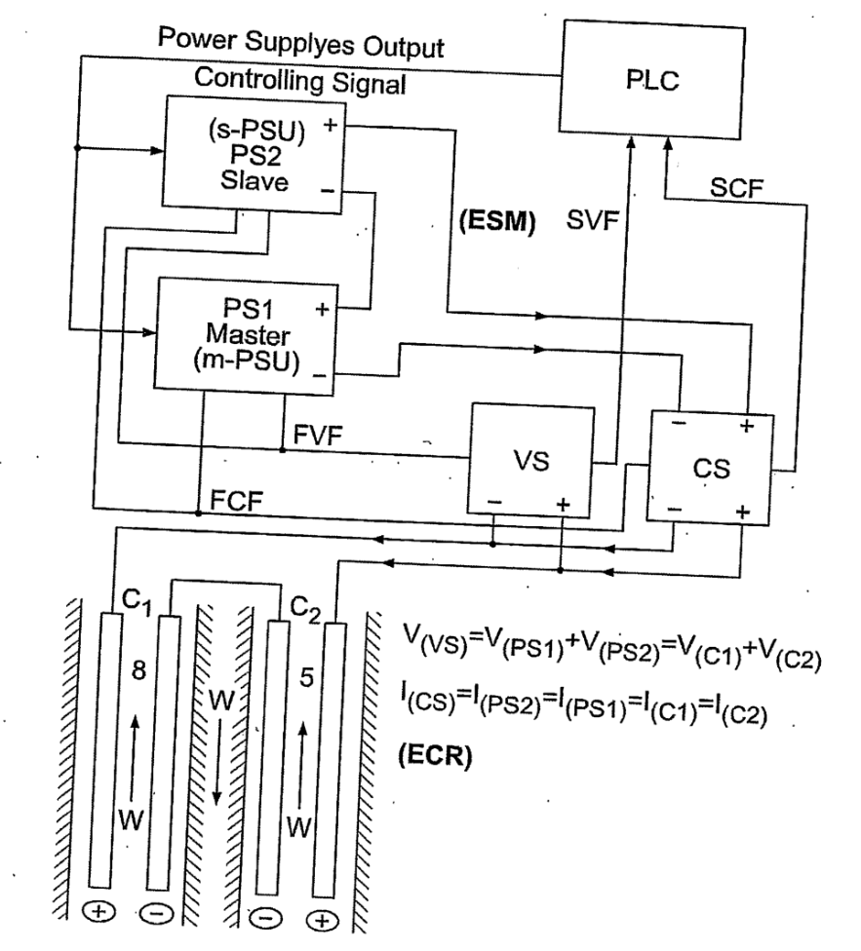
Fig. 30 is a schematic diagram showing power supplies connected in series and electrodes connected in series.
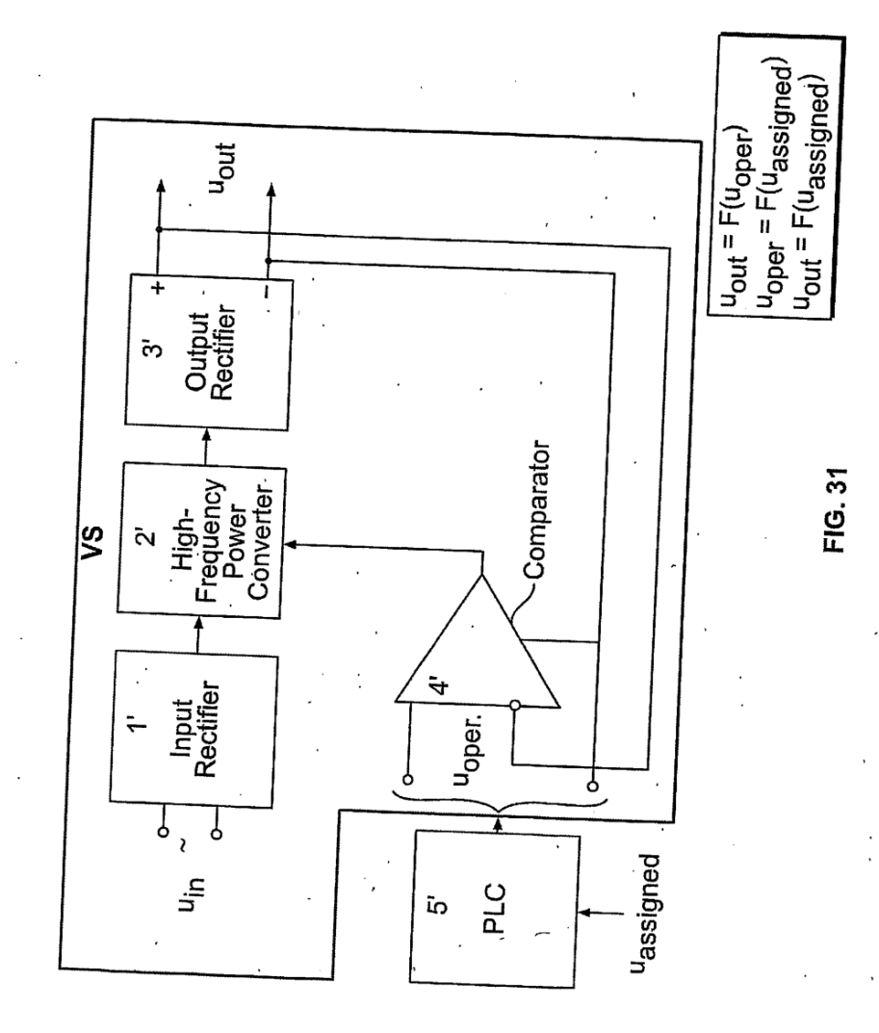
Fig. 31 is a schematic diagram of one embodiment of a voltage sensor/stabilizer and its connection to a PLC.
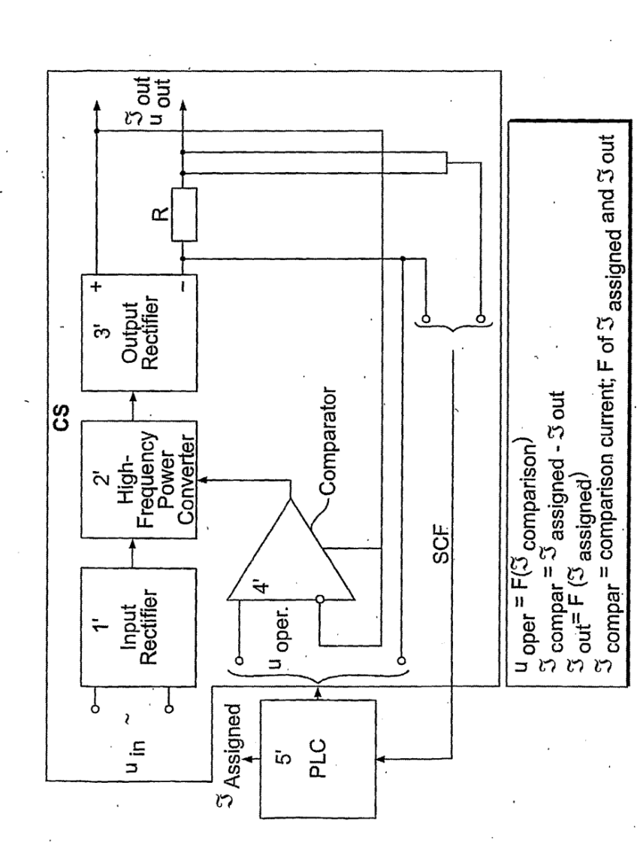
Fig. 32 is a schematic diagram of one embodiment of a current 20 sensor/stabilizer and its connection to a PLC.

Detailed description of the invention
The disclosure and description of the currently active Mey Rechavam PCT International Patent Application No. PCT/IL02/00911, filed Nov. 14, 2002, entitled: “WASTEWATER TREATMENT SYSTEM”, taking priority from U.S. Provisional Patent Application No. 60/387,585, filed June 12, 2002, is incorporated herein by reference. The cited Mey Rechavam PCT patent application illustratively describes in detail the design, construction, and implementation, of the electrochemical reactor, pre-treatment sub-systems, and post-treatment sub-systems, without any direct or indirect description of synchronous and/or synergistic design, construction, and/or operation, of the electrochemical reactor for providing stable and synchronous electrochemical process and hydrodynamic flow conditions.
The present disclosure and description of the Mey Rechavam (W2W™ ) invention, hereinafter, also equivalently referred to as the Mey Rechavam (W2W) invention, or as the Mey Rechavam (W2W) electrochemical reactor, or as the W2W system, or as the Mey Rechavam (W2W) water treatment/ purification/ regeneration system, is arranged and presented in four main parts. Part 1 is a general introduction and overall description of the W2W system.
Part 2 is an illustrative detailed description of the structure, function, and operation, of main and alternative embodiments, and components thereof, of the W2W system. Part 3 is a detailed description of exemplary “actual” practice and applications, and analysis of results obtained therefrom, of the W2W system. Part 4 is a detailed description of how the power control of the present invention synchronizes the power supply to a W2W electrochemical reactor.

Brief Product Description
Proprietary integrated, scalable, adaptive, and modular, systems and equipment, and technical support services thereof, for treating/ purifying/ regenerating commercial types and quantities of impure flowable water.
Based on separating and removing inorganic and/or organic impurities (e.g., metals, sulfates, phosphates, oils, and grease) from the impure water flowing through, and interacting with electrodes housed in, at least two electrode cells specially designed and constructed for providing stable and synchronous electrochemical process and hydrodynamic flow conditions. Efficient and cost effective design and operation of an energy supply mechanism including a 20 pair of synchronously connected and operative power supply units, for synchronously energizing the electrodes which oxidize and reduce components in the contacting flowing water. Generated oxidized/reduced water components complex impurities in the flowing water via mechanisms involving coagulation and precipitation, thereby forming impurity complexes removable, for example, by sedimentation, from the flowing water. Automated and computerized, including automatic process and feedback control equipment, procedures, and software.

Exemplary “Actual” Practice and Applications, and Analysis of Results Obtained Therefrom
The following is a detailed description of several exemplary “actual” practices and applications, and analysis of results obtained therefrom, of the Mey Rechavam (W2W) water treatment / purification / regeneration system.

Estimate of Operating Efficiency of The W2W Water Treatment/ Purification/ Regeneration System for an Input of Water Containing a Measured Amount of Various Metals
- Composition of the loaded water
In order to test out the capability of the W2W system, a special quantity of water was prepared in two, 200 liter portions, identical and to be tested in parallel. Each portion consisted of tap water only, plus an aqueous solution of the following metals:
- 200 ml of solution containing Cu (140.000 ppm).
- 200 ml of solution containing Ni (30.000 ppm).
- 200 ml of solution containing Mn (30.000 ppm).
- 200 ml of solution containing Zn (30.000 ppm).
- 200 ml of solution containing Cr (1.000 ppm).
In each of these portions the metal concentrations were as follows:
- Cu: 90 to 105 mg/1 (ppm).
- Ni: 25 mg/1 (ppm).
- Mn: 20 to 25 mg/1 (ppm).
- Zn: 25 to 35 mg/1 (ppm).
- Cr: 15 to 20 mg/1 (ppm).
2. Technical characteristics of the W2W system (serial no. 3-0015)
The general scheme of the W2W system used is shown in Fig. 22 As shown in Fig. 22, the W2W system includes the following main components: input tank 1, input water flow meter 2, the electrochemical reactor 3 including two electrode cells connected in parallel, sedimentation tanks 4, and reactor output intermediate storage/transfer tank 5.
2.1 The electrochemical reactor 3 contains 4 electrode cassettes (2 in each electrode cell). The anodes are made of aluminum, the cathodes of stainless steel. The cassettes are without a membrane.
2.2 The test portions included 3 portions of 80 liters each. The total quantity was 240 liter. The water in each portion was let in and withdrawn separately, that is, in parallel. At the input each portion was passed through woven filters of 50 micron mesh.
2.3 Reserved portion: 200 liters meters of water was preserved after sedimentation (catholite), as well as directly from the electrode cells (anolyte). The anolyte water was also filtered through a 50 micron mesh.
2.4 Power source. Two synchronized power sources were installed in the W2W system, each supplying a 50A current at 60V.
3. Point of water sampling
Sampling of the flowing water was performed according to the W2W system water sampling plan shown in Fig. 23. Sampling points, also referred to as tapping points, were selected so as to enable obtaining an estimate of efficiency of the electrochemical reaction, and, of the sedimentation and filtration processes.
4. Measuring Instrumentation
4.1 Metal content in the water was determined with a PF-11 photometer and the set of kits for metal assay manufactured by the firm of Visocolor:
- Cu test kit for copper determination, 0.1 - 3.0 mg/1 Cu²⁺.
- Ni test kit for nickel determination, 0.2-10 mg/1 Ni²⁺.
- Mn test kit for the colorimetric determination of manganese in the range of 0.1-4.0 mg/1 Mn.
- Zn test kit for zinc determination 0.25 to 3 mg/1 Zn²⁺.
- Cr test kit for chrome determination 0.1 to 2 mg/1 CrCO₄ ²⁺.
4.2 The conductivity was measured using a conductivity meter model CD-4301.
4.3 pH was measured using an AD 10 pH meter.
4.4 The energy dissipated in the cassettes was measured using an ammeter (Fc-80p) and a voltmeter (Dixsen DE-80).
4.5 The water throughput in the electrode cell of the electrochemical reactor was measured using a George Fischer SR20 flowmeter.
5. Test results
The test results are presented in Tables 1 and 2.
6. Analysis of the test results
Based on the test results reported in Tables 1 and 2, electrochemical reactor operation is analyzed (6.1), and the types of sediments on the 50 micron mesh filters, as well as on such filters from the anolyte in the reserve quantity, are listed.
6.1 Electrochemical Reactor Operation
Effectiveness of water purification from metals is shown in Table 1. To estimate the effectiveness, mean values were calculated from the data obtained in the two tests (Tables 1 and 2), according to the analysis of water entering into and exiting out of the electrode cells (separately for the catholite and anolyte).

Table 1. Effectiveness of water purification from metals
Metal | Cu | Ni | Mn | Zn | Cr
Purification effectiveness on input  line – anolyte, % | 80 | 96 | 80 | 61 | 42
Purification effectiveness on input  line – catholite, % | 87 | 95 | 96 | 73 | 35

The effective operation of the electrode cells of the electrochemical reactor is due to the low flow velocity, 0.06 m/s, of the water flowing through the electrode cassettes, and to the markedly long transit time, 5 sec, of the water flowing between the electrodes. At such flow velocity, the Reynolds number, Re, previously defined by equations (1) and (2) and described above, is less than 500, and the flowing water is consequently laminar. Laminarity is conducive to thorough breakdown of the entering water.
Chemical reactions taking place in aqueous solutions next to electrodes may be considered as redox reactions. Electrolysis thus consists of a reduction reaction at the cathode and an oxidation at the anode. A metallic anode may be a non­dissolving and only acting as an electron transfer site during electrolysis, or dissolving (active) whereby it is oxidized upon electrolysis. The redox activity of the electric current in many cases reinforces chemical oxidation and reduction reactions. Examination of the tables of standard electrode metals shows the following:
- Metal cations, for example, Cu⁺², Hg⁺², Ag⁺, Pt⁺², . . . ., and Pt⁺⁴, having a standard electrode potential greater than that of hydrogen, during electrolysis are completely dissolved either at and/or by the anode, and are deposited in metal form onto the cathode.
- b. Metal cations, for example, Li⁺, Na⁺, K⁺..., . . ., and Ni⁺², down to Al⁺³, having a standard electrode potential less than that of hydrogen, during electrolysis, remain attached to the anode without dispersing among the water molecules.
- c. Metal cations, for example, Mn⁺², Zn⁺², Cr⁺³, and Fe⁺², having a standard electrode potential less than that of hydrogen, and greater than that of aluminum, during electrolysis, deposit onto the cathode, and become dispersed among the water molecules.
For a metal cation total concentration of larger than 200 mg/l (200 ppm), then the ionic concentration is relatively high. As a result of this, there is a type of inter­ ion secondary affect, whereby each ion influences to a varying degree or extent, the measurement, via the spectrophotometer, of the total ionic concentration of the flowing water. With regard to strong ionic solutions, the above analysis results may be somewhat affected by ion attachment to other metals. According to the test results obtained herein, there is a general tendency towards consistent behavior, but the quantitative relationships may vary.
6.2 The effectiveness of sedimentation (as shown by the filters) is supported by the results of the water analysis after passing through the electrochemical reactor (catholite) and at the entry. The results are presented in Table 2.

Table 2. The results
Metal | Cu | Ni | Mn | Zn | Cr
Effective separation in the catholyte line – sedimentation % | 64 | 30 | 50 | 86 | 72

It follows from the experimental results that the hydrodynamic efficiency (sedimentation rate of metal hydroxy compounds) differs. Hydroxy compounds of zinc, chromium and copper coagulate and precipitate sufficiently well, but those of nickel and manganese do not. Presence of nickel and manganese hydroxy compounds in polluted water may therefore reduce the effectiveness of operation of the electrochemical reactor, their sedimentation may take longer, a larger volume needs to be processed, or, the throughput will be slower.
6.3. The effectiveness of capture of metal ions and their hydroxy compounds on a 50-micron mesh filter at the anolyte entry is shown in Table 3.

Table 3. The effectiveness of capture of metal ions
Metal | Cu | Ni | Mn | Zn | Cr
Effectiveness along the anolyte line – reserve % | 67 | 29 | 25 | 98 | 0

The results shown in Table 3 show good retention capability relative to the coagulated sediments of zinc and copper hydroxy compounds, moderate ability in retaining nickel and manganese hydroxy compounds, and complete non-suitability of that filter for the retention of chromium hydroxy coagulation species.
Overall, the experimental test of water treatment/purification capability using water loaded with various metal complexes showed effective operation of the W2W system, with regard to sedimentation capacity, filtering, and electrochemical reactor operation. Total water treatment/purification effectiveness is represented in Table 4, along with reference made to Fig. 20.

Table 4. Total water treatment/purification effectiveness
Metal | Cu | Ni | Mn | Zn | Cr
Anolyte, % removed via sedimentation | 95 | 98 | 85 | 99 | 50
Catholite, % removed via sedimentation | 96 | 97 | 98 | 97 | 82,5

As shown by the above results, the W2W system is very effective for treating/ purifying water loaded with metal complexes. In the case of chromium, the effectiveness is reduced by 50 % because the mesh filter used does not effectively retain chromium hydroxy coagulation products. For all other metals, the effectiveness is at least 85 % (somewhat low for manganese), and about 95 % for all other metals (copper, nickel, and zinc).

Test of the Effectiveness of Operation of the W2W Electrochemical Reactor and System
The effectiveness of operation of the electrochemical reactor was estimated on a W2W series-production system under normal conditions at the Mei Rechavam works. The loaded water for the test was local tap water, to which CuSO4was added in a quantity to make the concentration of copper at the input to the electrochemical reactor about 50 to 100 mg/1 (ppm). The main tasks of this test were the following:
- Estimation of the influence of electrochemical reactor throughput on the effectiveness of reducing metal ion concentration.
- Estimation of the influence of electrode material on the effectiveness of reducing metal ion concentration.
- Estimation of the influence of membrane inserts in the cassettes on the effectiveness of lowering metal ion concentration.
In addition, it was necessary to estimate the expediency of using two synchronized power sources, connected either in parallel or in series. Water samples were taken from the input as well as from the output of the electrochemical reactor (from the anolyte as well as from the catolyte line). The measuring instrumentation used was already described hereinabove. The tests were conducted with two types of power sources: 50A/60V, and 30A/100V. The test results are presented in Tables 1-3 Analysis of the test results shows the following:
1. In all cases, less copper collected on the anode than on the cathode (also after filtration). This indicates that copper in the output water was present as CuSO₄. Water flowing over the electrodes led to dissociation of CuSQ₄
into the ions Cu²⁺ and SO₄⁻. Copper ions drifted (in the absence of a membrane) to the cathode, where they either formed hydroxy compounds, such as Cu (OH)₂, which is insoluble and precipitates, settling in the sedimentation tanks and on the filters, or settled in as pure copper on the cathode surface. Due to the drift of Cu²⁺ ions from the anode towards the cathode, the anolyte contained fewer copper ions and hydroxy compounds.
2. When the current was stepped up, increasing across the electrodes from 55A up to 96A, the effectiveness of concentration reduction also increased. For example, for an anode and cathode used for testing each made material, for example, solid aluminum, the percentage was 44.6 % in the anolyte, and 25 % in the catolyte 25 %.
3. The effectiveness of concentration reduction also depends on the electrode material. According to the effectiveness obtained, desirable electrodes are graded in the following order: Al - Al (aluminum,) Ti - Ti (titanium), and SS - SS (stainless steel). It is apparent that the anode material has the largest effect.
It is interesting to make the comparison between and analyze the experimental results. Medium effectiveness for reducing the concentration of copper, both in the anolyte and in the catolyte, was obtained without having a membrane in each electrode cassette, amounting to 56 % and 20 %, respectively. With a membrane, the results were 29 % and 9 %, respectively. For operating the electrochemical reactor having the electrode cassette with a membrane, the energy demand or consumption is estimated from the input power to have been at least twice as large compared to using the electrode cassette without a membrane. Thus, the results conclusively show higher effectiveness for reducing Cu ion concentration and lower energy demand or consumption for operating the configuration of the electrochemical reactor having the electrode cassette without a membrane, compared to operating the alternative configuration of the electrochemical reactor having the electrode cassette with a membrane.
In all cases considered above, two synchronized power sources were used, connected in parallel or in series. The use of two synchronized power sources can lead to results equivalent to those obtainable with a single power source but, with two power sources, the power required is halved. Thus, for example, using a current of 96A supplied to four electrode cassettes, which is more effective for lowering the concentration of copper, requires a voltage of 26V, for the case of two synchronized power sources connected in parallel.
The power input was 2.496 kW. Effectiveness of Cu concentration reduction in the anolyte was 94 %, and 35 % in the catolyte. Each of the two power supply sources (PSI and PS2, Figs. 16-19) was supplied at 48A and at 26V. If a single water source would be used for obtaining the same current, that is, for the same water conductivity, then to get a current of 96A requires increasing the voltage from 26V to 52V, thus multiplying the source output power by a factor of 2, in order to reach the a power of 4.99 kw.
Based on operation of the W2W system, along with the aforesaid results and analysis, the following conclusion is arrived at: to obtain the most effective current through the electrode cassettes, in our case 96A, it is most expedient to use two synchronized power sources. This reduces required power output by a factor of 2 for the same effectiveness of operation of the electrode cells in the electrochemical reactor.

Use of the W2W Water Treatment/Purification/Regeneration System for Reducing Water Hardness
The problem of reducing the hardness of water supplied to steam boilers and the like is of great importance in commercial applications. A test was conducted at Mey Rechavam Ltd. works to examine the possibility and effectiveness of using the W2W system, without additional resinous ion-exchange columns, for the reduction of water hardness. The experiments were conducted using the W2W system, schematically illustrated in Fig. 24, having various sedimentation capacities, for example, 360 and 420 liters, as supplied by a preliminary tank 2. As stated, in this test case, the columns were not charged with ion-exchange resin. The raw water used was ordinary tap water from the mains of the southern town of Sderot, Israel. The pair of oppositely charged electrodes were constructed of two different types of material: stainless steel (SS), and aluminum (Al), respectively. The water was tested using the following means:
- Total hardness - test kit for determination of total hardness, model H70F, made by Visocolor.
- Water conductivity - using a CD-4301 conductivity meter.
- pH - using an AD-100 pH meter.
- Water throughput in the W2W system - using a Georg Fischer SK2 flowmeter.
The load on the electrode cassettes was measured using an FS-80 ammeter and a Dixsen DE-80 voltmeter, mounted on electronic racks. Electrical energy was supplied by two synchronized power sources connected in parallel, providing 50A and 60V.
Sampling of the flowing water, at various tapping points, was performed according to the W2W system water sampling plan shown in Fig. 25 Test results obtained using the W2W system are presented in Tables 1 and2. Analysis of theresults listed in Tables 1 and 2, shows the following:
- For all test regimes, the total hardness value of the water at the system output was 13 to 14 °d (degrees of hardness, German scale).
- The test results lead to the conclusion that the final result is not materially affected by the water throughput (1000, 2000, or 3000, liters / min), nor by the type of electrode material, Al or SS, nor by the capacity, 360 and 420 liters, of the sedimentation tank.
Physical and chemical examination of the obtained results show highly effective operation of the electrochemical reactor and sedimentation tank. In effect, a test of the input water by boiling and filtering showed that total water hardness was 12.5 to 13 °d (degrees of hardness, German scale). It is known from theory that total ardness is made up of a constant hardness plus a time-dependent hardness, and that in boiled and filtered water, only the constant hardness remains. Consequently, processing of water using a W2W system should lower the time-dependent hardness.
The hardness of the output water had a very acceptable value of 0.5 to 1.5 °d. It is known that time-dependent hardness is a component of the total hardness, and constitutes a major risk factor in technology. This is due to the fact that time dependent hardness is due to the presence of potassium and magnesium carbonates in water (CaCO₃ and MgCO₃). Upon heating of water these carbonates settle on internal surfaces of heating vessels, causing rapid deterioration of conditions for heat exchange, and consequently of the working order of heat-exchange facilities and equipment.
On the strength of the obtained results it may be stated that the calcium and magnesium carbonates, CaCO₃ and MgCO₃, are effectively dissociated, in the electrode cells of the electrochemical reactor, into the corresponding ions Ca²⁺, Mg²⁺and CO₃²⁻. In view of the presence in the water flowing between the electrodes, of the basic ion (OH)⁻ and of the acidic ion H⁺, these ions are expected to associate with the ions Ca²⁺ and Mg²⁺, to produce the corresponding insoluble calcium and magnesium hydroxide salts, Ca(OH)₂ and Mg(OH)₂, respectively. These hydroxide salts were indeed deposited in the sedimentation tank and in the collection tank of the W2W system. In this way, use of the W2W system, without ion-exchange resin, appears to provide a highly effective means for reducing time-dependent hardness of water supplies.

Detailed Description of How the Power Control of the Present Invention Synchronizes the Power Supply to a W2W Electrochemical Reactor
The overall, general fundamental “patentable” concept and principle of the present invention is that the electrochemical reactor (electrode cells and electrodes therein, and housing thereof), along with its energy supply mechanism (interconnected power supply units and programmable logic controller), are implemented for treating flowing water according to stable and integrated synchronized operation of electrochemical, electrocoagulation, and hydrodynamic, mechanisms.
A primary overall objective of the stable and integrated synchronized operation is to maximize use, and therefore, efficiency, of the energy generated by 20 the energy supply mechanism and supplied to the electrochemical reactor, in particular, the electrode cells and electrodes therein, for treating the flowing water.

Synchronized Operation of the Electrochemical Reactor (ECR) and the Energy Source Mechanism (ESM)
The electrochemical reactor (ECR), functioning as the physical location of treating the flowing water, includes at least two, preferably, several, identically structured and operable electrode cells, wherein each electrode cell includes two electrodes - a cathode and an anode. The energy source mechanism (ESM), functioning as the source of energy for operating the electrochemical reactor (ECR) of the water treatment system, includes at least two, preferably, several, identically operable power supply units (PSUs), and a programmable logic controller (PLC). The power supply units (PSUs) are appropriately interconnected to each other, to the programmable logic controller (PLC), and to the electrochemical reactor (ECR), according to various alternative configurations such that there is complete synchronization of the output parameters (voltage, current) generated by the power supply units (PSUs) and supplied to the electrochemical reactor (ECR).
During implementation of the water treatment system, the electrochemical, electrocoagulation, and hydrodynamic, mechanisms taking place inside the electrochemical reactor (ECR), and the energy source mechanism (ESM) generating energy which is supplied to the electrochemical reactor (ECR), operate in a synchronized manner. Synchronized operation takes place in the time domain, from one water treating cycle to the next water treating cycle, during a period of operation lasting for a given amount of time or number of water treating cycles, where a water treating cycle corresponds to a single cycle of treating or processing a single electrochemical reactor volume of incoming flowing water by the electrochemical reactor (ECR).
During synchronized operation of the energy supply mechanism (ESM), a single power supply unit (PSU) is designated the “master” power supply unit, herein, referred to as (m-PSU), operates on and is synchronized with the other “slave” power supply unit or units, herein, referred to as (s-PSU or s-PSUs, respectively). This master-slave type of synchronized operation of the power supply units (PSUs) is automatically controlled by the programmable logic controller (PLC) sending feedback signals to the master power supply unit (m-PSU). The feedback signals are20 based on data and information continuously (typically, on the order of every 0.1 second) being sent to the programmable logic controller (PLC) by a plurality of strategically located sensors sensing various electrochemical, hydrodynamic, and electrical, parameters of the water flowing through the electrochemical reactor (ECR), and of the energy (voltage, current) generated by the power supply units (PSUs) and supplied to the electrochemical reactor (ECR).
During the process of treating the flowing water, particularly as part of an automatic production line or more encompassing manufacturing process, synchronized operation of the electrochemical reactor (ECR) and of the energy source mechanism (ESM) is according to either a “steady-state” mode of synchronization, or, according to a “non-steady-state” or “transient” mode of synchronization. In the “steady-state” mode of synchronization, the operating range of values of the output parameters (voltage, current) of the interconnected power supply units (PSUs) remains constant, typically, to within about (+ / -) 1 %, from one water treating cycle to another water treating cycle, during a steady-state period of operation lasting for a given amount of time or number of water treating cycles during which the master power supply unit (m-PSU) operates on and is synchronized with the other “slave” power supply unit or units in a constant or steady manner. In the “non-steady-state” or “transient” mode of synchronization, the operating range of values of the output parameters (voltage, current) of the interconnected power supply units (PSUs) varies, typically, by about (+ / -) 7 - 10 % of the steady-state range, during a transient period of operation lasting for a relatively short amount of time, typically, on the order of less than one second, during which the master power supply unit (m-PSU) operates on and is synchronized with the other “slave” power supply unit or units in a non-steady-state or transient manner, until there is quick return to a steady-state mode of synchronization.
Ordinarily, for example, for at least about 90 % of total operating time, the electrochemical reactor (ECR) and the energy source mechanism (ESM) operate in the steady-state, rather than a non-steady-state or transient, mode of synchronization.
At various instantaneous times during the remaining part of the total operating time, either controllable or uncontrollable, situations or instances occur where there is a spontaneous or instantaneous transition from a steady-state to a non-steady-state or transient mode of synchronized operation. An example of this phenomenon is the situation when the water flowing into the electrochemical reactor (ECR) suddenly stops flowing for a relatively short, but finite, period of time. Additional examples ofthis phenomenon are situations when one or more parameters (conductivity, linear velocity, volumetric flow rate, chemical concentrations, temperature, and gradients thereof) of the water flowing through and treated inside the electrochemical reactor (ECR) suddenly “spikes” in the form of either an increase or decrease. Accordingly, the electrochemical reactor (ECR) and the energy source mechanism (ESM) are designed and operated with the objective of being rapidly adaptable to constant as well as variable operating conditions, whereby a spontaneous or instantaneous transition from a steady-state mode to a non-steady-state or transient mode, and return to a steady-state mode, of synchronized operation, occurs within lessthan 1 second.
The steady-state mode of synchronized operation of the power supply units (PSUs) of the energy supply mechanism (ESM), as well as that of the electrochemical reactor (ECR), is based on a dynamic symmetry of the structure, function, and operation, of the electrochemical reactor (ECR). Following below are the main parameters defining the properties, characteristics, and behavior, of this dynamic symmetry:
- Structural and functional equivalence, uniformity, and symmetry, of all components and elements of the electrochemical reactor (ECR), in particular, the electrode cells and the electrodes therein, and the water flow channels inside and outside of the electrode cells. In particular, wherein a given configuration and structure of the electrochemical reactor (ECR), each electrode cell is identically structured and configured. More specifically, regarding the electrodes, such that the (i) geometrical shape or form and dimensions, (ii) material or materials of construction, and (iii) physicochemical properties, characteristics, and behavior, of the anode of a first anode-cathode electrode pair are as identical as practically possible to those of the anode of each other anode-cathode pair in the same electrode cell, for each and all the electrode cells in the same electrochemical reactor (ECR). The same applies to the cathode of each anode-cathode pair in the same electrochemical reactor (ECR). It is noted that above characteristics (i), (ii), and (iii), of a given cathode may, but need not, be identical to those of the anode of the anode-cathode pair. For typical implementation of the present invention, the above characteristics (i), (ii), and (iii), of a given cathode are different than those of the anode of the anode-cathode pair.
- Equivalent, uniform, and symmetrical, static and dynamic operation of all components and elements of the electrochemical reactor (ECR), in particular, the electrode cells and the electrodes therein, and the water flow channels inside and outside of the electrode cells.
- Equivalent, uniform, and symmetrical, operation of electrochemical, electrocoagulation, and hydrodynamic, mechanisms taking place in the electrochemical reactor (ECR). Specifically, as relating to electrical charges on and along the electrode surfaces, and as relating to the parameters (conductivity, linear velocity, volumetric flow rate, chemical concentrations, temperature, and gradients thereof) of the flowing water and components therein, throughout the water flow channels inside and outside of the electrode cells, inside the electrochemical reactor (ECR).
- Equivalent, uniform, and symmetrical, calibration of all components and elements of the electrochemical reactor (ECR), in particular, the electrode cells and the electrodes therein, and the water flow channels inside and outside of the electrode cells.
- A set of parameters of the dynamic symmetry relating to various possible non-steady-state or transient modes of operation of the electrochemical, electrocoagulation, and hydrodynamic, mechanisms, taking place inside the electrochemical reactor (ECR), that is, such states which do not have a predetermined or known energy requirement, and the extents of which are determined by a variable range of values of the parameters (conductivity, linear velocity, volumetric flow rate, chemical concentrations, temperature, and gradients thereof) of the water flowing through and treated inside the electrochemical reactor (ECR).

Hydrodynamic Synchronization
Figs. 2' and 3' are slight revisions of Figs. 2 and 3, respectively.
During operation of the electrochemical reactor (ECR), establishing and maintaining hydrodynamic synchronization are for achieving the following:
- Uniformity and steady-state control of each of the various input and output flows of the water through the electrochemical reactor (ECR), during each water treating cycle.
- Uniformity and steady-state control of the minimum level of energy consumption by the electrochemical reactor (ECR) of the various input and output flows of the water through the electrochemical reactor (ECR), during each water treating cycle.
- Uniformity and steady-state control of the maximum level of energy consumption by the electrochemical reactor (ECR) of the various input and output flows of the water through the electrochemical reactor (ECR), during each water treating cycle. Immediately following are listed the main characteristics, features, conditions, and operating parameters, of hydrodynamic synchronization of the water flowing through and treated inside the electrochemical reactor (ECR).
- Several parallel continuously vertically ascending flows of water solution, identical with respect to all geometrical parameters and dimensions.
- Each flow is vertically directed and limited by functionally active surfaces of the electrodes. Preferably, the electrodes are configured as rectangular, relatively flat, and parallel to each other, but may also be configured as cylindrical and coaxial with each other.
- Two electrodes in any electrode cell are entirely identical with respect to all geometrical parameters and dimensions, and their functionally active surfaces are like minor images of each other.
- The electrodes are permeable to the flow of water solution at the entrance into and exit from the inter-electrode space.
- The nature of interaction of the various water input and output flows with the functionally active surfaces of the electrodes, including local hydraulic resistance, is identical for all homologous points in all the flows.
- In each electrode cell, two flows of the water solution, separated by a mobile inter-boundary layer (IB1 and IB2), pass in the space between the two electrodes, as shown in Fig. 26.
- Thickness of the mobile inter-boundary layer (IB1 and IB2) depends on the physicochemical properties, characteristics, and behavior, of the flowing water. In particular, viscosity; temperature; acidity or alkalinity level; presence of inorganic, organic, and/or biological, chemicals and/or chemical complexes (such as metal complexes); presence of chromium types of organo-metallic compounds (which are usually especially difficult to treat); hardness; and electrical conductivity. The thickness also depends on the physicochemical properties, characteristics, behavior, and quality, and, geometry, of the functionally active surface of electrodes.
Other (hydrodynamic) conditions and parameters of the flowing water and the physical basis of these parameters follow hereinbelow.
1. Linear velocity, V, of the vertically ascending water flowing in between the inter-electrode space, in units of mm/sec:
V₁ = V₂ = [ F, volumetric flow rate (ml/sec) ] / [ AS_{i} (mm²) ], where AS_{i} is the area of the inter-electrode space cross-section, as shown in Fig. 26.
2. Duration, t, of the water treating cycle, in units of sec:
t = L₁ / V₁ = L₂ / V₂, where L is the length of the functionally active surface of a given electrode, as shown in Fig. 26
3. Difference in height, AH, between the supply or input channels and the permeable zone of the electrodes in the area of exit (discharge):
H - ∆H = h, and H + ∆H = H, as shown in Figs. 2' and 3'.
4. Degree of filling the volume of all the channels from the entrance to the exit of the inter-electrode space. Based on the use of internal pressure, denoted P. For a purely hydrodynamic synchronization, within a single electrochemical reactor (ECR),
wherein the reactor includes two (2) electrode pairs, and four (4) parallel flows of water. Then, at any instant of time, and at any homologous point, the following conditions are observed (Fig. 26):
V₁ =V₂ = V₃ = V₄ (for all four flows, at any point of the flow),
T₁ = t₂ = t₃ = t₄ (for all four flows, at any point of the flow, from the point of entry into the inter-electrode space),
∆H₁ = ∆H₂ = ∆H₃ = ∆H₄ (for all four flows), and
P₁ = P₂ = P₃ = P₄ (for any identical point within the volume of any of
the four flows).
5. All the flows are hydrodynamically synchronized. Hydrodynamic synchronization is achieved by an appropriate design of the casing or housing of the electrochemical reactor (ECR). As shown in Figs. 2' and 3', the menorah-shaped labyrinth automatically divides the incoming flow having flow rate F into two equal identical flows having flow rates F₁ and F₂, which are further divided by means of channels A, B, C, and D, (Fig. 2') into four identical flows having flow rates F₁₋₁, F₁₋₂, F₂₋₁, and F₂₋₂.

Electro-hydrodynamic Synchronization
Immediately following are listed the main characteristics, features, conditions, and operating parameters, of electro-hydrodynamic synchronization of the water flowing through and treated inside the electrochemical reactor (ECR).
Each electrode cell is identically structured and configured. More specifically, regarding the electrodes, such that the (i) geometrical shape or form and dimensions, (ii) material or materials of construction, and (iii) physicochemical properties, characteristics, and behavior, of the anode of a first anode-cathode electrode pair are as identical as practically possible to those of the anode of each other anode-cathode pair in the same electrode cell, for each and all the electrode cells in the same electrochemical reactor (ECR). The same applies to the cathode of each anode-cathode pair in the same electrochemical reactor (ECR). Above characteristics (i), (ii), and (iii), of a given cathode may, but need not, be identical to those of the anode of the anode-cathode pair. For typical implementation of the present invention, the above characteristics (i), (ii), and (iii), of a given cathode are different than those of the anode of the anode-cathode pair. Accordingly:
- All like electrodes are made of the same material(s).
- All like electrodes have the same cross-section area.
- Identical distance between pairs of opposite electrodes within the same electrochemical reactor (ECR) connected to the power supply units (PSUs) of the energy supply mechanism (ESM).
- All electrodes have identical distance between entrance and exit.
- Length of the conductors forming the electrical connections or contacts between the power supply units (PSUs) and the electrodes is the same for all electrodes or pairs of electrodes.
- All like electrodes have identical cross-section area and specific resistance.
- Same nature of electrical connections or contacts for all like electrodes.
With all the above listed characteristics, features, conditions, and operating parameters, fulfilled, and provided that the instantaneous electrical conductivity of all the four flows of the water are identical, the electrochemical reactor (ECR) and the energy supply mechanism (ESM) operate according to an integrated electro­hydrodynamic synchronization.

Example
Flowing water solution containing ~ 57.6 mg/1 Cu and Cu as a part of CuSO₄;, having pH = 6.5.
1 electrochemical reactor (ECR) with two cassettes, each cassette having two electrodes, with the anode made of aluminum (Al) having a thickness of 2 mm, and the cathode made of stainless steel having a thickness of 2 mm; distance between the electrodes is 6 mm, and the functionally active surface area = 3 dm².
Necessary rate of consumption: 750 1/hr.
For one electrode: 187.5 1/hr.
For one electrode per 1 sec = 0.052 1/hr.
For one electrode, cross-section area, AS₁ = AS₂ (Fig. 26) =3 mm (half of inter-electrode distance) x 100 mm (width of each electrode) = 300 mm².
Linear velocity of the vertically ascending flowing water: V = 52,000 mm³/sec 300 mm²= 173.3 mm/sec.
Duration of the water treatment cycle: t = 300 : 173 = 1.73 sec.
These parameters are synchronized for all four electrodes and all four flows (Fig. 26).
Conductivity of the input water solution: 1600 µs.
Hardness of the input water solution ~ 200 mg/1.
As shown in Fig. 26, the electrodes and two power supply units (m-PSU and s- PSU) are connected in parallel. The master power supply unit (m-PSU) parameters are set at 60 V and 50 A (max). The rate of the pump is 3 m³ / hr. The pump is switched on and the water flow is set at 0.75 m³ / hr. The flow sensor (32) is set to the lowest limit of 500 1 / hr.
The master power supply unit (m-PSU) voltage and current parameters are set according to automatic feedback, at values of 46 V and 41 A, respectively. The programmable logic controller (PLC) synchronizes these master power supply unit parameters with the slave power supply unit (s-PSU). Based on the parallel connection of the master and slave power supply units (m-PSU and s-PSU), one electrode receives 41 x 2= 82 A : 4 = 20.5 A, with a current density of 20.5 A per 3 dm²= 6.83 A / dm².
Current density at the anode is 683 A / m². Range of current variation is ~ 39 - 42 A.
The programmable logic controller (PLC) synchronizes the master and slave power supply units (m-PSU and s-PSU) with these parameters within 0.1 sec, such that the difference in current between the master and slave power supply units does 20 not exceed 0.1 A.

Water Treatment Capacity
General capacity: 82 A x 46 V = 3772 Watt
Capacity per electrode: 943 Watt
Capacity per dm2 of electrode surface area: 314.3 Watt.
Capacity of all the four electrodes is synchronized with a range of variation of ±
7.1 % of the steady-state values.
Result: Input: 57.5 mg/1 Cu. Output: cathode - 0.23 mg/1 Cu.
The synchronized operation prevents secondary electrochemical processes from taking place during the time the water solution flows in the inter-electrode space.
Characteristic of secondary electrochemical processes is intensive generation of gas(es). Synchronized operation of the electrochemical reactor (ECR) and the energy supply mechanism (ESM) also stabilizes the dynamics of elementary electrochemical reactions, thereby preventing breaking symmetry of molecules in the flowing water solution, such as the process of asymmetric dissociation of the type: H₂O→OH + ¹/₂H₂ (g).

Hydraulics of the Casing (Housing) of the Electrochemical Reactor (ECR)
Immediately following are listed the main characteristics, features, conditions, and operating parameters, of the hydraulics of the casing (housing) of the electrochemical reactor (ECR), with reference to Figs. 26, 2', and 3'.
- Two equivalent symmetrically identical channel systems of vertical input (supply) and output (discharge) channels.
- At points where entries of supply channels and exits of discharge channels come together, especially seen in Figs. 2' and 3', there is a vertical “prismatic” type of geometrical water treatment chamber. This water treatment chamber is hydraulically connected with supply channels in its lower part and with discharge channels in its upper part.
- All the supply channels have identical cross-section area at homologous points.
- All the discharge channels have identical cross-section area at homologous points.
- In each channel system, supply channels are placed on one side of the vertical water treatment chamber, the channels are adjacent and have a common partition wall with openings in the lower and the upper parts communicating with the channels. In the lower part of the electrochemical reactor casing, the two channel systems are separated along the axis of symmetry by a wall, such that the wall has a stabilizing and leveling opening which connects the channel systems, and the diameter of the opening is significantly smaller than the cross section of the supply channels.

Detailed Description of Electro-hydrodynamic Synchronization
During normal operation, each of the operating parameters (voltage, current, and power) generated by the energy supply mechanism (ESM) and supplied to the electrochemical reactor (ECR) changes as a direct consequence of treating the water by the electrochemical reactions taking place inside the working chambers of the electrochemical reactor (ECR). The overall objective of the synchronized operation of the ESM - ECR is to provide and maintain, in a stable manner, a high quality of the treated water output from the electrochemical reactor (ECR). This is accomplished by highly controlling and regulating, in a synchronized manner, the electrical operating parameters of voltage, current, and power, and variations thereof, generated by the energy supply mechanism (ESM) and supplied to the electrochemical reactor (ECR), during the water treating cycle.
Figs. 27 - 30 are schematic diagrams each illustrating a different exemplary specific preferred embodiment of the configuration (parallel or series) of the electrical connections of the power supply units (PSUs: master power supply unit (m-PSU) and slave power supply unit (s-PSU)) of the energy supply mechanism (ESM), relative to a different exemplary specific preferred embodiment of the configuration (parallel or series) of the electrical connection of the two electrodes in each electrode cartridge or cell (Cl) and (C2) positioned in a corresponding working chamber 8 and 5, respectively, of the electrochemical reactor (ECR), required for synchronized operation.
In each of Figs. 27 - 30, the terms 'FVF', 'SVF', 'FCF', and ’SCF, refer to fast voltage feedback, slow voltage feedback, fast current feedback, and slow current feedback, respectively. Each of these terms is appropriately described below when further describing structure (electrical configuration), function, and synchronized operation, of the energy supply mechanism (ESM). Additionally, in each of Figs. 27-30, the letter “w” accompanied by an arrow indicates direction of the water flowing 20 through the inter-electrode space in each working chamber 8 and 5, or through the inter-electrode cell space, of the electrochemical reactor (ECR).
Figs. 31 and 32 are schematic diagrams illustrating an exemplary preferred embodiment of the voltage sensor (VS), hereinafter, referred to as the voltage sensor/stabilizer (VS), and of the current sensor (CS), hereinafter, referred to as the current sensor/stabilizer (CS), respectively, and the 'functional' relation of each to the programmable logic controller (PLC), of the energy supply mechanism (ESM) of Figs. 27 - 30.
Included in each of Figs. 27 - 30, are the equations relating the voltage, V(vs), sensed by the voltage sensor/stabilizer (VS), to the voltages, V(ps1), V(ps2), V(c1), and V(c2), of the power supply units (PSUs: master power supply unit (m-PSU or psi) and slave power supply unit (s-PSU or ps2), respectively) of the energy supply mechanism (ESM), and of the electrode cells ((Cl) and (C2), respectively) of the electrochemical reactor (ECR), respectively, during synchronized operation. Also included in each of Figs. 27 -30, are the equations relating the current, I(cs), sensed by the current sensor/stabilizer (CS), to the current, I(ps1), I(ps2), I(c1), and I(c2), of the power supply units (PSUs: master power supply unit (m-PSU or ps1) and slave power supply unit (s-PSU or ps2), respectively) of the energy supply mechanism (ESM), and of the electrode cells ((Cl) and (C2), respectively) of the electrochemical reactor (ECR), respectively, during synchronized operation.
The energy supply mechanism (ESM), via the programmable logic controller (PLC) automatically controlling the master power supply unit (m-PSU) for operating on and synchronizing with the slave power supply unit or units (s-PSU or s-PSUs, respectively), operates according to three synchronizable criteria, associated with operation of the electrochemical reactor (ECR), for establishing, maintaining, and when appropriate, for re-establishing, a steady-state mode of synchronized operation:
- Maximal accumulated charge (potential) on the active functional surface of each electrode in relation to instantaneous conductivity of the water flowing through and treated inside the electrochemical reactor (ECR).
- Maximal current density on the active functional surface of each electrode in relation to instantaneous conductivity of the water flowing through and treated inside the electrochemical reactor (ECR).
- Maximal use of the area of the active functional surface of each electrode while maintaining maximal values of current density.
Hence, the main purpose of the stable and integrated synchronized operation is to maximize use, and therefore, efficiency, of the energy generated by the energy supply mechanism (ESM) and supplied to the electrochemical reactor (ECR), in particular, the electrode cells and electrodes therein, for treating the flowing water. This is accomplished by maximizing use of active capacity of all the power supply units (PSUs), while there is continuously changing values of the parameters (conductivity, linear velocity, volumetric flow rate, chemical concentrations, temperature, and gradients thereof) of the water flowing through and treated inside the electrochemical reactor (ECR). By achieving this, following a minimal residence time of the water flowing through and treated inside the electrochemical reactor (ECR), there is obtaining maximal concentrations of oxidants and coagulants in the treated flowing water exiting the electrochemical reactor (ECR).
For implementing the above described steady-state mode, and, non-steady- state or transient mode, of synchronization, the master power supply unit (m-PSU) operates as part of a feedback loop, as shown in Figs. 27- 30, receiving instructions fed back by the programmable logic controller (PLC). The result of this feedback
process is to achieve operating conditions characterized by stable voltage and stable current generated by both the master and slave power supply units (m-PSU and s- PSU), and supplied to the electrochemical reactor (ECR), while the water flows through and is treated inside the electrochemical reactor (ECR).
Via feedback information continuously supplied by the programmable logic controller (PLC), the master power supply unit (m-PSU), instantaneously reacts to changes in total electrical resistance defined by the combination of (i) the electrical resistance of the electrical wires connecting the power supply units (PSUs) to the electrodes in the electrochemical reactor (ECR), (ii) the electrical resistance of the electrodes in the electrochemical reactor (ECR), and (iii) the electrical resistance, in the form of conductivity, of the water flowing through and treated inside the electrochemical reactor (ECR).
With reference to Figs. 27 - 32, the master power supply unit (m-PSU) reacts to a spontaneous or instantaneous change in the electrical resistance (conductivity) of the water flowing through and treated inside the electrochemical reactor (ECR) in two stages. In the first stage, there is checking (by comparing (PLC) output and input voltages, via the voltage sensor/stabilizer element (VS)), and if needed, changing (via the voltage sensor/stabilizer element (VS)), the maximal value of voltage, in accordance with a steady-state mode, or, non-steady-state or transient mode, of synchronized operation (according to the order of magnitude of the spontaneous or instantaneous change (within about (+ / -) 1 % of the steady-state range, or within about (+ / -) 7 -10 % of the steady-state range, respectively) of the electrical resistance (conductivity) of the water flowing through and treated inside the electrochemical reactor (ECR)), with the slave power supply units (s-PSUs), via the programmable logic controller (PLC). Checking and changing are performed until the maximum possible voltage is supplied by the energy supply mechanism (ESM) to the electrodes in the electrode cells ((Cl) and (C2)) in the electrochemical reactor (ECR).Immediately following the first stage, the master power supply unit (m-PSU) automatically switches to the second stage of checking and possible changing. In the second stage, there is checking (by comparing (PLC) output and input currents, via the current sensor/stabilizer element (CS)), and if needed, changing (via the current sensor/stabilizer element (CS)), the maximal value of current, in accordance with a steady-state mode, or, non-steady-state or transient mode, of synchronized operation (according to the order of magnitude of the spontaneous or instantaneous change (within about (+ / -) 1 % of the steady-state range, or within about (+ / -) 7 - 10 % of the steady-state range, respectively) of the electrical resistance (conductivity) of the water flowing through and treated inside the electrochemical reactor (ECR)), with the slave power supply units (s-PSUs), via the programmable logic controller (PLC).
Checking and changing are performed until the maximum possible current is supplied by the energy supply mechanism (ESM) to the electrodes in the electrode cells ((Cl) and (C2)) in the electrochemical reactor (ECR).During ordinary operation of the electrochemical reactor (ECR) and of the energy supply mechanism (ESM), these two stages of checking and possible changing, of the operating voltage and/or operating current, along with completing the steady-state mode, or, non-steady-state or transient mode, of synchronized operation of the master and slave power supply units (m-PSU and s-PSUs), rapidly take place within a relatively short time period of on the order of less than one second.
Each change in total electrical resistance causes immediate reaction by the master power supply unit (m-PSU), along with an instantaneous steady-state mode, or, non-steady-state or transient mode, of synchronized operation of the master power supply unit (m-PSU) with each slave power supply unit (s-PSU). During operation of the electrochemical reactor (ECR), electrical resistance of the connecting wires and 20 of the electrodes remain essentially constant. Any change in total electrical resistance is essentially determined by a change in the dynamic characteristics, in terms of the parameters (conductivity, linear velocity, volumetric flow rate, chemical concentrations, temperature, and gradients thereof) of the water flowing through and treated inside the electrochemical reactor (ECR). Accordingly, the above two stages of checking and possible changing, of the maximal values of voltage and current, along with completing the steady-state mode, or, non-steady-state or transient mode, of synchronized operation of the master and each slave power supply unit (m-PSU and s-PSU), result in utilizing the maximum possible capacity of the electrodes for treating the flowing water. This provides conditions for increasing the specific concentrations of oxidants and coagulants, which in turn translates to increasing the overall efficiency of the electrochemical reactor (ECR) for treating the flowing water. Referring again to Figs. 27 - 30, during synchronized operation of the energy supply mechanism (ESM) and of the electrochemical reactor (ECR), the voltage sensor/stabilizer (VS) and the current sensor/stabilizer (CS) sense and register the operating voltage and current of the electrodes in the electrode cells ((Cl) and (C2), respectively) of the electrochemical reactor (ECR). Then, the voltage sensor/stabilizer (VS) and the current sensor/stabilizer (CS) simultaneously send appropriately timed fast feedback signals, FVF and FCF, respectively, to the power supply units (PSUs: master power supply unit (m-PSU or psi) and slave power supply unit (s-PSU or ps2), respectively).
The fast voltage feedback signal, FVF, and the fast current feedback signal, FCF, perform two important functions: (1) for preventing undesirably large (for example, larger than 7 - 10 %) and potentially system damaging changes in the voltage and current, and therefore, for preventing undesirably large and potentially system damaging changes in the power, sent from the energy supply mechanism (ESM) to the electrochemical reactor (ECR), and (2) for stabilizing transmission of the operating parameters of voltage, current, and power, throughout the entire (ESM)-(ECR) electronic circuit. This accounts for the stabilizing affect or function of the voltage sensor/stabilizer (VS) and of the current sensor/stabilizer (CS).
Immediately following completion of the fast feedback process, the voltage sensor/stabilizer (VS) and the current sensor/stabilizer (CS) send appropriately timed slow feedback signals, SVF and SCF, respectively, to the programmable logic controller (PLC). According to the values of the SVF and SCF feedback signals, the20 programmable logic controller (PLC) then performs the synchronized operation and regulation of the power supply units (PSUs: master power supply unit (m-PSU or ps1) and slave power supply unit (s-PSU or ps2), respectively), as previously described above.
The fast feedback signals, FVF and FCF, are sent to the power supply units (PSUs), in approximately half (1/2) the time that the slow feedback signals, SVF and SCF, are sent to the programmable logic controller (PLC). The (ESM) electronic circuit is intentionally designed and constructed such that the lengths of the signal paths from the voltage sensor/stabilizer (VS) and the current sensor/stabilizer (CS) to the power supply units (PSUs) are substantially shorter than the lengths of the signal paths to the programmable logic controller (PLC), for performing the two functions stated above, thereby preventing undesirable and potentially costly “down-time” during the overall water treatment process.
Reference is again made to Figs. 31 and 32, schematic diagrams illustrating an exemplary preferred embodiment of the voltage sensor/stabilizer (VS), and of the current sensor/stabilizer (CS), respectively, and the “functional” relation of each to the programmable logic controller (PLC), of the energy supply mechanism (ESM) of Figs. 27 - 30. As shown in Figs. 31 and 32, each of the voltage sensor/stabilizer (VS), and of the current sensor/stabilizer (CS), respectively, includes operative connections of an input rectifier 1', a high-frequency power converter 2', an output rectifier 3’, and a comparator 4'. Comparator 4' is operatively connected to the programmable logic controller (PLC). In Fig. 32, R corresponds to a resistance or load in the circuit.
Each of the voltage sensor/stabilizer (VS), and of the current sensor/stabilizer (CS), respectively, generates and feeds back the previously described slow feedback signals, SVF and SCF, respectively, to the programmable logic controller (PLC). During operation of the voltage sensor/stabilizer (VS), as indicated in Fig. 31, an operator of the water treatment system selects or assigns an assigned voltage, Uassigned, to the programmable logic controller (PLC). The operating voltage, Uoper, is a function of the assigned voltage, Uassigned. The output voltage, U out, is a function of the operating voltage, Uoper, and consequently, the output voltage, U out, is a function of the assigned voltage, U assigned. Comparator 4' compares the
operating voltage, Uoper, to the output voltage, Uout.
During operation of the current sensor/stabilizer (CS), as indicated in Fig. 32, an operator of the water treatment system selects or assigns an assigned current, Uassigned, to the programmable logic controller (PLC). The operating voltage, Ioper, (same as that existing in the voltage sensor/stabilizer (VS) circuit of Fig. 31) is a function of a comparison current, Icomparison, which in turn is defined by the difference between the assigned current, Iassigned, and the output current, lout. The output current, lout, is a function of the assigned current, Iassigned.
Actual operating specifications and tolerances of each of the separate components, input rectifier 1', high-frequency power converter 2', output rectifier 3', comparator 4', and resistance or load R, of each of the voltage sensor/stabilizer (VS), and of the current sensor/stabilizer (CS), respectively, shown in Figs. 31 and 32, are selected primarily according to the output current, lout, and secondarily according to the output voltage, Uout, since current density along the surface area of the electrodes is the controlling parameter during operation of the electrochemical reactor (ECR) for treating the water. Moreover, even though each of these separate components of the voltage sensor/stabilizer (VS) and of the current sensor/stabilizer (CS) are well known about and used in the prior art, and readily available in the marketplace, their combination is customized for particularly performing the above described sensing, stabilizing, and feedback, functions, as part of the energy supply mechanism (ESM).
The programmable logic component (PLC) of the energy supply mechanism (ESM) is a logic component which has built-in pre-designed logic, which operates or performs according to particular algorithmic input parameters, output parameters, and commands, for the purpose of operating and regulating the overall (ESM)-(ECR) circuit, for example, based on the operating parameters of voltage, current, and power, and time of response to changes in these parameters. The programmable logic component (PLC) is a well known and used electronic component which is readily available on the marketplace. Once obtained, the programmable logic component (PLC) is programmed according to the specific requirements of the user or operator, for example, in the present case, for providing synchronized operation of the (ESM)-(ECR) circuit, as part of a more encompassing water treatment system.
It should be understood that the invention is defined by the claims that follow, and is not limited by the details of the illustrative embodiments.

Table 5: Results of Comparative Tests of Various Cassettes

Table 6: Results of Comparative Tests of Various Cassettes
Table 7: Test Bench Results
* - total copper concentration
** - copper concentration after filtration

CLAIMS
I claim:
1. A power control for an electrically powered water treatment apparatus
having electrode cells, comprising:
- a master power supply unit having a control input;
- a slave power supply unit having a control input;
- a current sensor adapted to measure the electrical current flowing through the cells of the water treatment apparatus;
- a voltage sensor adapted to measure the voltage applied to the cells of the water treatment apparatus;
- a PLC having inputs from said current sensor and said voltage sensor and outputs for said master and slave power supply units;
- wherein, said PLC is programmed so as to be able to maximize the electrical power applied to the cells without overheating.
2. The power control of claim 1, wherein the cells are driven in a series circuit.
3. The power control of claim 1, wherein the cells are driven in a parallel circuit.
4. The power control of claim 1, wherein the cells are driven in a psuedo-parallel circuit, wherein the cells are connected in series and the current regulated8 to simulate parallel operation.

REFERENCES, PATENT AND LICENSE INFORMATION
APPENDIX 1
INTERNATIONAL SEARCH REPORT |  |  | International application No.  PCT/US04/16628
A. CLASSIFICATION OF SUBJECT MATTER
IPC (7) : C25B 15/00; C25C 7/06
US CL : 204/228.1,229.4,229.8,230.2
According to International Patent Classification (IPC) or to both national classification and IPC
B. FIELDS SEARCHED
Minimum documentation searched (classification system followed by classification symbols)
U.S. : 204/228.1, 229.4, 229.8, 230.2
Documentation searched other than minimum documentation to the extent that such documents are included in the fields searched
Electronic data base consulted during the international search (name of data base and, where practicable,
search terms used)
EAST: power adj supply and current adj sensor and voltage adj sensor and water adj treat$4 and slave adj power
C. DOCUMENTS CONSIDERED TO BE RELEVANT
Category * | Citation of document, with indication, where appropriate, of the  relevant passages |  |  | Relevant to claim No.
Y  A  Y | uS 5,060,167 A (TICCIONI et al) 22 October 1991 (22.10.1991),  col. 2, lines 30-40, lines  63-68; column 3, lines 10-35; column 4, lines 1-10; column 8,  lines 45-60  US 5,007,993 A (HULL et al) 16 April 1991 (16.04.1991)  US 5,389,214 A (ERICKSON) 14 February 1995 (14.02.1995),  column 3, lines 10-45;  column 5, lines 25-50; column 8, lines 11-59; column 9, lines 1-60. |  |  | 1-4  1-4
___ Further documents are listed in the continuation of Box C. ___ See patent family annex.
Special categories of cited documents:  «A» document defining the general state of the art which is not considered to be of particular relevance  «E» earlier application or patent published on or after the international filing date  «L» • document which may throw doubts on priority claimfs) or which is cited to establish the publication date of another citation or other special reason (as specified)  «O» document referring to an oral disclosure, use, exhibition or other means  «P» document published prior to the international filing date but later than die priority date claimed |  | «T» later document published after the international filing  date or priority date and not in conflict with the application but cited to understand the principle or theory underlying the invention  «Х» document of particular relevance; the claimed invention cannot be considered novel or cannot be considered to involve an inventive step  when the document is taken alone  «Y». document of particular relevance; the claimed  invention cannot be considered to involve an inventive  step when the document is combined with one or more other such documents, such combination being obvious  to a person skilled in the art  «&». document member of the same patent family
Date of the actual completion of the international search  01 October 2004 (01.10.2004) |  | Date of mailing of the international search report  10 OCT 2004
Name and mailing address of the ISA/US  Mail Stop PCT, Attn: ISA/US  Commissioner for Patents  P.O. Box 1450  Alexandria, Virginia 22313-1450  Facsimile No. (703) 305-3230 |  | Authorized officer  Donald R. Valentine  Telephone No. 571-272-12^/

