Передача гравитации по кабелю Eng 9 18 19
Transmission of gravity by cable and the use of this phenomena
in space.
C&R, Alexander Bolonkin
abolonkin@gmail.com
Abstract
Everyone knows that electrical voltage and energy can be transmitted through a conductive cable and widely use this phenomenon in engineering. But few people know that gravitational voltage (force and energy) can also be transmitted via a conventional (non-conductive) cable. Apparently, for the first time in 2002 A. Bolonkin drew attention to this possibility and developed a theory of such a transfer in space to change the trajectory of spacecraft. This paper popularly presents some of the ideas of ^{[1]}. For full familiarization with theory and calculations cosmic transfer of recommend turn to sources ^{[1] - [3]}.
Summary of asteroid using
Currently, rockets are used to change the trajectory of space ships and probes. Sometimes space probes use the gravity field of a planet. However, there are only nine planets in the solar system, all separated by great distances. There are tens of millions of asteroids in outer space. This chapter offers a revolutionary method for changing the trajectory of space probes. This method uses the kinetic or rotary energy of asteroids, comet nuclei, meteorites or other space bodies (small planets, natural planet satellites, space debris, etc.) to increase (to decrease) ship (probe) speed up to 1000 m/s (or more) and to achieve any new direction in outer space. The flight possibilities of space ships and probes are increased by a factor of millions.

Introduction
At the present time, rockets are used to carry people and payloads into space¹. Other than rockets, methods used to reach space speed include the space elevator², tethers³, the electromagnetic system³, and the tube rocket³. The space elevator is not technically feasible at the present time; it would require substantial costs for development. In particular, the space elevator concept requires extremely strong nanotubes. Tethers are very complex and would require two artificial bodies. Electromagnetic systems are also complex and expensive. The author has previously discussed several other non-rocket launch methods (see other author proposals and articles ²⁻³) that are potentially low cost, but which require much additional research. These include cable launchers, circle launchers, and inflatable towers.
There are many small solid objects in the Solar System called asteroids. The vast majority are found in a swarm called the asteroid belt, located between the orbits of Mars and Jupiter at an average distance of 2.1 to 3.3 astronomical units (AU) from the Sun. Scientists know of approximately 6,000 large asteroids of a diameter of 1 kilometer or more, and of millions of small asteroids with a diameter of 3 meters or more. Ceres, Pallas, and Vesta are the three largest asteroids, with diameters of 785, 110 and 450 km (621, 378, and 336 miles), respectively. Others range all the way down to meteorite size. In 1991 the Galileo probe provided the first close-up view of the asteroid Caspra; although the Martian moons (already seen close up) may also be asteroids, captured by Mars. There are many small asteroids, meteorites, and comets outside the asteroid belt. For example, scientists know of 1,000 asteroids of diameter larger than one kilometer located near the Earth. Every day 1 ton meteorites with mass of over 8 kg fall on the Earth. The orbits of big asteroids are well known. The small asteroids (from 1 kg) may be also located and their trajectory can be determined by radio and optical devices at a distance of hundreds of kilometers.
Radar observations enable to discern of asteroids by measuring the distribution of echo power in time delay (range) and Doppler frequency. They allow a determination of the asteroid trajectory and spin and the creation of an asteroid image.
Most planets, such as Mars, Jupiter, Saturn, Uranus, and Neptune have many small moons that can be used for the proposed space transportation method.
There are also the asteroids located at the stable Lagrange points of the Earth–Moon system. These bodies orbit with the same speed as Jupiter, and might be very useful for propelling spacecraft further out into the solar system. Comets may also be useful for propulsion once a substantial spacecraft speed is obtained. It seems likely that the kinetic and rotational energy of both comets and asteroids will eventually find application in space flight.
Most asteroids consist of carbon-rich minerals, while most meteorites are composed of stony-iron.
The present idea is to utilize the kinetic energy of asteroids, comets, meteorites, and space debris to change the trajectory and speed of space ships (probes). Any space bodies more than 10% of a ship’s mass may be used, but here mainly bodies with a diameter of 2 meters (6 feet) or larger are considered. In this case the mass (20–100 tons) of the space body (asteroid) is some 10 times more than the mass of probe (1 ton, 2000 lb) and the probe mass can be disregarded.
Connection Method
The method includes the following main steps:
(a) Finding an asteroid using a locator or telescope (or looking in catalog) and determining its main parameters (location, mass, speed, direction, rotation); selecting the appropriate asteroid; computing the required position of the ship with respect to the asteroid.
(b) Correcting the ship’s trajectory to obtain the required position; convergence of the ship with the asteroid.
(c) Connecting the space apparatus (ship, station, and probe) to the space body (planet, asteroid, moon, satellite, meteorite, etc.) by a net, anchor, and a light strong rope (cable), when the ship is at the minimum distance from the asteroid.
(d) Obtaining the necessary position for the apparatus by moving around the space body and changing the length of the connection rope.
(e) Disconnecting the space apparatus from the space body; spooling the cable.
The equipment required to change a probe (spacecraft) trajectory includes:
(a) A light strong cable (rope).
(b) A device to measure the trajectory of the spacecraft with relative to the space body.
(c) A device for spacecraft guidance and control.
(d) A device for the connection, delivery, control, and disconnection and spooling of the rope.

Description of Utilization
The following describes the general facilities and process for a natural space body (asteroid, comet, meteorite, or small planet) with a small gravitational force to change the trajectory and speed of a space apparatus.
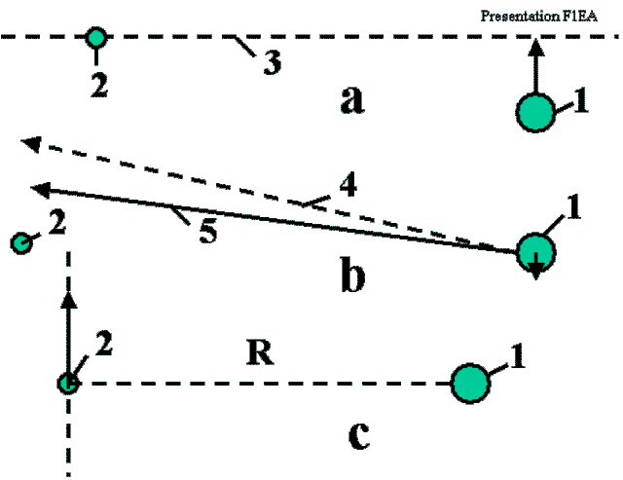
Fig. 1. Preparing for employment of the asteroid. Notations: 1 – space ship, 2 – asteroid, 3 – plane of maneuver. 4 – old ship direction, 5 – corrected ship direction. a) Reaching the plane of maneuver; b) Correcting the flight direction and reaching the requested radius; c) Connection to the asteroid.
Figs. 1a,b,c show the preparations for using a natural body to change the trajectory of the space apparatus; for example, the natural space body 2, which is moving in the same direction as the apparatus (perpendicular to the sketch, Fig. 1a). The ship wants to make a maneuver (change direction or speed) in plane 3 (perpendicular to the sketch), and the position of the apparatus is corrected and moved into plane 3. It is assumed that the space body has more mass than the apparatus.
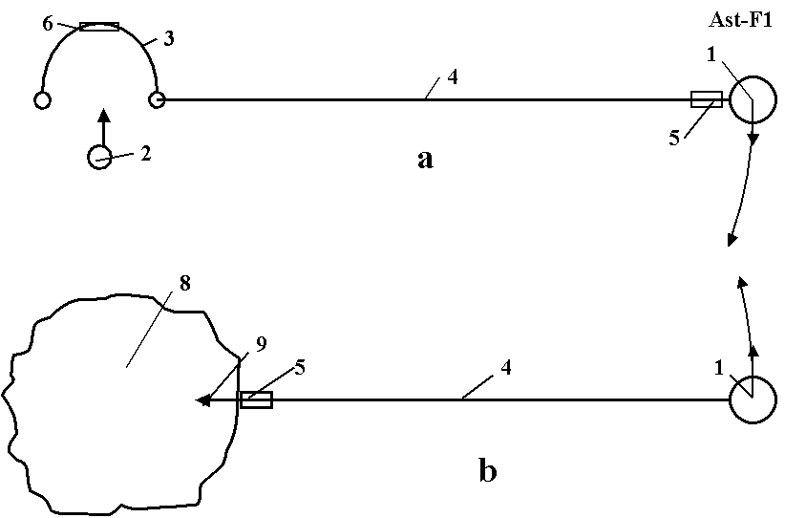
Fig. 2. a) Catching a small asteroid using net; b) Connection to a big asteroid using an anchor and cable. Notation: 1 – space ship, 2, 8 – asteroid, 3 – net with inflatable ring, 4 – cable (rope), 5 – load cabin, 6 – valve, 9 – anchor.
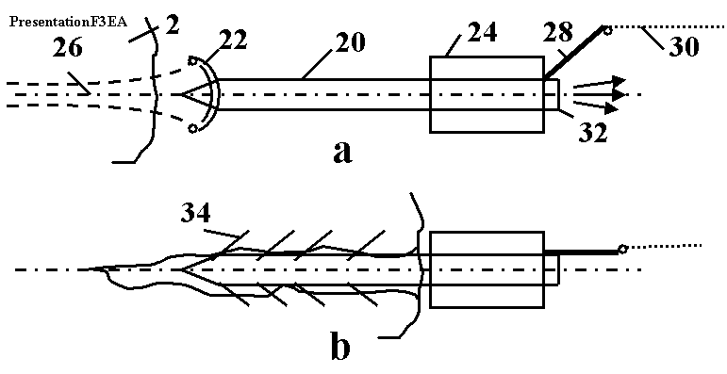
Fig. 3. a) Anchor (harpoon fork). Notation: 2 – asteroid, 20 – body of anchor; 22 – cumulative charge (shaped charge), 24 – rope spool, 26 – canal is made by shaped charge, 28 – rope keeper, 30 – rope, 32 – rocket impulse engine, which implants the anchor into the asteroid, 34 – anchor catchers. b) Anchor connected to the asteroid.
When the apparatus is at the shortest distance R from the space body, it connects to the space body means of the net (Fig. 2a) or by the anchor (Fig. 2b) and rope. The apparatus rotates around the common center of gravity at the angle j with angular speed w and linear speed DV (Fig. 4). The cardioids of additional speed and direction of the apparatus are shown in Fig. 4 (right side). The maximum additional velocity is DV = 2V_{a}, where V_{a} is the relative asteroid velocity when the coordinate center is located in the apparatus.
Fig. 4b shows the case where the space body moves in the opposite direction to the apparatus with velocity DV.
Fig. 2a shows how a net can be used to catch a small asteroid or meteorite. The net is positioned in the trajectory of the meteorite or small asteroid, supported in an open position by the inflatable ring and connected to the space apparatus by the rope. The net catches the asteroid and transfers its kinetic energy to the space apparatus. The space apparatus changes its trajectory and speed and then disconnects from the asteroid and spools the cable. If the asteroid is large, the astronaut team can use the asteroid anchor (Figs. 2b, 3).
The astronauts use the launcher (a gun or a rocket engine) to fire the anchor (harpoon fork) into the asteroid. The anchor is connected to the rope and spool. The anchor is implanted into the asteroid and connects the space apparatus to the asteroid. The anchor contains the rope spool and a disconnect mechanism (Fig. 3). The space apparatus contains a spool for the rope, motor, gear transmission, brake, and controller. The apparatus may also have a container for delivering a load to the asteroid and back (Fig. 2b). One possible design of the space anchor is shown in Fig. 3. The anchor has a body, a rope, a cumulative charge (shared charge), the rocket impulse (explosive) engine, the rope spool and the rope keeper. When the anchor strikes the asteroid surface, the cumulative charge burns a deep hole in the asteroid and the rocket-impulse engine hammers the anchor body into the asteroid. The anchor body pegs the catchers into the walls of the hole and the anchor’s strength keeps it attached to the asteroid. When the apparatus is to be disconnected from the asteroid, a signal is given to the disconnect mechanism.
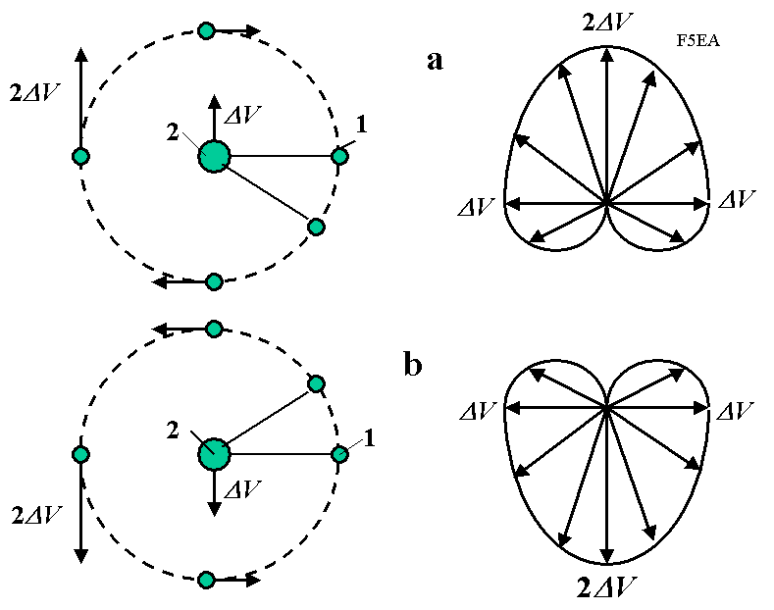
Fig. 4. Using the kinetic energy of an asteroid to change the space ship trajectory (speed and direction). On the right are cardioids of the additional velocity and its direction. The ship can get this velocity from the asteroid. Notations: 1 – space ship, 2 – asteroid, ΔV – difference between velocities of space ship and asteroid. a) Case when the asteroid has the same direction as the ship; b) Case when the asteroid has the opposite direction to the ship a.
If the asteroid is rotated with angular speed w (Fig. 5), its rotational energy can be used for increasing the velocity and changing the trajectory of the space apparatus. The rotary asteroid spools the rope on its body. The length of the rope is decreased, but the apparatus speed is increased (see a momentum theory in physics).
The ship can change the length of the cable. When the radius decreases, the linear speed of the apparatus increases; conversely, when the radius increases the apparatus speed decreases. The apparatus can obtain energy from the asteroid by increasing the length of the rope.
The computations and estimations show the possibility of making this method a reality in a short period of time (see projects than follows).
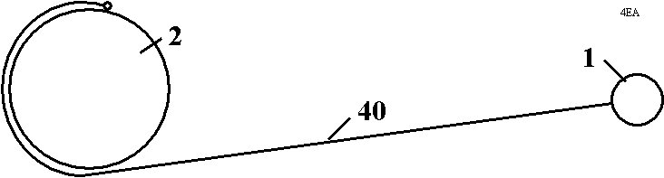
Fig. 5. Using the rotary energy of a rotating asteroid. Notations: 1 – space ship, 2 – asteroid, 40 – connection cable.

An abandoned space vehicle or large piece of space debris in Earth orbit can also be used to increase the speed of the new vehicle and to remove the abandoned vehicle or debris from orbit.

Discussion
If the change in the ship’s speed is less than 1000 m/s, the conventional widely produced fiber (safe K = 0.1) can be used. The cable mass is about 8% of the ship’s mass. After disconnection the cable will be spooled and can be used again. The reader can make estimations for other cases. Radio or optical devices can locate asteroids at distance of thousands of kilometers. Their speed, direction of flight and mass can be computed. The ship (probe) can make small corrections to its own trajectory to obtain the required position relative to the asteroid. All big asteroids with a diameter of more than 1 kilometer are listed in astronautic catalogs and their trajectories are well known. One thousands of them are located near the Earth. For those, we can compute in advance the intercept parameters. At the present time, long-range space apparatus uses the gravity of a planet to change its trajectory. However, the solar system has only nine planets, and they are located very far from one another. The employment of asteroids increases this possibility a million times over.
Estimation of the probability of meeting a small asteroid. It is known that every day about a ton of meteorites with a mass greater than 8 kg fall into the Earth’s atmosphere. The Earth’s surface area is about 512 million km². If the average mass of meteorites is 10 kg, then the Earth encounters 100 meteorites per day or one meteorite a day for every 5 million km². If a space probe has a mass around 100 kg, a 10 kg meteorite has enough mass for it to be employed to change the direction and speed of the space probe. Ground locators can detect a 1 kg space mass at distances up to thousands of km. If the space ship can detect over a range of 1000 km, it means it can see a space body with an area of one million km², or about one meteorite in every 5 days. If one meteorite in ten is suitable for employment, it means every 50 days the space apparatus will meet an eligible meteorite near the Earth. The likelihood is ten times greater in the asteroid belt between Mars and Jupiter. For 6,000 big asteroids, we can compute the intercept parameters now. This number is expected to increase as more small asteroids are registered.
There are about 8,000 fragments of old rockets and space equipment near the Earth. The trajectories of these are known. They also can be used to accelerate space apparatus. In this case we will have a double benefit: to accelerate the current space apparatus and remove space garbage into the Earth’s atmosphere (or into outer space). This space garbage is dangerous for current ships and the problem increases every year.
Note that the kinetic energy of space bodies may be used if the space body has a different speed or direction. It is difficult to use a tether system (for example, the last stage of a rocket and the Shuttle ship) because they have the same speed and direction.
Cable. If the required change of speed is less than 1,000 m/s, then cable from current artificial fibers can be used. In chapter 1 [2] the reader with find a brief overview of the research information regarding the proposed experimental test fibers.
Conclusion
The availability of both current and new materials makes the suggested propulsion system and projects more realistic for a long trip to outer space with a minimum expenditure of energy.
References.
1. Journal British Interplanetary Society, JBIS, vol, 56, No 3/4, 2003, pp. 98–107.
2. A. Bolonkin, Non-Rocket Space Launch and Flight, Elsevier, 2005. Pp. 209-222. ISBN-13: 978-0-08044-731-5.
3. Launch and Flight in Space without Rockets (v.2). USA, LULU, 2011, Chapter 11. Pp. 172-178.
ISBN 978-1-365-81382-5.

