High-tech ecosystem in construction

Konstantin Ragozin
Civil engineer,
President of the organization Tekhnadzor IZHS
Subtitle:
Stability and safety of energy equipment in ecosystems of complex construction projects;

Abstract:
The issues of ensuring the stability and safety of energy generating equipment, including through various innovative aspects of cyber security, are currently extremely relevant;
Energy equipment when used within the framework of construction projects is quite autonomous and issues of operational management and online control can be fully resolved within the capacity of their internal processors and controllers.
In many cases, issues of computer modeling of the operating cycle parameters of such equipment, with the correct and economical formulation of the problem, can also be solved using the above resources.
Construction and Electricity companies have significant engineering resources to optimize the processes of electricity production, including using the latest fuel mixtures of diesel fuel and methanol, with a tendency to increase the proportions of methanol in the fuel mixture up to 95-100%.
Changing the type and kind of fuel requires prompt restructuring of the operation of all control and management systems and loading special software onto these systems that takes into account all the nuances and changes in the operating parameters of the equipment and settings, and calibration of the control and monitoring systems;
Production experience and practice have shown that mobile and very simple systems are required that can ensure the operation of equipment in an autonomous mode, without involving additional data carriers in the circuits;
In this regard, it is necessary to note the fact that, having familiarized ourselves with the most interesting integrative inventions and informative publications of the famous innovation specialist Dmitry Starkov on the subject of high-tech ecosystems in the construction industry, our working group recognized the utmost necessity and promise in testing the data carrier encoding system in accordance with his proposals and recommendations;
As can be seen from the above publications, Dmitry Starkov's developments in this area as a whole ensure compliance with all of the above technical requirements and a fairly significant number of both independent requirements and their combinations, as well as new requirements that open up a new and promising technological field - high-tech ecosystems and infrastructures in construction projects using magnetic resonance, non-contact control methods and nanoscale measurements.
Keywords: Power equipment; Methanol; Diesel fuel; Dynamic mixing; High-tech ecosystems; Computer modeling; Equipment duty cycle; Fuel system of heating equipment;
Introduction:
The issues of ensuring the stability and safety of energy-producing equipment, including through various innovative aspects of cyber security, are of exceptional importance;
Power and energy-producing equipment as the most important part of construction projects is quite autonomous during operation, and issues of operational management and online control can be fully resolved within the capacity of their internal processors and controllers, including using elements of artificial intelligence and artificial neural networks;
In many cases, issues of computer modeling of the operating cycle parameters of such equipment, with a correct and economical formulation of the problem, can also be solved using the above-mentioned resources.
Almost every large Electric Company has significant engineering resources to optimize the processes of electricity production, including the use of the latest fuel mixtures of diesel fuel and methanol, with a tendency to increase the proportions of methanol in the fuel mixture up to 95-100%.
Changing the type and kind of fuel requires prompt restructuring of the operation of all control and management systems and loading special software onto these systems that takes into account all the nuances and changes in the operating parameters of the equipment and settings, and calibration of the control and monitoring systems.
In production conditions, methods and devices for protection are needed that, without complicating the schemes familiar to operators, can at the same time provide real and complete protection for the control and management equipment, while maintaining almost all the circuit, kinematic and fundamental elements of the device, with the introduction of new elements that do not require changes in the basic equipment during adaptation.
Production experience and practice have shown that mobile and very simple systems are required that can ensure the operation of equipment in an autonomous mode, without involving additional data carriers in the circuits
During the search and analysis of existing protection systems, specialists from Electric Companies came to the conclusion that the most economical and effective should be a system for protecting data carriers that does not require any significant changes in the designs and circuit solutions of energy-producing equipment.
Advanced Electric Companies are pioneers in the field of using methanol as an alternative fuel for energy-producing gas turbines.
Turbines of such power (20-25 megawatts) use diesel fuel number 2 as the main fuel.
One of the original tasks that the group of developers of the new innovative technology set for themselves was the task of using the so-called evaporation energy, which is the highest in methanol, compared to other types of liquid fuel used.
To implement this and other innovative tasks, various modifications and optimizations of the turbine fuel system were used, which, in addition to options for completely replacing diesel fuel with methanol, also contained innovative options for dynamic mixing of methanol with small proportions of conventional diesel fuel. This mixing, in principle, helped to reduce the impact on the combustion process of some properties of methanol - primarily directly related to the relatively low flame temperature of methanol. Since hundreds and thousands of turbines with a long service life are in operation today, which also use heavy diesel fuel as fuel, such as fuel oil and natural gas and coal dust, and other types of fuel and fuel mixtures, it makes sense to focus on the differences in the adaptation systems of devices for dynamic mixing of methanol with these types of fuel and the analysis of the mixing devices themselves.

Differences in the adaptation systems of devices for dynamic mixing of methanol with these types of fuel and analysis of the mixing devices themselves.
During pilot tests and qualification tests, the fundamental technical solutions of such devices were verified, which have some differences depending on the type of fuel used and the amount of mixed fuel components.
At the same time, despite the high level of unification and standardization of fuel and fuel mixture preparation systems, this does not reduce the overall dependence of the entire thermodynamic equipment infrastructure on the mobility and efficiency of control, monitoring and calibration systems, including the operational adaptation of all supplied and sent signals in real time.
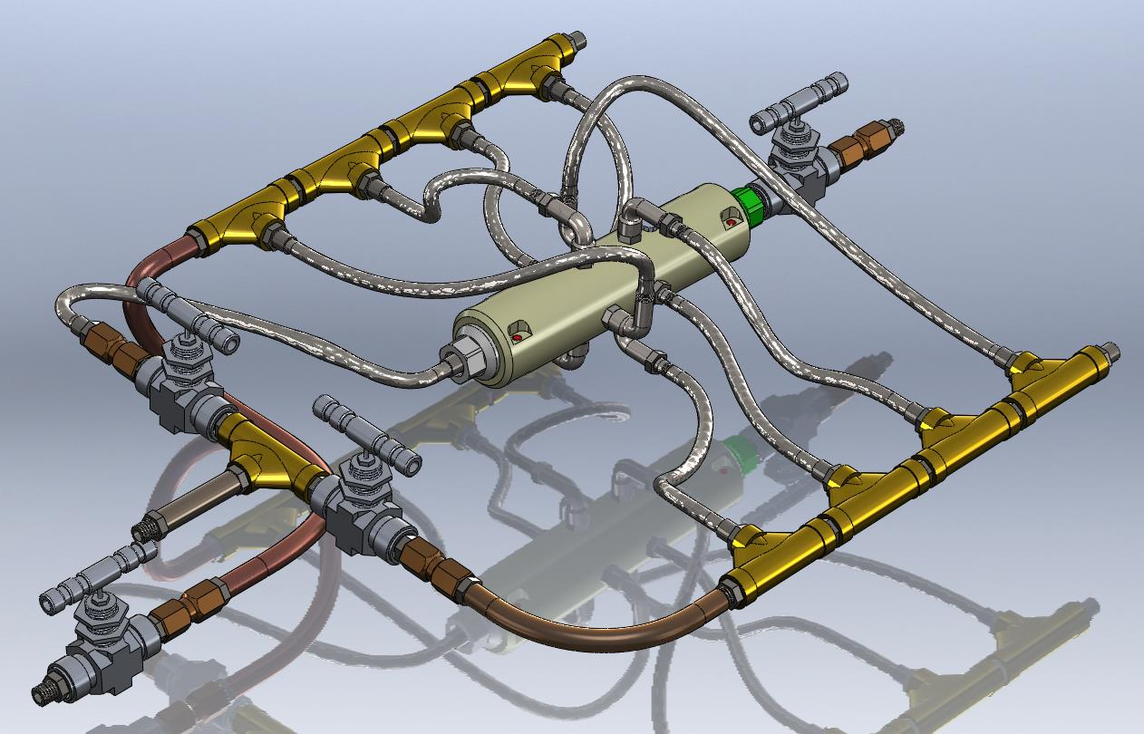
The first photo shows a three-dimensional model of a device for dynamic mixing of diesel fuel with methanol directly in the fuel line of thermodynamic equipment
The device is extremely simple and even in this design can have at least two options for use - both as a static mixer (there are no moving parts in the device) and as a static on-line device for homogenizing fuel or fuel mixture directly in the fuel line.
In view of the special uniqueness and complexity of energy-producing equipment, the introduction of even such a compact and simple device into its composition requires adequate adjustment of its operating characteristics, which in turn leads to the need to change the software devices of processors and on-board computers.
The process of such a replacement is absolutely standard from the point of view of mechanical and hydraulic installation and does not cause any complications, but from the point of view of computer security, the temporary pause necessary for adjusting or replacing the program is precisely the window and channel through which computer viruses can penetrate the control and monitoring system of thermodynamic equipment.
Considering the inertia of such a system, it can be assumed that it will be possible to notice such penetration after some time, during which the most important components of the equipment may be disabled.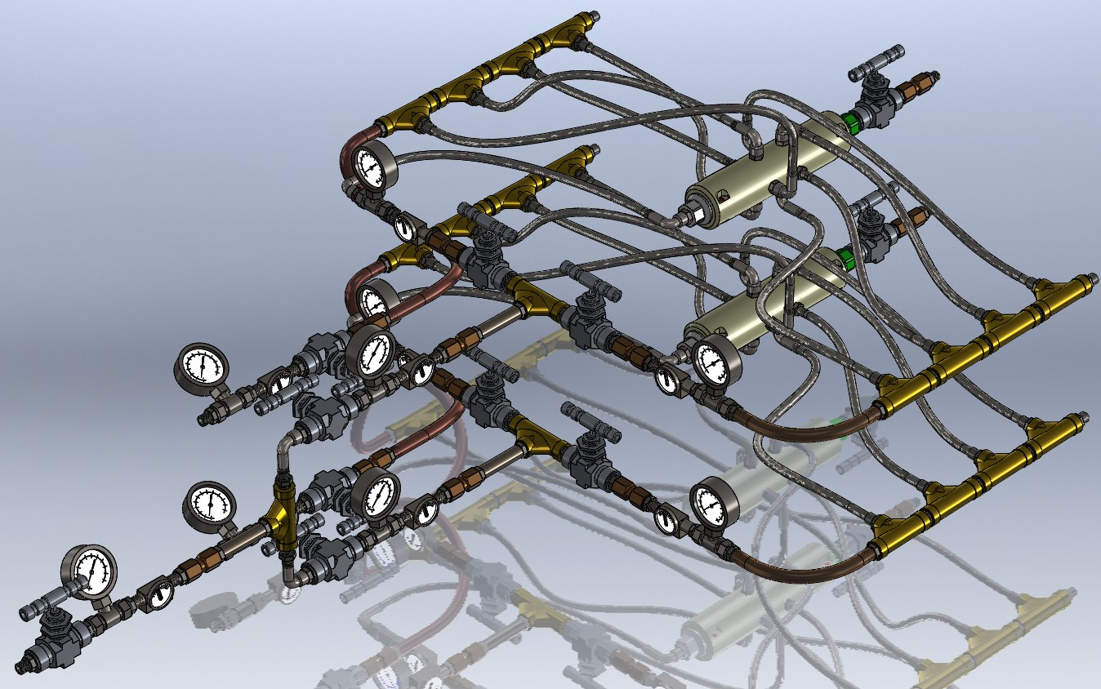
In addition, if a dual mixing system is adapted to the equipment, the corresponding risk practically doubles, and in addition, if the system also has a recirculation of excess fuel, then under the influence of a hostile program there may be several times more units and mechanisms, which can further increase the risk of modernization.
In a real situation, there is often a need for a significantly higher volume or weight fuel consumption, since if we compare the energy calorific value of methanol and, for example, diesel fuel, then methanol has such an indicator two times lower than diesel fuel, which requires an increase in fuel consumption by more than two times during modernization.
This further complicates the modernization process and forces the system to have twice as many devices with all the necessary control and management elements.
Such a system requires even greater power and capacity of processors and programmable controllers, which confirms the correctness of the previous conclusions.
The next photo shows such a quadruple system, which has 4 independent and, in principle, autonomous devices if necessary.
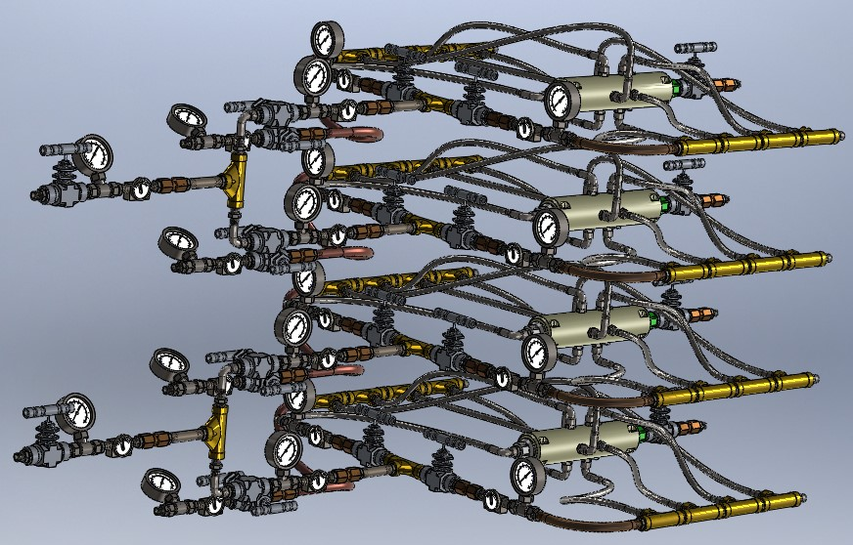
Recently, powerful and productive systems have also appeared that can, in principle, replace multi-element systems with the same or more effective thermodynamic indicators.
The following photo shows such a system with a capacity of 1000 liters per hour.
In this system, despite the fact that it has only 3 external inputs and one output, the specifics of control, monitoring and hydrodynamic coordination require no less volumes of control and management operations and the corresponding potentials of control systems, control and modeling of the working cycle of thermodynamic equipment.
That is, the importance of high-quality and guaranteed protection of operational downloads of software control and management components in control and control and analytical tools remains at the highest level, regardless of the type and kind of device for mixing fuel mixtures.
If we consider the original technical requirements for such systems, the following can be highlighted:
- information carriers must have original system protection;

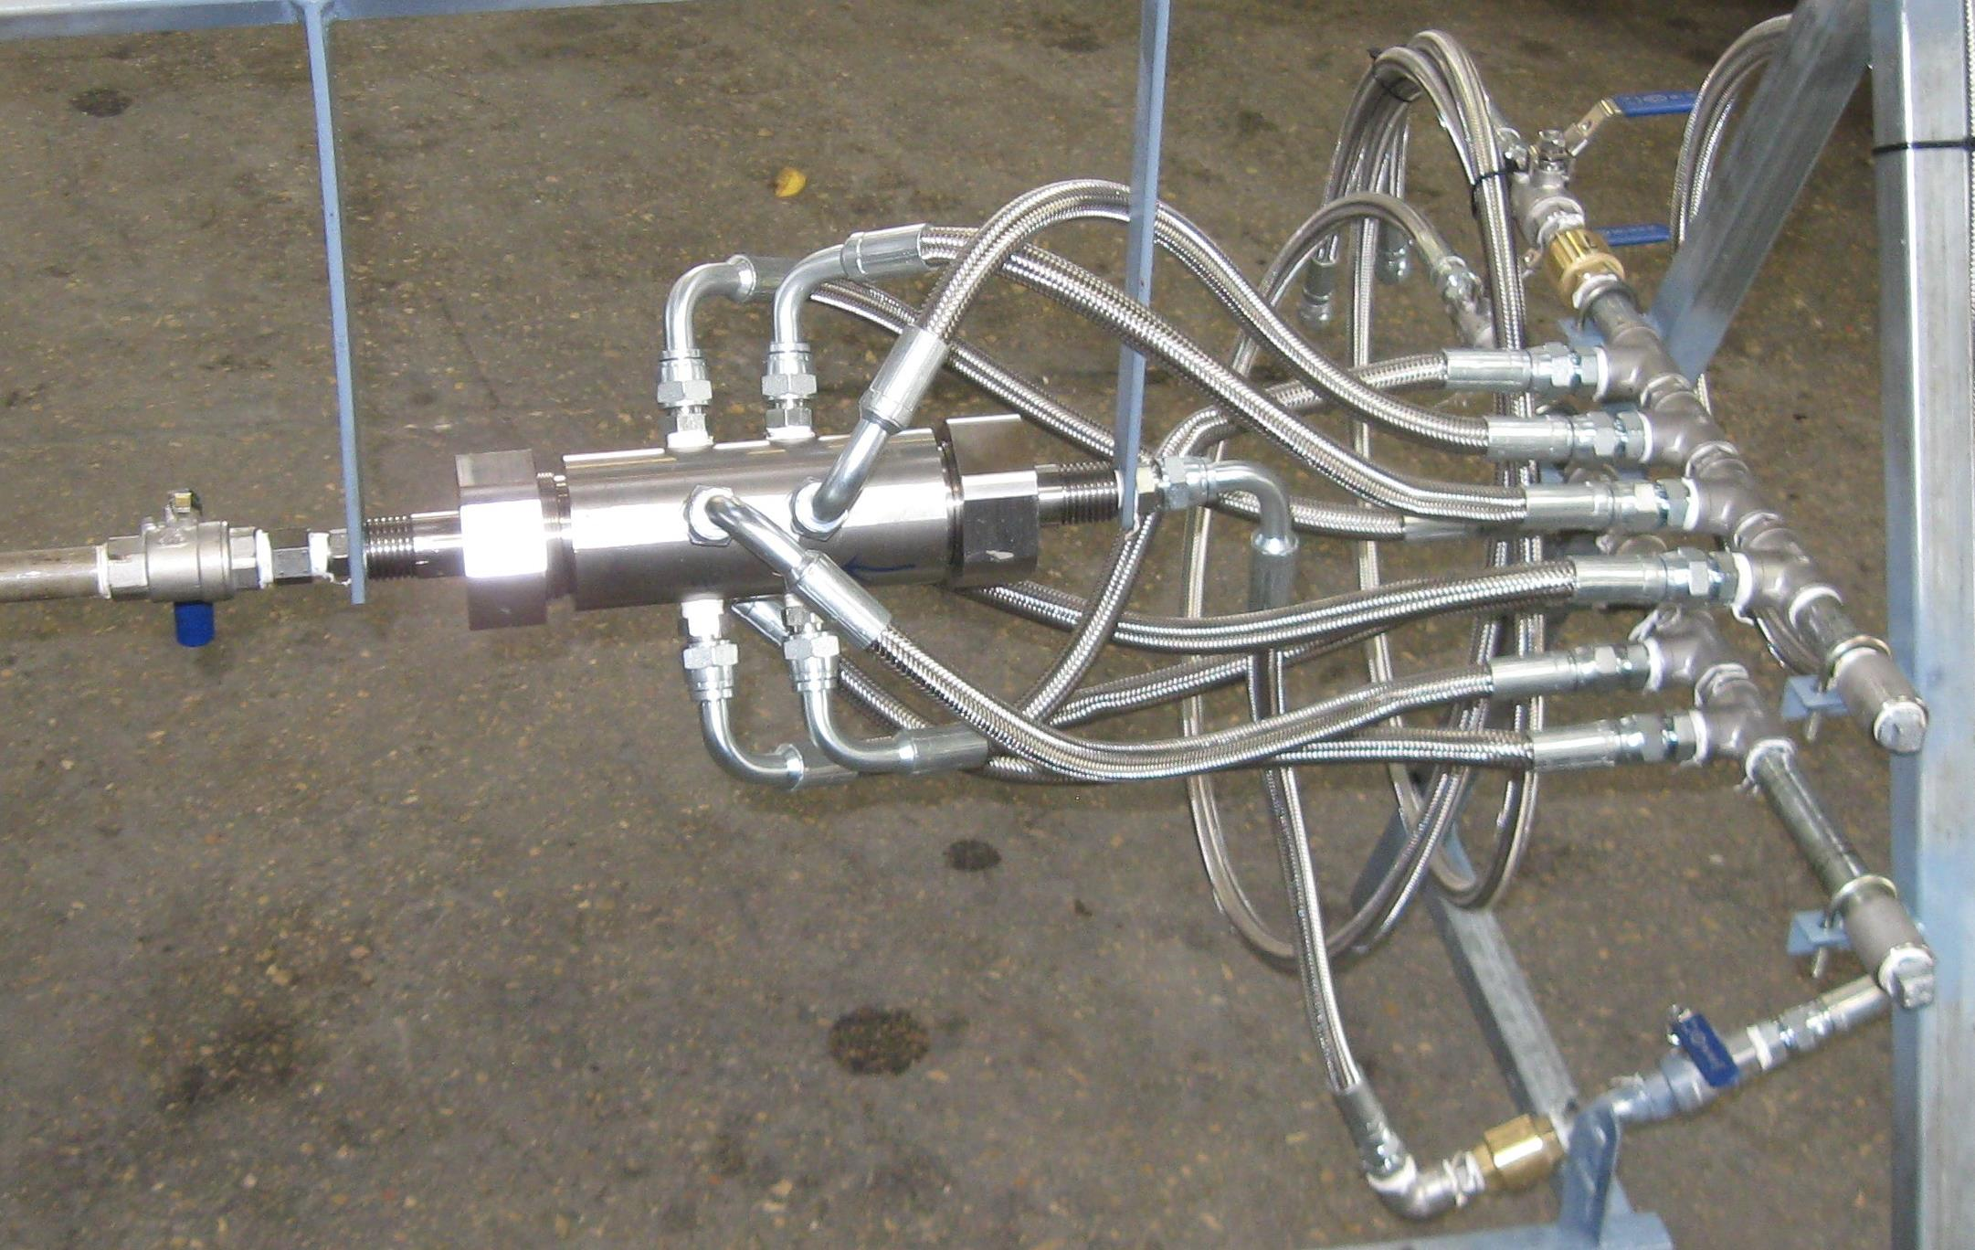
- information carriers must have an identification system and methodology equivalent to the information reading systems in processor and on-board computer equipment;
- the identification code must be applied to the information carrier in such a way as not to change the standard shape and dimensions of the connecting elements of the information carrier
- the identification code must have only one control and measuring parameter
- this parameter must be identified without contact
Some characteristic requirements are listed above, but comprehensive compliance with these requirements in today's conditions is not ensured by the availability of mobile information carriers that have at least some of the specified properties
In this regard, it is necessary to note the fact that, having familiarized ourselves with the most interesting developments and publications of Dmitry Starkov on this topic, our working group recognized the utmost necessity to test the information carrier coding system in accordance with his proposals and recommendations;
As can be seen from the above publications, Dmitry Starkov's developments in this area in a complex ensure compliance with all the above technical requirements and a fairly significant number of both independent requirements and their combinations, as well as new requirements that open up a new and promising technological field, magnetic resonance, non-contact control method and nanoscale measurements using elements of artificial intelligence and artificial neural networks;
At the same time, as a specialist in the field of operation of energy-producing industrial equipment, it seems to me that the most effective way to disseminate this method is among manufacturers and users of special computer equipment for power plants and construction projects;
Due to the fact that the equipment for mixing and preparing fuel mixtures has a very clear and effective scale factor, it can be assumed that due to this, the coding system can be implemented in almost all areas of energy, not only in turbines, but also in diesel generators, boilers, thermal power plants and other thermodynamic equipment. The following photo shows three-dimensional models of a device for dynamic mixing arranged according to size and scale factors, where the smallest systems can be installed in household machines, and the largest can provide operation with a fuel consumption of tens of thousands of liters per hour. Dmitry Starkov's proposal allows to expand the areas of integration in construction projects of special energy innovation projects, which on the scale of only one power plant with a capacity of several tens of megawatts can provide savings of hundreds of thousands of dollars per year, while ensuring the maximum possible and effective protection of circuits and control systems of energy equipment. In addition, in modern energy, such a proposal speaks of the originality of the concept, thinking and unique extraordinary nature of the new, innovative technological and software direction, allowing, at relatively low costs, to ensure the solution of the most problematic issue of modern energy - ensuring an adequate level of computer security;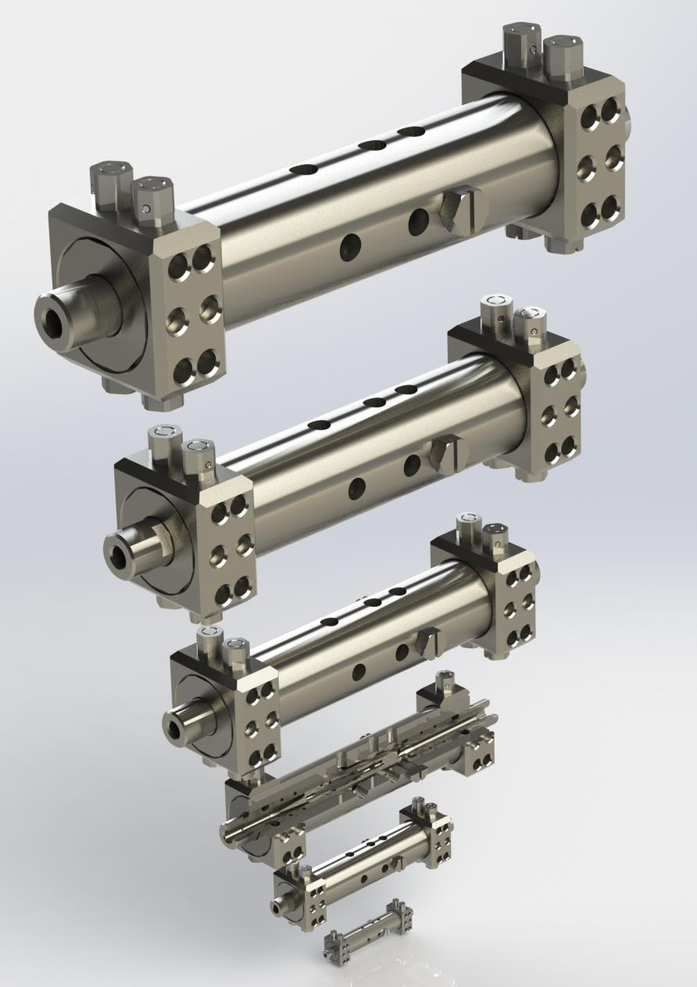

List of borrowed literature, patent and license information:

Appendix 1
United States Patent Application | 20110069579
Kind Code | A1
 | March 24, 2011

FLUID MIXER WITH INTERNAL VORTEX
Abstract
The present disclosure generally relates to a fluid mixer, a system for mixing fluids utilizing the fluid mixer, and a method of mixing fluids using the fluid mixer or the system for mixing fluids, and more specifically, to a compact static mixing device with no moving parts and capable of mixing any fluid, such as air, nitrogen gas, water, oil, polluted water, and the like. A first pressurized, incoming fluid is accelerated locally by a section reduction, is split into streams, and then is released into a second fluid found in a closed volume or an open volume after a period of stabilization. The directed and controlled first fluid slides along an insert up to directional and angled fins at a vortex creator where suction forces from a self-initiating vortex in an internal cavity draws in at least part of the first fluid to fuel the vortex. The compactness and simplicity of the fluid mixer with internal vortex can be used alone within a closed volume in a conduit, in a sprayer, or within a fixed geometry to direct the mixing vortex to specific dimensions. One or more fluid mixers can also be used in an open volume such as a reservoir, a tank, a pool, or any other fluid body to conduct mixing. The technology alone, as part of a multi-mixer system, or as a method of mixing using the fluid mixer with internal vortex is contemplated to be used in any field where mixing occurs.

Appendix 2
United States Patent Application | 20100243953
Kind Code | A1
 | September 30, 2010

Method of Dynamic Mixing of Fluids
Abstract
Methods are provided for achieving dynamic mixing of two or more fluid streams using a mixing device. The methods include providing at least two integrated concentric contours that are configured to simultaneously direct fluid flow and transform the kinetic energy level of the first and second fluid streams, and directing fluid flow through the at least two integrated concentric contours such that, in two adjacent contours, the first and second fluid streams are input in opposite directions. As a result, the physical effects acting on each stream of each contour are combined, increasing the kinetic energy of the mix and transforming the mix from a first kinetic energy level to a second kinetic energy level, where the second kinetic energy level is greater than the first kinetic energy level.

Appendix 3
United States Patent Application | 20100281766
Kind Code | A1
 | November 11, 2010

Dynamic Mixing of Fluids
Abstract
Methods, systems, and devices for preparation and activation of liquids and gaseous fuels are disclosed. Method of vortex cooling of compressed gas stream and water removing from air are disclosed.

Приложение 4
United States Patent Application | 20120102736
Kind Code | A1
 | May 3, 2012

MICRO-INJECTOR AND METHOD OF ASSEMBLY AND MOUNTING THEREOF
Abstract
The invention relates to a compact device for producing a composite mixture made of two or more fluids, and for aerating and energizing the composite and injecting it into a volume, and more specifically a micro-fuel injector mixing water, air, or any other types of fluid before it is injected into a volume such as a combustion chamber of an engine made of stackable mechanical elements, and the method of assembly and mounting thereof.

