Changes in the portrait of automotive market customers in 2014-2021

Marat Khaitbaev,
Independent researcher
Professional member of
New York Academy of Sciences
Porsche Center Pulkovo
Saint Petersburg, Russia

Abstract: comparative characteristics of the features of Premium segment customers in car sales
Keywords: configuration, options, market

The development of the automotive market is in an overactive way. New trends in technology, design and technical data are considered. Auto giants are constantly updating their marketing departments, aiming to apply the most advanced ideas of young and active specialists for the highest results in the creation of new models. But at the same time, the client-consumer of this product is also changing and improving. Let's take a closer look at the features of changes in the portrait of the Premium level car market over the past few years.

The active phase of the development of the premium auto segment in the Russian market took place in the second half of the 2010s. Close economic cooperation with partners of the Western and Eastern countries gave direct lines of logistics and well-established schemes for the supply of luxury cars in sufficient quantities, considering the individual wishes of the buyers.

2014-2016 were characterized by an abundance of complete vehicles in the warehouses of retailers. The formation of the client portrait was slow and did not have much personality. Strict colors and agreement on the dark shades of interiors gave a single picture of the purchased products of auto brands. According to sales statistics over the years, white and brown body colors and black interior color were the most requested. The lack of desire to wait for their choice and a sufficient number of offers in stock led customers to a one-sided influence of the market on their portrait.

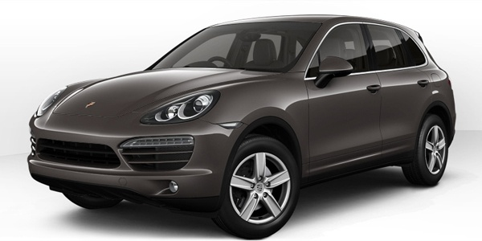
Figure 1. Example of Porsche Cayenne model of 2014.

2016-2019 have become the driving force behind the promotion of new Internet resources for private configuration by the client of their own taste and choice without the significant influence of car dealers. Dealerships switched to accepting orders with a 2-3 month wait for the final car. This manifestation of freedom led to the formation of unique, differentiated customer sentiments. The flow of fresh vehicles became more diverse with each coming of spring, when the desire to renew the fleet increased the sales results of dealerships. However, financial education also occupied a leading position with the client when creating a future car. The final portrait of the client of the Premium segment was a combination of the desire for a unique appearance and the logic of verified functionality at no extra cost.
2020-2021 became an exemplary period for the embodiment of wishes and grand gestures. Europe's top luxury car makers are having trouble getting components to production lines. This led to a significant increase in the time of manufacture and delivery of the finished product. However, customers have become more information-savvy and willing to take on the challenge of getting the car they want. The client portrait in that period became the most striking, unique and thirsty for something new. This was reflected in a significant increase in the results of sales of additional and exclusive options, and, as a result, the cost of the final cars. Purchasing power has turned from streaming to private. The seller-buyer relationship became more and more friendly, despite the classic M-C-M relationship: “Money-Commodity-Money”. The client began to lead the process of forming the final list of positions for his future vehicle. Employees of car centers have become a tool for technical implementation to a greater extent and a consulting party to a lesser extent. The awareness of the increased expectation and the ever-growing list of configuration options have created a thirst for uniqueness and rich equipment in the customer mood. According to Porsche sales analytics in Russia for the second half of 2010s, the delta of the increase gap between the value of optional equipment compared to standard equipment in 2015 and 2020 was more than 26%. As a result - a portrait of the client in 2020-2021. became involved, wealthy and truly enjoying the result of close work "seller-buyer".
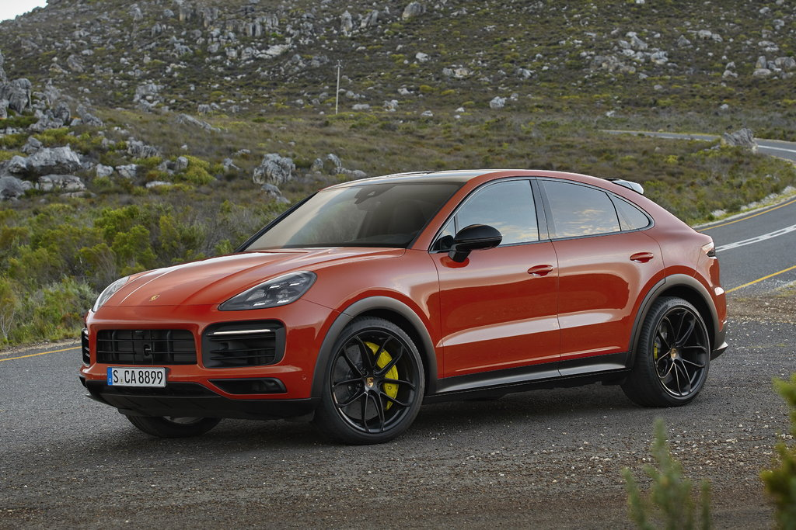
Figure 2. Example of Porsche Cayenne model of 2021.

Figure 3. Product cost chart in Russian rubles based on 2014-2021 Porsche Cayenne model.

Bibliography:
- Sales department, who sells, E.V. Schmidt, 2019
- Das Kapital, Маркс К.Г., 1867
- Whole life clients, Sewell C. & Paul B. Brown, 1990
- Analytics as an intellectual weapon, Y.V. Kurnosov, 2012

© Marat Khaitbaev, 2023

