Energy Transfers from Airborne Wind Turbine:
Review and Comparison of Airborne Turbines.
By Alexander Bolonkin
Strategic Solutions Technology Group, abolonkin@juno.com

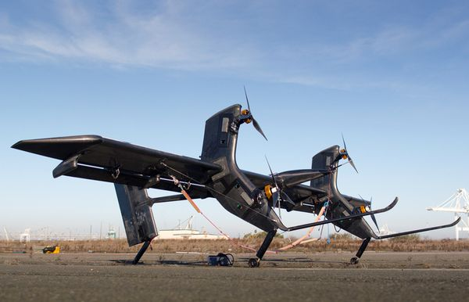

New York, April, 2013

Article Airborne Wind Turbines 4 24 13
Energy Transfers from Airborne Wind Turbine:
Review and Comparison of Airborne Turbines.
By Alexander Bolonkin
Strategic Solutions Technology Group, abolonkin@juno.com

Abstract
Ground based, wind energy extraction systems have reached their maximum capability. The limitations of current designs are wind instability and high cost of installations. The wind energy industry is in need of revolutionary ideas to increase the capabilities of wind systems. This article suggests a revolutionary innovation which produces a dramatic increase in power per unit at a lower cost per unit of energy extracted and is independent of prevailing weather. The main innovation consists of large free-flying air rotors positioned at high altitude for power and stable air stream, and two types (mechanical and electrical) of an energy cable transmission system between the air rotor and a ground system. The air rotor system flies at high altitude up to 10 km. Stability and control systems is provided which also enable changing altitude.
This article includes the theory of airborne wind systems and provides the analysis of four examples having a high unit power output (up to 50 MW). The proposed examples provide the following main advantages: 1) Large power production capacity per unit - up to ten - hundred times more than conventional ground-based small rotor designs; 2) The rotor operates at high altitude of 0.5 - 10 km where the wind flow is strong and steady; 3) Installation cost per unit energy is low and 4) The installation is environmentally friendly (no propeller noise).
Author also provides a brief review of other main wind systems/turbines describing their advantages and disadvantages.
----------------------------------------------------------------------------------------------------------------------------------------
Keywords: wind energy, cable energy transmission, electric airborne transmission, utilization of wind energy at high altitude, air rotor, airborne wind turbines, windmills, Bolonkin.
Introduction
High Altitude Winds.
Power generation from winds usually comes from winds very close to the surface of the earth. Winds at higher altitudes are stronger and more consistent, and may have a global capacity of 380 TW. Recent years have seen significant advances in technologies meant to generate electricity from high altitude winds. Worldwide there are now over two hundred thousand wind turbines operating, with a total nameplate capacity of 282,482 MW as of end 2012. The European Union alone passed some 100,000 MW nameplate capacities in September 2012, while the United States surpassed 50,000 MW in August 2012 and China passed 50,000 MW the same month.

Some Information about Wind Energy.
The power of wind engine strongly depends on wind speed (to the third power). Low altitude wind (H = 10 m) has the standard average speed of V = 6 m/s. High altitude wind is powerful and practically everywhere is stable and constant. Wind in the troposphere and stratosphere are powerful and permanent. For example, at an altitude of 5 km, the average wind speed is about 20 M/s, at an altitude 10 - 12 km the wind may reach 40 m/s (at latitude of about 20 - 35⁰ N).
There are permanent jet streams at high altitude. For example, at H = 12-13 km and about 25⁰ N latitude, the average wind speed at its core is about 148 km/h (41 m/s). The most intensive portion has a maximum speed of 185 km/h (51 m/s) latitude 22⁰, and 151 km/h (42 m/s) at latitude 35⁰ in North America. On a given winter day, speeds in the jet core may exceed 370 km/h (103 m/s) for a distance of several hundred miles along the direction of the wind. Lateral wind shears in the direction normal to the jet stream may be 185 km/h per 556 km to right and 185 km/h per 185 km to the left.
The wind speed of V = 40 m/s at an altitude H = 13 km provides 64 times more energy than surface wind speeds of 6 m/s at an altitude of 10 m.
This is an enormous renewable and free energy source. (See reference: Science and Technology, v.2, p.265).
High altitude jet stream.
Jet streams are fast flowing, narrow air currents found in the atmospheres of some planets, including Earth. The main jet streams are located near the tropopause, the transition between the troposphere (where temperature decreases with altitude) and the stratosphere (where temperature increases with altitude). The major jet streams on Earth are westerly winds (flowing west to east). Their paths typically have a meandering shape; jet streams may start, stop, split into two or more parts, combine into one stream, or flow in various directions including the opposite direction of most of the jet. The strongest jet streams are the polar jets, at around 7–12 km (23,000–39,000 ft.) above sea level, and the higher and somewhat weaker subtropical jets at around 10–16 km (33,000–52,000 ft.). The Northern Hemisphere and the Southern Hemisphere each have both a polar jet and a subtropical jet. The northern hemisphere polar jet flows over the middle to northern latitudes of North America, Europe, and Asia and their intervening oceans. The southern hemisphere polar jet mostly circles Antarctica all year round.
Jet streams are caused by a combination of a planet's rotation on its axis and atmospheric heating (by solar radiation and, on some planets other than Earth, internal heat). Jet streams form near boundaries of adjacent air masses with significant differences in temperature, such as the polar region and the warmer air towards the equator.
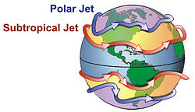
Figure 1. General configuration of the polar and subtropical jet streams.
Other jet streams also exist. During the northern hemisphere summer, easterly jets can form in tropical regions, typically in a region where dry air encounters more humid air at high altitudes. Low-level jets also are typical of various regions such as the central United States.
Meteorologists use the location of some of the jet streams as an aid in weather forecasting. The main commercial relevance of the jet streams is in air travel, as flight time can be dramatically affected by either flying with the flow or against the flow of a jet stream. Clear-air turbulence, a potential hazard to aircraft passenger safety, is often found in a jet stream's vicinity but does not create a substantial alteration on flight times.
Economy of conventional utilization wind energy.
Wind power plants have low ongoing costs, but moderate capital cost. The marginal cost of wind energy once a plant is constructed is usually less than 1-cent per kW·h. As wind turbine technology improved this cost has been reduced. There are now longer and lighter wind turbine blades (up 75 m), improvements in turbine performance and increased power generation efficiency. Also, wind project capital and maintenance costs have continued to decline.
The estimated average cost per unit incorporates the cost of construction of the turbine and transmission facilities, borrowed funds, return to investors (including cost of risk), estimated annual production, and other components, averaged over the projected useful life of the equipment, which may be in excess of twenty years. Energy cost estimates are highly dependent on these assumptions so published cost figures can differ substantially. In 2004, wind energy cost a fifth of what it did in the 1980s, and a continued downward trend is expected as larger multi-megawatt turbines were mass-produced. As of 2012 capital costs for wind turbines are substantially lower than 2008–2010 but are still above 2002 levels. A 2011 report from the American Wind Energy Association stated, "Wind's costs have dropped over the past two years, in the range of 5 to 6 cents per kilowatt-hour recently.... about 2 cents cheaper than coal-fired electricity, and more projects were financed through debt arrangements than tax equity structures last year.... winning more mainstream acceptance from Wall Street's banks.... Equipment makers can also deliver products in the same year that they are ordered instead of waiting up to three years as was the case in previous cycles.... 5,600 MW of new installed capacity is under construction in the United States, more than double the number at this point in 2010. Thirty-five percent of all new power generation built in the United States since 2005 has come from wind, more than new gas and coal plants combined, as power providers are increasingly enticed to wind energy as a convenient hedge against unpredictable commodity price moves."
A British Wind Energy Association report gives an average generation cost of onshore wind power of around 3.2 pence (between US 5 and 6 cents) per kW·h (2005). Cost per unit of energy produced was estimated in 2006 to be comparable to the cost of new generating capacity in the US for coal and natural gas: wind cost was estimated at $55.80 per MW·h, coal at $53.10/MW·h and natural gas at $52.50. Similar comparative results with natural gas were obtained in a governmental study in the UK in 2011. A 2009 study on wind power in Spain by Gabriel Calzada Alvarez of King Juan Carlos University concluded that each installed MW of wind power led to the loss of 4.27 jobs, by raising energy costs and driving away electricity-intensive businesses. The U.S. Department of Energy found the study to be seriously flawed, and the conclusion unsupported. The presence of wind energy, even when subsidized, can reduce costs for consumers (€5 billion/yr in Germany) by reducing the marginal price, by minimizing the use of expensive peaking power plants.
In February 2013 Bloomberg New Energy Finance reported that the cost of generating electricity from new wind farms is cheaper than new coal or new baseload gas plants. In Australia, when including the current Australian federal government carbon pricing scheme their modeling gives costs (in Australian dollars) of $80/MWh for new wind farms, $143/MWh for new coal plants and $116/MWh for new baseload gas plants. The modeling also shows that "even without a carbon price (the most efficient way to reduce economy-wide emissions) wind energy is 14% cheaper than new coal and 18% cheaper than new gas." Part of the higher costs for new coal plants is due to high financial lending costs because of "the reputational damage of emissions-intensive investments". The expense of gas fired plants is partly due to "export market" effects on local prices. Costs of production from coal fired plants built in "the 1970s and 1980s" are cheaper than renewable energy sources because of depreciation.
High-altitude wind power (HAWP)
HAWP has been imagined as a source of useful energy since 1833 with John Etzler's vision of capturing the power of winds high in the sky by use of tether and cable technology. An atlas of the high-altitude wind power resource has been prepared for all points on Earth. A similar atlas of global assessment was developed at Joby Energy. The results were presented at the first annual Airborne Wind Energy Conference held at Stanford University by Airborne Wind Energy Consortium.
Various mechanisms are proposed for capturing the kinetic energy of winds such as kites, kytoons, aerostats, gliders, gliders with turbines for regenerative soaring, sailplanes with turbines, or other airfoils, including multiple-point building- or terrain-enabled holdings. Once the mechanical energy is derived from the wind's kinetic energy, then many options are available for using that mechanical energy: direct traction, conversion to electricity aloft or at ground station, conversion to laser or microwave for power beaming to other aircraft or ground receivers. Energy generated by a high-altitude system may be used aloft or sent to the ground surface by conducting cables, mechanical force through a tether, rotation of endless line loop, movement of changed chemicals, flow of high-pressure gases, flow of low-pressure gases, or laser or microwave power beams. There are two major scientific articles about jet stream power.
Programs for Developing Wind Energy
Wind is a clean and inexhaustible source of energy that has been used for many centuries to grind grain, pump water, propel sailing ships, and perform other work. Wind farm is the term used for a large number of wind machines clustered at a site with persistent favorable winds, generally near mountain passes. Wind farms have been erected in New Hampshire, in the Tehachapi Mountains. at Altamont Pass in California, at various sites in Hawaii, and may other locations. Machine capacities range from 10 to 500 kilowatts. In 1984 the total energy output of all wind farms in the United States exceeded 150 million kilowatt-hours.
A program of the United States Department of Energy encouraged the development of new machines, the construction of wind farms, and an evaluation of the economic effect of large-scale use of wind power.
The utilization of renewable energy (‘green’ energy) is currently on the increase. For example, numerous wind turbines are being installed along the British coast. In addition, the British government has plans to develop off-shore wind farms along their coast in an attempt to increase the use of renewable energy sources. A total of $2.4 billion was injected into renewable energy projects over the last three years in an attempt to meet the government's target of using renewable energy to generate 10% of the country's energy needs by 2010.
This British program saves the emission of almost a million tons of carbon dioxide. Denmark plans to get about 30% of their energy from wind sources.
Unfortunately, current ground wind energy systems have deficiencies which limit their commercial applications:
- Wind energy is unevenly distributed and has relatively low energy density. Huge turbines cannot be placed on the ground; many small turbines must be used instead. In California, there are thousands of small wind turbines. However, while small turbines are relatively inefficient, very huge turbines placed at ground are also inefficient due to the relatively low wind energy density and their high cost. The current cost of wind energy is higher than energy of thermal power stations.
- Wind power is a function of the cube of wind velocity. At surface level, wind has low speed and it is non-steady. If wind velocity decreases in half, the wind power decreases by a factor of 8 times.
- The productivity of a wind-power system depends heavily on the prevailing weather.
- Wind turbines produce noise and visually detract from the landscape.
While there are many research programs and proposals for the wind driven power generation systems, all of them are ground or tower based. The system proposed in this article is located at high altitude (up to the stratosphere), where strong permanent and steady streams are located. This article also proposes a solution to the main technologist challenge of this system; the transfer of energy to the ground via a mechanical transmission made from closed loop, modern composite fiber cable.
The reader can find the information about this idea in [1]-[2], a detailed description of the innovation in [3]-[6], and the wind energy in references [7]-[8], new material used in the proposed innovation in [9]-[13]. The review of last airborne concepts in [14]-[17].

Description of Innovation
The main proposed high altitude wind system is presented in Figure 2. That includes: rotor (turbine) 1, support wing 2, cable mechanical transmission and keep system 3, electro-generator 4, and stabilizer 5. The transmission system has three cables (Figure 2e): main (central) cable, which keeps the rotor at a given altitude, and two transmission mobile cables, which transfer energy from the rotor to the ground electric generator. The device of Figure 2f allows changing a cable length and a rotor altitude. In calm weather the rotor can be support at altitude by dirigible 9 (Figure 2c) or that is turned in vertical position and support by rotation from the electric generator (Figure 2d). If the wind is less of a minimum speed for support of rotor at altitude the rotor may be supported by autogiro mode in position of Figure 2d. The probability of full wind calm at a high altitude is small and depends from an installation location.
Figure 3 shows other design of the proposed high altitude wind installation. This rotor has blades, 10, connected to closed-loop cables. The forward blades have a positive angle and lift force. When they are in a back position the lift force equals zero. The rotor is supported at the high altitude by the blades and the wing 2 and stabilizer 5. That design also has energy transmission 3 connected to the ground electric generator 4.
Figure 4 shows a parachute wind high altitude installation. Here the blades are changed by parachutes. The parachutes have a large air drag and rotate the cable rotor 1. The wind 2 supports the installation in high altitude. The cable transmission 3 passes the rotor rotation to the ground electric generator 4.
A system illustrated in Figure 5 uses a large Darries air turbine located at high altitude. This turbine has four blades.
The other components are same with previous projects.

Problems of Launch, Start, Guidance, Control, Stability, and Others
Launching. It is not difficult to launch the installations having support wing or blades as described in Figure 2 - 5. If the wind speed is more than the minimum required speed (>2-3 m/s), the support wing lifts the installation to the desired altitude.
Starting. All low-speed rotors are self-starting. All high-speed rotors require an initial starting rotation from the ground motor-generator 4 (figure 2).
Guidance and Control. The control of power, revolutions per minute, and torque moment are operated by the turning of blades around the blade longitudinal axis. The control of altitude may be manual or automatic when the wind speed is normal and over admissible minimum. Control is effected by wing flaps and stabilizer (elevator), fin, and ailerons (figs. 2, 3, 5).
Stability. Stability of altitude is produced by the length of the cable. Stability around the blade longitudinal axis is made by stabilizer (see figs.2, 3, 5). Rotor directional stability in line with the flow can be provided by fins (figs. 2). When the installation has the support wing rigidly connected to the rotor, the stability is also attained by the correct location of the center of gravity of the installation (system rotor-wing) and the point of connection of the main cable and the tension elements. The center-of-gravity and connection point must be located within a relatively narrow range 0.2 - 0.4 of the average aerodynamic chord of the support wing (for example, see Figure 2). There is the same requirement for the additional support wings such as Figures 3 - 5.
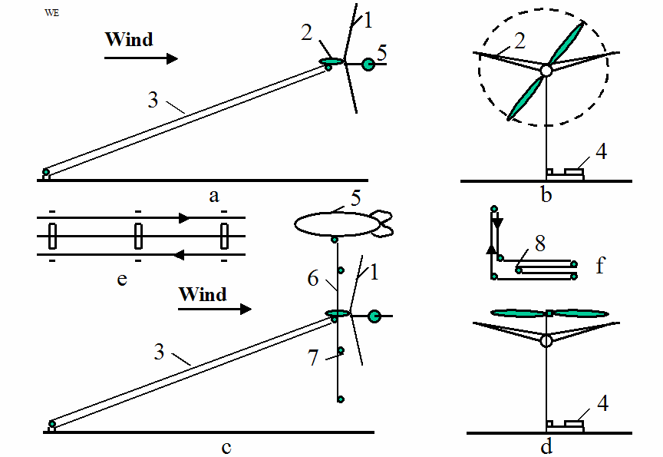
Figure 2. Propeller high altitude wind energy installation and cable energy transport system. Notation: a – side view; 1 – wind rotor; 2 – wing with ailerons; 3 – cable energy transport system; 4 – electric generator; 5 – stabilizer; b – front view; c – side view with a support dirigible 9, vertical cable 6, and wind speed sensors 7; d - keeping of the installation at a high altitude by rotate propeller; e – three lines of the transmission - keeper system. That includes: main (central) cable and two mobile transmission cables; f – energy transport system with variable altitude; 8 – mobile roller.

Figure 3. High altitude wind energy installation with the cable turbine. Notation: 10 – blades.
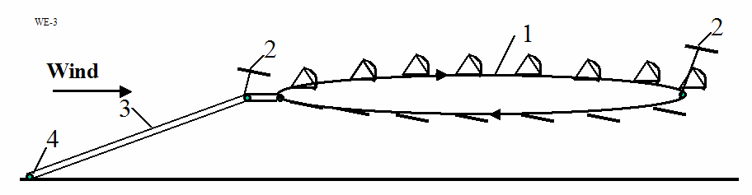
Figure 4. High altitude wind energy installation with the parachute turbine.
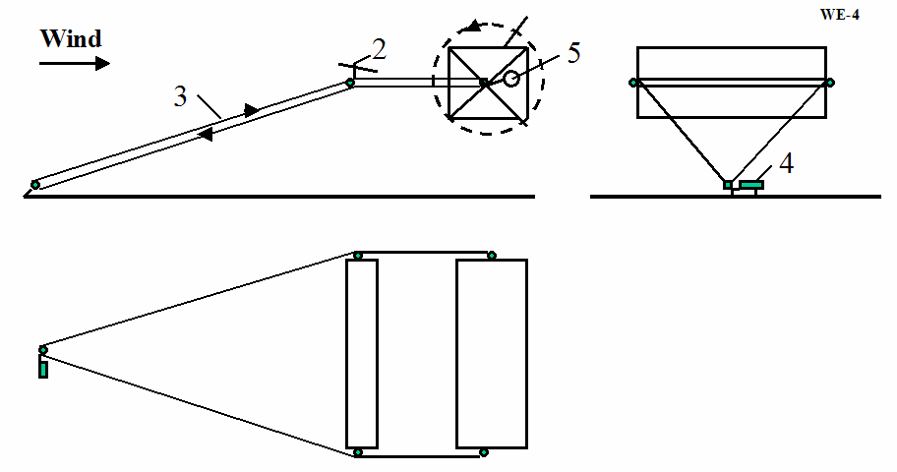
Figure 5. High altitude wind energy installation with Darrieus turbine.
Torque moment is balanced by transmission and wing ailerons (see figs.2 - 5).
The wing lift force, stress of main cable are all regulated automatic by the wing flap or blade stabilizer.
The location of the installation of Figure 3 at a given point in the atmosphere may be provided by tension elements. These tension elements provide a turning capability for the installation of approximately ± 45⁰ degrees in the direction of flow (see Figure 3.).
Minimum wind speed. The required minimum wind-speed for most of the suggested installation designs is about 2 ÷ 3 m/s. The probability of this low wing speed at high altitude is very small (less 0.001). This minimum may be decreased still further by using the turning propeller in an autogiro mode. If the wind speed is approximately zero, the rotor can be supported in the atmosphere by a balloon (dirigible) as is shown on Figure 2c or a propeller rotated by the ground power station as is shown on Figure 2d. The rotor system may also land on the ground and start again when the wind speed attains the minimum speed for flight.
A Gusty winds. Large pulsations of wind (aerodynamic energy) can be smoothed out by inertial fly-wheels.
The suggested Method and Installations for utilization of wind energy has following uniqueness ion comparison with current conventional methods and installations:
- Proposed installation allows the collection of energy from a large area – tens and even hundreds of times more than conventional wind turbines. This is possible because an expensive tower is not needed to fix our rotor in space. Our installation allows the use of a rotor with a very large diameter, for example 100 - 200 meters or more.
- The proposed wind installations can be located at high altitude 100 m - 10 km. The wind speeds are 2-4 times faster and more stable at high altitude compared to ground surface winds used by the altitude of conventional windmills (10 - 100 meters of height). In certain geographic areas high altitude wind flows have a continuous or permanent nature. Since wind power increases at the cube of wind speed, wind rotor power increases by 27 times when wind speed increases by 3 times.
- In proposed wind installation the electric generator is located at ground. Researched also the proposals where electric generator located near a wind rotor and sends electric current to a ground by electric wares. However, the rotor and power may be very large (see projects below). Proposed installations produce more power by hundreds of times compared to the typical current wind ground installation (see point 1, 2 above). The conventional electric generator of 20 MW together with transformer and wires weighs about 100 tons (specific weigh of the conventional electric generator is about 3 - 8 kg/kW). It is impossible to keep this weigh by wing at high altitude for wind speed lesser than 100 m/s. We must use the special aviation generator having high frequency and needed in special frequency converter.
- One of the main innovations of the given invention is the cable transfer (transmission) of energy from the wind rotor located at high altitude to the electric generator located on ground. In proposed Installation it is used a new cable transmission made from artificial fibers. This transmission has less a weigh in tends times then copper electric wires of equal power. The wire having diameter more 4 mm passes 1-2 ampere/sq.mm. If the electric generator produces 20 MW with voltage 1000 Volts, the wire cross-section area must be 20,000 mm², (wire diameter is 160 mm). The cross-section area of the cable transmission of equal power is only 200 mm² (cable diameter 16 mm² for cable speed 100 m/s and admissible stress 100 kg/mm², see Project 1). The specific weight of copper is 8930 kg/m³, the specific weight of artificial fibers is 1800 kg/m³. If the cable length for altitude 10 km is 25 km the double copper wire weighs 8930 tons (!!), the fiber transmission cable weighs only 8.93 tons. It means the offered cable transferor energy of equal length is easier in 100 times, than copper wire. The copper wires is very expensive, the artificial fiber is cheap.
All previous attempts to place the generator near the rotor and connect it to ground by electric transmission wires were not successful because the generator and wires are heavy. The author offers the new electric high frequency generator and transformer, new electric wires which degrease the mass of the electric system by tenths times and make one acceptable for airborne wind installation. This author also suggests in this proposed system a new electrostatic generator which has the specific mass ten times less yet produces high voltage.

Cable Energy Transmitter
The primary innovations presented in this paper are locating the rotor at high altitude, and an energy transfer system using a cable to transfer mechanical energy from the rotor to a ground power station. The critical factor for this transfer system is the weight of the cable, and its air drag.
Thirty years ago, the mass and air drag of the required cable would not allow this proposal to be possible. However, artificial fibers are currently being manufactured, which have tensile strengths of 3 - 5 times more than steel and densities 4 - 5 times less than steel. There are also experimental fibers (whiskers) which have tensile strengths 30 - 100 times more than a steel and densities 2 to 5 times less than steel. For example, in the book [9] p.158 (1989), there is a fiber (whisker) C_{D}, which has a tensile strength of σ = 8000 kg/mm² and density (specific gravity) of γ = 3.5 g/cm³. If we use an estimated strength of 3500 kg/mm² (σ = 7.10¹⁰ N/m²), γ = 3500 kg/m³, then the ratio is γ/σ = 5×10⁻⁸ or σ/γ = 2×10⁷. Although the described (1989) graphite fibers are strong (σ/γ = 10×10⁶), they are at least still ten times weaker than theory predicts. A steel fiber has a tensile strength of 5000 MPA (500 kg/sq.mm), the theoretical limit is 22,000 MPA (2200 kg/mm²)(1987); the polyethylene fiber has a tensile strength 20,000 MPA with a theoretical limit of 35,000 MPA (1987). The very high tensile strength is due to its nanotubes structure.
Apart from unique electronic properties, the mechanical behavior of nanotubes also has pique interest because nanotubes are seen as the ultimate carbon fiber, which can be used as reinforcements in advanced composite technology. Early theoretical work and recent experiments on individual nanotubes (mostly MWNT’s, Multi Wall Nano Tubes) have confirmed that nanotubes are one of the stiffest materials ever made. Whereas carbon-carbon covalent bonds are one of the strongest in nature, a structure based on a perfect arrangement of these bonds oriented along the axis of nanotubes would produce an exceedingly strong material. Traditional carbon fibers show high strength and stiffness, but fall far short of the theoretical, in-plane strength of graphite layers by an order of magnitude. Nanotubes come close to being the best fiber that can be made from graphite.
For example, whiskers of Carbon nanotube (CNT) material have a tensile strength of 200 Giga-Pascals and a Young’s modulus over 1 Tera Pascals (1999). The theory predicts 1 Tera Pascals and a Young’s modules of 1-5 Tera Pascals. The hollow structure of nanotubes makes them very light (the specific density varies from 0.8 g/cc for SWNT’s (Single Wall Nano Tubes) up to 1.8 g/cc for MWNT’s, compared to 2.26 g/cc for graphite or 7.8 g/cc for steel).
The artificial fibers are cheap and widely used in tires, fiber and many other products. The price of SiC whiskers produced by Carborundum Co. with σ = 20,690 MPa and γ = 3.22 g/cc was $440 /kg in 1989. The market price of nanotubes is too high presently (~ $200 per gram) (2000). In the last 2 - 3 years, there have been several US companies that were established to produce and market nanotubes. It is anticipated that in the next few years, nanotubes will be available to consumers for less than $100/pound.
Below, the author provides a brief overview of recent research information regarding the proposed experimental (tested) fibers. In addition, the author also addresses additional examples, which appear in these projects and which can appear as difficult as the proposed technology itself. Industrial fibers with σ = 500 - 600 kg/mm², γ = -1800 kg/m³, (safety σ = 50 - 150 kg/mm²) (see below).
In theory, metallic nanotubes can carry an electric current density of 4×10⁹ A/cm², which is more than 1,000 times greater than those of metals such as copper.
The temperature stability of carbon nanotubes is estimated to be up to 2800 °C in vacuum and about 750 °C in air.
Figures for some other experimental whiskers and industrial fibers are given in Table 1.
Table 1. Properties whiskers and fibers
Material  Whiskers | Tensile Strength  kg/mm² | Density  g/c³ | Fibers | MPa | Density  g/c³
AlB₁₂ | 2650 | 2.6 | QC-8805 | 6200 | 1.95
B | 2500 | 2.3 | TM9 | 6000 | 1.79
B₄C | 2800 | 2.5 | Thorael | 5650 | 1.81
TiB₂ | 3370 | 4.5 | Allien 1 | 5800 | 1.56
SiC | 1380–4140 | 3.22 | Allien 2 | 3000 | 0.97
See References [9]-[12].

Brief Theory of Estimation of Airborne Wind Installations

Wind (Speed, Duration, Altitude Distribution, Speed Distribution)
We can calculate the minimum and maximum acceptable wind necessary for operation of the air borne wind installation (ABWI). Our purpose is estimation of time (% or a number of days/hours in year) when the ABWI cannot operate.
Annual average wind speed. The United States Annual Average Wing Speed is taken from a map in Wind Energy Resource Atlas of the United States. The map was published in 1987 by Battelle’s Pacific Northwest Laboratory for the U.S. Department of Energy. The complete atlas can be obtained by writing the American Wind Energy Association or the National Technical Information Service. The same maps are accessible around the world. They are presented in publication of the USA Department of Energy. The maps show the average wind speed at altitude 10 and 50 meters. This speed is 4 - 8 m/sec.
Wind speed and Height. Wind speed increases with height. The speed may be computed by equation
(1)
where V₀ is the wind speed at the original height, V the speed at the new height, H₀ the original height, H the new height, and α the surface roughness exponent (Table 2).
Table 2. Typical surface roughness exponents for power
law method of estimating changes in wind speed with height
Terrain | Surface Roughness  Exponent, α
Water or ice | 0.10
Low grass or steppe | 0.14
Rural with obstacles | 0.20
Suburb and woodlands | 0.25
Reference: P.Gipe, Wind Energy comes of Age, 1995,[7].
The result of computation of equation (1) for different α is presented at Figure 6. The wind speed increases on 20 - 50% with height 1000 m.
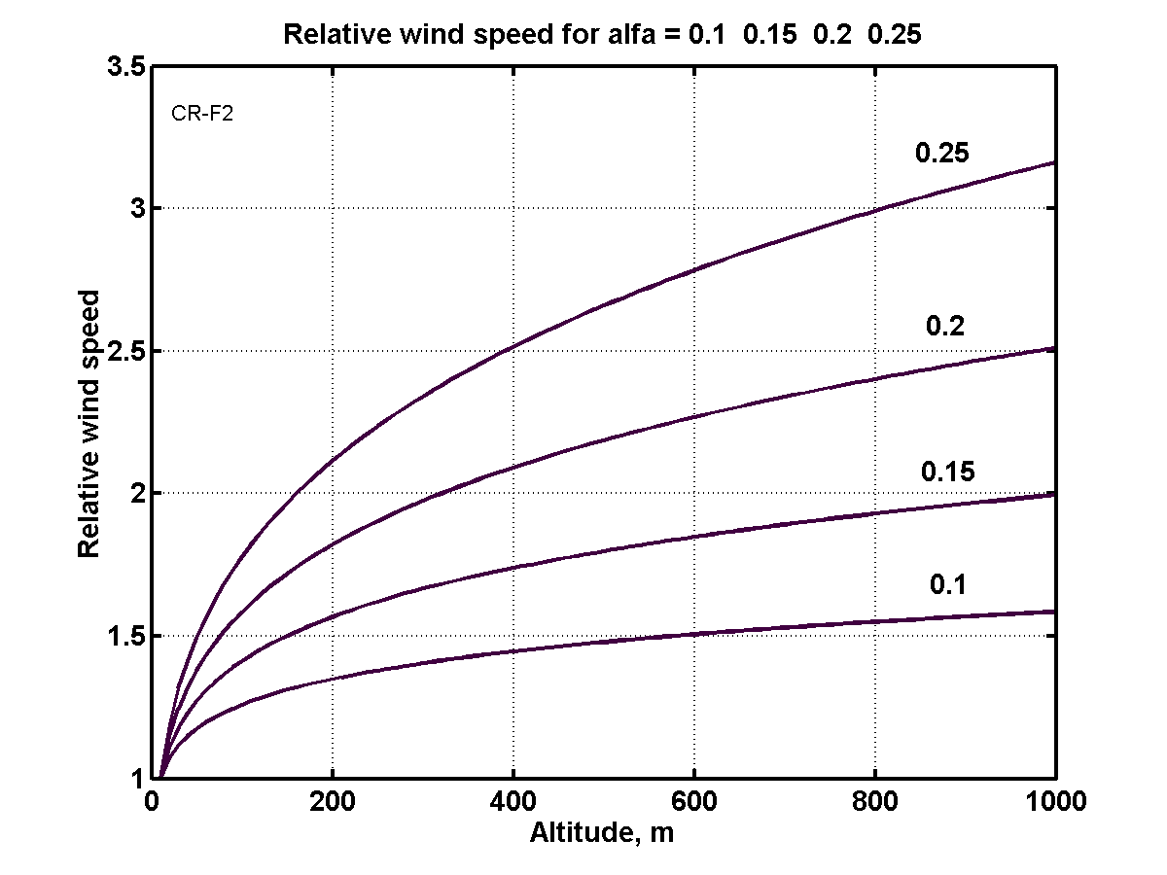
Figure 6. Relative wind speed via altitude and Earth surface. For sea and ice α = 0.1.
Annual Wind speed distribution. Annual speed distributions vary widely from one site to another, reflecting climatic and geographic conditions. Meteorologists have found that Weibull probability function best approximates the distribution of wind speeds over time at sites around the world where actual distributions of wind speeds are unavailable. The Rayleigh distribution is a special case of the Weibull function, requiring only the average speed to define the shape of the distribution.
Equation of Rayleigh distribution is
(2)

where α is parameter.
Figure 7 presents the annual wind distribution of average speeds 4, 5, and 6 m/s. These data gives possibility to easy calculate the amount (percent) days (time) when ABWI can operate in year (Figure 8). It is very important value for the estimation efficiency of offered turbines.
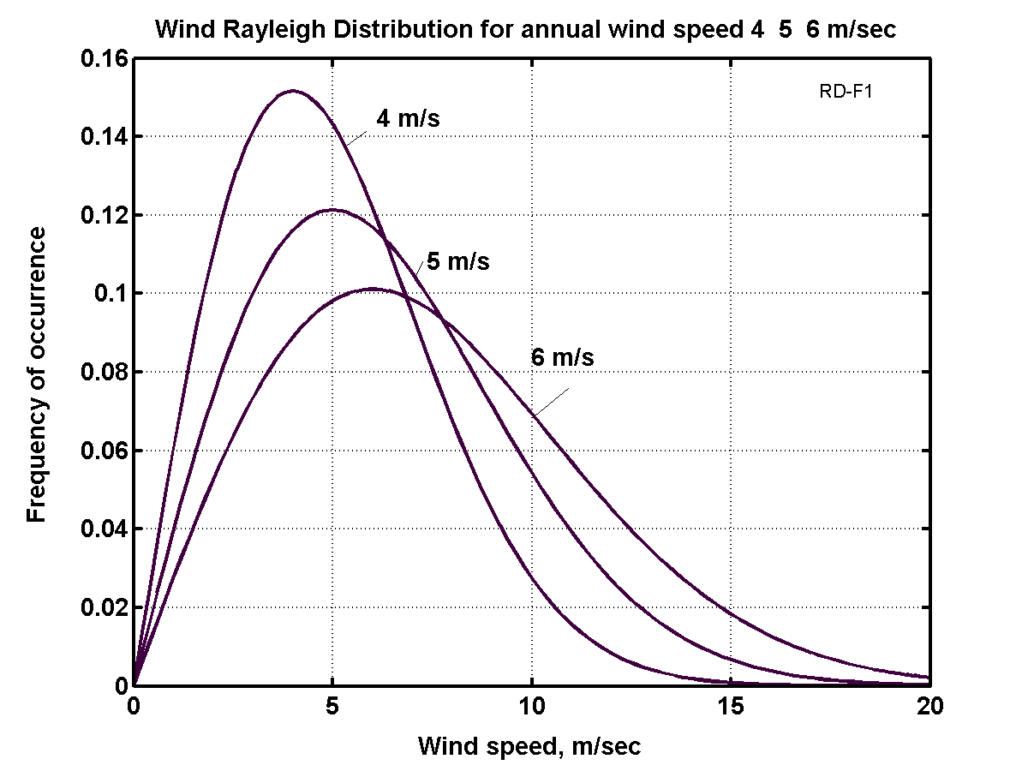
Figure 7. Wind speed distribution.
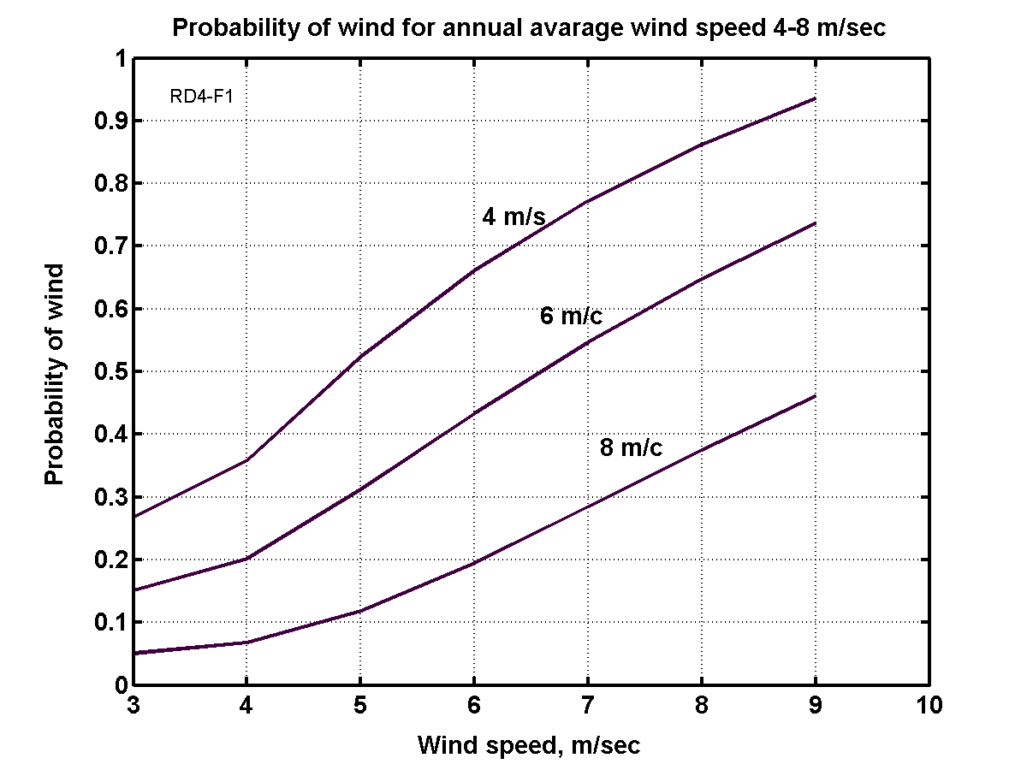
Figure 8. Probability of wind for annual average wind speed 4 - 8 m/s.
Let us compute two examples:
Assume, the observer has minimum wind speed 3 m/s, maximum safety speed 25 m/s, altitude 100 m, the average annual speed in given region is 6 m/s. From Figure 6, 7, 8, Eq. (1) , we can get the wind speed is 8.4 at H = 100m, the probability that the wind speed will be less the 2 m/s is 8%, less 3 m/sec is 15%, the probability that the wind speed will be more 25 m/s is closed to 0.
Forces of the Airborne Wind Installation
The next forces are acting in airborne wind installation: lift forces of wing and dirigible (air balloon), weight of installation (turbine + electric generator and transformer), approximately half of main cable weight, approximately half of transmission weight, drag of turbine, drag of wing, drag of dirigible (if one is used), approximately half drag of main cable, approximately half drag of transmission cable.
These forces are presented in figure 9.
The balance equations in axis x (horizontal) and axis y (vertical) are:
∑_{x} F_{c} cos α = D_{r} + D_{w} + D_{d} + 0.5D_{c} + 0.5D_{tr ,} (3)
∑_{y} L_{w} + L_{d} = F_{c} sin α + Mg + 0.5m_{c}g+ 0.5m_{tr}g . (4)
Here F_{c} is force of main cable, N; D_{r} is air drag of wind rotor/turbine, N; D_{w} is air drag of wing, N; D_{d} is air drag of dirigible, N; D_{c} is air of main cable, N; D_{tr} is air drag of transmission, N; L_{w} is wing lift force, N; L_{d} is dirigible lift force, N; M is mass of installation (air turbine + electric generator and transformer), kg; g = 9.81 m/s is Earth gravity; m_{c} is mass of main cable, kg; m_{tr} is mass of transmission cable, kg; α is angle between line from initial point at Earth to air installation and Earth surface.
For given design parameters, given angle α (α ≈ 25º ÷ 35º) and the given row of the wind speed (from given V_{min} throw the safety V_{max}) we can find (after using the equation below) the cable force F_{c} from Eq. (3) and requested the wing force L_{w} from Eq. (4) and compare with initial data (cross section of main cable area). If they are significantly different – recalculate for new data.
Figure 9. Forces active in air borne wind installation
Rotor Computation.
Power of a wind energy N [Watt, Joule/sec]
N = 0.5ηρ AV³ [W] . (5)
The coefficient of efficiency, η, equals 0.15 ÷ 0.35 for low speed propeller rotors (ratio of blade tip speed to wind speed equals λ ≈ 1); η = 0.45 ÷ 0.5 for high speed propeller rotors (λ = 5-7). The Darrieus rotor has η = 0.35 - 0.4. The gyroplane rotor has 0.1 ÷ 0.15. The air balloon and the drag (parachute) rotor has η = 0.15 - 0.2. The Makani rotor has 0.15 ÷ 0.25. The theoretical maximum equals η = 0.67. A - front area of rotor, air balloon or parachute [m²]. ρ - density of air: ρ_{o} =1.225 kg/m³ for air at sea level altitude H = 0; ρ = 0.736 at altitude H = 5 km; ρ = 0.413 at H = 10 km. V is average annually wind speed, m/s.
Table 3. Relative density ρ_{r} and temperature of the standard atmosphere via altitude
H, km | 0 | 0.4 | 1 | 2 | 3 | 6 | 8 | 10 | 12
ρ_{r}=ρ/ρ_{o} | 1 | 0.954 | 0.887 | 0.784 | 0.692 | 0.466 | 0.352 | 0.261 | 0.191
T, K | 288 | 287 | 282 | 276 | 269 | 250 | 237 | 223 | 217
Issue [ 6 ].
The salient point here is that the wind power very strong depends from the wind speed (in third order!). If the wind speed increases by two times, the power increases by 8 times. If the wind speed increases 3 times, the wind power increases 27 times!
The wind speed increases in altitude and can reach in constant air stream at altitude H = 5 – 7 km up V = 30 – 40 m/s. At altitude the wind is more stable/constant which is one of the major advantages that the airborne wind rotor can has over ground wind rotor.
For comparison of different systems of wind rotors the engineers must make computations for average annual wind speed V₀ = 6 m/s and altitude H₀ = 10 m. For standard wind speed and altitude the wind power equals 66 W. The modern propeller wind turbines have diameter up 132 – 154 m. For their comparison the engineers take the average standard the H₀ = 50 m and V₀ = 10 m/s. The power of the propeller turbine having rotor diameter 154 m reaches up 5.6 MW for standard conditions.
The energy, E, is produced in one year is (1 year ≈ 30.2×10⁶ work sec) [J]
E = 3600×24×350N ≈ 30×10⁶N, [J]. (6)
The drag of the rotor equals
D_{r} = N/V, [N]. (7)
The drag of the dirigible is
D_{d} = 0.5C_{D,d}ρV²A_{d} , [N], (8)
C_{D,d} ≈ 0.01÷ 0.03 is coefficient of air drag; A_{d} is cross section of dirigible A_{d} = πd²/4 , m².
The lift force of the wing,
L_{w}, is L_{w} = 0.5C_{L}ρ V²A_{w}, [N], (9)
where C_{L} is lift coefficient (maximum C_{L} ≈ 2 - 2.5); A_{w} is area of the wing, m².
The drag of the wing is
D_{w} = 0.5C_{D}ρV²A_{w}, [N], (10)
where C_{D} is the drag coefficient (C_{D} ≈ 0.02 ÷ 0.2).
The air drag, D_{c} , of main cable and air drag, D_{tr} , of the transmission cable is
D_{c} = 0.5C_{d,c}ρV²Hd_{c} , D_{tr} = 0.5C_{d,r}V²Hd_{tr}, [N], (11)
where C_{d,c} - drag coefficient of main cable, C_{d,c} ≈ 0.05 – 0.15; H is rotor altitude, m; d_{c} is diameter of the main cable, m. C_{d,r} - drag coefficient of the transmission cable, C_{d,r} ≈ 0.05 – 0.15; d_{tr} is diameter of the transmission cable, m. Only half of this drag must be added to the total drag of wind installation:
D ≈ D_{r} + D_{w} + D_{d} + 0.5D_{c} + 0.5D_{tr}, [N] (12)
If the wind installation is supported by dirigible, the lift force and air drag of dirigible must be added to wing lift force (6) and total (9) of system. The useful lift force of dirigible is about 5 N/m³ (0,5 kg/m³) at H = 0 and zero at H = 6 km. Full lift force is:
L = L_{w} + L_{d} – Mg – 0.5g(m_{c} + m_{tr}) , [N]. (13)
Here M is mass of installation (propeller + reducer + electro-generator + transformer), kg; g = 9.81 m/s² is Earth acceleration. Lift force of dirigible L_{d} ≈ 5U_{d} [N], where U_{d} is dirigible volume, m³.
The mass of main and transmission cable are:
m_{c} = γ_{c}S_{c}L, m_{tr} = 2γ_{tr}S_{tr}L, [kg], (14)
where γ_{c} is specific weight/density of cables, kg/m³, γ_{c} ≈ 1500 ÷ 1800 kg/m³; S_{c} is cross section area of cables, m²; L is length of cable, m.
Required diameter of propeller for the power P = 100 kW and V = 10 m/s is 22.5 m; for speed V = 15 m/s diameter is 12.3 m.
The optimal speed of the parachute rotor equals 1/3V and the theoretical maximum of efficiency coefficient is η = 0.5, real is 0.2.
The average angle α of connection line to horizon is
sin α ≈ L/D, (15)
The annual energy produced by the wind energy extraction installation equals
E = 8.33N [kWh] . (16)
Cable Energy Transfer, Wing Area, and other Parameters
Cross-section area of the mechanical transmission cable,
S_{t} , is S_{t} = N/vσ , (17)
where N is transmission energy, W; v is speed of mechanical transmission, m/s; σ is safety stress of the mechanical transmission cable N/m², for good artificial fibers σ ≈ 50 ÷ 100 N/mm² (σ ≈ (50 ÷ 100)×10⁶ N/m²). For long mechanical transmission v ≈ 50 ÷ 150 m/s.
The cable force from wind turbine is
F_{t} = N/v, (18)
For example, if the transmission energy is N = 100 kW, speed of the mechanical transmission is v = 50 m/s, safety stress of artificial fiber is σ = 100 kg/mm² = 10⁹ N/m², the cross-section area of the mechanical transmission cable is s_{m} = 2 mm² = 2×10⁻⁶ m². Diameter of the cable is d = 1.6 mm². F_{t} = N/v = 10⁵/50 = 2000 N.
The air drag of transmission cable D_{t} , opposed the moving force is
D_{t} = 0.5C_{D}ρv²S_{t} , (19)
where C_{D} ≈ 0.008 ÷ 0.012 is air drag coefficient; ρ is air density, kg/m³, S_{t} is surface area of cable, m². The surface area of double transmission cable is
S_{t} = πd²L_{c}/2, (20)
where d is diameter of the cable, m; L_{c} is length of the cable, m.
The coefficient of transmission efficiency is
η = 1 – D_{t}/F_{t} , (21)
For our cable and L_{c} = 1 km = 1000 m, the S_{t} = 10 m² . N = 100 kW, F_{t} = 2000 N and air drag D_{t} = 150 N (Newton)/km, coefficient efficiency is η = 0.9625 km⁻¹.
Cross-section area of main cable, S_{m} , is
S_{m} $=\frac{\sqrt{D^{2}+L^{2}}}{σ}$ [m²] , (22)
where σ is the safety stress of the main cable N/m².
The production cost, c, in kWh is
, (23)
where M₀ – annual maintenance [$]; I₀ - cost of Installation [$]; K₁ - life time (years); E - annual energy produced by flow installation [J];
The annual profit
F₀ = (C-c)E . (24)
where F₀ – annual profit [$]; C - retail price of 1 kWh [$].
In first estimation of the required area of the support wing is about
A_{w} ≈ ηAsinα/C_{L ,} (25)
where α is the angle between the support cable and horizontal surface.
The wing area is served by ailerons for balancing of the rotor (propeller) torque moment
, (26)
r - distance from center of wing to center of aileron [m]; R - radius of rotor (turbine)[m]; ΔC_{L,a} - difference of lift coefficient between left and right ailerons;
The minimum wind speed for installation support by the wing alone
, (27)
where W = L is force of the total weight of the airborne system including transmission, [N]. If a propeller rotor is used in a gyroplane mode, minimal speed will decrease by 2 – 2.5 times. If wind speed equals zero, the required power for driving the propeller in a propulsion (helicopter) mode is
N_{s} = W/K₂ [kW], (28)
where W - weight of installation (rotor + generator + transformer + cables)[kg]; K₂ – rotor lift coefficient (5 - 12 [kg/kW]).
The specific weight of energy storage (flywheel) can be estimated by
E_{s}=σ/2γ [J/kg]. (29)
For example, if σ = 200 kg/mm², γ = 1800 kg/m³, then E_{s}= 0.56 MJ/kg or E_{s}= 0.15 kWh/kg.
Electric Transfer of Energy
Properties of the matter needed for computation of characteristics of the electric line from airborne rotor to ground installation is below.
1. Electric current safety for different wires.
Table 4. Safe electric currents via different materials and cross-section of wires [16 ] p.115.
Cross-section wire  mm²/matter | 1 | 1.5 | 2.5 | 4 | 10 | 25 | Resistance,  Ohm..m  ρ, 10⁻⁸ | Specific  weight,  γ, kg/m³
Aluminum | 8 | 11 | 16 | 20 | 34 | 80 | 2.8 | 2700
Copper | 11 | 14 | 20 | 25 | 43 | 100 | 1.75 | 8930
Iron | - | - | 6 | 10 | 17 | - | 9.8 | 7900
Author employs electric wire design which allows permanently maintaining the electric current safely at about 10 A/mm². It is that value which we use in our calculation.
Table 5. Spark gap between bare wires in atmosphere. [16] p.126.
El.Voltage,  kV | Distance,  mm | El.Voltage,  kV | Distance,  mm | El.Voltage,  kV | Distance,  mm
20 | 16 | 100 | 200 | 300 | 600
40 | 46 | 200 | 410
Table 6. Dielectric strength of insulators [5]-[6].
Matter | MV/m
Lexan | 320 - 640
Kapton H | 120 – 320
Mylar | 160 - 640
Parylene | 240 - 400
Polyethylene | 500– 700*
Vacuum | 100
Air | 1 - 3
*For room temperature
2. Mass m_{e} [kg/kW.km] of the 1 km electric wires is
s = P/(pU) , m_{e} = 2k₂γsL, (30)
were s is cross section of electric wire, m²; p ≈ 5 ÷ 10 A/mm² is safety electric current A/m²; U is voltage, V; k₂ ≈ 2 ÷ 3 is insulator coefficient, γ is the specific weight of wire, kg/m³; L is length of wire, m; P is electric power, W. For example, if P = 10⁵ W = 100 kW, U = 10⁴ V, p = 10 A/mm² = 10⁷A/m², γ = 2800 kg/m³ (aluminum wire), L = 1000 m, the s = 1 mm², than m_{c} ≈ 11 kg/km, or m_{c} ≈ 0.11 kg/(kW.km).
3. Electric resistance and coefficient of electric efficiency are:
R = ρ_{e}L/s, η = 1 – ΔU/U = 1 – 2Iρ_{e}L/sU , (31)
where R is electric resistance, Ω; ρ_{e} is coefficient of electric resistance (Table # 1), ohm.m; η is coefficient electric efficiency; I is electric currency, A; ΔU is the loss of voltage in transmission wire, V; s is cross-section of wire, m². Example, if P = 10⁵ W = 100 kW, U = 10⁴ V, p = 10 A/mm² = 10⁷A/m², ρ_{e} = 2.8×10⁻⁸ Ω.m (aluminum wire), L = 1000 m, the s = 1 mm², then η = 0.944 km⁻¹.
4. Air drag of main cable and electric wires, connected in one cable is
D_{c+w} = 0.5C_{D}ρ_{a}V²A_{c+w} , [N], A_{c+w} = s_{c+w}H , (32)
where C_{D} is the drag coefficient C_{D} = 0.015 ÷ 0.15; ρ_{a} – air density, ρ_{a} ≈ 1 kg/m³; s_{c+w} is cross-section area of common cable, H is altitude, m. Example, if s_{c+w} = 3×10⁻⁶ m², H = 1000 m, V = 15 m/s, C_{D} = 0.02, then D_{c+w} = 500 N/km.
5. Electric generator.
Specific mass of the conventional (car) electric generator is about 4 – 5 kg/kW. This mass is inversely related to electric frequency. Standard electric frequency is 50 Hertz. Aviation generator which has frequency 400 Hertz has specific mass of about 0.5 kg/kW. Example, the aviation electric generator ГТ120 П46А (Russia) has power N = 120 kW, U = 120/208 V, frequency is ν = 400 Hertz, n = 100 ÷ 6000 revolution/min, mass 67 kg, cooling by air. That means we can take for our estimation the specific weight about 0.5 kg/kW.
6. Transformer.
For passing the electric energy from airborne turbine to the Earth we need the electric transformer which converts the electric energy to high voltage. That allows decreasing the weight the electric wire. The typical data of the conventional 3-fases transformer is following: the transformer having power 100 kW, frequency 50 Hertz has weight 505 kg, site 890×1105×600 mm, enter 400 V, exit 6/10 kV. The Transformer ТМГ-1000/6-10 has power 1000 kW, weight 2900 kg, frequency 50 Hertz, enter 400 V, exit 6/10 kV, cooling – oil. That is not suitable for us because the weight and size is big. If we will use the frequency 400 Hertz the transformer weight decreases in 400/50 = 8 times and equals about 0.5 kg/kW. That is acceptable. But it is possible that there will be cooling problem of generator and transformer.
The offered electric system needs in the frequency convector 400 Hertz to 50 Hertz or rectifier. But one is located on Earth surface and is needed for all airborne turbines having the electric transmission.
The total mass of electric transmission system (electric generator + transformer + wires) is about additional 1.2 ÷ 1.5 kg/kW in comparison with mechanical system having 0.3 ÷ 0.5 kg/kW. That also increases also the requested the wing area and weight, because the wing must support the full installation in minimal wind speed. But the electric translation system is better equipped for changing the altitude which allows selection of the altitude where is the wind speed is optimal. If we want an airborne wind system without transformer, we must design special high voltage generator.
The ABWI having an electric transmission is a high altitude lighting conductor in storm and, as such, is in need of special equipment for this case as protection or landing system.
7. Result of estimation the electric transfer/system.
The total mass of the airborne wind installation (P = 100 KW, L = 1 km) with electric transfer is:
Rotor (propeller): 1 kg/kW,
Wing: 1 ÷ 2 kg/m² , or 1.5 ÷ 3 kg/kW ,
Electric generator + transformer: 1 ÷ 1.2 kg/kW,
Main cable: 0.4 ÷ 0.6 kg/kW.km (turbine gets ≈ 50% of this weight),
Electric wires: 0.1 ÷ 0.15 kg/kW.km (turbine gets ≈ 50% of this weight); or
Mechanical transmission 0.1 ÷ 0.15 kg/kW.km (turbine gets ≈ 50% of this weight).
Total mass is about 4 ÷ 5 kg/kW, or 400 ÷ 500 kg (for average P = 100 kW). Mass of wing is 200 ÷ 250 kg (wing have the area 150 ÷ 200 m² and support the installation for a minimal wind speed 3 ÷ 5 m/s).
If airborne wind installation has the mechanical transmission then the total mass of installation will be about two times less, but airborne wind installation will require developing a special system for change the altitude.
The dirigible (special air balloon) can support the airborne in windless conditions. The needed volume is about 900 m³ for the electric transmission and 500 m³ for the mechanical transmission. Size of dirigible is 14×60 m and 10×45 m respectively. Support by dirigible is very useful because for exploitation of the airborne wind installation because we not expend energy for supporting the turbine at altitude in weak winds (speed less 3 m/s) or in windless conditions. This situation may be in 5 ÷ 10% of total time in low (< 1 ÷ 2 km) altitudes.
8. Electrostatic generator.
Electrostatic generator produces electricity of a very high voltage and is not encumbered by have heavy iron and wire, nor does it have a cooling problem. The relative mass may be less than mass of the magnetic generator and transformer. The estimation of mass can be made by equations: m_{g} = M_{g}/P, P = IV, I = qv, q = cU, c = ε_{o}S/a, (33)
where m_{g} is relative mass of electrostatic generator, kg/kW; M_{g} is mass of generator, kg; P is power, kW; I is electric currency, A; V is voltage, produced by generator, V; q is electric charge, C; v is relative speed of generator plates, m/s; c is electric capacity of plates, F; U is voltage between plates, V; ε_{o} = 8.85×10⁻¹² is electric constant, F/m; S is area of plates, m²; a is distance between plates, m.
Let us, for example, take 250 plates of area 1 m² each with distance 2 mm and voltage between plates U = 10⁵ V and thickness of isolator 1 mm, the plate speed v = 700 m/s. We take the exit voltage of generator V = 2×10⁵ V. Produced voltage V may be any (up 1 MV), but transfer more high voltage to Earth surface is difficult. Estimation show: the electric current may be I = 350 A and mass of generator M_{g} = 1000 kg, size 1.2×1.2 m (diameter × length). The produced energy will be P = 70 MW. The relative mass is m_{g} ≈ 0.015 kg/kW which is a very small value which shows the electrostatic generator/engine is very perspective for R&D. But design power electrostatic generator is not an easy problem to solve.
Total Estimation and Optimization Airborne Wind System
Below are summary equations which help estimate and select the suitable parameters of installation. The first equation is preliminary; the second/last equation is final.
- Relative mass m_{e} [kg/W] of the electric cable m_{e} = M_{e}/N , m_{e} = 2k₁γ_{e}L/pU , (34)
where M_{e} is wire mass, kg; N is transfer power, W; k₁ ≈ 2 is relative mass of insulator; γ_{e} is
specific mass of wire, kg/m³; L is length of wire, m; p is safety density of electric current,
A/m²; U is electric voltage of system, V.
- Coefficient of electric efficiency of electric wire transmission
η = 1 – ΔU/U, η = 1 – 2pρL/U , (35)
where ΔU is loss of voltage in transmission wire, V; U is voltage of full system V; ρ is specific electric resistance of wire, Ω.m. Increasing of voltage reduces the electric loss and mass of electric wire.
- Relative mass m_{g} [kg/W] of the electric generator and electric transformer
m_{g} = 2k₂μ_{o}γ/B²ν , (36)
where k₂ ≈ 2 is relative mass of generator/transformer wire; μ_{o} = 4π×10⁻⁷ is magnetic constant; γ = 7900 kg/m³ is specific mass of the generator/transformer iron, B ≈ 1 is maximal magnetic inductivity; ν is electric frequency, Hertz. Increasing of the electric frequency reduces the generator and transformer mass, but complicates their cooling.
- Relative mass m_{c} [kg/W] of main cable m_{c} = M_{c}/N , m_{c} = 2γ_{c}Lcosα/σV , (37)
where M_{c} is mass of main cable, kg; σ is safety stress of main cable, N/m²; V is wind speed, m/s; γ_{c} is the specific mass of the main cable;
- Relative mass m_{c} [kg/W] of mechanical transmission cable
m_{t} = M_{t}/N, m_{t} = γ_{t}L/σV, (38)
where M_{t} is mass of transmission cable, kg; σ is safety stress of transmission cable, N/m²; V is wind speed, m/s; γ_{t} is the specific mass of the transmission cable.
- Coefficient of efficiency the mechanical transmission
η = 1 – D_{f}v/N , η = 1 – C_{f} ρv³Ld/N , η = 1 – 2π^{0.5}C_{f} ρv³L/(σVN)^{0.5} , (39)
where D_{f} is friction drag of transmission, N; v is transmission speed, m/s; C_{f} is coefficient of friction drag; d is diameter of transmission cable, m. As you see the degreasing of the transmission speed ν can significantly reduce the transmission loss. ρ is air density, kg/m³.
Cost of construction and economy of wind turbines.
Cost of renewable energy
Average cost of the ground wind installation in 2012 were: 1 kW - $2K, 2 kW - $3.5K, 5 kW - $14K, 10kW – 35 ÷ 50K. Wind turbine $1,3 ÷ 2,2M per MW. Ground transmission $1500/km. The average allocation of cost: tower 27%, rotor blades 21%, generator 4%, transformer 4%, power convertor 6%, gearbox 11%, others 27%.
Table 7: Comparison of capital cost breakdown for typical onshore and offshore wind power systems in developed countries, 2011
Source: Blanco, 2009; EWEA, 2009; Douglas-Westwood, 2010; and Make Consulting, 2011c.
Onshore Offshore
Capital investment costs (USD/kW) 1 700-2 450 3 300-5 000
Wind turbine cost share¹ (%) 65-84 30-50
Grid connection cost share² (%) 9-14 15-30
Construction cost share³ (%) 4-16 15-25
Other capital cost share⁴ (%) 4-10 8-30
----------------------------------------------------------------------------------------------------------------
¹ Wind turbine costs includes the turbine production, transportation and installation of the turbine.
² Grid connection costs include cabling, substations and buildings.
³ The construction costs include transportation and installation of wind turbine and tower, construction wind turbine foundation (tower), and building roads and other related infrastructure required for installation of wind turbines.
⁴ Other capital cost here include development and engineering costs, licensing procedures, consultancy and permits, SCADA (Supervisory, Control and Data Acquisition) and monitoring systems.
Comparison of different airborne designs
There are a number of alternative designs of airborne wind turbines. Unfortunately in many cases the inventors are people who do not have the needed technical education, cannot develop the corresponded theory, and make the correct estimations and computations. Unfortunately, the entire wind energy industry is plagued by the paucity of contiguity of scientific knowhow and business acumen. Governmental agency and business leaders most often do not select the projects that are scientifically feasible. Conversely, some inventors are well connected with funding sources; be they governmental authorities or heads of large companies. They may receive large grants for perspective projects with little scientific merit. Before funding a high altitude wind energy device, mathematical modeling is necessary to detail the physics in order to persuade the experts that it is not only physically feasible but economically feasible and largely profitable.
Wind at high altitudes is faster and more consistent than winds near the Earth’s surface and contains more than three times the power providing a phenomenal untapped resource. A comprehensive understanding of winds ranging from the upper boundary layer through the upper troposphere and its availability is critical to the development of our technology. Let us estimate the parameters of some airborne wind systems same power (100 kW). The first systems will have this power.
1. Mogenn and system is lighter than air (MARS).
Some of these systems shown in Fig. 10 are air balloon having shoulder blades which rotate the balloon under wind.
If the strong wind is V = 15 m/s and coefficient of efficiency η = 0.15 the requested the frond area of balloon is
A = P/(0.5ηρV³) ≈ 400 m² , (38)
If length of balloon is 3 times of diameter, the diameter of balloon will be about 12 m, length 36 m and volume 4500 m³. The helium cost was ≈ $16/m³ at 2012. Total cost only helium is $72K. Useful (without weight of balloon) lift force is 23000 N = 2300 kg. The mass of good generator + transmission ≈ 300 kg.
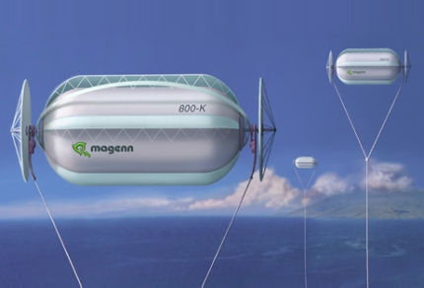
Fig.10. The airborne wind system which are lighter than air.
Air drag of balloon is
D = 0.5C_{D}ρV²A = 0.5×0.3×1×15²×400 = 13500 N . (39)
Angle of the main cable to horizon in wind 15 m/s is about 35 ÷ 40º. It is acceptable. But in storm the wind can reach the speed up 35 m/s and angle will be about 10 ÷ 12º. That is not good especially at city having high buildings.
Magenn Power is developing a 10 kW airborne wind turbine system that floats 1,000 feet in the air, tethered to the ground. The inflatable Helium balloon portion of the device has vanes on it that capture the wind energy, similar to a paddle wheel, turning it on a horizontal axis that is fastened on two ends. A generator is affixed to both ends, and the electricity is transmitted down the tether to the ground.
The set-up costs for MARS are projected to run around $4 to $5 per Watt. In comparison, the set-up costs for a traditional utility-scale wind farm run around $2.5 to $3 per Watt. But those are huge installations, and require a good ground-level wind profile. The Magenn system can go where the wind farms are not feasible. The installation costs for a comparable Diesel generator system are about $1.00 per Watt, but then there is the continual cost of the fuel to run the generators. Magenn has secured around a $1 million (Canadian) grant from the Canadian government to further their refinement of the design. The grant is a matching-funds grant, contingent on Magenn being able to raise $2 million from private sources. Magenn landed a separate $300,000 grant to build a 1 kW sized unit. It is unknown what was actually built.
2. The airborne wind propeller supported by dirigible.
This design is presented in fig. 11. It is acceptable for altitude up 3 – 5 km. One may be also used for lifting and delivering of loads. Disadvantage is high cost of installation.
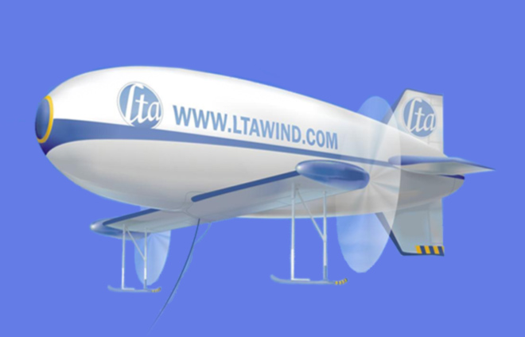
Fig. 11. Air borne wind propeller supported by dirigible.
The properties and data of this ABWI can be easily estimated by our theory.
3. The autogyro (gyroplane) rotor
Fig. 12 illustrates one of the autogyro designs by inventor Roberts.
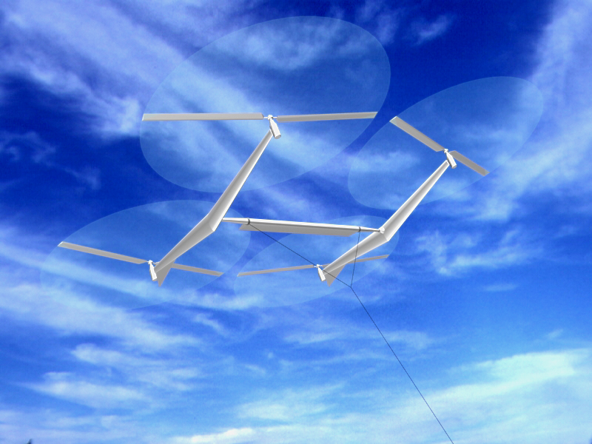
Fig. 12. Autogyro wind rotor
In Roberts design, if the wind is V = 15 m/s and coefficient of efficiency η = 0.15, the requested the area of propellers is A = 400 m². Or diameter of the 4 propellers is D = 11.3 m each. Gyroplanes rotor is easy for design. The flying windmills would initially get in position under their own power, using their motors to drive the propeller blades and helicopter upwards until they reached altitude. Then the motors would turn off and become generators as wind pushes the propeller blades, and the whirligig would float instead of fall because when tethered, the lift generated by the wind would overcome the craft's weight as it also generates power.
His claims are unrealistic because the power 240 kW for a diameter less than 10.7 m because the autogyro rotor axis has small angle to vertical line (10 ÷ 20º not 90º as conventional wind propeller). It is necessary because the autogyro rotor must also produce the vertical force for supporting the weight of installation. The problem of transporting of wind energy to the Earth surface is the same problem for all airborne wind rotors. The other problem is saving the installation in stormy weather because the propellers may be damaged by very strong wind. In contrast, the designs detailed in this paper include proposals which avoid these disadvantages.
4. Tube Airborne Wind Energy.
An air balloon tube and propeller installed inside tube is a wind installation is shown in fig. 13.
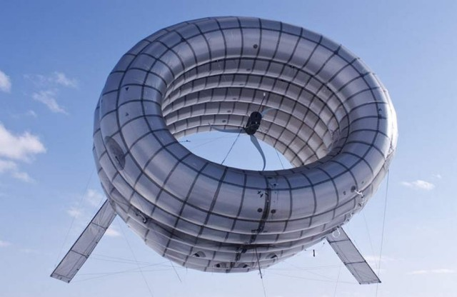
Fig.13. Altaeros Wind turbines
The company describes the installation as the Altaerod Airborne Wind Turbine, which makes use of an inflatable shell filled with helium, allowing it to gain high altitude. This gives it better access to more consistent and stronger winds, much higher than those turbines mounted on towers. The power uses tethers to reach the ground. Harnessing winds at higher altitudes will allow the turbine to reduce the costs of energy by almost 65%. Since it has a unique design that is easily installed, the start-up time amounts to only days, which means that each shell can be prepared and assembled more readily, for increased energy production.”
The corrected design of tube can increase the speed inside maximum in 2^{0.5} times or the power in 2.8 times. But from figure 13 it is obvious that the inventor does not know aerodynamics and the presented installation is not efficient.
5. Makani Airborne Wind Turbine.
The original airborne turbine was offered by Makani figs.14 – 15. That is a single blade which flies in a circle. Blade has the propellers which produce the electric energy. If no wind the propellers may consume the energy from ground installation. They also lift the installation to altitude.
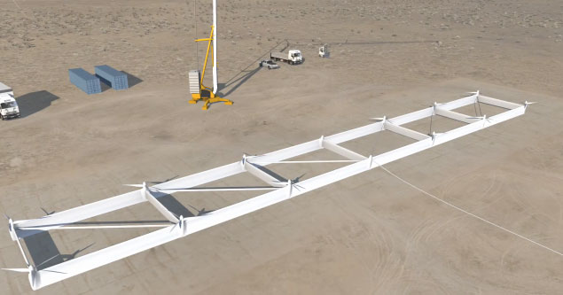
Fig. 14. Makani airborne wind turbine at Earth surface.
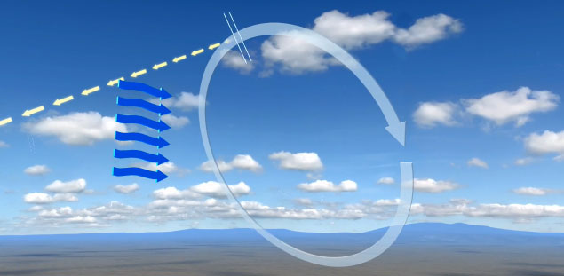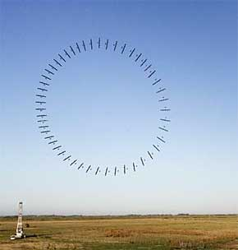
Fig.15. Makani Airborne Wind Turbine in air.
Joby Energy Co. is developing airborne wind turbines which will operate in the upper boundary layer and the upper troposphere. Their description from their company advertising: “Joby Energy’s multi-wing structure supports an array of turbines. The turbines connect to motor-generators which produce thrust during takeoff and generate power during crosswind flight. Orientation in flight is maintained by an advanced computer system that drives aerodynamic surfaces on the wings and differentially controls rotor speeds. A reinforced composite tether transmits electricity and moors the system to the ground. The high redundancy of the array configuration can handle multiple points of failure and remain airborne. For launch, the turbines are supplied with power to enable vertical take-off. Upon reaching operating altitude, the system uses the power of the wind to fly cross-wind in a circular path. The high cross-wind speeds result in the turbines spinning the generators at high speeds, eliminating the need for gearboxes and increasing efficiency. The energy is transferred to the ground through the electrical tether. During occasional periods of low wind the turbines are powered to land the system safely.”
Capacity Comparison. A comparison between the energy output potential of a 2 MW conventional turbine operating at 400 feet and a 2 MW Joby Energy airborne wind turbine operating at 2,000 feet shows a significant improvement in capacity factor. Our airborne wind turbine yields a capacity factor of nearly double the conventional turbine.
An airborne wind turbine must utilize less material than those found in ground based wind turbines. It is estimated that the Makani turbine will be 1/10 the weight of a standard wind turbine and cost half the price to install. It will be rated at the same amount of power. The price per kilowatt-hour would be even lower than coal-fired power at the present time, or about three cents per kilowatt hour.

The rotors on the flying wing of the Makani turbine function as generators and propellers. They use stored or backup power to reach their cruising altitude. When they reach 1,000 feet (≈ 300 m) in altitude, they begin creating resistance to the higher winds and then generate electricity just like electric cars do with their brakes.

Is this turbine affected when there is no wind? The wing structures can use steady breezes to remain aloft, but if the wind goes below nine miles per hour, they would actually use electricity instead of generating it. Plans are to land the wing if there are long periods of forecasted low winds. But it will still be able to generate electricity with double the consistency of wind farms that are in operation today. This is due to the winds at the increased altitude, which may be twice as strong as those on the ground.

The future of the Makani airborne wind turbine looks quite bright. It won Popular Mechanics' Energy Breakthrough Award and got three million dollars in grant money from the Department of Energy. It also received 20 million dollars from Google, for venture capital funding.

In order to be fully successful, the airborne wind turbine must be able to generate a consistent and high rate of power. They are developing a larger turbine system that will float at about 1600 feet (≈ 500 m) in altitude, and this can potentially produce enough power for 600 houses. The prototype of this design should be launched in 2013 and in operation commercially in 2015. The Makani turbine may also be used above deeper offshore water, where even more energy can be produced. Fig.14 shows the company does not have good specialists. The offered installation is unstable and very complex in operation. Company received large sums of money but did not create any successful design.

Projects with mechanical transmission

Project 1. High-speed air propeller rotor (fig.2)
For example, let us consider a rotor diameter of 100 m (A = 7850 m²), at an altitude H = 10 km (ρ = 0.4135 kg/m³), wind speed of V = 30 m/s, an efficiency coefficient of η = 0.5, and a cable tensile stress of σ = 200 kg/mm². Then the power produced is N = 22 MW [Eq. (5)], which is sufficient for city with a population of 250,000. The rotor drag is D_{r} = 73 tons [Eq.(7)], the cross-section of the main cable area is S =1.4D_{r}/σ =l.35×73/0.2 ≈ 500 mm², the cable diameter equals d = 25 mm; and the cable weight is W = 22.5 tons (for L = 25 km). The cross-section of the transmission cable is 36.5 mm², d = 6.8 mm, weight of two transmission cables is 3.33 tons for cable speed v =300 m/s [Eq.(14)]. The required wing size is 20×100 m (C_{L} = 0.8), wing area served by ailerons is 820 sq.m. If C_{L}=2, the minimum speed is 3 m/s. The installation will produce an annual energy E =190 GWh [Eq.(16)]. If the installation cost is $200K, has a useful life of 10 years, and requires maintenance of $50K per year, the production cost is c = 0.37 cent per kWh [Eq(23)]. If retail price is $0.15 per kWh, profit $0.1 per kWh, the total annual profit is $19 million per year [Eq.(24)].

Project 2. Air low speed wind engine with free flying cable flexible rotor (fig.3)
Let us consider the size of cable rotor of width 50 m, a rotor diameter of 1000 m, then the rotor area is A = 50×1000 = 50,000 sq.m. The angle rope to a horizon is 70º. The angle of ratio lift/drag is about 2.5º. The average conventional wind speed at an altitude H = 10 m is V = 6 m/s. It means that the speed at the altitude 1000 m is 11.4 - 15 m/s. Let us take average wind speed V=13 m/s at an altitude H = 1 km. The power of flow is N=0.5.ρV³Acos20⁰=0.5×1.225×13³×1000×50×0.94=63 MW.
If the coefficient efficiency is η = 0.2 the power of installation is η = 0.2×63 = 12.5 MW. The energy 12.5 MW is enough for a city with a population at 150,000. If we decrease our Installation to a 100x2000 m the power decreases approximately by 6 times (because the area decreases by 4 times, wind speed reaches more 15 m/s at this altitude. Power will be 75 MW. This is enough for a city with a population about 1 million of people.
If the average wind speed is different for given location the power for the basis installation will be: V =5 m/s, N =7.25 MW; V =6 m/s, N =12.5 MW; V=7 m/s, N = 19.9 MW; V = 8 m/s, N = 29,6 MW; V = 9 m/s, N = 42.2 MW; V = 10 m/s, N = 57.9 MW.
Economic efficiency
Let us assume that the cost of our installation is $1 million. According to the book “Wind Power” by P. Gipe [7], the conventional wind installation with the rotor diameter 7 m costs $20,000 and for average wind speeds of 6 m/s has power 2.28 kW, producing 20,000 kWh per year. To produce the same amount of power as our installation using by conventional methods, we would need 5482 (12500/2.28) conventional rotors, costing $110 million or 28M for costing 5K each installation. Let us assume that our installation has a useful life of 10 years and a maintenance cost is $50,000/year. Our installation produces 109,500,000 kWh energy per year. Production costs of energy will be approximately 150,000/109,500,000 = 0.14 cent/kWh. The retail price of 1 kWh of energy in New York City is $0.15 now (2000). The revenue is 16 million dollars. If profit from 1 kWh is $0.1, the total profit is more 10 million dollars per year.
Estimation of some technical parameters.
The cross-section of main cable for an admissible fiber tensile strange σ = 200kg/sq.mm is S =2000/0.2 = 10,000 mm². That is two cables of diameter d = 80 mm. The weight of the cable for density 1800 kg/m³ is W = SLγ = 0.01×.2000×.1800 = 36 tons .
Let us assume that the weight of 1 sq.m of blade is 0.2 kg/m² and the weight of 1 m of bulk is 2 kg. The weight of the 1 blade will be 0.2 x 500 = 100 kg, and 200 blades are 20 tons. If the weight of one bulk is 0.1 ton, the weight of 200 bulks is 20 tons.
The total weight of main parts of the installation will be 94 tons. We assume 100 tons for purposes of our calculations.
The minimum wind speed when the flying rotor can supported in the air is (for C_{y} = 2)
V=(2Wg/C_{L}ρS)^{0.5}=(2×100×10⁴/2×1.225×200×500)^{0.5} = 2.86 m/s
The probability of the wind speed falling below 3 m/s when the average speed is 12 m/s, is zero, and for 10 m/s is 0.0003. This equals 2.5 hours in one year, or less than one time per year. The wind at high altitude has greater speed and stability than near ground surface. There is a strong wind at high altitude even when wind near the ground is absent. This can be seen when the clouds move in a sky on a calm day.

Project 3. Low speed air drag rotor (fig.4)
Let us consider a parachute with a diameter of 100 m, length of rope 1500 m, distance between the parachutes 300 m, number of parachute 3000/300 = 10, number of worked parachute 5, the area of one parachute is 7850 sq.m, the total work area is A = 5 x 7850 = 3925 sq.m. The full power of the flow is 5.3 MW for V=6 m/s. If coefficient of efficiency is 0.2 the useful power is N = 1 MW. For other wind speed the useful power is: V = 5 m/s, N =0.58 MW; V = 6 m/s, N = 1 MW; V = 7 m/s, N =1.59 MW; V = 8 m/s, N=2.37 MW; V = 9 m/s, N =3.375 MW; V = 10 m/s, N = 4.63 MW.
Estimation of economic efficiency.
Let us take the cost of the installation $0.5 million, a useful life of 10 years and maintenance of $20,000/year. The energy produced in one year (when the wind has standard speed 6 m/s) is E = 1000x24x360 = 8.64 million kWh. The basic cost of energy is 70,000/8,640,000 = 0.81 cent/kWh.
Some technical parameters.
If the thrust is 23 tons, the tensile stress is 200 kg/sq.mm (composed fiber), then the parachute cable diameter is 12 mm, The full weight of the installation is 4.5 tons. The support wing has size 25x4 m.

Project 4. High speed air Darreus rotor at an altitude 1 km (fig.5).
Let us consider a rotor having the diameter of 100 m, a length of 200 m (work area is 20,000 sq.m). When the wind speed at an altitude H=10 m is V = 6 m/s, then at an altitude H = 1000 m it is 13 m/s. The full wind power is 13,46 MW. Let us take the efficiency coefficient 0.35, then the power of the Installation will be N = 4.7 MW. The change of power from wind speed is: V = 5 m/s, N = 2.73 MW; V = 6 m/s, N = 4.7 MW; V = 7 m/s, N = 7.5 MW; V = 8 m/s, N = 11.4 MW; V = 9m/s, N = 15.9 MW; V = 10 m/s, N = 21.8 MW. At an altitude of H = 13 km with an air density 0.267 and wind speed V = 40 m/s, the given installation will produce power N = 300 MW.
Estimation of economic feasibility.
Let us take the cost of the Installation at $1 million, a useful life of 10 years, and maintenance of $50,000/year. Our installation will produce E = 41 million kWh per year (when the wind speed equals 6 m/s at an altitude 10 m). The prime cost will be 150,000/41,000,000 = 0.37 cent/kWh. If the customer price is $0.15/kWh and profit from 1 kWh is $0.10 /kWh the profit will be $4.1 million per year.
Estimation of technical parameters.
The blade speed is 78 m/s. Numbers of blade is 4. Number of revolution is 0.25 revolutions per second. The size of blade is 200×0.67 m. The weight of 1 blade is 1.34 tons. The total weight of the Installation is about 8 tons. The internal wing has size 200×2.3 m. The additional wing has size 200x14.5 m and weight 870 kg. The cross-section area of the cable transmission having an altitude of H = 1 km is 300 sq.mm, the weight is 1350 kg.
Conclusion
Relatively no progress has been made in windmill technology in the last years. While the energy from wind is free, its production is more expensive than its production in conventional electric power stations. Conventional windmills are approached their maximum energy extraction potential relative to their installation cost. At present time the largest wind installations involves a tower with height up to 100 m, propeller diameter up to 154 m and power up to 5.6MW for wind speed 10 m/s. Current wind installations cannot essential decrease a cost of kWh, stability of energy production. They cannot continue increasing of power of single energy unit.
The renewable energy industry needs revolutionary ideas that improve performance parameters (installation cost and power per unit) and that significantly decreases (in 5-10 times) the cost of energy production. The airborne wind installations delineated in this paper can move the wind energy industry from stagnation to revolutionary potential.
The following is a list of benefits provided by the proposed high altitude new airborne wind systems compared to current grown installations:
- The produced energy is least in 10 times cheaper than energy produced in conventional electric stations which includes current wind installation.
- The proposed system is relatively inexpensive (no expensive tower), it can be made with a very large blades thus capturing wind energy from an enormous area (tens of times more than typical wind turbines).
- The proposed installation does not require large ground space.
- The installation may be located near customers and not require expensive high voltage equipment. It is not necessary to have long, expensive, high-voltage transmission lines and substations. Ocean going vessels can use this installation for its primary propulsion source.
- Neither noise nor marring the landscape ruining the views.
- The energy production is more stable because the wind is steadier at high altitude. The wind may be zero near the surface but it is typically strong and steady at higher altitudes. This can be observed when it is calm on the ground, but clouds are moving in the sky. There are a strong permanent air streams at a high altitude at many regions of the USA and World.
- The installation can be easy relocated to other places.
As with any new idea, the suggested concept is in need of research and development. The theoretical problems do not require fundamental breakthroughs. It is necessary to design small, free flying installations to study and get an experience in the design, launch, stability, and the cable energy transmission from a flying wind turbine to a ground electric generator.
This paper has suggested some design solutions from patent application [2]. The author has many detailed analysis in addition to these presented projects. Organizations interested in these projects can address the author (http://Bolonkin.narod.ru , aBolonkin@juno.com , abolonkin@gmail.com).
The other ideas are in [1]-[6].
Acknowledgement
The author wishes to acknowledge Shmuel Neumann for correcting the English and offering useful advices and suggestions.
References
(Reader can find part of these articles in WEBs: http://Bolonkin.narod.ru/p65.htm, http://www.scribd.com(23); http://arxiv.org , (45); http://www.archive.org/ (20) and http://aiaa.org (41) search "Bolonkin" ).
- Bolonkin A.A., Utilization of Wind Energy at High Altitude, AIAA-2004-5756, AIAA-2004-5705. International Energy Conversion Engineering Conference at Providence, RI, USA, Aug.16-19, 2004.
- Bolonkin, A.A., ”Method of Utilization a Flow Energy and Power Installation for It”, USA patent application 09/946,497 of 09/06/2001.
- Bolonkin, A.A., Transmission Mechanical Energy to Long Distance. AIAA-2004-5660.
- Bolonkin, A.A., “New Concepts, Ideas, Innovations in Aerospace, Technology and the Human Sciences”, NOVA, 2006, 510 pgs. http://www.scribd.com/doc/24057071 , http://www.archive.org/details/NewConceptsIfeasAndInnovationsInAerospaceTechnologyAndHumanSciences;
- Bolonkin, A.A., “New Technologies and Revolutionary Projects”, Lulu, 2008, 324 pgs,
http://www.scribd.com/doc/32744477 ,
http://www.archive.org/details/NewTechnologiesAndRevolutionaryProjects,
- Bolonkin, A.A., Cathcart R.B., “Macro-Projects: Environments and Technologies”, NOVA, 2007, 536 pgs. http://www.scribd.com/doc/24057930 . http://www.archive.org/details/Macro-projectsEnvironmentsAndTechnologies
- Gipe P., Wind Power, Chelsea Green Publishing Co., Vermont, 1998.
- Thresher R.W. and etc, Wind Technology Development: Large and Small Turbines, NRFL, 1999.
- Galasso F.S., Advanced Fibers and Composite, Gordon and Branch Scientific Publisher, 1989.
- Carbon and High Performance Fibers Directory and Data Book, London-New York: Chapmen& Hall, 1995, 6th ed., 385 p.
- Concise Encyclopedia of Polymer Science and Engineering, Ed. J.I.Kroschwitz, N.Y.,Wiley,1990,1341p.
- Dresselhaus, M.S., Carbon Nanotubes, by, Springer, 2000.
- Joby turbines. http://www.jobyenergy.com/tech.
- Makani turbine: http://theenergycollective.com/energynow/69484/airborne-wind-turbine-could-revolutionize-wind-power , http://www.treehugger.com/wind-technology/future-wind-power-9-cool-innovations.html .
- Cost of renewable energy.
http://www.irena.org/DocumentDownloads/Publications/RE_Technologies_Cost_Analysis-WIND_POWER.pdf
- Koshkin P., Shirkevuch M., Directory of Elementary Physics., Moscow, Nauka, 1982 (in Russian).
- Wikipedia. Wind Energy.
24 April 2013

