Principle of the optimal motion (in brief, english)
Vladimir Reznikov
Engineer by education
E-mail: reznikov_51@yahoo.com
Abstract
This article is a practical conclusion of "hypotheses atomic (quantum) motion", registered on the site of intellectual protection:
http://www.a-priority.ru/Priority/1estestv/1estestv_catalog.html
registration number: A1B031 (project of the European Academy of Natural Sciences).
Article is devoted to the proposed energy savings.
Keywords: principle, optimal, motion, acceleration, hypothesis, atomic, quantum, own, gravitational, field.

Millions of people saw the apples fall, but only Newton asked why.
Bernard Baruh

Dear reader, in brief about the hypothesis. Hypothesis of the atomic (quantum) motion refers to the section of physics: “Classical mechanics”. This is the hypothesis of discreteness of mechanical motion. It represents a new, more profound approach to the second law of Newton.
So, a famous experiment Isaac Newton: the cart of mass m moves on the table under the influence of the force F with acceleration a = F/m. In connection with the experiment, there are some eternal questions: the velocity of the body grows continuously in time?; What is the cause of inertia of a body m?; Why the body does not can transit instantaneously in new motion state (in the new velocity)? What is the mechanism of motion of the body m?
The answers to these questions is my hypothesis:

The velocity of the body grows continuously in time?
The velocity of a body grows not continuously in time but discretely (quantums), and the continuous increase of velocity of a body moving under the influence of the force is impossible. Instantaneous transition of a body from the previous motion state in subsequent is contrary to the inertness of a body itself.

What is the cause of inertia of a body m? Why the body does not can transit instantaneously in new motion state (in the new velocity)?
The cause of inertia of the body is its own gravitational field¹, because the inertial mass of a body is proportional to the mass gravity . Not yet reacted own gravitational field of a body m to the action of force F, body velocity will not change.
What is the mechanism of motion of the body m?
The quant of the motion is the process of reaction own gravitational field of a body to the action of the force. This process is periodical and accompanied elementary deformation of a body m (reaction gravitational field of a body) and subsequent redeformation of a body in the direction of travel (after reaction of the field). Thus, the mechanism of body motion under the action of the force is a collection of very small deformations and redeformations of a body. It reminds motion of the caterpillar.
¹After the publication in 2011 my hypotheses of the atomic (quantum) motion, I found information in the Internet about the opening theoretical physicist Alexander Koreysha (maded ​​back in 1981). The essence of this discovery, as my hypothesis, is that the body's own gravitational field is the cause of its inertness
If force, that acts on the body, grows with velocity of reaction of the own gravity field of a body, then the quantum of the motion of this body will be most effective. It is a practical conclusion from the hypothesis, which built on the “Principle of optimal motion”, - the alleged use of the hypothesis: for each mass m of the various moving objects (people, vehicles, industrial equipment during switching on, alternating current - as the mass of the electrons, and so on) there its optimal (effective) acceleration – a_{opt.}, that allows to increase efficiency of motion.
Formuls, alleged use of hypothesis and its experimental verification see on the page http://www.sciteclibrary.ru/texsts/eng/stat/st3180eng.pdf
For example: the principle of optimal motion of the vehicle (Fig.1) is based on the optimal fuel supply to the engine cylinders. This is optimal alternation of the maximum and minimum portions of the fuel supplied to the engine cylinders.

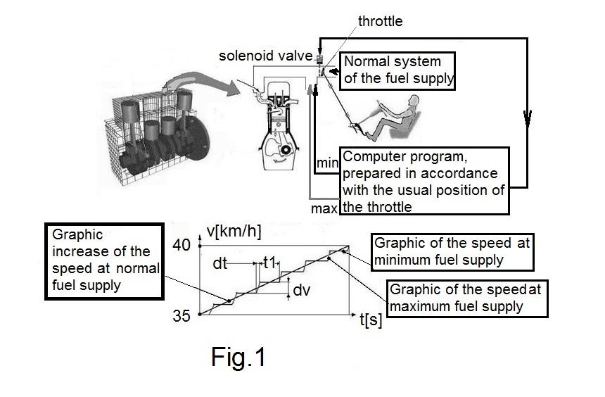
The fuel supply is controlled by a computer program, prepared in accordance with the graphic increase of the speed at normal fuel supply (the usual position of the throttle and gas pedal,for example, for the range of speed (35-40 km / h).
Computer program alternation maximum and minimum servings fuel in the cylinder chamber is prepared for each position of the throttle (gas pedal) taking into account the deterioration of the engine:initially tested throttle position (solenoid valve is open), and then compiled computer program and carried the optimal fuel supply (solenoid the valve is closed). Maximum portion of fuel - is the portion of fuel , allowing the car to move with the maximum possible acceleration ( closest to the optimal ), but less than the maximum acceleration ( at maximum engine power ) to ensure safety and smooth driving - time dt + t1 should be minimal . When driving on the highway optimal fuel supply coincides with the usual , ie, the vehicle is moving with maximum acceleration , the closest to the optimal.
The principle of optimal motion will not only improve efficiency of the motion various motor vehicles, but also to reduce the size and capacity of the batteries for run the starter motor. This is achieved by a slight increase in battery voltage, that will accelerate the starter shaft closest to the optimal acceleration.
The principle of optimal motion for energy savings - is motion of the mass charge carriers (electrons) with acceleration closest to the optimal a_{opt} in electrical circuits, industrial and civil buildings, presumably to 5000 m/s². Optimal acceleration of mass of the charge carriers (electrons) depends on the size of the electrical circuit (wire size and length). This is achieved by replacing a sinusoidal signal, a modified sinusoidal signal with the required number of stages (Fig.2).
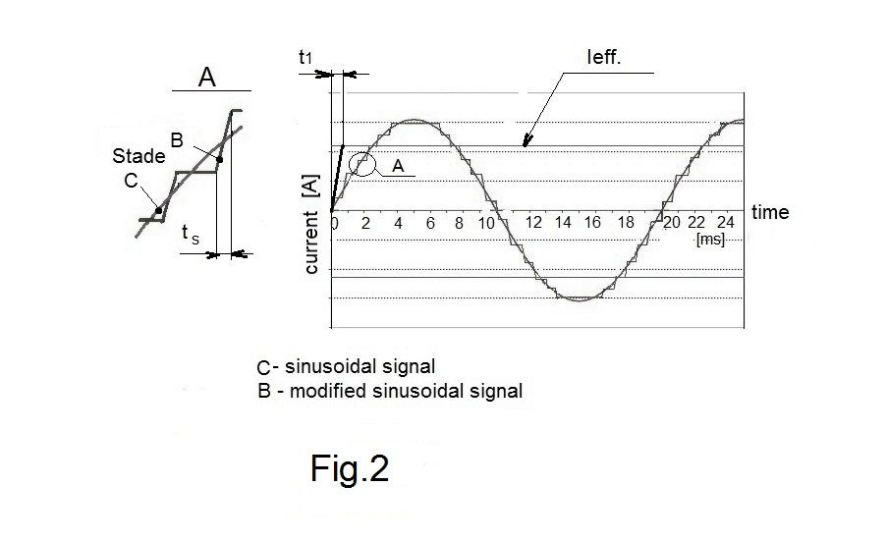
A real acceleration of mass of charge carriers:
a_{r} = v_{d} / 0,005 = 0,1 m/s²;
v_{d} ≈ 0.5 × 10⁻³m/s - drift velocity of electrons in the metal,
0,005 s - time rise of industrial current (50 Hz) to the effective value – Ieff.
Conclusion: a_{opt} >> a_{r}.
Thus, the principle of optimal motion to save energy carried by using the waveform inverter - 220 AC/220 AC from sinusoidal to the modified sinusoidal form of the signal. In this inverter real acceleration - v_{d} / t₁ closest to a_{opt}.
z-number stages of a modified sinusoidal signal during 0.005 second,
t_{s}-time of one step.
The inverter operates by computer program that takes into account:
- size-specific circuit for calculating the mass of the electrons and the subsequent determination a_{opt},
- V_{d}./t₁ ratio closest to a_{opt}.
It is understood that the energy losses in inverter circuit must be minimized.

It should be noted, that there is inverter 12 DC/220 AC for solar panels and wind turbines with an output modified sinusoidal signal. This simplifies the creation of a new inverter for energy savings.
In conclusion, I wish to note,that I suppose discreteness, "discontinuity" of the classical mechanical motion as philosophical category. But "discontinuity" opposite, and, most importantly, is consistent with the "continuity". This suggests about significant probability of coincidence with the truth of my hypothesis, and hence coincidence with the truth of its practical conclusion - "Principle of optimal motion."

References
1.Translation from English edited by Akhmatova A. S. Physics, mechanics, part 3. M., 1974.
2.Reznikov V. A. Principle of optimal motion.Lap Lambert Academic Publishing,2012.
3. URL. http://www.a-priority.ru/Priority/1estestv/1estestv_catalog.html

