Application of developments, inventions, and computer programs by Artem Aleksanian in the model of smart home infrastructure development
Alibekov Igor Yusupovich
Candidate of Technical Sciences, Associate Professor
Moscow Polytechnic University
Moscow, Russian Federation
Abstract
Current trends in the development of technologies for comprehensive optimization of fuel systems in thermodynamic power equipment within smart home infrastructure reflect the integrative conceptual proposals of the specialist Artem Aleksanian, whose management and control approaches incorporate elements of artificial intelligence and artificial neural networks, while monitoring systems rely on fundamental principles of electromagnetic resonance spectroscopy.
In recent years, extensive efforts by researchers and industrial practitioners have focused on identifying and selecting the most practical and efficient technical solutions aimed at optimizing the preparation and supply of fuel mixtures to the combustion chambers of thermodynamic equipment used in smart home systems.
Experimental testing was conducted on diesel engines, boilers, diesel generators, gas turbines, and other types of thermodynamic equipment forming fuel supersystems and subsystems of smart home and smart industrial infrastructures.
Alongside these developments, fully automated operational modes based on contactless monitoring and control systems utilizing electromagnetic resonance spectroscopy have emerged, resulting in an integrative synthesis of technical effectiveness aligned with the capabilities and interests of investment partners.
Keywords: innovative developments; computer programs; technological and logistical model for smart home infrastructure development; technological and logistical model for smart home ecosystem development; trends in technological advancement; conceptual integrative proposals; selection of the most practical and efficient technical solutions; integrative synthesis of the effectiveness level of technical ideas in combination with the capabilities and interests of investment partners.
In this type of research, the conclusions, recommendations, and characteristics provided by multidisciplinary specialists are of particular interest to innovators in the technological domain. Such specialists possess, to an equal extent, both technological and design expertise as well as a deep understanding of investment support mechanisms across all stages and phases of project implementation.
In this regard, developments, publications, inventions, and the investment strategy developed in an integrated manner by the well-known specialist Artem Aleksanian are of exceptional importance for comprehensive design practice and its practical implementation.
In his original and, to some extent, unique developments, a clear logical relationship can be observed between the investment strategy and the corresponding project development stages and phases that comply with its requirements and constraints, combined with a systemic innovative logistics framework.
From the perspective of the author of the present document—whose own developments are based on coordinating investment criteria and design parameters through a specific algorithm—the professional fundamental knowledge and experience of Artem Aleksanian, both in the field of technology and in the area of targeted financing of innovative projects, play an exceptionally important role. Their correct and harmonious integration serves as a key prerequisite for the commercial success of a project.
Let us consider, using the example of one of the most in-demand projects in the energy sector of the smart home, the importance and significance of combining the stages and phases of technological project development with a targeted investment strategy linked to the project’s development stages and phases and to the results obtained upon their completion.
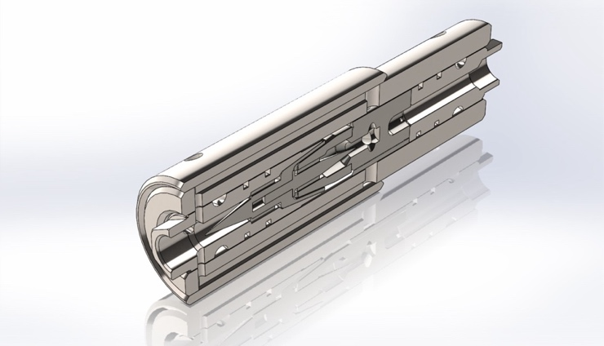
Figure 1 – Three-dimensional model of a linear device for online stabilization of the turbulence level of the fuel mixture flow in the section between the low-pressure fuel pump and the high-pressure fuel pump.
As practice in innovative project development shows, one of the most challenging issues is the determination of criteria used to evaluate newly developed technologies and to compare their compliance with counter parameters established by investors, as assessed jointly by developers and investors.
Among the merits of Artem Aleksanian is the fact that he proposes comparing achieved results with investor-defined benchmark parameters on the basis of the patent–licensing strategy developed by him and its core operational algorithm.
Undoubtedly, the fact that Artem Aleksanian, as the author of the patent–licensing strategy and its fundamental algorithms, is also an active inventor—particularly in the energy and fuel sectors—facilitates understanding and significantly increases the level of trust in his highly effective recommendations and developments.
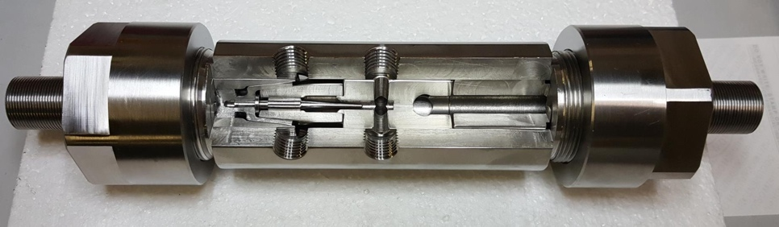
Figure 2 – Internal structure of a system for online mixing, homogenization, and stabilization of the turbulent flow regime of a fuel mixture.
As shown in Figure 2, the system contains a minimal number of components that are non-moving during operation.
The figure demonstrates the capabilities of the device and technology for dynamic mixing and activation of diesel fuel with real-time stabilization of its flow prior to delivery to a burner, combustion chamber, or injection nozzles of an engine’s cylinders.

1. Tasks to Be Addressed During Comparative Testing of the Device (System) and Tasks Associated with Presenting Test Results to Investors
1.1. Prior to testing, the objective is to verify the effectiveness of the technology for preliminary mixing and activation of diesel fuel before supplying the mixture, emulsion, or blend to a standard burner.
1.2. The purpose of such tests is to compare system performance results obtained with and without the use of the device for preliminary dynamic mixing and activation of diesel fuel.
1.3. When evaluating the performance of the proposed device, the comparison baseline should include primary criteria characterizing the device operation, as well as indirect criteria (aligned with the initial technical requirements, the project’s technical specifications, and the project’s development stages and phases, which in turn are harmonized with applicable international standards).
1.4. The primary comparison criteria should include: specific diesel fuel consumption required to achieve identical combustion parameters; concentrations of nitrogen compounds and carbon compounds in exhaust gases under identical combustion conditions.
1.5. Indirect comparison criteria should include: the amount of oxygen required for the process; the amount of air required for the process; the total volume of exhaust gases (all under identical combustion parameters and in full compliance with the requirements and constraints of applicable standards).
1.6. The objectives of comparative testing also include verification of the device’s effectiveness when operating with diesel fuels of varying viscosity, as well as when operating with methanol, ethanol, and biofuels.
As noted by the author of the present document, to determine compliance with the initial technical requirements and technical specifications, it is most appropriate to use the proposals and methodologies developed by Artem Aleksanian, which take into account all relevant nuances of interaction between investor requirements for intermediate test results and compliance with the technical specifications, which are likewise agreed upon with investors.
Equally important is the fact that the comprehensive system for evaluating test results, based on Artem Aleksanian’s systems and computer programs, makes it possible at an early stage to identify problematic aspects and to adjust project development plans in a timely manner, prior to reaching an irreversible phase.
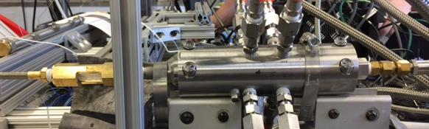
Figure 3 – The system under testing at one of the leading research centers in the United States, where it was tested for integration into the fuel line of a gas turbine.

2. Parameters to Be Monitored and Regulated on the Pipelines Supplying Diesel Fuel and Compressed Air to the Device
2.1. Pressure must be monitored and regulated on all supply pipelines. Of particular importance is monitoring the level of pressure drop of the fuel mixture as it passes through the channels of the device for homogenization and stabilization of pulsation phenomena in the fuel flow. All developers of thermodynamic equipment consider the absence of pressure loss in the fuel mixture flow to be one of the key conditions for successful integration of an innovative system into the fuel line of thermodynamic equipment.
2.2. Flow rate must be monitored and regulated on all supply pipelines, with particular attention paid to the absence or substantial minimization of pulsations and turbulence surges.
2.3. Based on flow rate and pressure data, a comprehensive assessment should be conducted of the quantity and volume of the working medium supplied to the device, and the mixing proportions should be determined.
2.4. For compressed air, provision must be made for regulation and measurement at pressures of 3, 4, 5, 6, 7, and 8 atmospheres.
2.5. For compressed air, provision must be made to ensure equal flow rates for all four supply pipelines in the range from 0.3 liters per second to 2.5 liters per second at a pressure of 8 atmospheres. For turbines, the flow rate applies at a pressure of 30 atmospheres.

3. Requirements for Instruments Needed to Test the Device for Dynamic Mixing and Activation of Diesel Fuel Prior to Its Continuous Supply to a Burner
3.1. The accuracy of measuring instruments must comply with the accuracy requirements stipulated by applicable international standards and by applicable local standards, where such standards impose more stringent requirements than international ones.
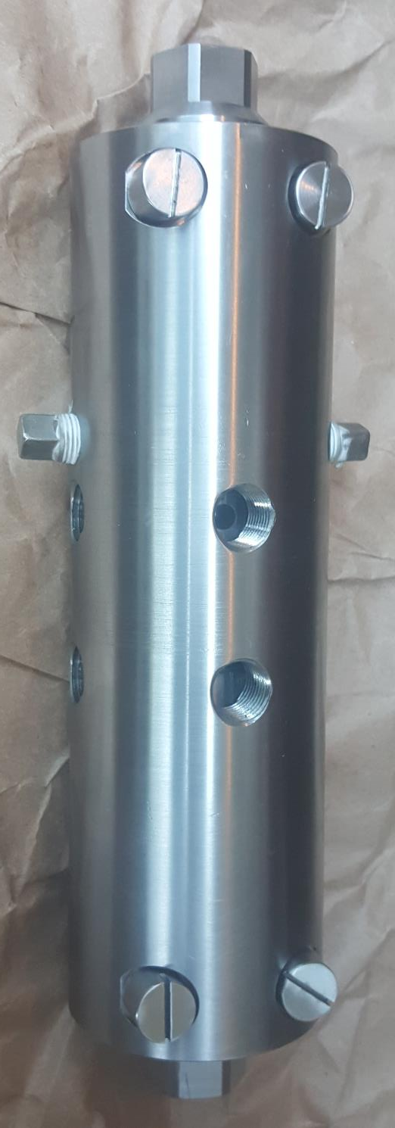
Figure 4 – A system with an operating diameter of 30 millimeters, prepared for installation on a test bench.

4. Testing Methodology and Procedure
4.1. The device for dynamic mixing and activation of diesel fuel must be installed into an existing fuel preparation system that has previously been tested using existing technology.
4.2. Instruments for monitoring flow rate and pressure must be installed on all supply pipelines.
4.3. Devices for regulating flow rate and pressure must be installed on all supply pipelines upstream of the corresponding measuring instruments.
4.4. Tests must be conducted both with oxygen supply and without oxygen supply.
4.5. Instruments used to monitor all combustion process parameters and all instruments used to monitor the composition and quantity of exhaust gases must be completely identical for tests conducted using existing technologies and for tests conducted using the device for dynamic mixing and activation of diesel fuel.
5. Questions to the Company at Whose Production Facilities the Testing Will Be Conducted
5.1. What is the performance capacity of the air compressor (flow rate and pressure limits)?
5.2. With what accuracy can the flow rate of compressed air be measured and regulated?
5.3. With what accuracy can the flow rate of diesel fuel be measured and regulated?
5.4. With what accuracy can the pressure level of compressed air be measured and regulated?
5.5. With what accuracy can the pressure level of diesel fuel be measured and regulated?
5.6. What diesel fuel flow rate and pressure are considered optimal for burners of the same type and size when used within existing technologies?
5.7. What oxidizer flow rate (air separately and oxygen separately) is considered optimal for burners of the same type and size when used within existing technologies?
5.8. Is there a practice of replacing one type of diesel fuel with another during testing? If so, what is the procedure for such replacement, and how much time is required to switch from one type of diesel fuel to another?

6. Test Results for Burners of the Same Type and Size When Using Existing Fuel Mixture Preparation Technologies
6.1. Fuel mixture flow rate;
6.2. Total volume of exhaust gases;
6.3. Concentration of nitrogen oxides and nitrogen compounds in exhaust gases (all categories), in absolute values and in compliance with standard requirements;
6.4. Concentration of toxic nitrogen compounds in exhaust gases, in absolute values and in comparison with standard requirements;
6.5. Concentration of toxic carbon compounds in exhaust gases, in absolute values and in comparison with standard requirements;
6.6. Concentration of carbon oxides and carbon compounds in exhaust gases (all categories), in absolute values and in compliance with standard requirements;
6.7. Exhaust gas temperature (in absolute values and in compliance with standard requirements).

7. Approximate Methodology for Comparative Evaluation of Test Results
7.1. A fully equivalent comparison baseline for all critical parameters;
7.2. Fully identical dimensionality of all monitored and compared parameters, including external factors (atmospheric pressure, humidity, ambient temperature, diesel fuel temperature, composition of the initial diesel fuel, degree of its purification, parameters of the supply pipeline—including nominal diameter, construction material, and quality of internal surface finishing);
7.3. Fully identical temporal factors (to exclude the influence of averaged indicators over long combustion periods compared to short combustion periods).
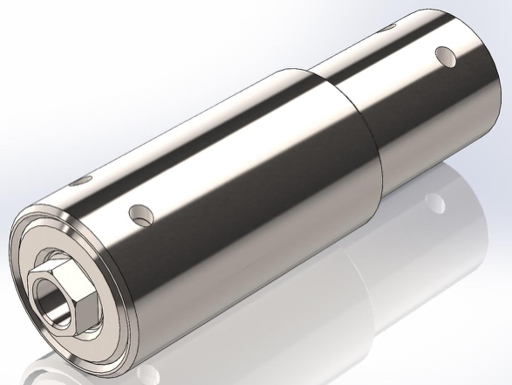
Figure 5 – Model of the system whose primary function is stabilization of the turbulence level of the fuel mixture flow in the fuel pipelines of thermodynamic equipment, including gas turbines.
As can be seen from the model (Figure 5), integration of the system presents no complexity, allowing it to be installed in virtually any pipeline configuration without significant modifications. The system does not require special tuning or adjustment and is ready for installation in its as-supplied condition.
References
- Aleksanian A.A. Ecosystem and Infrastructure of a Smart Real Estate Object: Transforming the Smart Facility Ecosystem into a Supersystem with Online Control. ISBN 978-620-9-39850-6. English language edition. Published November 26, 2025.
- Cella, C. H., et al. Methods and Systems for Equipment Monitoring in an Internet of Things Mining Environment. United States Patent Application US 2018/0321666 A1, published November 8, 2018.
- Cella, C. H., et al. Methods and Systems for Data Storage and Communication in an Internet of Things Chemical Production Process. United States Patent Application US 2018/0284753 A1, published October 4, 2018.
- Chen, W.-L., et al. Universal and Integrated Wafer Testing Real-Time Monitoring Software System and Its Open System Architecture. United States Patent Application US 2006/0036394 A1, published February 16, 2006.
- Winstead, C. H., et al. Integrated Configuration, Flow and Execution System for Semiconductor Device Experimental Flows and Production Flows. United States Patent Application US 2007/0156272 A1, published July 5, 2007.
- Ushiku, Y., et al. Process-State Management System, Management Server and Control Server Adapted for the System. United States Patent Application US 2006/0064188 A1, published March 23, 2006.
- Nishi, S., et al. Production System for Printing Electronic Devices. United States Patent Application US 2017/0004985 A1, published January 5, 2017.
- Kim, J. H. Apparatus for Mass Production of Monodisperse Biodegradable Polymer-Based Microspheres and a Multi-Channel Forming Device Incorporatable Therein. United States Patent Application US 2018/0133677 A1, published May 17, 2018.

