Dynamic Vortex Mixing of Textile Paint Components
Dynamic vortex mixing of paint components for fabrics and knitted textiles within a sealed, conventional vortex tube formed by powdered pigment and spiral tangential flows of an oil-based component

Polovkovych Sviatoslav
Professor at Lviv Polytechnic National University, Lviv, Ukraine
Spolovkovych@ukr.net

Abstract
This work addresses current issues related to the development and improvement of technologies for the production of natural oil paints intended for both artistic applications and the restoration of works of art. Particular attention is given to the development of paints whose chemical composition and physicochemical and technological properties are as close as possible to those of historical materials produced from natural components.
The technological factors affecting the homogeneity, stability, and durability of the paint layer are analyzed. Particular consideration is given to the separation of egg-derived components in order to obtain highly purified egg oil and minimize residual albumin content, which may affect the properties and long-term stability of the final material.
An integrated technological approach to the production of natural oil paints is proposed. The approach includes the production of ultra-pure egg oil, the use of a natural preservative, mixing and homogenization of pigment components, encapsulation of pigment microparticles, and subsequent treatment of the resulting microcapsules with a natural preservative.
Special attention is given to the application of vortex mixing technologies and specialized vortex generators for intensive interaction between micronized pigment particles and the liquid component. The structural and technological principles governing component delivery, vortex-flow formation, mixing, and encapsulation of pigment particles within a shell of ultra-pure egg oil are considered.
The proposed approach is intended to provide an integrated technological basis for the production of natural artistic and restoration paints with specified characteristics of homogeneity, stability, and durability, as well as to support the further development of technologies for the restoration of historical works of art using materials that closely reproduce the composition and properties of the original materials.

Keywords: Oil Paints; Natural Artistic Materials; Art Restoration; Restoration Technologies; Egg Oil; Albumin; Natural Preservative; Pigment; Pigment Microparticles; Homogenization; Vortex Mixing; Vortex Generator; Encapsulation; Microencapsulation; Natural Components; Paint-Layer Stability; Paint Durability; Paint Production Technologies; Innovative Restoration Technologies.

Introduction
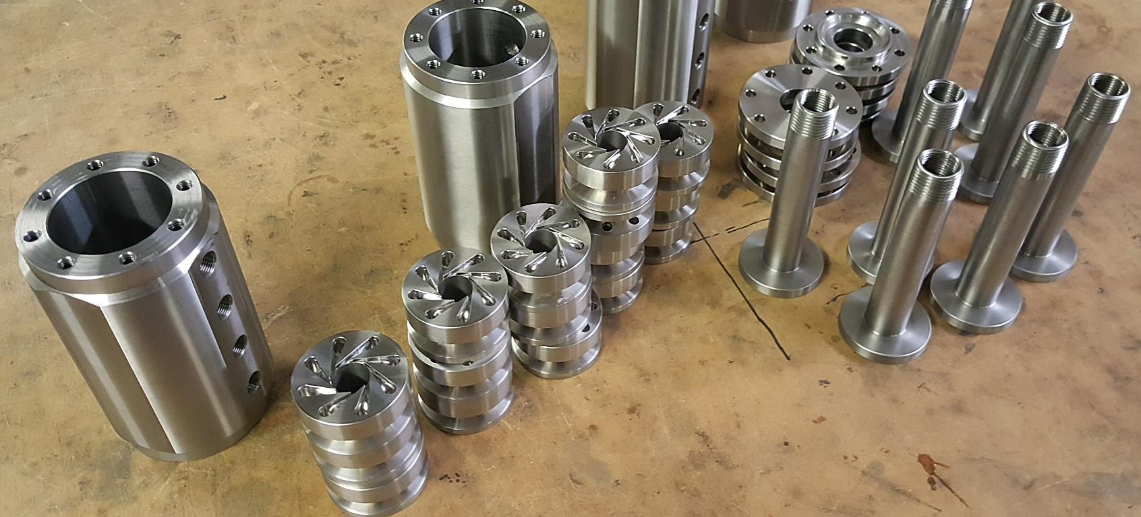
At present, a wide range of vortex mixing devices is manufactured on an industrial scale for mixing gases with gases, gases with liquids, and liquids with powders.
The degree of dispersion of an aerosol, gaseous, or liquid material supplied through the tangential channels of vortex generators determines the characteristics and type of the resulting mixture, ranging from nanocomposites with three-dimensional encapsulation to conventional mixtures. Before the resulting mixture leaves the formation zone, all of its components form a classical vortex tube.
At this stage, an appropriate question arises: why is such technological complexity necessary for the production of textile paints?
Textile paints are manufactured in large quantities using well-established technologies and existing industrial equipment and, at first glance, would appear not to require innovative intervention or the introduction of fundamentally new mixing methods.
However, is this actually the case?
The author of the present publication proposes considering the feasibility of an innovative transformation of the manufacturing process for highly homogeneous paints, particularly those intended, for example, for restoration applications, where the quality, stability, and durability of the materials used are of decisive importance.
As is known from the history of technological development, paints used by artists in earlier periods were produced from natural components. Egg-derived materials, including egg yolk, were historically used as binding media in certain traditional painting techniques.
Even under modern technological conditions, the complete separation of egg-yolk-derived lipid components (egg oil) from egg-white proteins (albumin) can present considerable technical difficulties. As a result, residual albumin may remain in the separated egg-oil fraction, while lipid components may remain in the protein fraction.
The presence of residual components of this kind may affect the uniformity, homogeneity, and long-term stability of the resulting paint system.
Microscopic examination of historical paint layers may reveal various forms of deterioration, including shrinkage, deformation, and cracking of the outer surface of the paint layer. Over time, such processes may contribute to progressive deterioration of the paint and a corresponding loss of the original visual characteristics of a work of art.
When restoration work is performed, it may therefore be necessary to use materials whose composition and production methods reproduce, as closely as reasonably possible, the properties of the original materials.
Even under modern conditions, achieving such correspondence may represent a significant technological challenge.
Accordingly, if the objective is to use restoration paints having chemical compositions and properties comparable to those of the original materials, it may be necessary to reproduce or technologically adapt certain historical production principles. This effectively brings the modern restoration process into contact with some of the same technological challenges encountered in historical paint production.
One of the principal technological issues, both historically and under the proposed approach, is the maximum possible separation and purification of egg-oil and albumin fractions.
The problem of homogeneous mixing also remains important. However, within the technological concept considered in this work, the purity and characteristics of the initial paint components are treated as fundamental factors determining the quality of the final product.
Thus, in order to develop an innovative and integrated process for producing a new type of paint suitable for both artistic applications and restoration purposes, a correspondingly comprehensive technological solution is required for each material and technological operation forming part of the overall production process.
The principal technological objectives may be formulated as follows:
- production of high-purity or ultra-pure egg oil;
- production of a natural paint preservative intended to improve the stability and durability of the resulting composition;
- reliable and rapid mixing of powdered pigment with ultra-pure egg oil;
- encapsulation of pigment microparticles within a shell formed from ultra-pure egg oil;
- coating of the capsules formed during the mixing process—comprising a pigment-particle core and an ultra-pure egg-oil shell—with a liquid natural preservative.
Assuming that the technological problems associated with obtaining ultra-pure egg oil and a correspondingly high-purity natural preservative have been resolved, the subsequent processes of mixing and encapsulation represent more technologically complex stages and therefore require more detailed consideration.
One possible approach is based on so-called vortex mixing technologies.
The implementation of such technologies requires specialized vortex generators. Depending on the required production capacity and operating configuration, multiple generators may be arranged and connected along a common axis.
Within the proposed generator configuration, the pigment in the form of a micropowder is introduced into a central axial passage, while the egg oil, or an equivalent oil-based component, is supplied under pressure to an annular trapezoidal channel. From this channel, the liquid component passes through peripheral axial channels into tangential channels, through which it is injected into the pigment stream.
The tangential channels are configured so that the oil outlet openings have dimensions within a range of approximately 5 to 10 μm. Accordingly, the atomized oil droplets are intended to have characteristic dimensions within approximately the same range.
The topology of the tangential channels is designed so that the flow discharged from each channel follows a spiral trajectory.
Since a single generator may incorporate up to 15 such channels, the generator can produce up to 15 spiral flows directed into the pigment stream. Their interaction with the pigment within the axial passage transforms the combined pigment and spiral oil flows into a vortex-tube flow structure, within which the proposed microencapsulation process takes place.
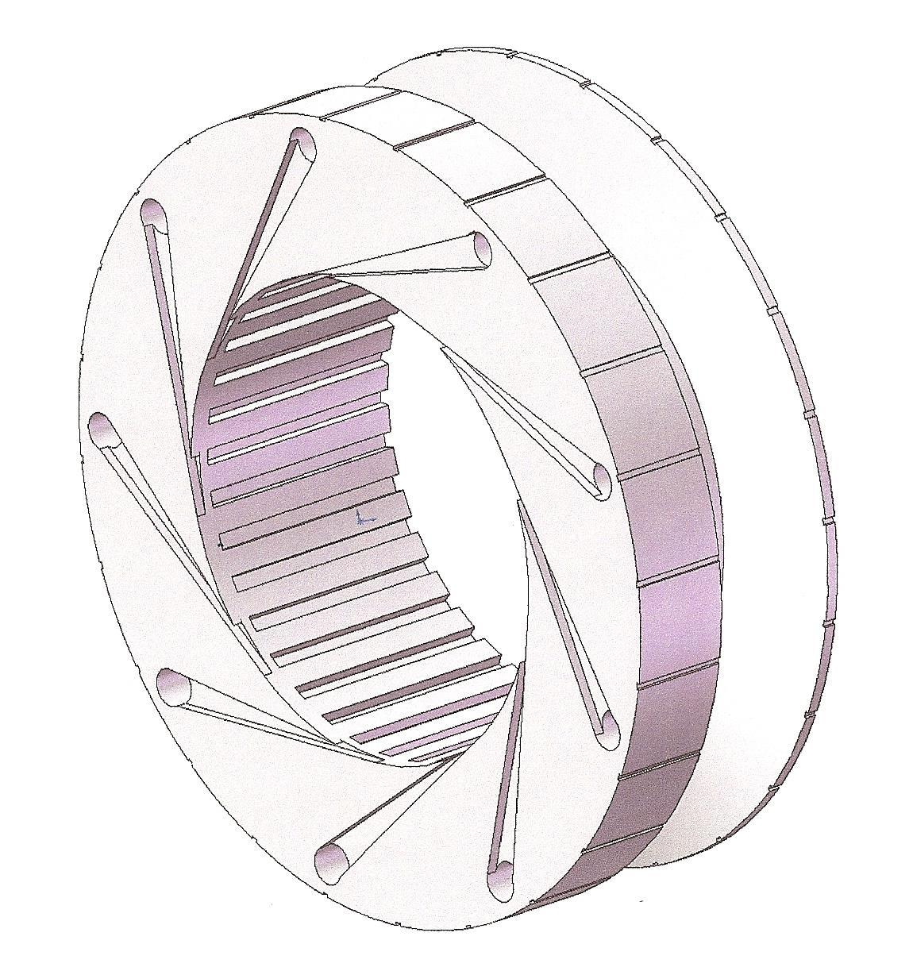
There is another important factor arising from the properties of the vortex tube: the contact time between the oil and the pigment within the vortex flow is increased by at least 3.5 times compared with conventional mechanical mixing, while the linear velocity of the mixture is not reduced.
Vortex generators are relatively straightforward from both a manufacturing and operational perspective and can be operated in combination with various types of pumps, which is particularly important when such equipment is used in restoration processes.
The following cross-sectional model illustrates these characteristics.
Generators of this type can be manufactured at different scales and dimensions, which is also important for restoration applications, where only very small quantities of paint may be required while exceptionally stringent requirements are imposed on its quality and consistency.
The following three-dimensional models illustrating different stages of assembly of the paint preparation unit demonstrate the relative simplicity of the proposed configuration while maintaining its full functionality.
The unit can be connected to a suitable pump supplying the oil-based component, thereby simplifying its installation and use at different restoration sites.
The diameter of the vortex generator determines its processing capacity. Accordingly, it may be assumed that, for the localized preparation and mixing of paint components intended for restoration purposes, a vortex generator having a diameter of no more than approximately 35 mm may be sufficient.
The overall concept of the proposed unit is relatively simple and allows the individual components to be designed using basic geometric configurations. This, in turn, facilitates operation of the device by personnel who do not possess specialized manufacturing or production skills.
The relative structural simplicity of the device may also contribute to a low manufacturing cost, which represents an important practical factor when establishing and equipping a restoration site.
Kristina Malerik, an innovation specialist in the field of high-quality apparel design, with a particular focus on beachwear and swimwear collections, initiated the development of a textile coloration system intended to achieve the highest possible quality of fabric coloration while minimizing the associated technological and production costs.
Practical experience indicates that the adaptation of innovative technologies originally developed for the preparation of oil-based paints to the production of paints and coloring compositions for high-quality textile products may contribute to improving the quality and durability of finished textile products.
The application of these technological principles may also create opportunities for the development of new approaches to innovative textile and fashion design, providing advanced functional characteristics, improved performance parameters, and enhanced durability of the resulting products.

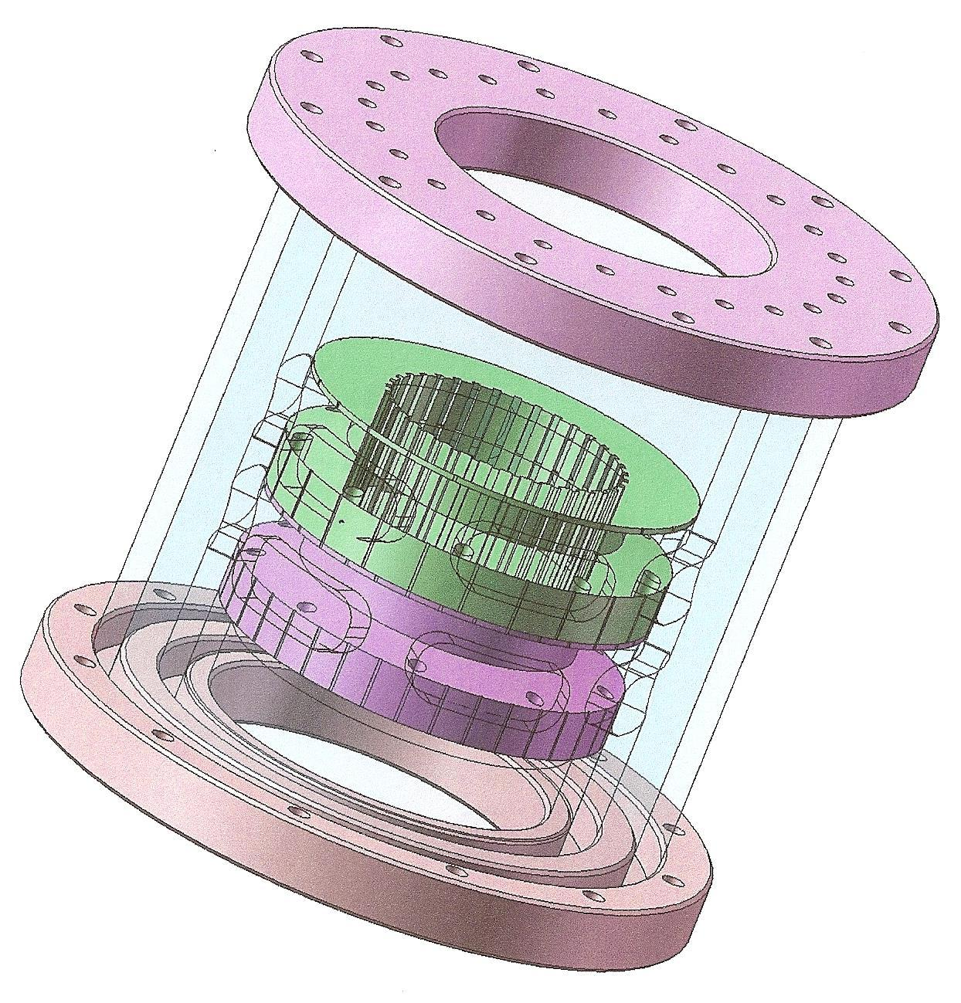
The author presents models of the proposed device that demonstrate the simplicity and manufacturability of all its components, as well as the ease of assembly and operation under the conditions of a restoration site.
As can be seen from the models, all housing components are designed to center and align the vortex generators with which they are in contact, thereby eliminating the need for numerous specialized components and significantly reducing the overall cost of the unit while maintaining the required level of paint preparation quality.
The unit is assembled using standard threaded rods, which further simplifies its design, assembly, and operation.

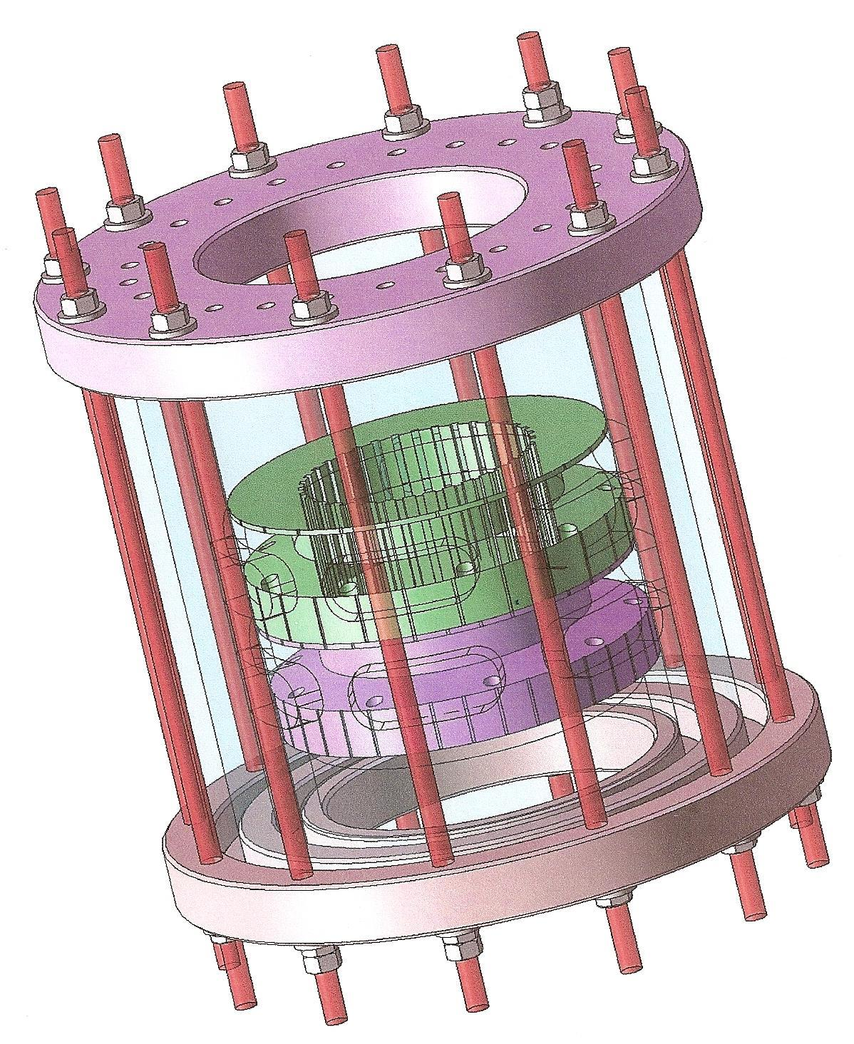

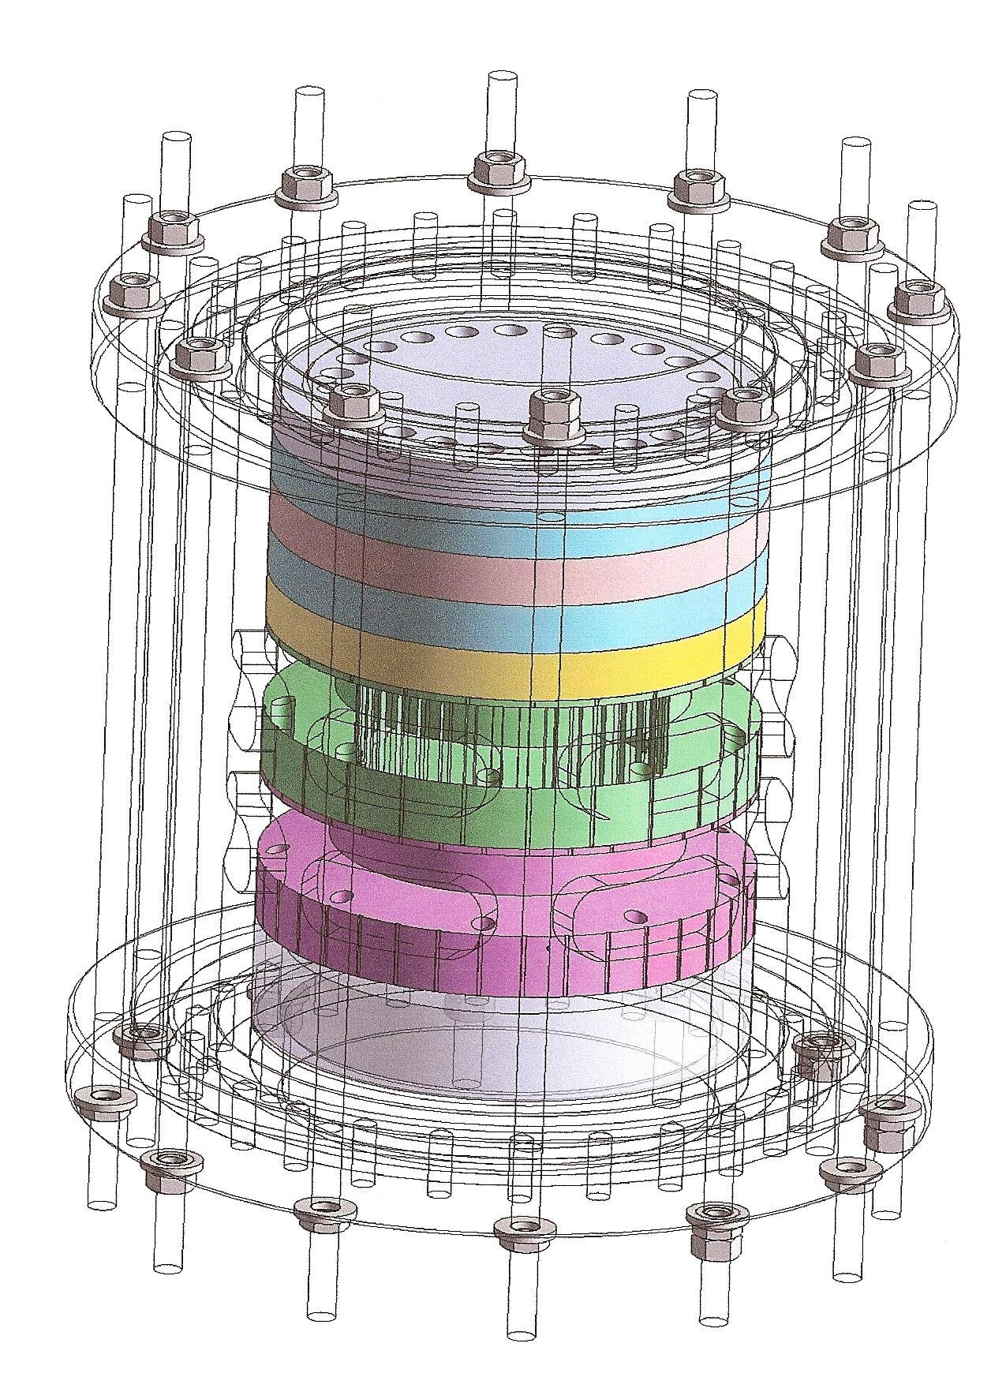
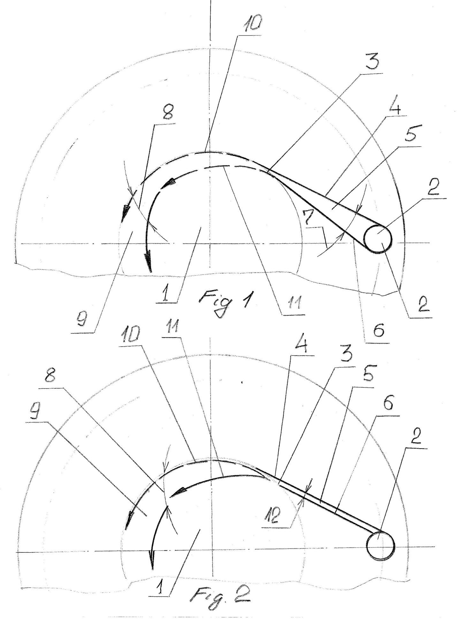
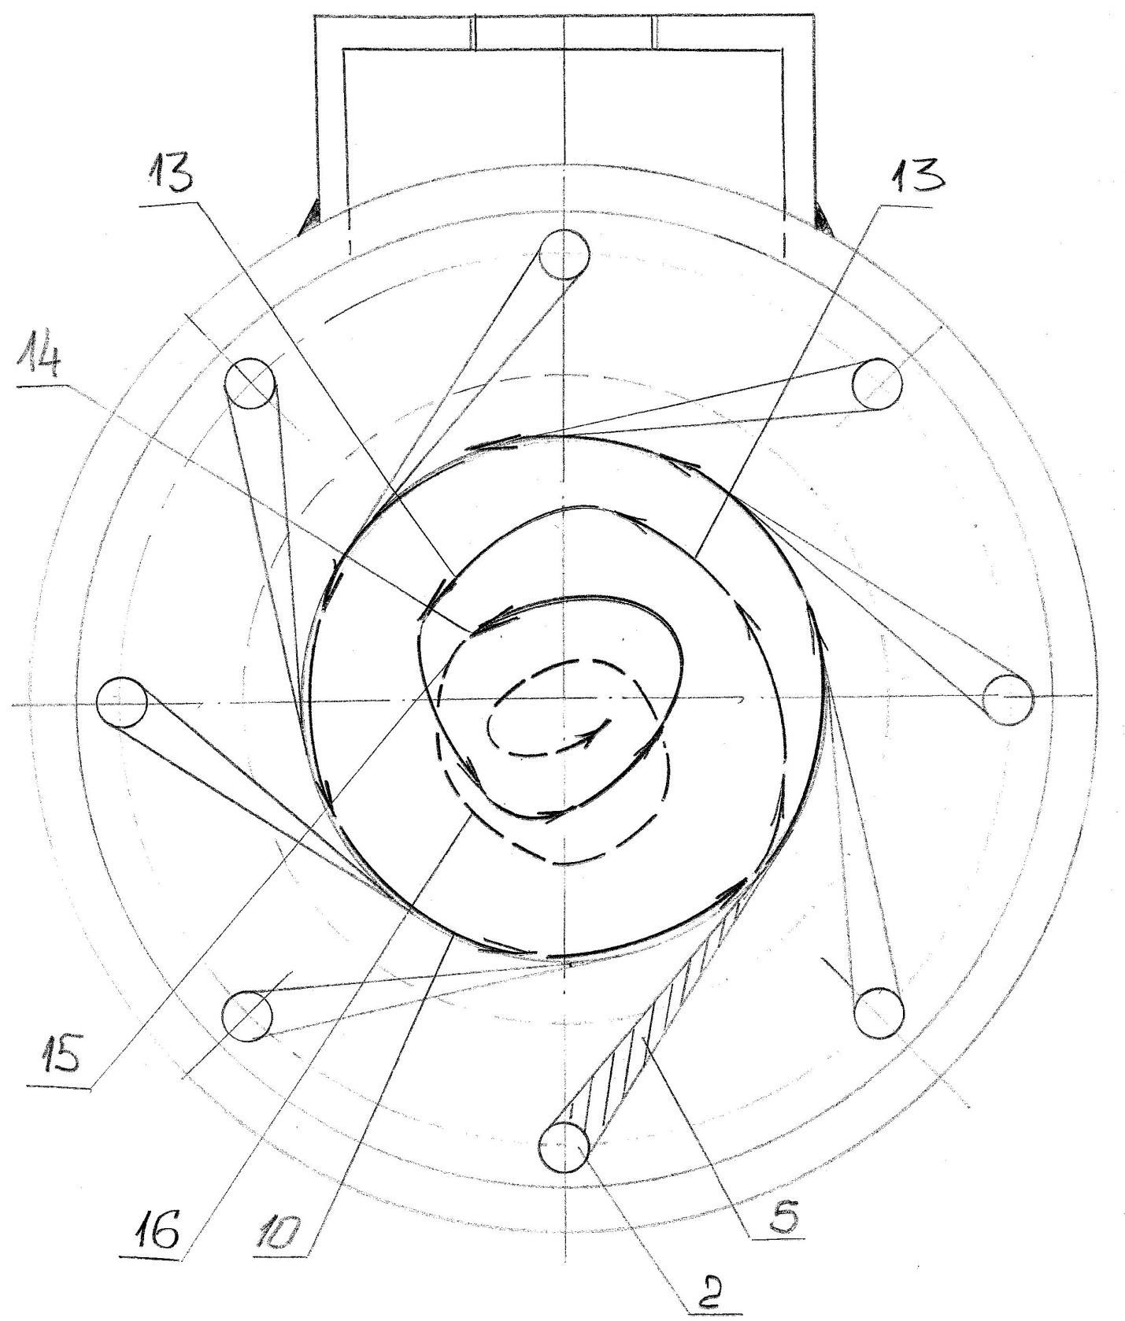

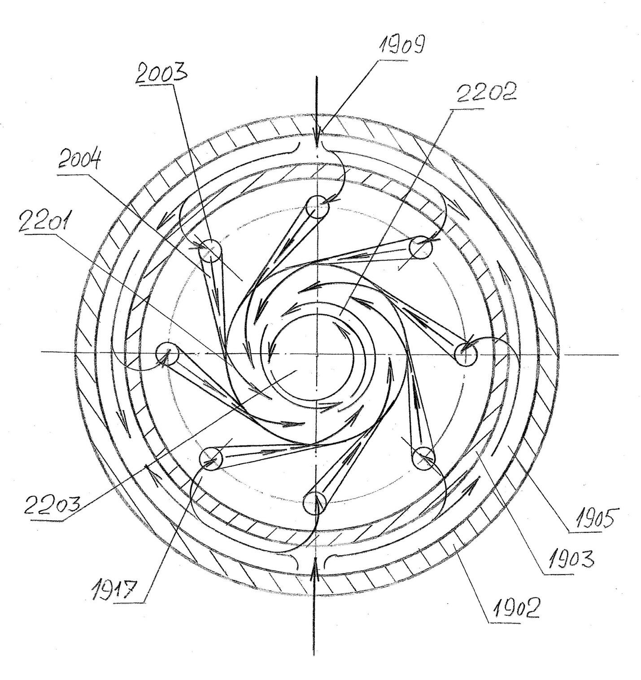
The presented diagrams provide a detailed illustration of the dynamic mechanisms involved in the formation of a vortex tube within the unit designed for the preparation of encapsulated paint.
As demonstrated by the diagrams, the mechanisms responsible for vortex-tube formation are sufficiently simple and reliable to enable the practical operation of such a unit under actual restoration-site conditions.
The following diagrams illustrate various versions of the proposed unit incorporating different design modifications, including configurations equipped with filtering elements made of carbon–carbon composite materials.

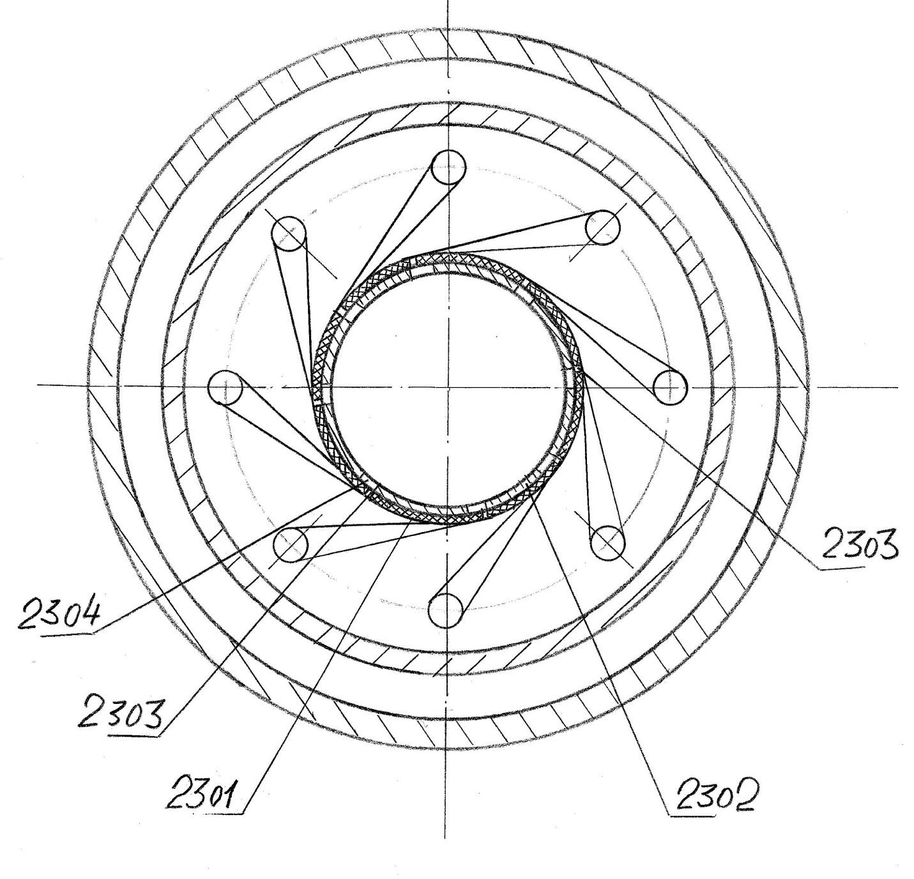

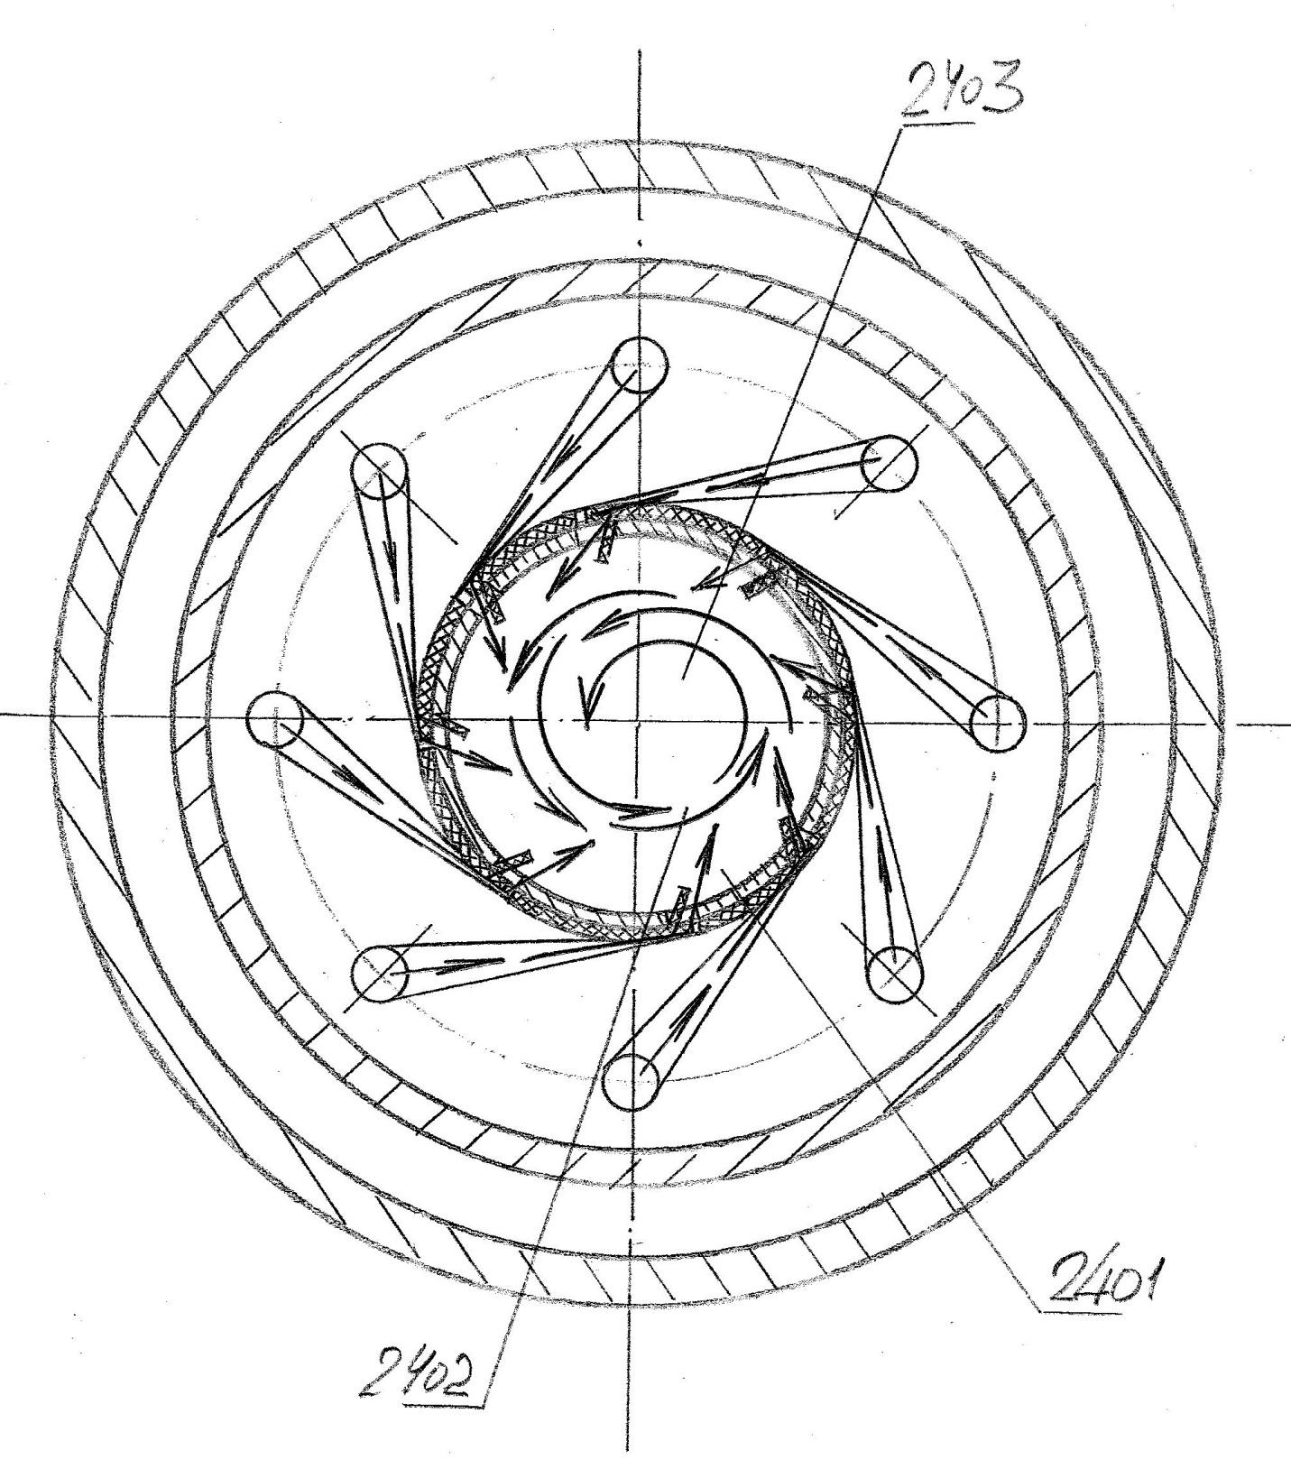

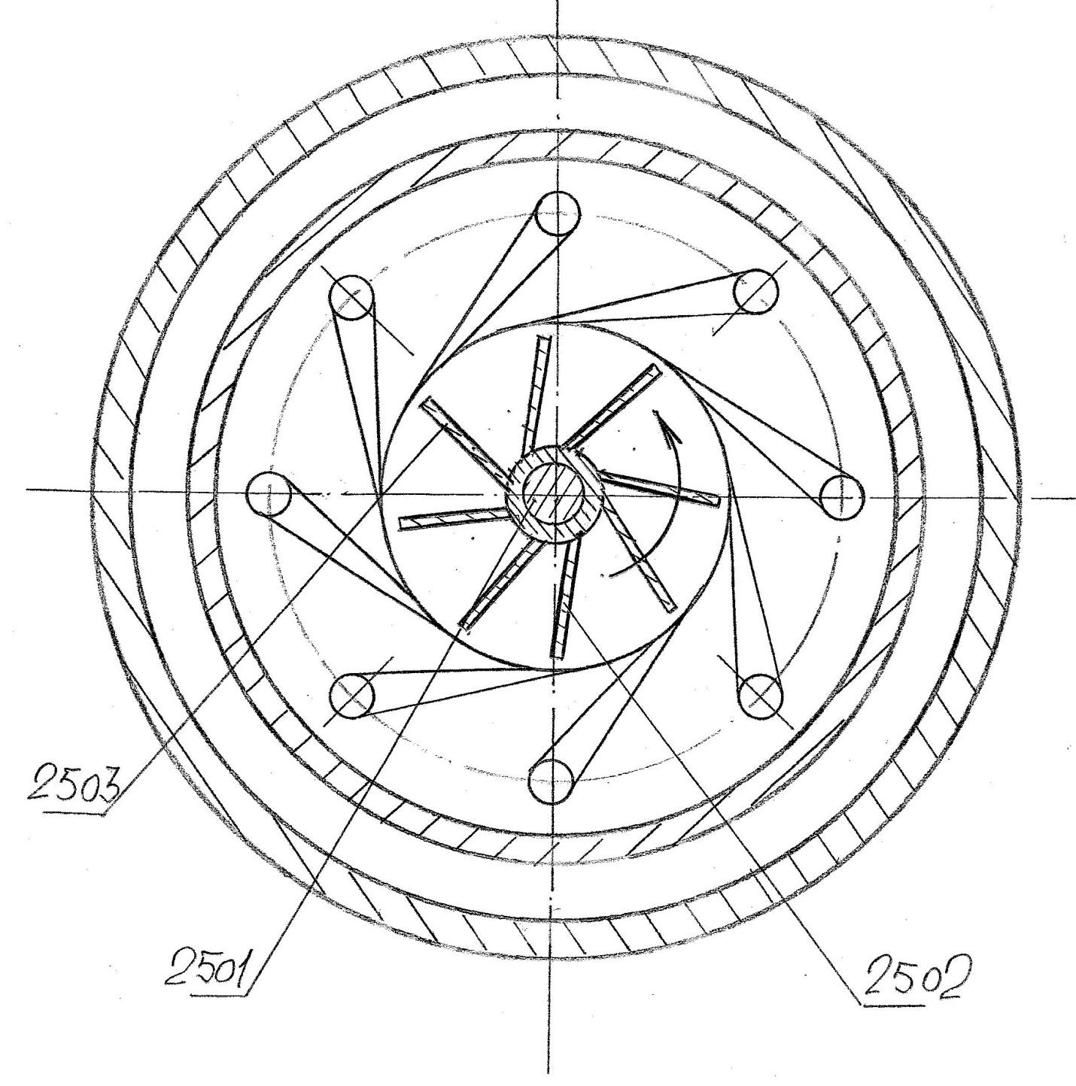
Following the description of the unit for vortex mixing of paint components, the author returns to the issue of selecting an appropriate oil-based medium for the paint formulation.
In this context, an innovative technology for the processing of chicken eggs is proposed. According to this technology, eggs, including those that do not meet conventional commercial quality standards, are processed using a specialized method to produce ultra-pure egg powder.
At the subsequent processing stage, specialized solvents are used to extract alpha-lecithin from the resulting powder. The obtained alpha-lecithin is proposed as an alternative to the oil component traditionally used in the paint formulation, while providing a significantly higher degree of purity.
The egg-processing technology also enables the production of highly purified lysozyme, which is proposed for use as a natural preservative.
Thus, the proposed approach to the production of paints intended for restoration applications provides a set of high-purity materials ultimately derived from the same natural raw material - chicken eggs - but subjected to substantially more advanced purification and processing.
According to the author, paints produced using these components may significantly improve the purity and quality of restoration treatments applied to works of fine art, while also contributing to an extended service life and improved long-term preservation of restored paintings.

References, Patent and Licensing Materials

- United States Patent Application №. 20100281766 A1
Title: Dynamic Mixing of Fluids. Publication Date: November 11, 2010.
- United States Patent Application №. 20100243953 A1
Title: Method of Dynamic Mixing of Fluids. Publication Date: September 30, 2010.
- United States Patent Application №. 20110056457 A1
Title: System and Apparatus for Condensation of Liquid from Gas and Method of Collection of Liquid, Publication Date: March 10, 2011.
- United States Patent Application №. 20100224506 A1
Title: Process and Apparatus for Complex Treatment of Liquids. Publication Date: September 9, 2010.
- United States Patent Application №. 20100193445 A1
Title: Foaming of Liquids. Publication Date: August 5, 2010.

