Maksim Strelchenko
POWER CONTROL FOR WATER TREATMENT APPARATUS
Part 1

CONTENT

Summary of the invention 3
Brief description of the drawings 4
Detailed description of the invention 30
Brief Product Description 30
General Introduction and Overall Description 31
Structure, Function, and Operation 37
Hetero-coagulation 37
Main Structural Characteristics of the Electrochemical Reactor 39
Empirical Parameters 39
Main Technological Characteristics of the Electrochemical Reactor 40
Description of Operation of the W2W System 40
Automatic Feedforward and Feedback Control of the W2W System 44
Power Input to the Electrochemical Reactor 46
Synchronized Operation of Electrochemical Reactor Power Sources in Series or in Parallel with the Electrode Cells of the Electrochemical Reactor 47
Series Connection 47
Parallel Connection 48
Pseudo-parallel Connection 48
Power Source Control Board Interface 48
Method of Electrochemical Reactor Operation and Control - Synchronization of Electrochemical and Hydrodynamic Mechanisms 49
REFERENCES, PATENT AND LICENSE INFORMATION 51

Summary of the invention
The invention provides a complete electrochemical water purification system. The complete configuration of this system, including alternative embodiments, is described at length.
One embodiment of this system includes a power control for an electrically powered water treatment apparatus having electrode cells. The power control comprises:
- a master power supply unit having a control input;
- a slave power supply unit having a control input;
- a current sensor adapted to measure the electrical current flowing through the cells of the water treatment apparatus;
- a voltage sensor adapted to measure the voltage applied to the cells of the
- water treatment apparatus;
- a PLC having inputs from said current sensor and said voltage sensor and outputs for said master and slave power supply units; and wherein, said PLC is programmed so as to be able to maximize the electrical power applied to the cells without overheating.
Other aspects and advantages of the present invention will be apparent from reading the detailed description that follows.

Brief description of the drawings
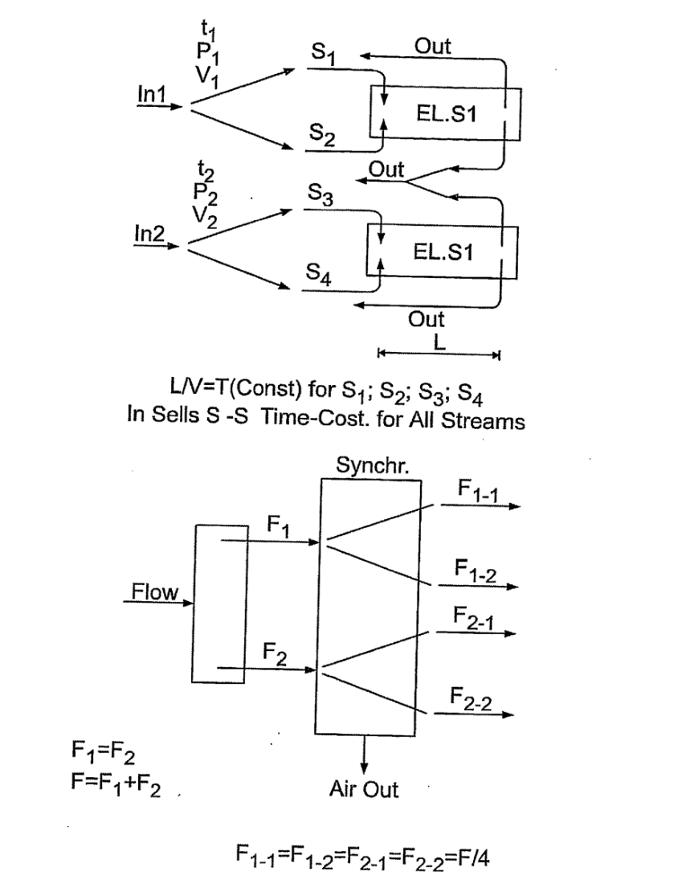

Fig. 1. A schematic representation of the motion of streams of impure water and their synchronization.

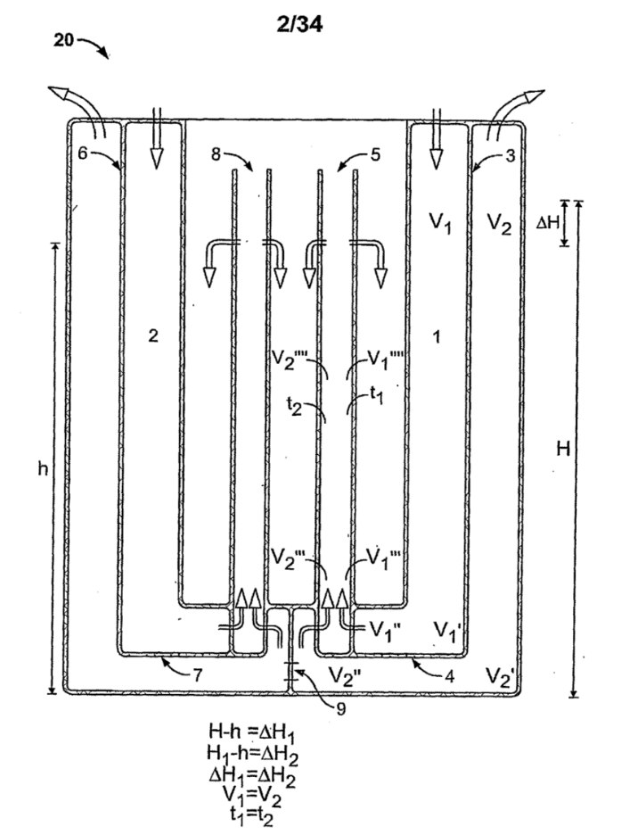
Fig. 2 A schematic cross-section view of a W2W electrochemical reactor body of the present invention.
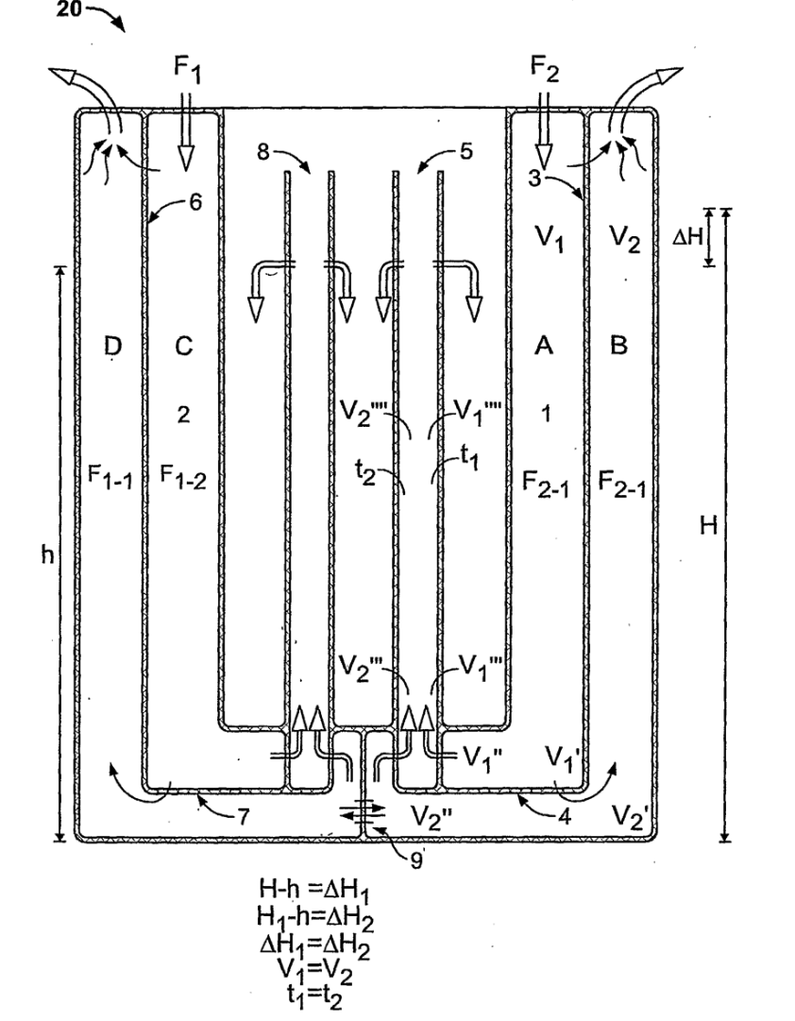
Fig. 2’ A slight revision of Fig. 2.

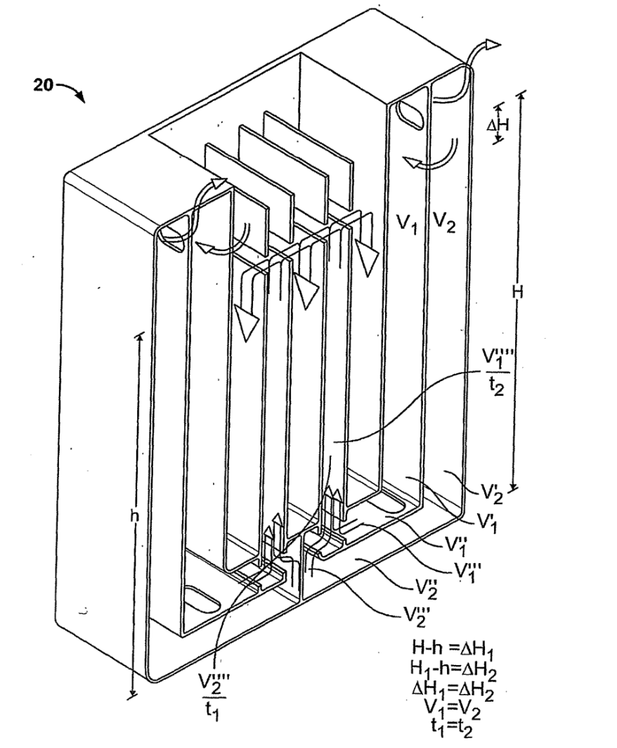
Fig. 3 A perspective schematic sectional view of a W2W electrochemical reactor body of the present invention.
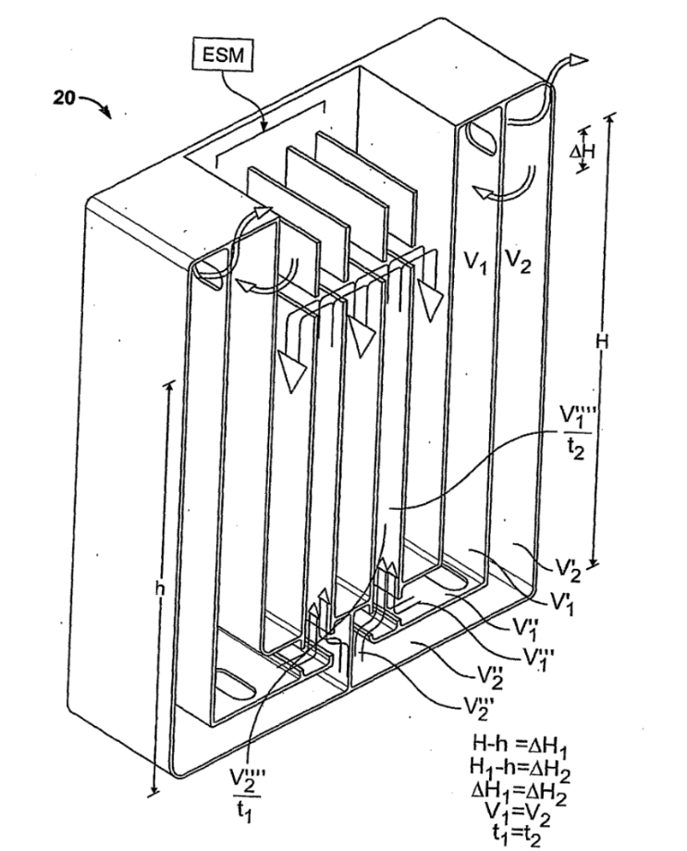
Fig. 3’ A slight revision of Fig. 3.
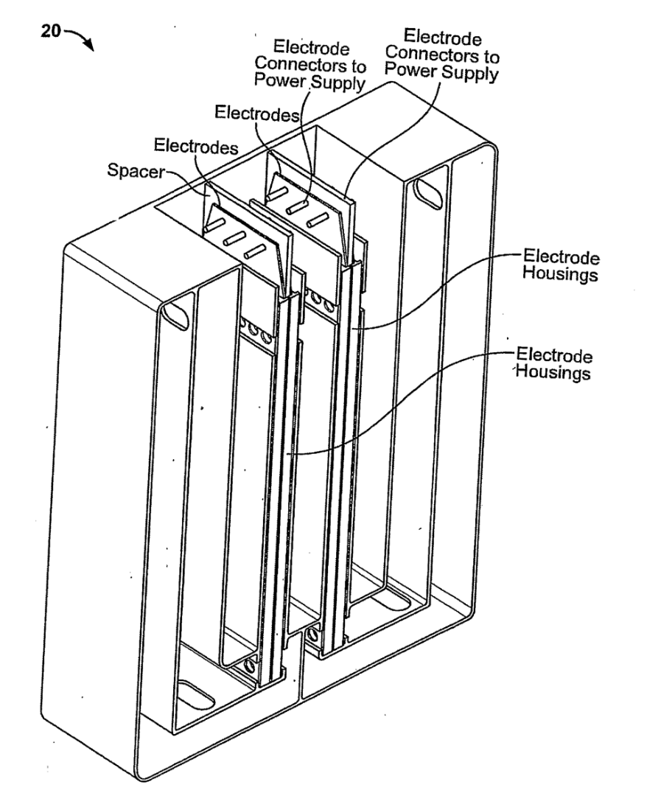
Fig. 4 A perspective view of a W2W electrochemical reactor with two electrode cell cassettes and the associated electrodes.
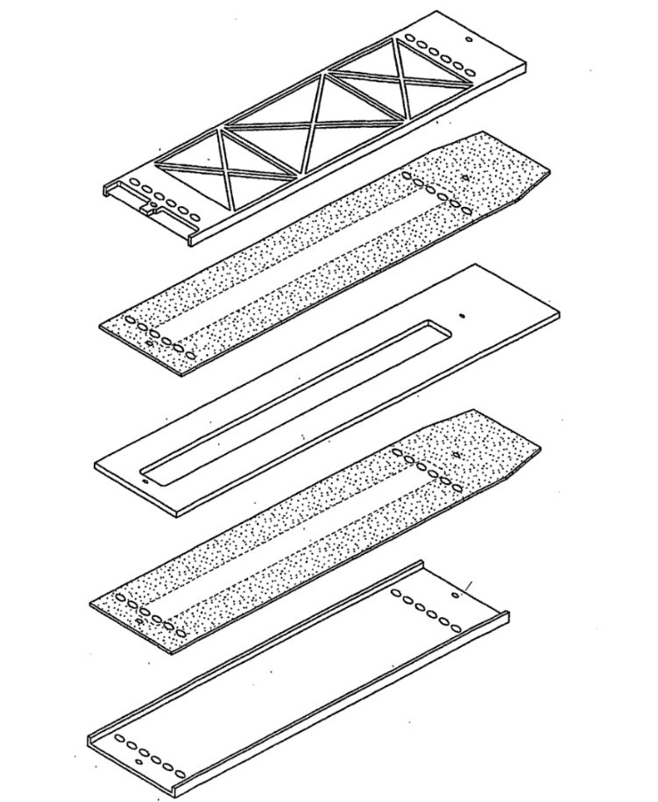
Fig. 5 An exploded view of one embodiment of electrode cell cassette and the associate electrodes of the present invention.
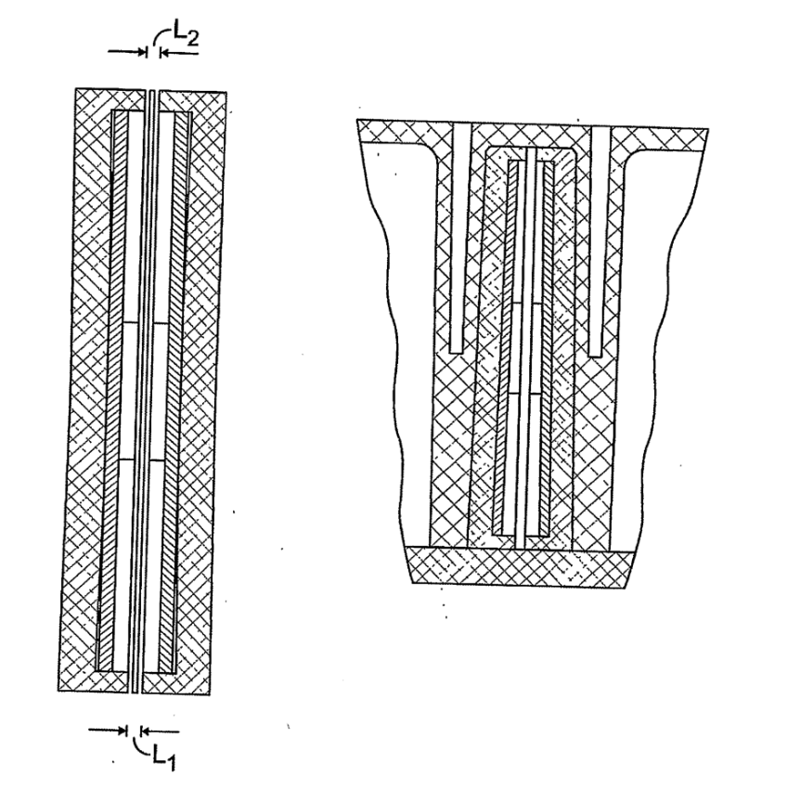
Fig. 6 The self-sealing construction of electrode cells of the present invention in two cross-section views.
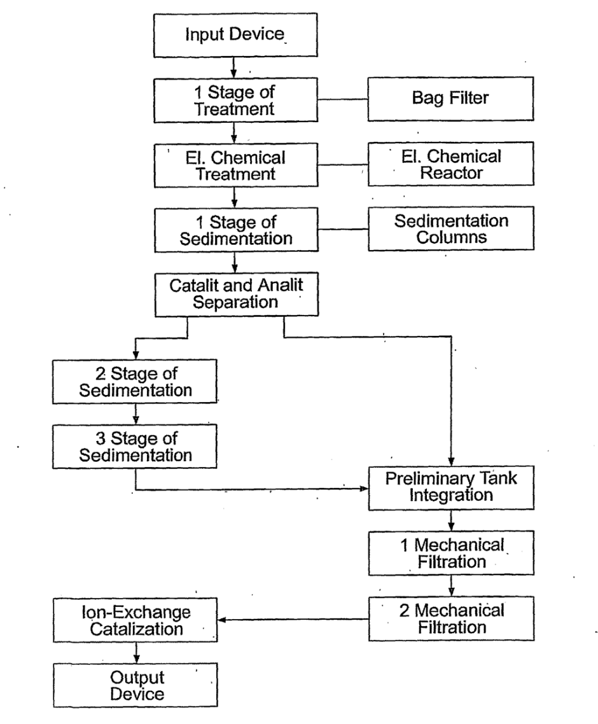
Fig. 7 A basic water flow chart of a W2W system.

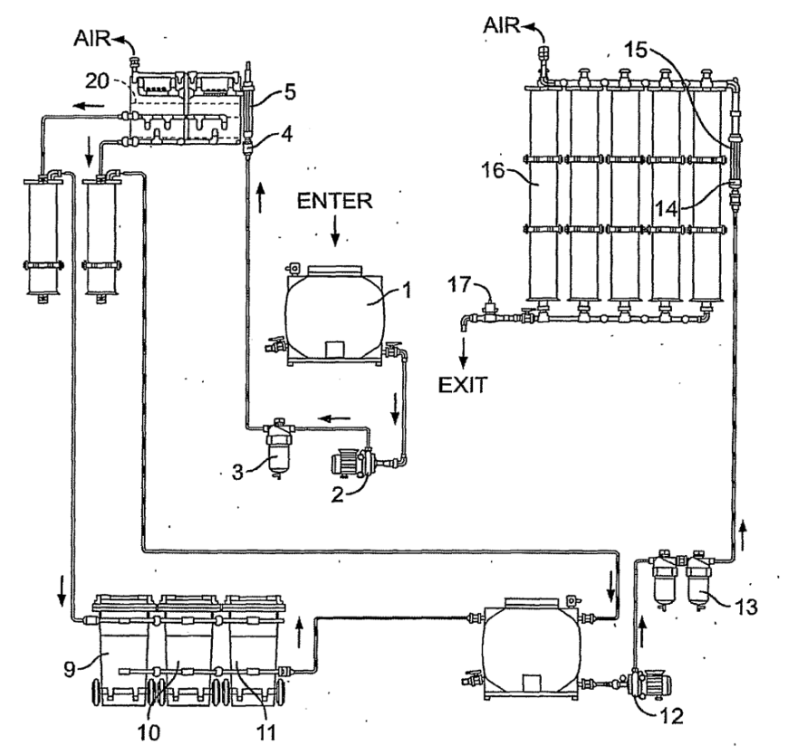
Fig. 8 A general scheme of one embodiment of a W2W system of the present invention.

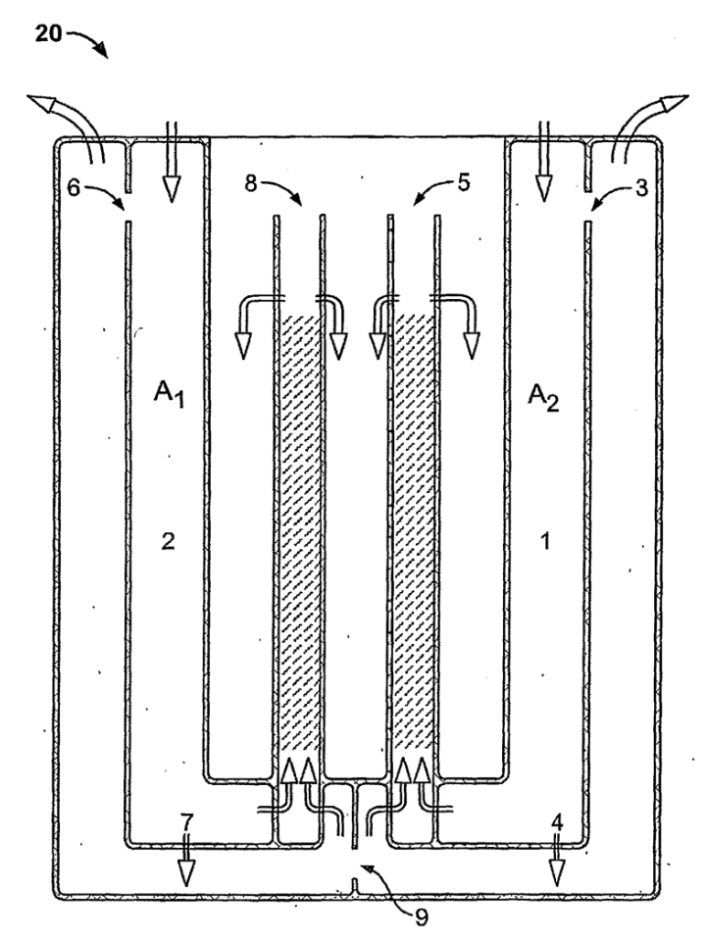
Fig. 9 A schematic cross-section view of one embodiment of a W2W electrochemical reactor of the present invention.

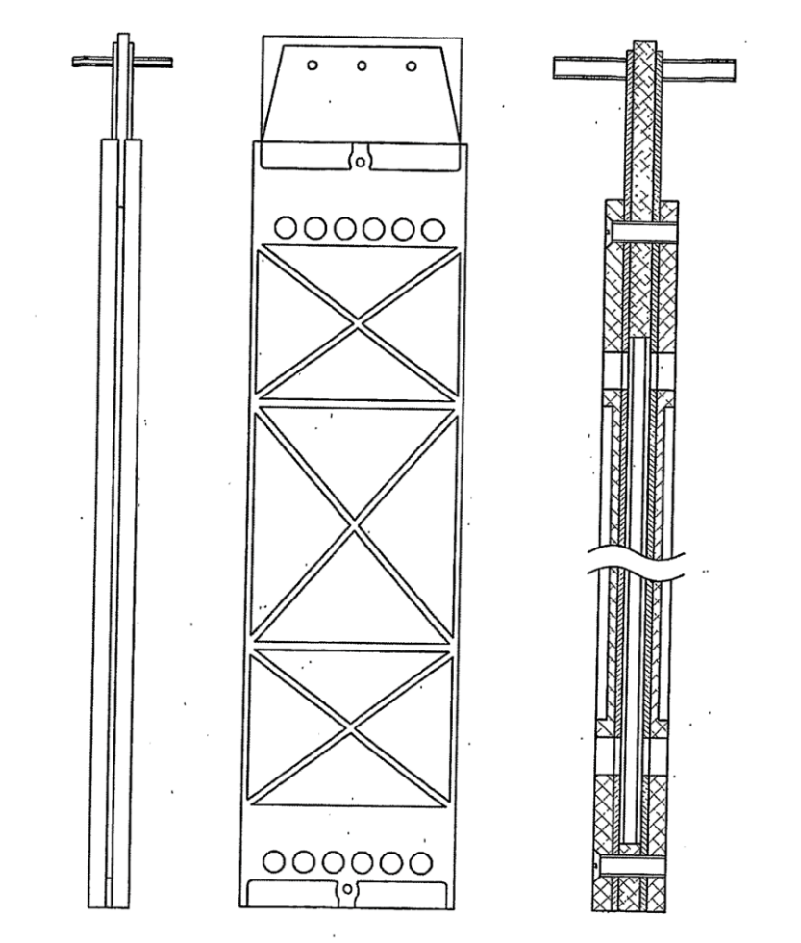
Fig. 10 An electrode cell cassette and its associated pair of oppositely charged electrodes of the present invention in three different views.
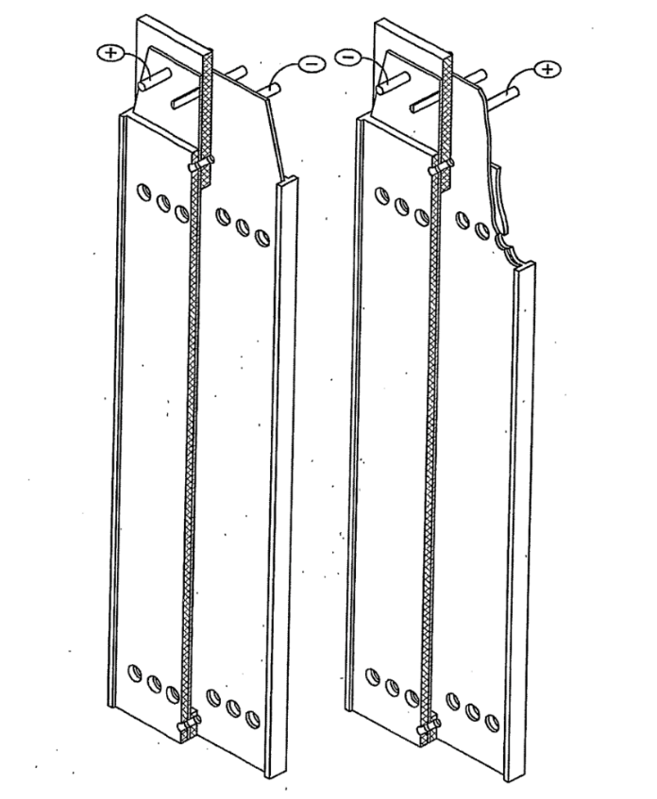
Fig. 11 is A perspective view of two electrode cell cassettes and their associated pair of oppositely charged electrodes of the present invention.
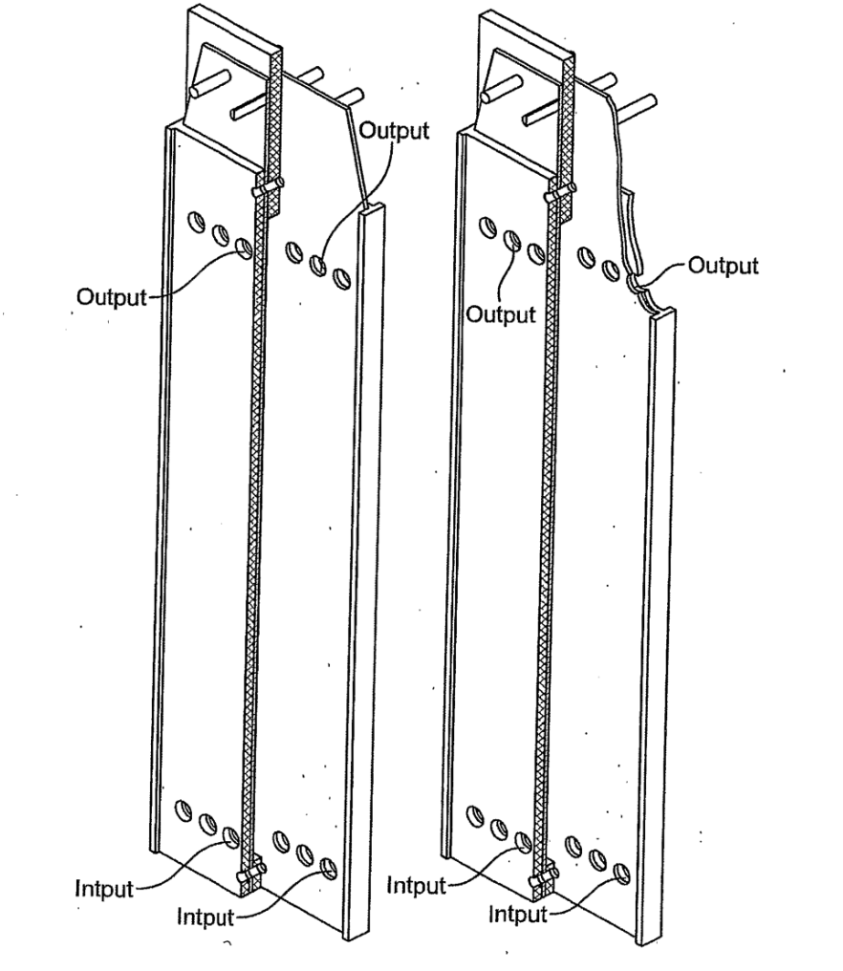
Fig. 12 Another perspective view of two electrode cell cassettes and their associated pair of oppositely charged electrodes of the present invention.
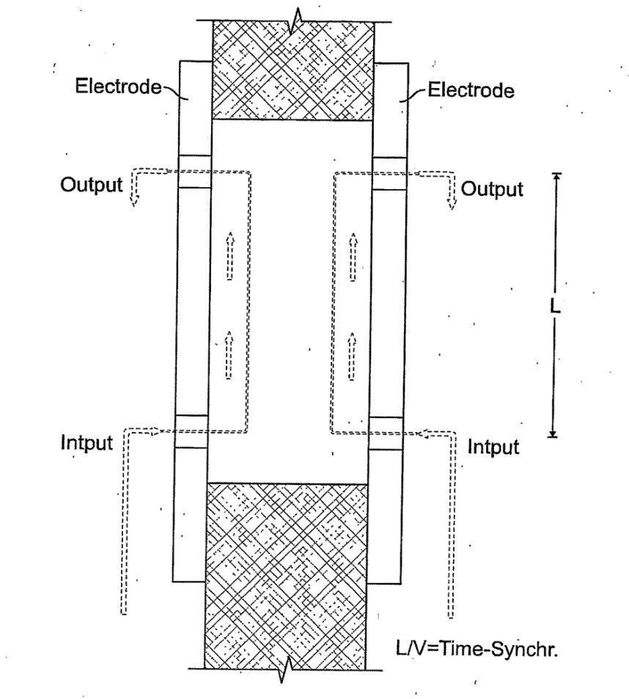
Fig. 13 A schematic diagram showing how the water flows through electrodes of the present invention.
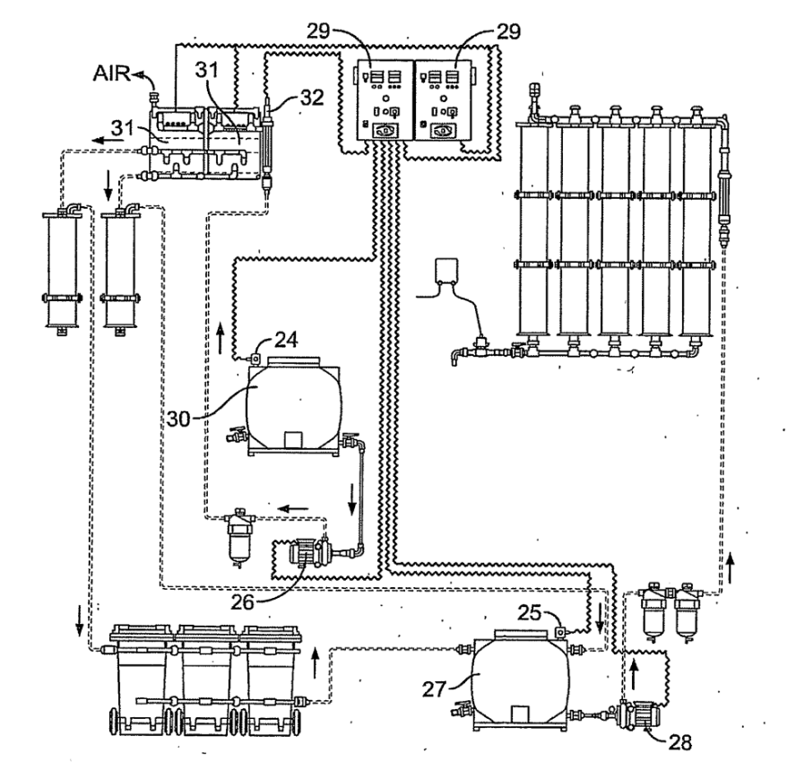
Fig. 14 A general scheme of one embodiment of a W2W system with automatically controllable power supplies.
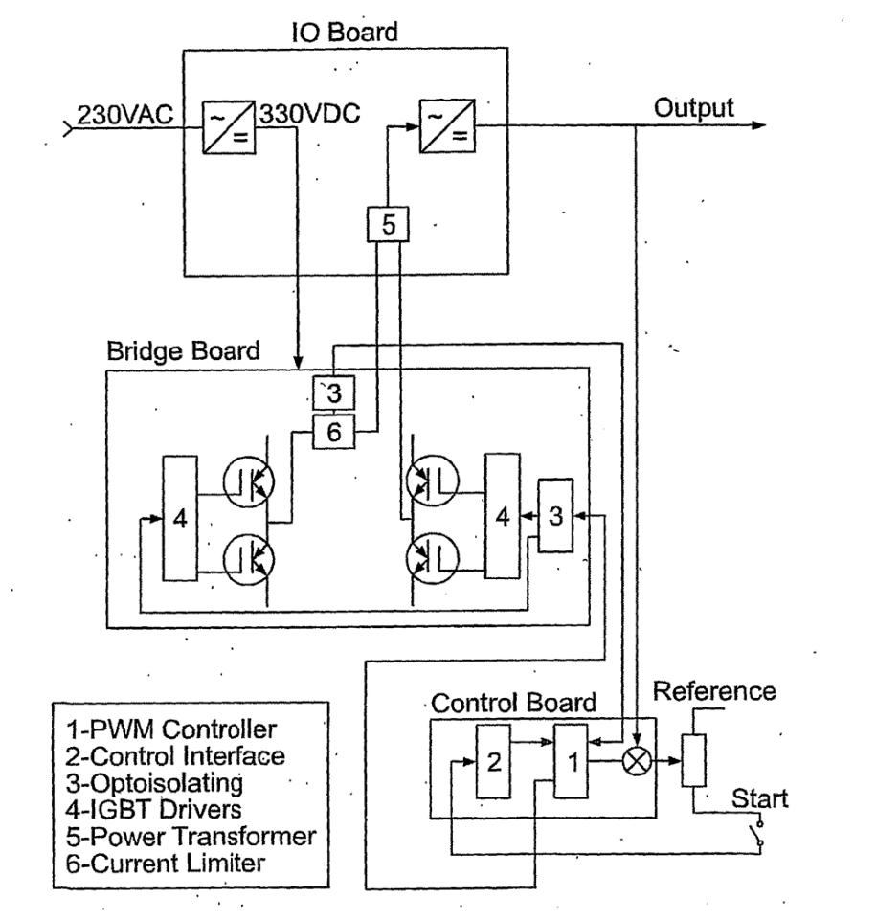
Fig. 15 A schematic diagram of the automatically controllable power supplies in Fig. 14.
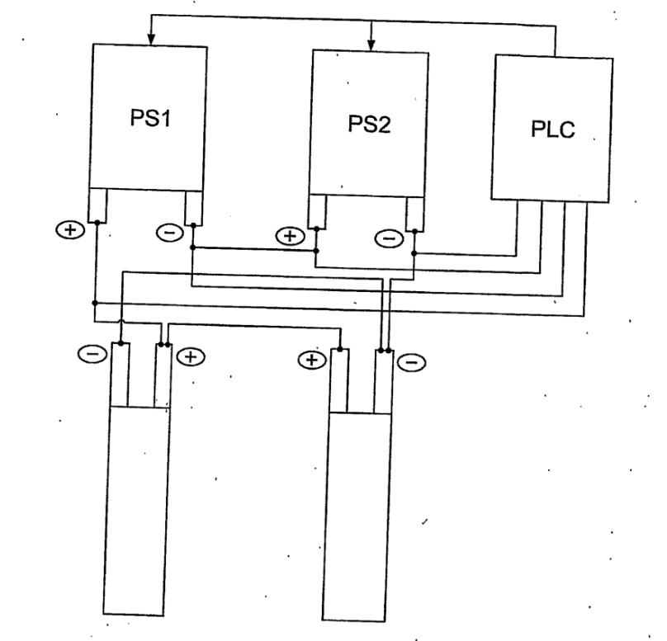
Fig. 16 A schematic diagram of power supplies connected in series and their connections to a PLC.
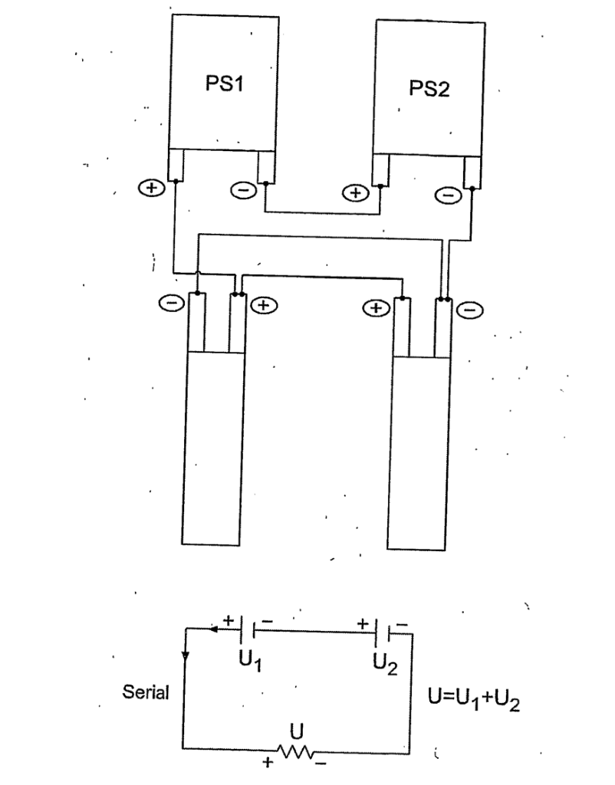
Fig. 17 Another schematic diagram of power supplies connected in series.

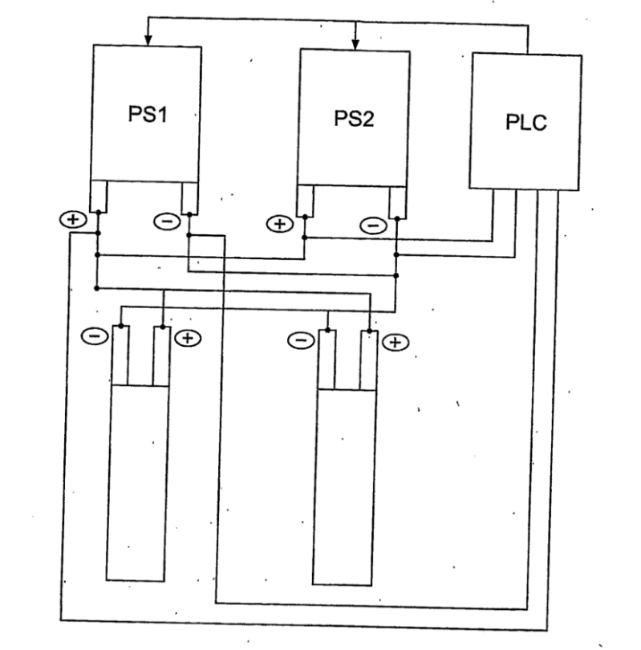
Fig. 18 is a schematic diagram of power supplies connected in parallel and
their connections to a PLC.

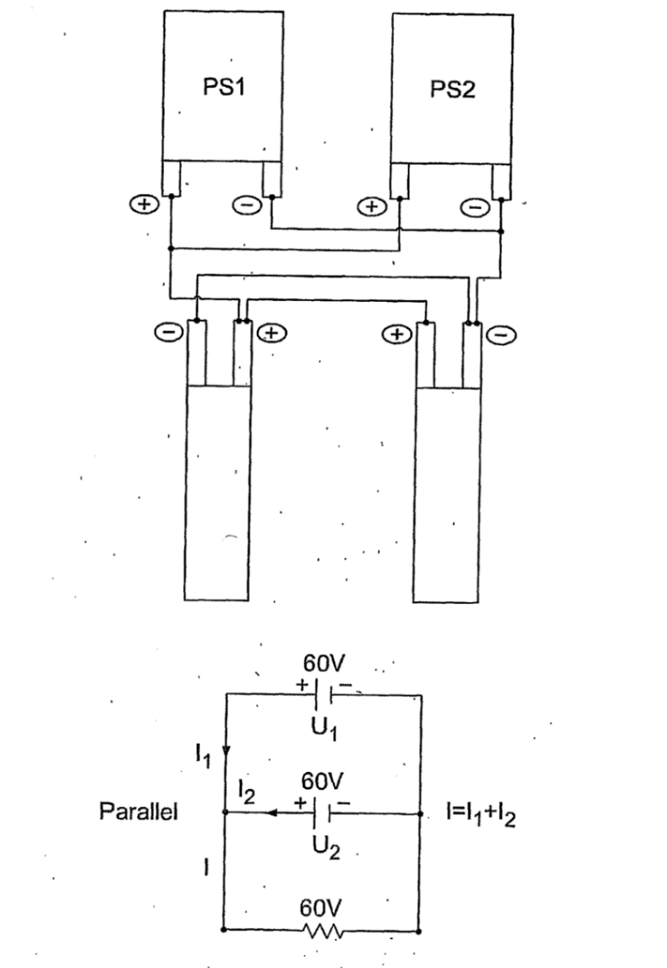
Fig. 19 Another schematic diagram of power supplies connected in parallel.

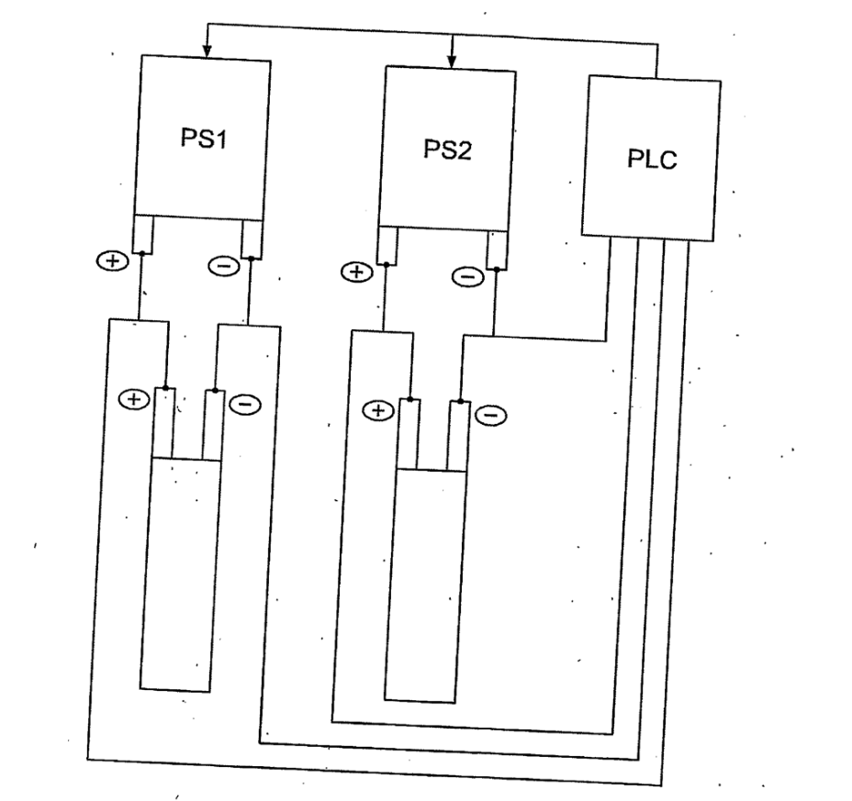
Fig. 20 A schematic diagram of power supplies connected in pseudo parallel and their connections to a PLC.

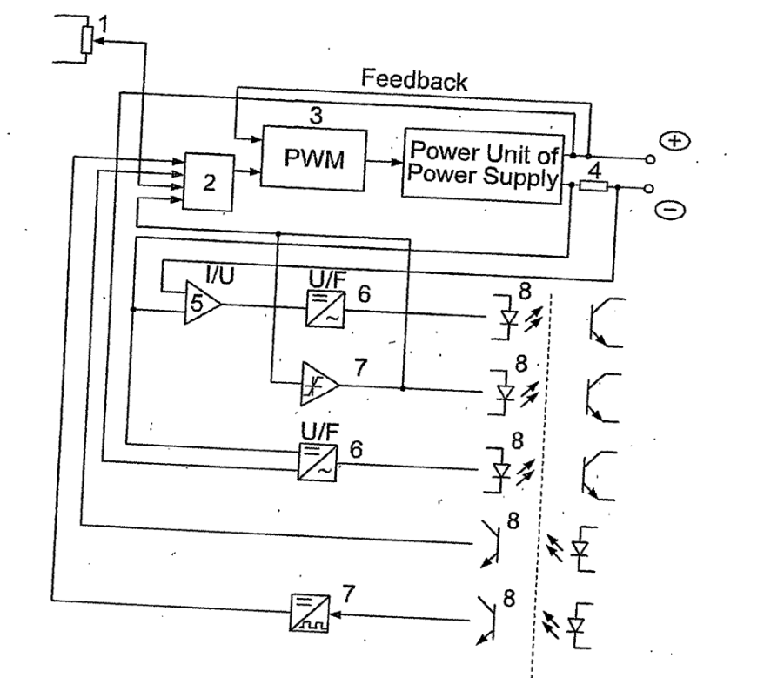
Fig. 21 A schematic diagram of a control board interface of the present invention.

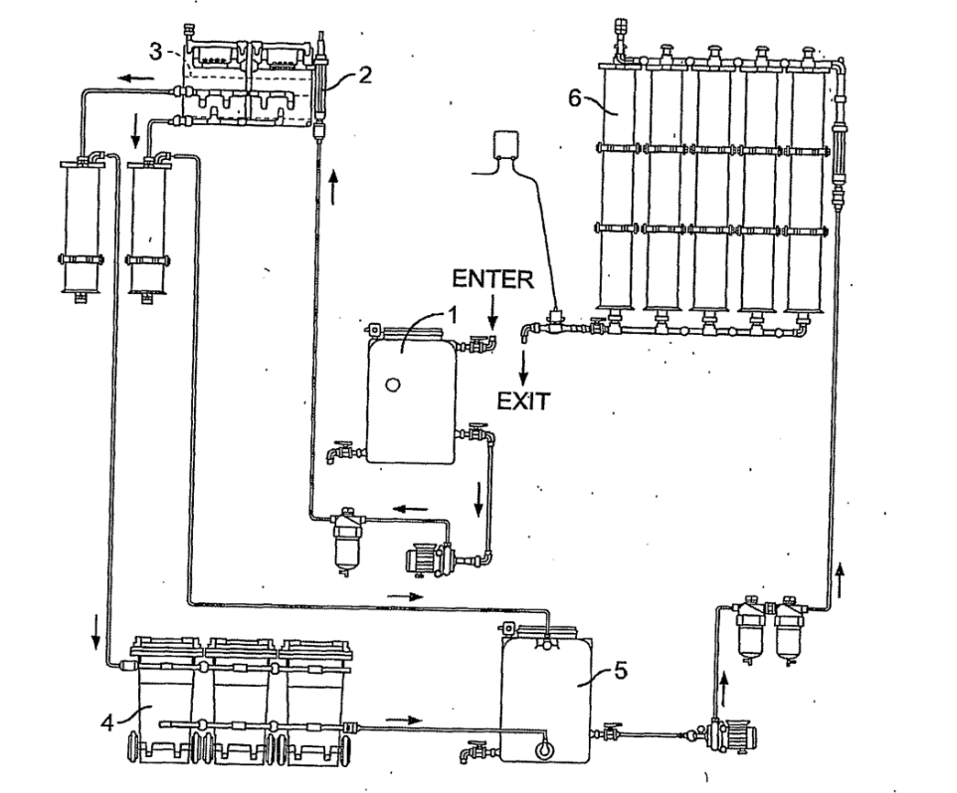
Fig. 22 A schematic diagram of a W2W system of the present invention.

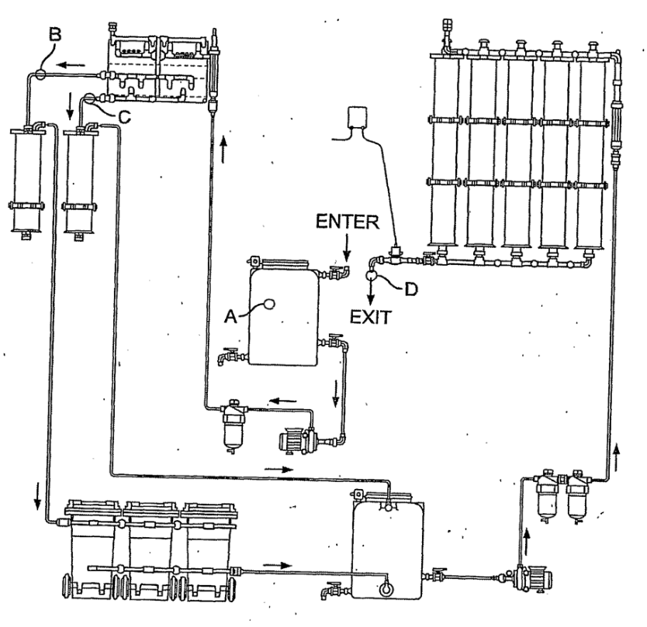
Fig. 23 A schematic diagram of a W2W system with a water sampling plan, in which A refers to a tapping point for inspection of water included in the W2W system, B refers to a tapping point for inspection of water coming out of the reactor (katholyte), C refers to a tapping point for inspection of water coming out of the reactor (anolyte), and D refers to a tapping point for inspection of water coming out of the W2W system.

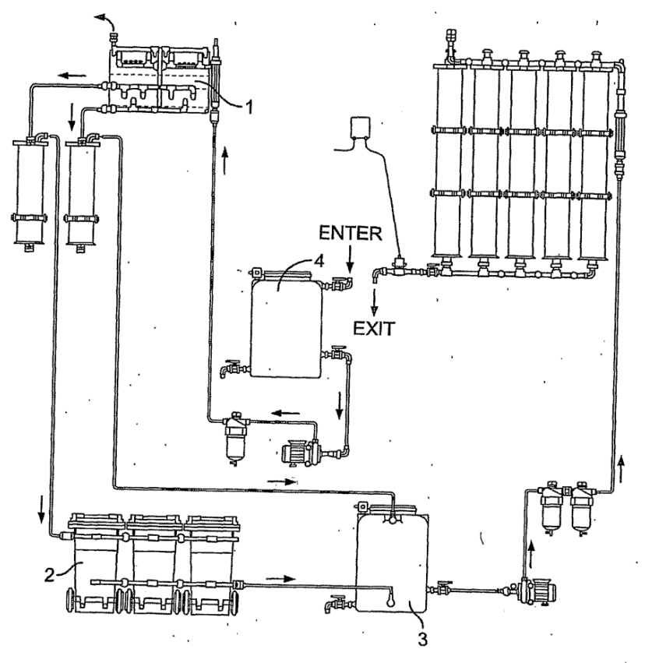
Fig. 24 is a schematic diagram of a W2W system with a water flow path indicated, in which 1 refers to an electrochemical reactor, 2 refers to sedimentation containers, 3 refers to a buffer tank, and 4 refers to a preliminary tank.

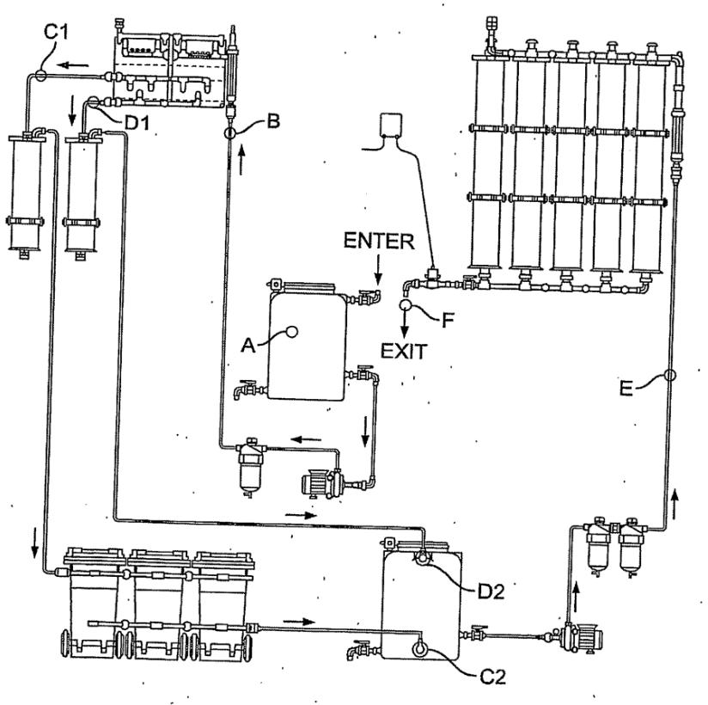

Fig. 25 is a schematic diagram of a W2W system with another water sampling plan, in which A refers to a tapping point for inspection of water included in the W2W system, B refers to a tapping point for inspection of water included in the reactor, Cl refers to a tapping point for inspection of water coming out of the reactor (katholyte), C2 refers to a tapping point for inspection of water coming out of the 3 filters in 50 micron and sedimentation containers, DI refers to a tapping point for inspection of water coming out of the reactor (anolyte), D2 refers to a tapping point for inspection of water coming out of the reactor (anolyte) on an input in intermediate container after filter in 50 micron, E refers to a tapping point for inspection of water flowing through the columns with ionic-exchange resin, and F refers to a tapping point for inspection of water coming out of the W2W system.

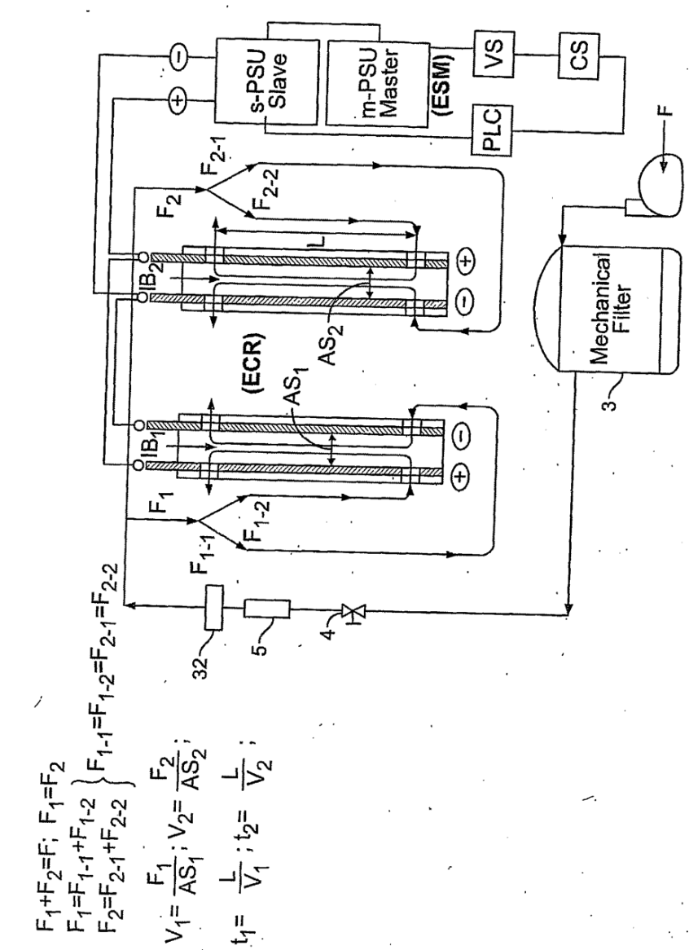
Fig. 26 is a schematic diagram of a W2W electrochemical reactor and its connections to power supplies and a mechanical filter, in which VS stands for voltage senor, and CS stands for current senor.
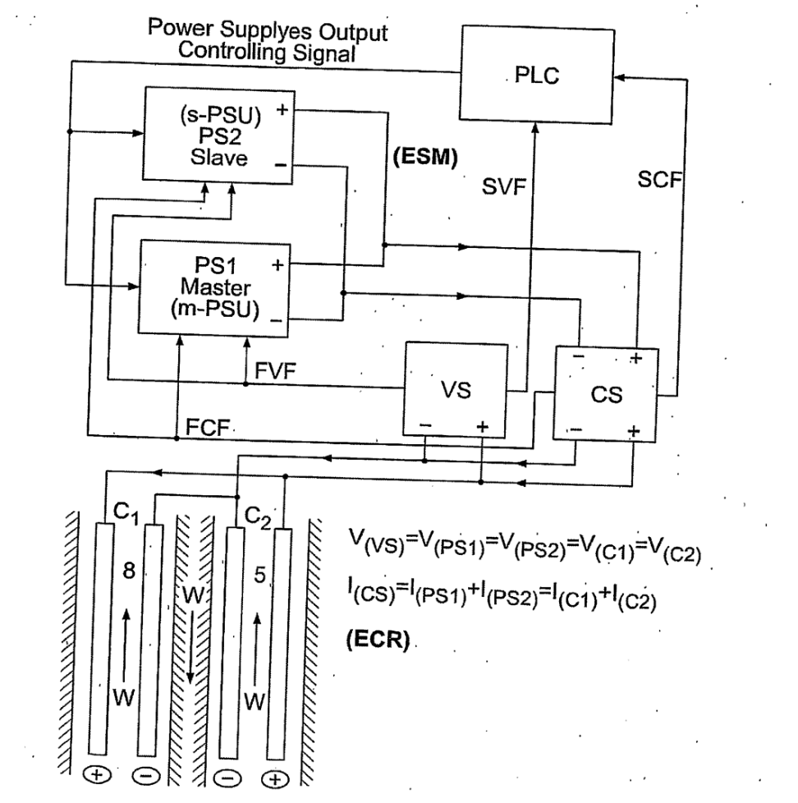
Fig. 27 is a schematic diagram showing power supplies connected in parallel and electrodes connected in parallel.

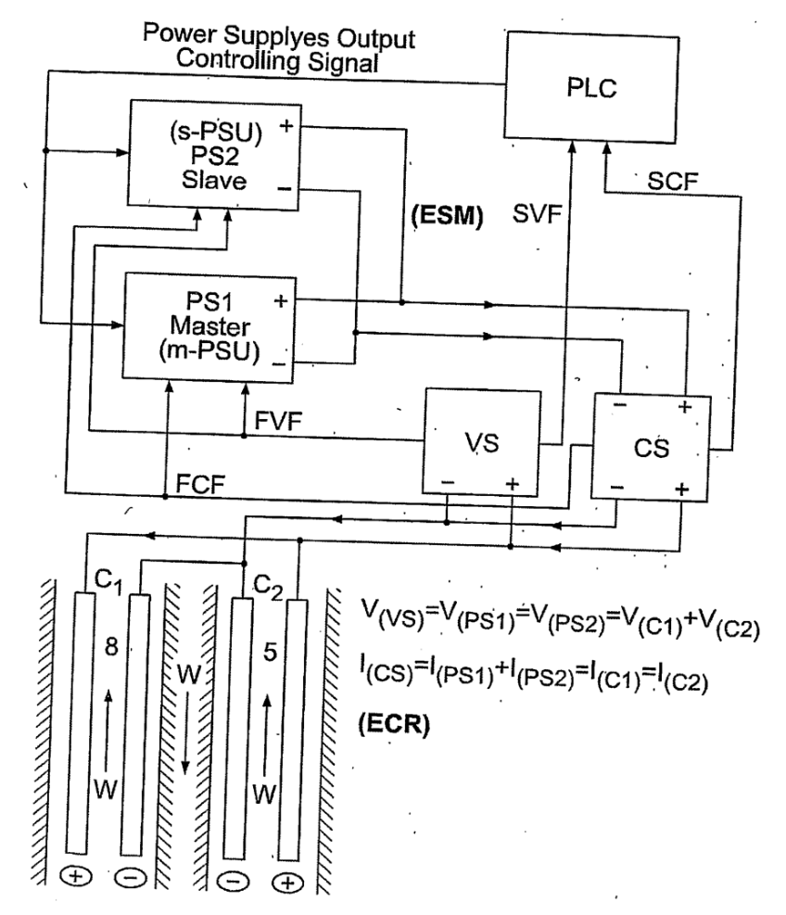
Fig. 28 is a schematic diagram showing power supplies connected in parallel and electrodes connected in series.

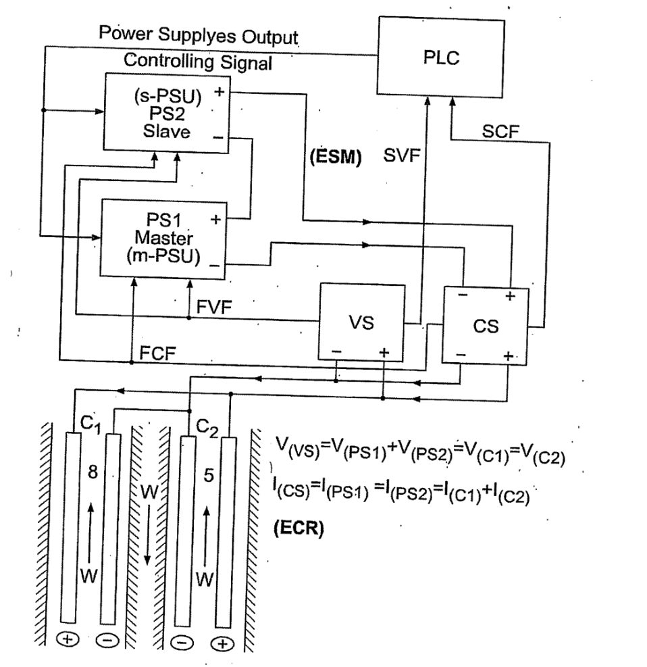
Fig. 29 is a schematic diagram showing power supplies connected in series and electrodes connected in parallel.

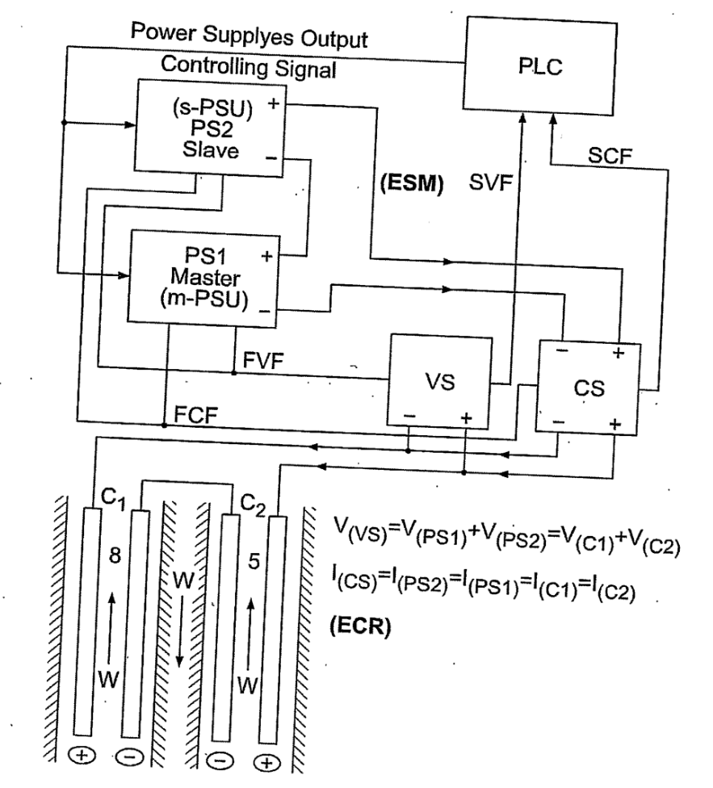
Fig. 30 is a schematic diagram showing power supplies connected in series and electrodes connected in series.
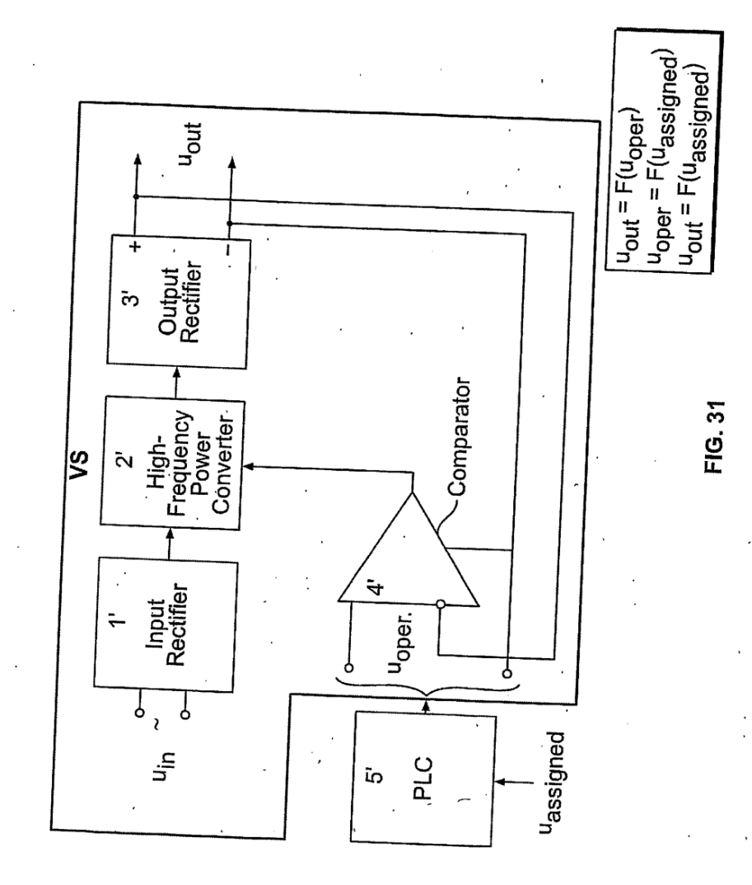
Fig. 31 is a schematic diagram of one embodiment of a voltage sensor/stabilizer and its connection to a PLC.
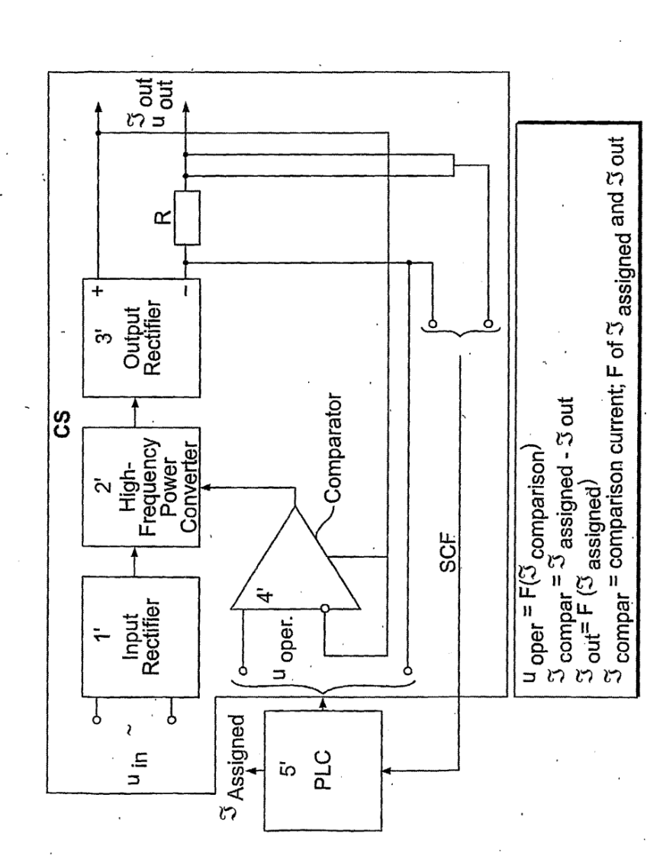
Fig. 32 is a schematic diagram of one embodiment of a current 20 sensor/stabilizer and its connection to a PLC.

Detailed description of the invention
The disclosure and description of the currently active Mey Rechavam PCT International Patent Application No. PCT/IL02/00911, filed Nov. 14, 2002, entitled: “WASTEWATER TREATMENT SYSTEM”, taking priority from U.S. Provisional Patent Application No. 60/387,585, filed June 12, 2002, is incorporated herein by reference. The cited Mey Rechavam PCT patent application illustratively describes in detail the design, construction, and implementation, of the electrochemical reactor, pre-treatment sub-systems, and post-treatment sub-systems, without any direct or indirect description of synchronous and/or synergistic design, construction, and/or operation, of the electrochemical reactor for providing stable and synchronous electrochemical process and hydrodynamic flow conditions.
The present disclosure and description of the Mey Rechavam (W2W™ ) invention, hereinafter, also equivalently referred to as the Mey Rechavam (W2W) invention, or as the Mey Rechavam (W2W) electrochemical reactor, or as the W2W system, or as the Mey Rechavam (W2W) water treatment/ purification/ regeneration system, is arranged and presented in four main parts. Part 1 is a general introduction and overall description of the W2W system.
Part 2 is an illustrative detailed description of the structure, function, and operation, of main and alternative embodiments, and components thereof, of the W2W system. Part 3 is a detailed description of exemplary “actual” practice and applications, and analysis of results obtained therefrom, of the W2W system. Part 4 is a detailed description of how the power control of the present invention synchronizes the power supply to a W2W electrochemical reactor.

Brief Product Description
Proprietary integrated, scalable, adaptive, and modular, systems and equipment, and technical support services thereof, for treating/ purifying/ regenerating commercial types and quantities of impure flowable water.
Based on separating and removing inorganic and/or organic impurities (e.g., metals, sulfates, phosphates, oils, and grease) from the impure water flowing through, and interacting with electrodes housed in, at least two electrode cells specially designed and constructed for providing stable and synchronous electrochemical process and hydrodynamic flow conditions. Efficient and cost effective design and operation of an energy supply mechanism including a 20 pair of synchronously connected and operative power supply units, for synchronously energizing the electrodes which oxidize and reduce components in the contacting flowing water. Generated oxidized/reduced water components complex impurities in the flowing water via mechanisms involving coagulation and precipitation, thereby forming impurity complexes removable, for example, by sedimentation, from the flowing water. Automated and computerized, including automatic process and feedback control equipment, procedures, and software.

General Introduction and Overall Description
Following is a general introduction and overall description of the Mey Rechavam (W2W) water treatment/ purification/ regeneration system.
The Mey Rechavam (W2W) invention relates to the general field of water treatment/ purification/ regeneration, and more particularly, to a method, device, and system, for treating/ purifying/ regenerating commercial types and quantities of impure flowable water.
The W2W invention features a variety of synchronized and synergistically interrelated electrochemical and hydrodynamical properties, characteristics, behavior, and phenomena, which are new (non-anticipated) and inventive (not obviously derived from) prior art inventions in the field of water treatment/purification/regeneration. Structure and operation of the W2W invention, and components thereof, are designed, constructed, and implemented, using conventional engineering techniques, equipment, and materials, based on well known established physical, chemical, and associated mathematical, theories, laws, and considerations. The W2W invention corresponds to a novel and unique synchronized and synergistic model of a non-linear system, influenced by continuously occurring fluctuations of primary system parameters relating to the flowing water being treated, that is, concentration of chemical components in the flowing water and conductivity of the flowing water.
In view of the fact that the W2W invention for purifying impure flowable water must handle fluctuating conditions, it therefore includes provisions for mitigating “selective instabilities” characteristic of most ecological technologies. This is accomplished via mechanisms of “organic” or “natural” order, which as part of the described invention for regeneration of impure flowable water, provide the capability of synchronizing and synergistically interrelating electrochemical 20 and hydrodynamical properties, characteristics, behavior, and phenomena.
An important goal of the W2W invention is based on comprehensive and well- founded principles of synchronization and synergetics as applicable to the technology of complex processing of impure flowable water. The W2W invention addresses the task of setting up an effective, mobile, adaptive, self-sufficient device (electrochemical and hydrodynamically stable reactor) as part of a larger overall system for regenerating impure flowable water. The effectiveness of the offered technical solution is due to:
- The low level of energy input required for the process.
- The low level of unproductive energy losses during a technological cycle of the process.
- The possibility of combining and synchronizing at the same time certain energy-consuming autonomous technological tasks, such as electric dissolution of the anode (the electro-coagulating element) and forming at the same time a space of highly concentrated oxidizers.
- Reduction of the process duration, by precisely synchronizing the cycle time with the interaction between the technological stages of the process.
- Stabilization and synchronization of process rates, concentrations, energy inputs and time factors.
- High level of reproducibility and technical standardization of the process.
Mobility of the proposed solution is due to the following:
- Minimized construction.
- Modular construction, with fully synchronized modules.
- Flexible interaction scheme between modules, possibility of synchronized change of additional processing, allowing operation of facilities during the transition time.
The proposed technical solution is adaptable in that:
- Synchronous automatic variation of the energy supply parameters of the process, upon change of conditions and initial characteristics of the process, such as change of the conductivity of the aqueous solution.
- Modular, stand-alone system, made up of identical, energy-conversion and energy-producing units, synchronously operating to supply energy for the process.
- A system of feedback sensors, supplying signals used to stabilize and synchronize the process parameters.
The self-sufficiency of the proposed solution consists in that there is:
- A full cycle of technological operations and transitions synchronized in all parameters among themselves, thus providing the ultimate regulation required.
- Fully autonomous system for processing various different types of sources and supplies of impure flowable water.
- Synchronously combining various operations in the treating/purifying/regeneration of impure flowable water so as to obtain the best possible result.
- Deriving from the process separate traditional results, such as pH corrections.
The main advantages offered by the W2W invention for treating/ purifying/ regenerating impure flowable water are due to the realization of the various fundamental characteristics of the W2W invention, and the following structural and technological advances:
- Effectively stimulating co-sedimentation (multi-sedimentation) when the impure water contains metals and other materials, enabling their sedimentation under fundamentally different conditions.
- Effective stimulation of co-sedimentation without significant change of the acidity or alkalinity of the water.
- Carrying out at the same time hydroxidation as well as electro-coagulation, without expenditure of energy and time.
- Effectively processing, via treating/purifying/regenerating, impure flowable water sources within a short space of time, permitting to speed up the operation of automatic production lines.
- Obtaining indirect data on the variation of readily-sensed parameters of operation of the system elements in treating/purifying/regenerating, impure flowable water sources using feedback to gather information on the quality of the treated/purified/regenerated water.
- Speeding up automatic control systems.
- Speeding up flexible automated technological modules and complexes.
- Adaptation to the treatment/purification/regeneration of impure flowable water having very low conductivity, for example, 1-5 micro-Siemens.
- Achieving two-fold increase in the parameters of electric current or voltage,20 without additional expenditure of energy, by facilitating electrochemical processing in the system, by changing one parameter without changing the other parameter.
- Remote control of the system, along with controlling process parameters and eliminating imbalance in the electrochemical and hydrodynamic parameters of the system.
- Autonomous local shutdown of the system and remote operation, without actuating treatment/purification/regeneration of the already treated/purified/regenerated flowing water, for closed-cycle recirculation of the water.
- Rapid change of the technological regime of system operation, automatically synchronizing the operation of sources of direct electric current and the hydrodynamic part of the system with an arbitrary change in configuration, and according to the character of interaction between system components.
Integrating the W2W invention into larger scale systems and processes, for example, reverse osmosis systems, ultra-filtration systems, etc.
Associated advantages obtainable due to specific advanced characteristics of parts of the W2W system for treating/purifying/regenerating impure flowable water:
- Indication of the presence of at least two synchronously acting sources of direct current.
- Series connection and voltage doubling relative to the maximum needed for a given conductivity of impure flowable water. A consequence of this is the increase of concentration of oxidizing and reducing agents at the output and as a result, leading to a higher percentage of hydroxides in the exiting treated/purified/regenerated water.
- Parallel connection and doubling of the current, relative to the maximum current required for a given conductivity of the impure flowable water. As a result, there is higher concentration of oxidizing and reducing agents at the output, leading to a higher quality of sedimentation of hydroxy compounds in the treated/purified/regenerated water.
- For parallel connection, there is achieving effective coagulation at high current regime - up to a current density of about 4A/dm2, enabling dissolution of an aluminum electrode to achieve twice the effective rate of reaction, compared to conventional electro-coagulation reaction rates (current density roughly 1 to 2A/dm").
- For parallel connection, there is setting up electrolytic extraction of precious metals from the impure flowable water at the stabilization stage of hydrodynamic 20 parameters, as the water passes between the electrodes in the electrode cells of the electrochemical reactor.
- The W2W invention is applicable to treating/purifying seawater.
- There is the capability of on-line monitoring. During signal of disturbance
- of the synchronous regime, there is an automatic signal indicating system irregularity, followed by automatic return to the synchronous regime, along with an automatic signal informing of return to normal operating regime.
- Maintaining the quality of the treatment/purification/regeneration process
- output, while having a two-fold reduction in power relative to using a single energy source providing a larger power to the electrochemical reactor electrodes.
- Indication of the presence of common cathodic and anodic sections in interelectrode spaces inside the electrode cells.
- Higher intensity of the electrical field strength in the inter-electrode spaces.
- Reduced resistance to the water flowing through the inter-electrode spaces.
- Higher concentration of generated oxidizing and reducing agents.
- Prevention of the shedding or release of salts from the cathode.
- Avoidance of retention of anode scale in die anode section of the electrochemical reactor.
- Facilitated utilization of system characteristics.
- Increased service life of the electrodes, in particular, and of the electrode cells, in general.
- Reduction of the loss of electric energy, due to the reduced resistance in
- inter-electrode space.
- Asymmetric configuration of the working surfaces of the electrodes.
- Use of electrodes of varying thickness, which is important for increasing the thickness of anodes, thereby increasing electrode service life.
- Performing electro-coagulation at the same time as performing electrooxidation and/or an electro-reduction reaction.
- Synchronously changing the effective active surface of the electrodes, and to the same extent on both cathode and anode.
- Unhindered division, into two equal parts, of the water flowing into or out of the inter-electrode space.
- Reduction of hydraulic resistance to the flowing water, for carrying out the process without requiring assistance of extra pressure in the inter-electrode space.
- Increasing the cross-sectional area between each pair of two electrodes, thereby increasing the rate of water flowing between the inter-electrode space, translating to increasing performance of the electrode cells, and therefore, of the electrochemical reactor.
- Increase of cross-sectional area (theoretical input) of the electrode cells, enabling higher input of water flowing through the electrode cells, and through the electrochemical reactor.
- Increased throughput capacity of the electrode cells and of the electrochemical reactor.
According to the result of experimental studies of the system, a highly significant advantage of the W2W invention is the twofold power reduction supplied to the electrodes, compared to prior art versions of energy conservation. As a consequence thereof, there is:
- Avoidance of formation of solid salts, or scaling, at the cathode surface.
- Avoidance of passivation or deactivation of electrodes (anode and/or cathode).
- Avoidance of unmitigated or total destruction of electrodes (anode and/or cathode).
- Avoidance of overheating electrodes (anode and/or cathode).
- Reduction of size of the power sources of the electrodes (anode and/or cathode).
- Reduction of the installed power of the power sources and a lower electrical safety threshold.
The W2W invention for regenerating aqueous solutions is designed, constructed, and implemented, using the principle of dynamic symmetry. Dynamic symmetry is defined as “the coordination of all non-stationary system states and the stabilization of all transitions among system states possessing different energies”, as stated in the Encyclopedia of Physics, p. 683, published by the Great Russian Encyclopedia, Moscow, 1999.
In general, the terms “synchronous” and “synchronization” are defined by, and refer to, actions, devices, systems, and/or processes, taking place or occurring, moving, and/or operating, at same time and/or at the same rate, for example, by having identical periods and/or phase. Moreover, the term “synchronize” is defined 20 by, and refers to, causing actions, devices, systems, and/or processes, to occur at the same time and/or at the same rate; to be simultaneous; to move and/or operate in unison.
Herein, with respect to the present invention, a special form of synchronization is used. As defined in the same Encyclopedia of Physics, p. 687, and as defined and described in “Synchronization of Dynamical Systems” by I.I. Blechman, Moscow, 1968, with particular reference to electronics applications, synchronization refers to the special situation when “the working parameters of two direct current sources are such, that one of the sources (the synchronization master) acts on the other (the synchronized slave) by feedback regulation”. For the present invention, the operating regime under dynamic symmetry of states for the system consists of two direct current sources, whereby all synchronizing parameters are taken to correspond in real time to the parameters of the synchronization master source. For the present invention, for example, as illustrated in Figs. 16-20, the operating regime under dynamic symmetry of states (conditions) for the water treatment system is determined by at least two direct current sources (power supply units), whereby all synchronizing parameters are taken to correspond in real time to the parameters of the synchronization master source.
The W2W invention features integrated, scalable, adaptive, and modular, sub systems and equipment, for treating/purifying/regenerating commercial types and quantities of impure flowable water. A main aspect of the W2W invention is based on separating and removing inorganic and/or organic impurities (e.g., metals, sulfates, phosphates, oils, and grease) from the impure water flowing through, and interacting with electrodes housed in, at least two electrode cells of an electrochemical reactor specially designed and constructed for providing stable and synchronous electrochemical process and hydrodynamic flow conditions. The W2W invention features efficient and cost effective design and operation of an energy supply mechanism including a pair of synchronously connected and operative power supply units, for synchronously energizing the electrodes which oxidize and reduce components in the contacting flowing water. Generated oxidized/reduced water components complex impurities in the flowing water via mechanisms involving coagulation and precipitation, thereby forming impurity complexes removable, for example, by sedimentation, from the flowing water. The W2W system is fully automated and computerized, including automatic process 20 control, feedforward control, and feedback control, equipment, procedures, and software.
Operation of the specially designed and constructed electrochemical reactor is initiated and maintained by two interrelated power sources (generators) which considerably differ in power. This is due to the fact that the first regulation (calibration) of voltage is carried out on the first source (the synchronization master), during which time the second source (the synchronized slave) remains in standby (starting pause). This means that the instantaneous power of the first source being calibrated will momentarily exceed the power of the second source. A detailed scientific explanation of the synchronization of two coupled systems is provided in the aforementioned cited Encyclopedia of Physics, p. 687. In this situation, the first source, having an instantaneous high output power, plays the role of the synchronizing master, while the second source which is momentarily weaker, plays the role of the synchronized slave.
After the starting calibration of the voltage of the first source, in relation to the conductivity of the flowing water during calibration, file second source starts running in an identical regime. Since both sources run in a “stabilized voltage” regime, during operation of the W2W invention, upon change of conductivity of the flowing water being treated/purified/regenerated, the master source reduces its output voltage and the second source steps up its voltage. The application of the herein defined and described synchronization principle leads to a non-linear system with continuously occurring fluctuations of primary system parameters relating to the water being treated/purified/regenerated, that is, concentration of chemical components in the water and conductivity of the water, in a steady engineering regime, and provides stable operation under all energy conditions, and a general energetic balance of the system for treating/purifying/regenerating an impure water source.

Structure, Function, and Operation
The following is an illustrative detailed description of the structure, function, and operation, of main and alternative embodiments, and components thereof, of the Mey Rechavam (W2W) water treatment/purification/regeneration system.

Hetero-coagulation
Installation into the water treatment/purification/regeneration electrochemical reactor of electrode cells having anodes made of aluminum or pure iron, leads to an effect whereby the basic process of generating oxidizing and reducing agents in the stream of water is complemented by anodic debris which is a coagulant. This 20 facilitates the process associated with the necessary separation of disperse phase substances from the dispersing medium. This “coagulation threshold” rises rather rapidly. In most cases, the flowing impure water contains various salts of polyvalent metals, which are hydrolyzed to produce colloidal hydroxides. This stimulates the process of hetero-coagulation, and often basic coagulation as well.
In hetero-coagulation, various disperse systems reciprocally coagulate with one another, resulting in particles of one disperse phase adhering to those of another phase. Hetero-coagulation increases upon mutual mixing of segregating salts with variously loaded particle surfaces, since ionic type of electrostatic forces among them lead to mutual attraction, and not repulsion, of the particles.
Brownian motion kinetics of coagulation of colloidal systems determines the needed contact time of the flowing water contacting the electrodes, and the flow through the cells in the inter-electrode space, so that the number of independent unrelated units is diminished by half, giving rise to a “coagulation threshold” contact time expressed in the following form, as described by the “Theory of Smoluchovski”, in Chemical Encyclopedia, vol. 2, p. 817, published by the Soviet Encyclopedia, Moscow, 1990:
t = 3 η / [ 4 kTn₀a ],
where t = the time in which the number of independent unrelated units is halved;
η = viscosity of the medium;
k = Boltzmann's Constant;
T = the absolute temperature (°K);
n₀ = initial particle concentration;
α = the so-called coefficient of coagulation slowdown. In the absence of an energy barrier, that is, at high current densities, which for the present invention is about 4A/dm², whereby α = 1; in the presence of an energy barrier, α < 1.
The time of stay in an electrode cell within the inter-electrode space in a system having a throughput of lm3 / hour is about 3 seconds. During this period of time, the entire volume of the water flowing through the electrode cell experiences the action of a space-coagulating network. For a sample of water passing through the electrode cell for approximately 0.2 - 0.6 second, after exiting from the interelectrode space, whether from the anode or from the cathode, the volumetric weight of the water sample characterizes the initial turbidity, that is, the segregated disperse medium (precipitate). The unstructured sediment phase deposited in the 20 course of between about 1 and 2 minutes passes into the structured sedimented phase and the consolidated precipitate layer.
The candelabra (in particular, menorah) -like labyrinth configuration or shape of the electrochemical reactor used in the W2W system, provides a synchronized electrochemically active and hydrodynamically stable environment for separating impurities from the flowing water. To obtain optimum conditions for hydrodynamic synchronization of all parallel streams of the flowing water, the electrochemical reactor body of the electrode cell is filled by a labyrinth in the form of a “menorah”.
This structure makes possible the following:
- Disposing the electrochemical reactor horizontally as well as vertically.
- Stabilizing the dynamic flow of all streams without additional energy expenditure.
- Synchronizing all entering streams for each of the electrode cells.
- Synchronizing the motion of parallel streams in the inter-electrode space.

The motion of streams of the impure water and their synchronization is schematically shown on Fig. 1, and the “menorah”-like labyrinth is schematically shown on Fig. 2. The flowing water is directed into two equal parallel streams, in1 and in2 (Fig. 1). Streams in1 and in2 are driven by a pressure in a range of between about 1.2 to 1.5 bars. As shown in Fig. 2, in electrochemical reactor 20, channels l and 2 are provided with openings 3 and 4 facing towards a working chamber 5, while openings 6 and 7 face the working chamber 8. Working chamber 5 and working chamber 8 are joined to the channels adjacent to channels l and 2, respectively. The channels of the two working chambers are interconnected by way of an opening 9. Since operation of chambers 5 and 8 proceeds in an absolutely identical, that is, synchronous, manner, it is possible to consider the hydrodynamic balance for only one of them. The flow in channel 1 comes out through opening 4 in the adjacent channel and reaches the level ∆H, whereby on account of the presence of openings 3 and 4, this level is identical in both channels, and continues upwards to come out through the channels into working chambers 5 and 8. The difference ∆H for the two channels is the same, and is maintained in a synchronous regime, whereby opening 3 stabilizes this regime, allowing passage of air out of both channels.
In electrochemical reactor 20, absolute working symmetry is obtained between channels 1 and 2, and the adjacent channels (Fig. 2). Due to the presence 20 of opening 9 and ∆H being symmetrical for both channels, the flow speed in the two identical parts is the same and symmetrical for all channels adjacent to one of the working chambers 5 and 8. This symmetry permits synchronization of the flow speed at all stages of motion of the water flowing throughout the labyrinth, and thus permits synchronizing the transit time of corresponding symmetrical parts (Fig. 1). This circumstance permits the electrochemical reactor to be considered as a synchronized tandem electrode cell, internally connected to provide hydrodynamic synchronization of the electrode cells. This also permits the drawing of electric energy from two synchronized power sources.
Fig. 3 is a schematic diagram illustrating a perspective view of the menorah like labyrinth configuration or shape of the electrochemical reactor 20 used in the W2W system, illustrated in Fig 2. Fig. 4 is a schematic diagram illustrating a perspective view of the electrode cells as part of the electrochemical reactor 20 used in the W2W system.

Main Structural Characteristics of the Electrochemical Reactor
- Construction of the electrochemical reactor body labyrinth in the form of a “menorah”, as illustrated in Figs. 2 and 4.
- Hydraulic connection between adjacent channels of the labyrinth.
- Geometric and hydraulic symmetry between homologous elements of the electrochemical reactor body labyrinth.
- Provision within the electrochemical reactor body for two electrode cells, identical in all structural and technological parameters.
- Trapezoidal cross-section of the electrode cells in the case of plane-parallel electrodes (as a variant) with parallel active working surfaces, for example, as illustrated in Fig. 5.
- Self-sealing construction of the electrode cells, for example, as illustrated in Fig. 6.
- Composite electrochemical reactor body.
- Other spatial position of the body (as a variant).
- Other form of the electrode cross-section (as variant).
- Co-axial tubular electrodes (as variant).
- Two independent, identical, sources of direct electric current, synchronized in all basic parameters.
- Symmetric position (as variant) of the active working surfaces in the electrode cells.
- Asymmetric position (as variant) of the active working surfaces in the electrode cells.
- Different combination of the cross-section of the inter-electrode space.
- Combined cathodic and anodic space in the cavity of the inter-electrode volume of the electrode cells (as variant).
- Communicating zones, connected by adjacent symmetrical channels in the electrochemical reactor body labyrinth.
- Empirical relationship between the area of the communicating zones and the cross-sectional area of the inter-electrode space:
Sc.z. = S_{j.e.s.} ,
where Sc.z. is the area of the communicating zones, and S_{j.-e.s}. is the area of the inter electrode space.

Empirical Parameters
Area of inter-electrode space is on the order of about 600 mm². Width of the active working surface of the electrodes is on the order of about 100 mm. Area of electrode cross-section is on the order of about 200 mm². Preferred electrode materials are stainless steel, titanium, aluminum, iron, or carbon-carbon.

Main Technological Characteristics of the Electrochemical Reactor
- Stabilization and even distribution of the flowing water at the input to the electrochemical reactor.
- Gravitational stabilization and synchronization of streams of aqueous solution at the input to the interelectrode space in the electrode cells.
- Synchronous passage of streams of aqueous solution through the interelectrode space in crossing magnetic lines of force of the electric field at high voltage between active working surfaces of the electrodes.
- Current supply by two synchronized, equivalent, identical sources of direct electric current, with doubling of one output parameter, current or voltage, by means of their synchronization in series or in parallel connection with hydrodynamic stabilization of the water flowing through the electrode cells.
- Simultaneous parallel action by the technique of generating oxidizing and reducing agents and the technique of electrically assisted dissolution (saturation 20 volume of coagulant ions), using a single energy supply mechanism operative with two synchronized power supplies.
- Separate output of catolyte and anolyte (as variant).
- Sedimentation in sedimentation tanks, using hydrophobic enhancers and using hydrophobic sedimentation threads, for the purpose of increasing rate of sedimentation as a function of time.

Description of Operation of the W2W System
The W2W system for water treatment/purification/regeneration is applicable to industrial waste water as well as sewage. The treated/purified/regenerated water is of a quality permitting reuse in technological cycles. Water treatment/ purification/ regeneration is performed by using an electrochemical method, whereby a direct voltage is applied across neighboring electrodes, resulting in the generation of alkalis (on the anode) and acids (on the cathode). Since water contains various pollutants and impurities, these enter into chemical reaction with the electrochemically generated alkalis and acids.
Chemical reactions taking place in flowing water immediately adjacent to the electrodes are considered as redox reactions. Electrolysis thus consists of a reduction reaction at the cathode and an oxidation reaction at the anode. A metallic anode may be (a) non-dissolving and only acting as an electron transfer site during electrolysis, or (b) dissolving (active), whereby it is oxidized upon electrolysis. The redox activity of the electric current in many cases reinforces chemical oxidation and reduction reactions.
Examination of the tables of standard electrode metals shows the following:
- Metal cations, for example, Cu⁺², Hg⁺², Ag⁺, Pt⁺²,. ..., and Pt⁺⁴, having a standard electrode potential greater than that of hydrogen, during electrolysis are completely dissolved either at and/or by the anode, and are deposited in metal form onto the cathode.
- Metal cations, for example, Li⁺, Na⁺, K⁺..and Ni⁺², down to A1⁺³, having a standard electrode potential less than that of hydrogen, during electrolysis, remain attached to the anode without dispersing among the water molecules.
- Metal cations, for example, Mn⁺², Zn⁺², Cr⁺³, and Fe⁺², having a standard electrode potential less than that of hydrogen, and greater than that of aluminum, during electrolysis, deposit onto the cathode, and become dispersed among the water molecules.
Cations of such substances are readily dispersed around the cathode, representing high positive potential. Reactions going on at the anode depend on the physical and chemical characteristics of the electrolyte, as well as on the anode material. Products detached from the electrodes may be involved in chemical reactions among themselves.
In electrolysis, the quantitative relationships between the transported substance and the current passing through the electrolyte are expressed by Faraday's First and Second laws:
- First law - the quantity of substance detached from an electrode is directly proportional to the electric charge transported between the electrodes.
- Second law - the quantity of substance detached from an electrode upon transport of one unit of electric charge is directly proportional to the chemical equivalent of the substance.
It follows from Faraday's laws that to detach a mass G of substance equal to 1 equivalent E requires a transport across the electrodes of 96,487 coulombs of electric charge. This constant is known as Faraday’s constant. Thus, G = EIT/96487, where I is the current strength, T is the duration of the electrolysis.
Typically, the electrochemical reactor of the W2W water treatment/ purification/ regeneration system can process contaminated water, which is fed into the electrochemical reactor, having the following physical and chemical properties, characteristics, and composition:
- pH from about 4 up to about 10.
- Salt content up to about 2000 mg/1.
- Total BOD (biological oxygen demand) up to about 150 mg/1.
- Suspended particles not larger than about 0.7 mm, in a concentration of not more than about 2% by volume of the contaminated water fed into the electrochemical reactor.
- Typically, according to the source, for example, a metallic plating process, of the contaminated water to be treated by the W2W system, there is a dominant metallic ion contaminant, for example, copper ion in water exiting from a copper plating process. The electrochemical reactor of the W2W system can process a maximum concentration of up to about 2000 mg/1 of the dominant metallic ion contaminant in the water fed into the electrochemical reactor. In cases where hexavalent chromium is the dominant metallic ion contaminant, the electrochemical 20 reactor can process a maximum concentration of up to about 100 mg/1 of hexavalent chromium in the input water.
- Separate from, or in addition to, the contaminated water including a dominant metallic ion contaminant, the electrochemical reactor of the W2W system can process water containing a 'total' concentration of up to about 100 mg/1 of non­ferrous metal ions, for example, zinc, copper, nickel, cadmium, trivalent chromium, as long as the concentration of any one of such non-ferrous metal ions does not exceed about 30 mg/1. In the event that the total concentration of non-ferrous metal ions is higher than about 100 mg/1 in the water fed into the electrochemical reactor, there is a need for reducing the total concentration by subjecting the input water to a pre-treatment process (included as part of an overall configuration of the W2W system), prior to feeding the input water into the electrochemical reactor. The particular type of pre-treatment process is selected, in part, according to the actual types and levels of contaminants in the input water.
- In cases where the input water includes insoluble compounds, for example, salt hydroxy compounds, there is a need for decreasing the total concentration of such insoluble compounds as much as possible, for example, by using one or more pretreatment processes (included as part of an overall configuration of the W2W system), prior to feeding the input water into the electrochemical reactor.
Any pre-treatment process, included as part of an overall configuration of the W2W system, used for the above indicated preliminary cleaning or pre-treatment of the input water before being fed into the electrochemical reactor is performed using reagents which are compatible with the downstream electrochemical process taking place inside the electrode cells of the electrochemical reactor. For example, reagents used in any such pre-treatment process should not influence (by increasing or decreasing) the solubility in water of the electrodes, for example, aluminum or iron electrodes, operative in the electrode cells of the electrochemical reactor.
The water treatment/purification/regeneration process does not need special reagents, and is controlled just by varying the electric parameters of the electrochemical reactor.
The facility power supply preferably consists of two sources. In case the impure water source is of high conductivity, the power sources will be connected in parallel, and in case the conductivity is low they will be connected in series. Each power source operates in a voltage stabilized regime, using negative voltage feedback. This recalls similar feedback of identical source operation under PLC (Programmable Logic Controller). An advantageous result of this solution is that no imbalance is involved at the output of the power sources, since the output current and voltage are kept identical.
The basic flow scheme of the W2W water treatment/purification/regeneration system is illustrated in Fig. 7, along with reference to an exemplary preferred embodiment illustrated in Fig. 8. Impure flowing water enters from a supply tank 1 by way of a valve 2, descending along a system pipeline through a mechanical filter 3 to reach the electrochemical reactor 20. The throughput is determined by means of a control output valve 4 at which an indicating output rotameter 5 is provided.
Within the electrochemical reactor 20 electrochemical processes take place, which result in the formation of certain hydroxy compounds of metals as wells as salts which exit the electrochemical reactor 20 in the form of small floccules, after two cycles of the catalite and one cycle of the analite. These cycles are characterized by reactions taking place in electrochemical reactor 20, and in electrochemical reactor outlet tanks 7 and 8 within which the floccules are built up.
From the electrochemical reactor outlet tanks 7 and 8, the flowing water is directed to the third phase of a vertical thin-walled sedimentation column 9. From sedimentation column 9, the clarified water passes through a regulator level vessel 10 into a reserve vessel 11. From that vessel, a water valve 12 allows passage of the flowing water out through mechanical mesh filters 13 to ion-exchange filters 16. The throughput across ion-exchange filters 16 is determined by an output valve 14, and indicated by means of a rotameter 17.
In addition to the previous description, above, of the electrochemical reactor 20, as illustrated in Fig. 2, further details of the electrochemical reactor 6 (Fig. 8) are herein provided, with reference to Fig. 9, a schematic diagram illustrating an exemplary preferred embodiment of the electrochemical reactor 20. For consistency and clarity, electrochemical reactor components and reference numbers thereof, shown in Fig. 9, are the same as those shown in Fig. 2.
As shown in Fig. 9, the electrochemical reactor 20 includes two working chambers 5 and 8, each with its specific two electrode cell cassettes and their associated pair of oppositely charged electrodes, as previously illustrated in Figs.4, 5, and 6, and illustrated herein, in Figs. 10,11, and 12, made of the same 20 or of different materials.
In order to optimize the regime of operation of the electrochemical reactor 20, the construction represented in Fig. 9 is specially designed and implemented for allowing estimation of the effectiveness of operation of the cassettes and of the electrolytic processes according to the electrical parameters which play a major part in controlling the operating regime in the inter-electrode gap and in the cassette covers. Exemplary electrode dimensions are 100 mm x 320 mm, and the inter-electrode gap between them is 6 mm. Accordingly, the cross-sectional area through which the water flows is 100 x 6 = 600 mm².
To estimate the character of the flow we make the following observations:
a. The flow temperature of the water across the gap is constant in the direction of the flow.
b. Rate of gas evolution from the liquid is negligible.
c. The internal electrode surface has an insignificant roughness coefficient.
d. No water is condensed in the course of operation.
In order to determine the character of the liquid flow, we apply the criterion of the Reynolds number (Re), determined by the formula:
Re = [p V D] / n, (1)
where p is the liquid density, V is the velocity of flow, D is the channel diameter, and n is the dynamic (=kinetic) viscosity.
For the specific case herein, whereby the cross-section through which the liquid flows is a right-angled channel, one arm of which being longer than the other arm by a factor of 16.5, the flowing water is considered as a streaming fluid through a narrow crack. In this case, the Reynolds number is determined by the formula:
Re = [ V L ] / n, (2)
where L is the channel characteristic dimension. In this case, the gap width = 6.00 mm. With reference to Fig. 13, for the flow of water through the electrode cassette, there is:
p = 1000 kg/m³, and n = 0.01 x 10⁻⁶⁸
The W2W electrochemical reactor and system operate at impure water throughput of Q = from 1.0 to 3.0 m³/hour. Knowing the cross-sectional area S to be 0.100 x 0.006 m², and the number of electrode cassettes in the electrochemical reactor, the flow velocity, V, is determined according to the formula:
V = Q/S 3600 0.006 = 0.116 Q m³/sec (3)
Formulas (2) and (3) are used for taking into account the value of the Reynolds number and of the flow velocity, V, at various values of the water throughput, Q, as follows:
Qm³/s 0. 1.0 1. 2.0 2. 3.0
V m/s 0.116 0.174 0.232 0.290 0.348
Re 773 1160 1546 1933 23
If the Reynolds number does not exceed a certain critical value, then the flow behavior of the water is laminar. If the Reynolds number exceeds a critical value, then the flow behavior becomes turbulent. For smooth tubes and nonviscous fluids, the critical Reynolds number is around 2300. In other cases reported in the literature, the transition conditions occur at a critical Reynolds number of around 1700. It is noted that the initial temperature gradient at the level of the electrode cassettes, and the evolution of gas in the process of flow between the electrodes, in the electrochemical reactor, make the critical Reynolds number rather lower, affecting the onset of turbulent flow.
In the case where considerable control of water throughput is exercised, it is emphasized that upon exit of purified water at a rate of at least 2.0 m³/hour, the flow through the inter-electrode gap could become turbulent. For normal electrochemical reactions under conditions of improved ion diffusion assisted by the electric field, ordinarily, the laminar flow regime is the rule rather than the exception.

Automatic Feedforward and Feedback Control of the W2W System
For describing automatic feedforward and feedback control of the W2W system, reference is made to Figs. 14 and 15. Automatic control of the W2W system permits processing of impure water without intervention at the given production output. Impure water undergoing processing goes through the following stages: preliminary filtration 40, electrochemical treatment 31, sedimentation 41 and 42, point filtration 43 and ion exchange 44. The flow of water through all treatment stages is subject to constant automatic control to enable full and proper operation of all parts in the hydrodynamic cycle with the one and only purpose of producing a proper output and avoiding “out-of-control” or “runaway” situations.
Automatic control of the W2W system is carried out by a programmable electronic controller. It is necessary to use a lock-up configuration of the 20 hydrodynamic system. The basic system version operates as follows: the water to be treated passes first into a system buffer tank 30, in which the water level is determined. The first buffer tank 30 is required in order to regulate the water flow from the demand tank and adjust it to the required flow rate through the system. The water level is determined by means of a level sensor 24, which establishes the existence of any of three significant water levels in the tank. Tire lowest level indicates the lowermost allowed water level in the tank and the minimum admissible quantity.
The power supply controller 1 (Fig. 15) receives data on the water level as a signal indicating whether first buffer tank 30 is empty and must be replenished.
The second level occurs between the low level and the top level. In this region, the controller 1 issues a command to undertake one of two possible processes, either replenish first buffer tank 30 by opening a valve 26, or empty first buffer tank 30 through the runout valve. The third level indicates top water level in the tank, or above it. The controller 1 interprets this case by issuing a signal “tank full” requiring closure of the filling valve.
Tank valve 26 from the first buffer tank 3.0 is the first valve in the basic version of the system. There is also a second release valve28 for a second buffer tank 27. Water enters second buffer tank 27 through electrochemical reactor 31 and sedimentation containers 41 and 42. The electrochemical reactor 31 receives power from a power source and control unit 29, but only when water enters the electrochemical reactor 31. The minimum sufficient water flow through the electrochemical reactor 31 which would operate power source and control unit 29 is triggered by a flow sensor 32. Flow sensor 32 is installed at the electrochemical reactor input where it senses incoming water. Other functions of flow sensor 32 are additional control of the hydrodynamic chain, from the first buffer tank 30 down to the point where the flow sensor is installed.
Data control is performed as follows. If a command is issued to open the first valve 26, a stream of water flows down through first valve 26, and if this stream turns out to be improper, that is, there is a problem at the top part of the hydrodynamic chain, and the system is threatened by a potentially disorderly or unstable situation, then the second buffer tank 27 serves to adjust the water flow after sedimentation 41 and 42, and regulates this flow after passing through 20 various filters 43 and ion exchange columns 44.
Random overfilling of the second buffer tank 27 is prevented by several measures. One of these is the preliminary indication of water flow entering the second buffer tank 27 and exiting that tank. This indication causes special measures to be taken for regulating the flow of water. Control of the water flow is carried out according to the readings of a flow meter 45. A preliminary indication of the water flow takes place when the water input into the second buffer tank 27 is 5 - 10 % less than the water flow out of the second buffer tank 27. The second buffer tank 27 is provided with a level sensor 25, which serves for control of a second valve 28 and operates the second valve in case of overfilling of the second buffer tank27. Such overfilling may occur due to erroneous initial indication of water flow in the flow regulator or due to a failure causing water flow from the hydrodynamic part to the second buffer tank 27. Therefore, lack of water level control at the second buffer tank 27 relative to the control of water level at the first buffer tank 30 could give rise to overfilling, and in turn to shutoff of the first valve 26. Cancellation of the blocking of the first valve 26 leads, if the water level in the second buffer tank 27 reaches the mean level, to a control indication analogous to high level being reached in the first buffer tank 30. Thus, when the water level reaches intermediate value in the second buffer tank 27, the second valve 28 opens. When the water level in the second buffer tank 27 reaches low level, the second valve 28 closes.
Water pressure in the ion-exchange columns 44 is limited to 1 bar. If the pressure exceeds this value, this may damage system components. A manometer 45 is installed to record the pressure, at the hydrodynamic chain next to the ion-exchange columns 44.

Power Input to the Electrochemical Reactor
The flowing impure water is processed in the electrochemical reactor (20 in Figs. 2, 3,4, 8, and 9; 31 in Fig. 14). Depending on the initial ion concentration, the flowing impure water may have widely varying conductivity. Effective breakdown of the impure water requires the best use of electrical input power, to enable the automatically controllable power source (29 in Figs. 14 and 15) of the electrochemical reactor to work with highest efficiency. Since the conductivity of the flowing impure water varies within a wide range, this is not a simple task to accomplish, since the maximum power delivered by the power source to the load, W_{max}= U_{max} x I_{max}, is strictly limited, where U_{max} is the maximum voltage of the 20 power source, and I_{max} is the maximum current this source can supply.
The maximum voltage and current may only be obtained at the same time for strictly defined specific conductivity of the impure water, S_{best}= K_{R}I_{max}/U_{max}, where K_{R} is a coefficient defined by the relation K_{R} = S_{W} R_{R}, where S_{W} is the specific conductivity of the impure water, R_{R} is the electric resistance of the electrochemical reactor at S_{W}, and K_{R} is a quantity dependent on the electrochemical reactor output at the given temperature and throughput of the water flowing through the electrochemical reactor, that is, determined by the particular structural configuration of the electrochemical reactor. This means that a power reserve, herein, referred to as ∆W, must be provided. Accordingly, if S_{W} does not equal S_{best}, that is, the power supplied by the power source is less than the nominal power W_{n} whereby W_{n} < W_{max}, then the power reserve ∆W = W_{max} - W_{n}.
Let us determine ∆W relative to W_{max}, in case S_{W} changes by a factor of 2, that is, K_{S} = S_{max}/X_{min} = 2. The value K_{S} = 2 is common in practice and is not exceeded as long as the same impure water is processed. This means that when, for example, U_{const} = U_{max}, the current may vary from I_{n} to I_{max}, where I_{max} = K_{s}I_{n}, and correspondingly ∆W = W_{max} - W_{n} = U_{max} I_{max} - U_{max} I_{max}/K_{S} = U_{max} I_{max} (1-1/K_{S}). The relative power reserve will then be K_{W} = ∆W/W_{max}:
K_{W} = ∆W/W_{max} = U_{max} I_{max} (1 - 1/K_{S}) / U_{max} A_{max}, = 1 - 1/K_{S} = 1 - 1/2 = 50 %.
This shows that for a conductivity variation whereby K_{S} = S_{max}/S_{min} = 2, the power reserve required is 50 %, which turns out in fact to be slightly in excess of the power required. The operating power source is therefore fitted with a smooth current limiter (6 in Fig. 15), in order to maintain a nominal power within a range from 1.5kW to 2kW upon variation of conductivity by a factor of 2 for each electrochemical reactor. The maximum power supplied by each source is
W_{max} = 2kW.
Such a source of power, not lower than 1.5 kW, supplies a current and voltage varying between the limits I₁ = 32A, U₁ = 48V, and I₂ = 49 A, U₂ = 32V. Here, K_{S} = R₁/R₂ = U₁/I₁ / U₂/I₂ = U₁I₂ / U₂I₁= 48V x 48A / 32V x 32A = 2.25.
Current limitation is applied when the current reaches 42A and the voltage reaches 48V, a condition of maximum power W_{max} = 2kW, but the power excess does not exceed K_{W} < 25 %, whereby K_{S} is not less than 2, since prolonged reduction of the load resistance makes the voltage fall automatically, and the current then increases. Another requirement which a universal power source, 20 applicable to the electrochemical reactor of the W2W system, must fulfill is the following. The initial conductivity of impure water, as pointed out above, may vary by a factor of 2, but only in case the impure water to be processed has a certain well defined ionic composition. For other ionic concentrations, an additional power source is connected in series, when the initial conductivity of the impure water is much lower, or the power sources have other current and voltage ranges. In practice, it is entirely satisfactory to make use of power sources having one of the following current and voltage ranges:
(a) W_{max} = 42A x 48V, and (b) W_{max} = 24A x 84V.
Analysis shows that it is more expedient to use an energy supply mechanism featuring synchronized combination of two power sources, and not let one power source supply energy to the electrochemical reactor. Connecting power sources either in series or in parallel is a practical way for tackling the conductivity range of impure water sources processed in the same electrochemical reactor. Series connection of power sources permits the source voltage to be doubled, whereas parallel connection permits the source current to be doubled. By using two power sources each having a maximum current and voltage Im and Um, respectively, it is possible to obtain from this combination in series connection a power of W_{S} = (2Um) x Im, or, for a parallel connection W_{p} = U_{m} x (21m). In order to obtain such a current and voltage range from a single power source, that source must be capable of supplying power, W = (2Um) x (21m), such that W_{u}/W_{p} = W_{u}W_{s} = 2, that is, a two-fold power reserve, which in practice means twice the cost and twice the facility size.

Synchronized Operation of Electrochemical Reactor Power Sources in Series or in Parallel with the Electrode Cells of the Electrochemical Reactor
The control algorithm of power sources is based on synchronized supply of power to the electrodes of the electrochemical reactor in the range W_{n} to W_{max}, where W_{n} is the nominal power and W_{max} is the maximum power. The electrodes in the electrode cells of the electrochemical reactor are connected in such manner that the voltage across the electrodes is synchronously obtained either by a series connection, or by a parallel connection, of the power sources.

Series Connection
Reference is made to Figs. 16 and 17. In a series connection of the power supplies (PSI and PS2), the regulated voltage across the electrodes of the 20 electrode cells of the electrochemical reactor acts on the side-by-side electrodes of the same polarity, whereby all positive electrodes of the electrode cells in the electrochemical reactor are interconnected and all negative electrodes are also interconnected, for synchronous operation of the electrode cells in the electrochemical reactor.

Parallel Connection
Reference is made to Figs. 18 and 19. In a parallel connection of the power sources (PSI and PS2), the source currents are added together. However, since the PLC (Programmable Logic Controller) allows the possibility of pseudo-parallel connection, permitting full release of power to any of the electrodes of the electrode cells in the electrochemical reactor, this simplifies the control of each electrode cell to the required current.

Pseudo-parallel Connection
Reference is made to Fig. 20. Each power source (PSI and PS2) is applied to an assigned electrode cell in the electrochemical reactor, whereby the regulated voltage across the electrode cells depends on the given voltage controlled by the PLC, so that the power provided to each electrode cell is never less than W_{n}. At that power level, the nearness of the voltages across the electrode cells to one another is determined by the accuracy of PLC control over the power sources.
Power sources are synchronously switched on and off, for a series connection, a parallel connection, as well as for a pseudo-parallel connection. When the power sources are switched on, their voltages synchronously rise to the required value within less than 0.5 second.

Power Source Control Board Interface
Reference is made to Fig. 21. In Fig. 21, the power source control board interface includes the following main components: manual controller of output voltage 1, control logic 2, pulse-width modulator 3, current sensor 4, voltage amplifier 5, voltage-to-frequency converter 6, current protection comparator 7, optoisolator 8.
The power source control assembly, or control board interface (also, partly described above and illustrated in Fig. 15), executes the following functions:
- Remote switching of the system power source on and off.
- Control and synchronization of output voltage in accordance with the data.
- Current limiting (6 in Fig. 15).
- Thermal protection.
- Protection against brief mains voltage variations.
- Issuing a 'ready' signal at the PLC (Programmable Logic Controller) input.
- Provision of pulses of a frequency proportional to the output voltage at the PLC input.
- Provision of pulses of a frequency proportional to the output current at the PLC input.
- Use of pulse-width modulation (PWM) (1 in Fig. 15) for voltage control.
- Regulation of power source output voltage.
- Galvanic decoupling of all internal control commands from the internal data transfer bus.
1. The power source may be switched on and off by one of the following two modes:
a. providing a voltage of 24V to the opto-isolator.
b. closure of the normally-open contactor relay.
2. The output voltage may be regulated by one of the following two modes:
a. with a potentiometer.
b. by applying positive 24V pulses of varying width to the opto-isolator.
3. Current limitation is carried out by applying 500 nsec long pulses at the current-limiting input of the PWM controller. This forces reduction of the impulses at the PWM output, lowering the voltage of the power source and thus bringing about a limitation of the power source output current.
4. The thermal protection is activated in case the heat-sink temperature reaches 60 °C. This forces a shutdown of the power source output voltage.
5. Protection against brief fluctuations in mains voltage is activated when the load current limit is attained and forces shutdown of the output voltage.
6. Provision of a 'ready' signal at the PLC input indicates that the power source is running normally.
7. Data transfer to the PLC input concerning the power source output current is carried out by voltage to frequency conversion, whereby the frequency is proportional to the load current. This frequency varies over the range 0 to 10kHz, the last value corresponding to the maximum load current.
8. Data transfer data to the PLC input concerning the output voltage of the power source, is also carried out by voltage to frequency conversion, whereby the frequency is proportional to the power source output voltage. That frequency 20 varies over the range 0 to 10kHz, whereby the frequency of 10kHz corresponds to the maximum output voltage of the power source.
9. The PLC can regulate the output voltage of the power source by emitting pulses at a frequency of 1kHz of width varying over the range 0 to 100%, whereby 100% corresponds to the maximum output voltage of the power source.
10. Regulation of the output voltage of the power source is carried out by feeding back the power source output voltage to the input of the PWM controller.
11. All connections to the PLC are provided with galvanic decoupling by means of opto-isolators, which isolate voltages of up to 1.5kV (RMS) at the power source output from the data transfer control bus of the PLC.

Method of Electrochemical Reactor Operation and Control - Synchronization of Electrochemical and Hydrodynamic Mechanisms
Electrochemical reactor operation is controlled by the PLC (Programmable Logic Controller). The PLC receives data on the electrochemical reactor throughput, current, and voltage. Electrochemical reactor throughput is recorded by a flowmeter.
If the throughput is too high, the PLC issues a command to the synchronized power sources. Power is provided to the electrochemical reactor only in case the throughput is not lower than a given threshold. This makes it possible to avoid electrochemical reactor overheating if the flow through them is insufficient. The electrochemical reactor current in case of series connection of the power sources is determined by the power source output current: I_{ps} = 2I_{R}, where I_{ps} is the power source output current, and I_{R} is the current of each of the two electrode cells.
The voltage across the electrode cells of the electrochemical reactor is V_{R} =V_{ps1} + V_{ps2}, where V_{ps1} and V_{ps2} are the voltages of the first and second power sources, PS1 and PS2, respectively. The PLC thus obtains data on the current and voltage of the power sources and the synchronized power supplied to the electrode cells of the electrochemical reactor.
In the case of parallel connection, I_{ps1} = I_{R1}, I_{ps2} = I_{R2}, where I_{ps1} and I_{ps2} are the currents of the power sources, and I_{R1} and I_{R2} are the electrode cell currents. V_{ps1} =V_{R1}, V_{ps2} = V_{R2}, where V_{ps1} and V_{ps2} are the voltages of the power sources, and V_{R1} and V_{R2} are the voltages across the electrode cells. The PLC equalizes the voltages across the electrode cells and provides them both with the same given voltage V, so that V = V_{ps1} = V_{ps2} = V_{R1} = V_{R2}. In this way the voltages across the electrode cells are 20 synchronized in the case of parallel connection.

REFERENCES, PATENT AND LICENSE INFORMATION
APPENDIX 1
INTERNATIONAL SEARCH REPORT |  |  | International application No.  PCT/US04/16628
A. CLASSIFICATION OF SUBJECT MATTER
IPC (7) : C25B 15/00; C25C 7/06
US CL : 204/228.1,229.4,229.8,230.2
According to International Patent Classification (IPC) or to both national classification and IPC
B. FIELDS SEARCHED
Minimum documentation searched (classification system followed by classification symbols)
U.S. : 204/228.1, 229.4, 229.8, 230.2
Documentation searched other than minimum documentation to the extent that such documents are included in the fields searched
Electronic data base consulted during the international search (name of data base and, where practicable,
search terms used)
EAST: power adj supply and current adj sensor and voltage adj sensor and water adj treat$4 and slave adj power
C. DOCUMENTS CONSIDERED TO BE RELEVANT
Category * | Citation of document, with indication, where appropriate, of the  relevant passages |  |  | Relevant to claim No.
Y  A  Y | uS 5,060,167 A (TICCIONI et al) 22 October 1991 (22.10.1991),  col. 2, lines 30-40, lines  63-68; column 3, lines 10-35; column 4, lines 1-10; column 8,  lines 45-60  US 5,007,993 A (HULL et al) 16 April 1991 (16.04.1991)  US 5,389,214 A (ERICKSON) 14 February 1995 (14.02.1995),  column 3, lines 10-45;  column 5, lines 25-50; column 8, lines 11-59; column 9, lines 1-60. |  |  | 1-4  1-4
___ Further documents are listed in the continuation of Box C. ___ See patent family annex.
Special categories of cited documents:  «A» document defining the general state of the art which is not considered to be of particular relevance  «E» earlier application or patent published on or after the international filing date  «L» • document which may throw doubts on priority claimfs) or which is cited to establish the publication date of another citation or other special reason (as specified)  «O» document referring to an oral disclosure, use, exhibition or other means  «P» document published prior to the international filing date but later than die priority date claimed |  | «T» later document published after the international filing  date or priority date and not in conflict with the application but cited to understand the principle or theory underlying the invention  «Х» document of particular relevance; the claimed invention cannot be considered novel or cannot be considered to involve an inventive step  when the document is taken alone  «Y». document of particular relevance; the claimed  invention cannot be considered to involve an inventive  step when the document is combined with one or more other such documents, such combination being obvious  to a person skilled in the art  «&». document member of the same patent family
Date of the actual completion of the international search  01 October 2004 (01.10.2004) |  | Date of mailing of the international search report  10 OCT 2004
Name and mailing address of the ISA/US  Mail Stop PCT, Attn: ISA/US  Commissioner for Patents  P.O. Box 1450  Alexandria, Virginia 22313-1450  Facsimile No. (703) 305-3230 |  | Authorized officer  Donald R. Valentine  Telephone No. 571-272-12^/

