Vladimir Nikiforov

The use of composite materials in smart medical equipment, including usage of innovative laser systems, controlled and monitored by complexes with elements of artificial intelligence and artificial neural networks

To a large extent, the advantages of the so-called smart medical equipment are formed through the use of various composites, both for structural components - diamond - copper, and for process solutions and liquids, where, thanks to innovative technologies, homogeneous emulsions are formed.

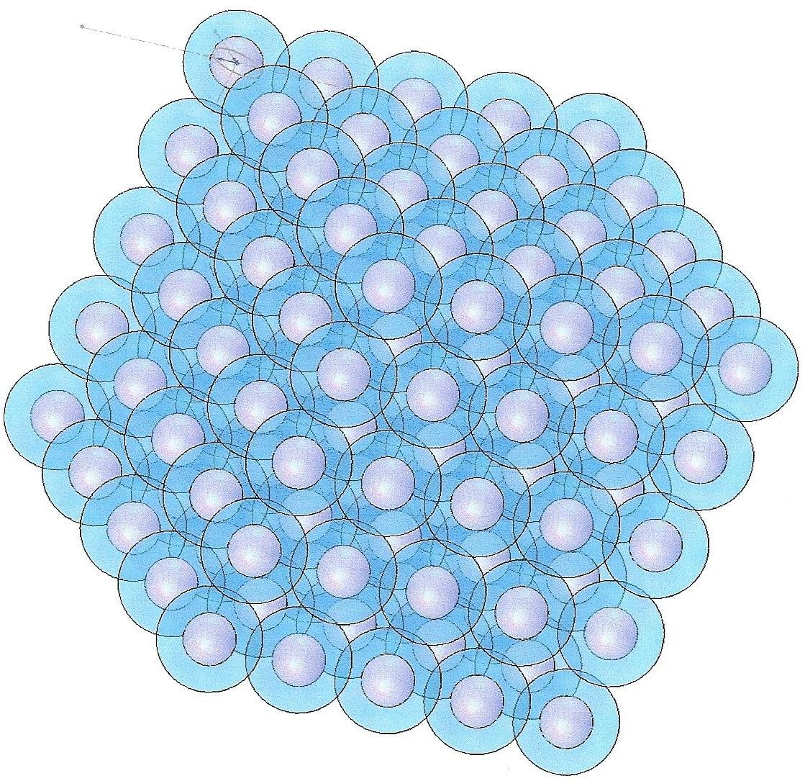

Figure 1. The figure shows a model of a composite structure constructed on the principle of a super hard core surrounded by a shell of superplastic material, that have mainly cold flow properties.
Thanks to the indicated structure of a material, smart cooling systems are formed in laser diode modules, where, due to the properties of the composite material, the effect of even dispersion of both thermal pulses and current pulses, which are especially dangerous when working with powerful laser diodes, forms.
The gray areas in the figure are the nuclei of capsules of the composite made of synthetic diamond, the blue shells are copper deposited on the nuclei of the capsules.
The material is shown before calibration, where the copper floats and fills all the gaps between the capsules during cold flow.

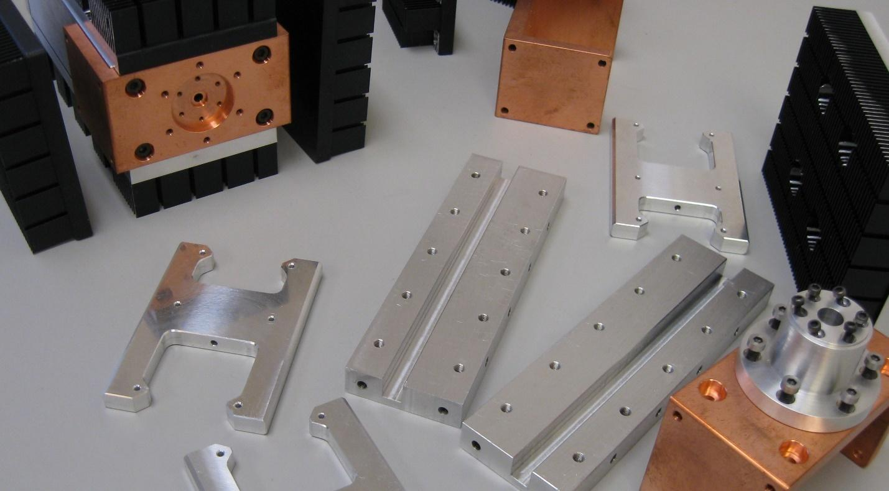
Figure 2. The figure shows the main structural elements of the laser diode module, where the holder of the laser diode is made of a composite diamond-copper, produced by the classical method, where spherical cores of composite capsules are made from synthetic diamond, which then is coated with copper shell. The capsules obtained this way are placed in a special form. There, under high-pressure material’s cold flow of the metal is initiated - in this case copper.
In addition to copper, other plastic and electrically conductive metals, such as silver, can be used.

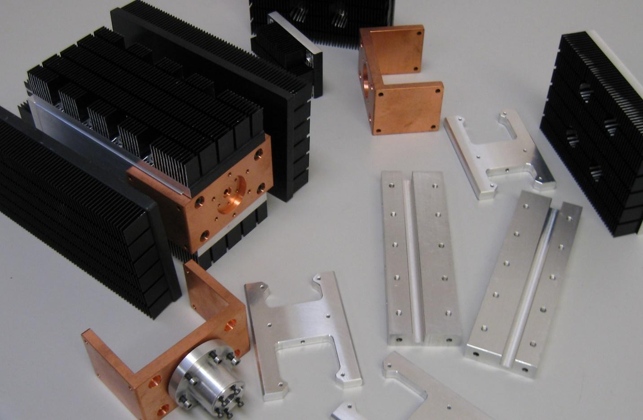
Figure 3. The figure shows the main structural elements of the laser diode module, where the holder of the laser diode is made of a composite diamond-copper, made by the classical method of production, where spherical cores of composite capsules are made from synthetic diamond, which then is coated with copper shell.
All elements are located in a different position than in Figure 2.
The case of the coding and decoding subsystem for identifying disposable instruments of the optical laser system is connected to the laser diode holder board, while the coding and decoding are performed using magnetic resonance spectroscopy.
This case is made of aluminum alloy, as can be seen from the figure.
The constructive version of the components shown in the figure allows one to prepare various versions of module assemblies based on them, including those containing engineering systems that are qualified as subsystems and that carry the functions of dissipating thermal pulses while dissipating current pulses.
The composition of the structural elements is also supplemented by the structural elements of electronic circuit boards manufactured according to RITM technology and providing a significant increase in the level of functional speed of all electronic circuits of the system.

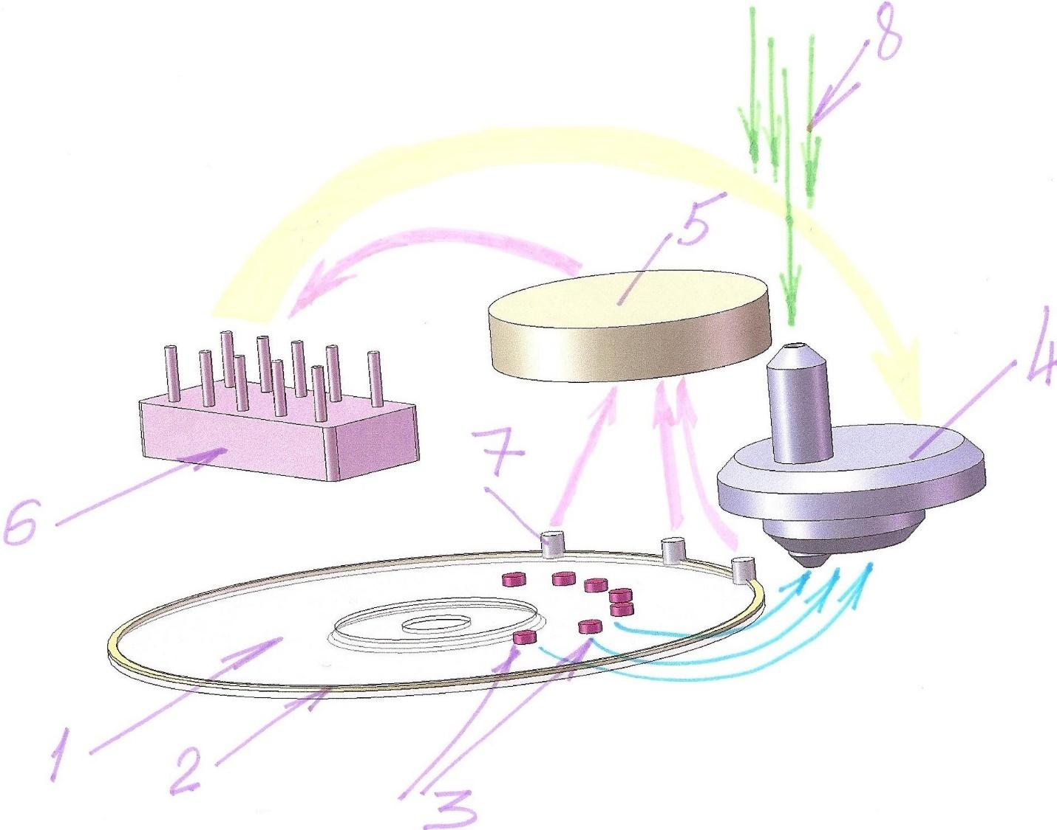
Figure 4. The figure shows a system of interaction of the components of the laser diode module with elements of artificial intelligence and artificial neural networks when high-speed and high-capacity information storage devices are included in the system. The system also includes a coding and decoding subsystem that operates using magnetic and resonance spectroscopy, data processing of which is also part of the important functions of artificial intelligence.
The numbers in the picture mark:
1 - an information accumulator, mainly a multilayer one, possibly having an individual code identification system, expressed in a measurement of a control tape of an information accumulator using magnetic and resonance spectroscopy, usually made of ductile metal or applied by electrochemical method to the periphery of an information accumulator (usually with a diameter of 120 millimeters).
2 - the coding ring on the information accumulator, the coding thickness of which differs by no more than 1 micron allows one to provide many code options and with the help of artificial intelligence elements when interacting with artificial neural networks is able to group signals in real-time and act as a dispatcher when distributing them between the components of the supersystem.
3 - conditional images of pieces of information on the tracks of the information accumulator synchronously transmitted to a complex, including a laser reading head, as well as a local analytical system coordinated using elements of artificial intelligence and artificial neural networks, the configuration of which varies depending on the profile of the tasks and equipment complexity.
4 - complex reading head (including a laser one), as well as a local analytical system coordinated using elements of artificial intelligence and artificial neural networks, the configuration of which varies depending on the profile of the tasks and equipment complexity.
5 - an intermediate control and analytical system, functionally connected with the processor included in the supersystem and accumulating signals from three sensors that measure the thickness of the control tape of the information accumulator, confirming the equivalence of the thickness of the control tape to the code and if it fits, allowing the operation that's next in cycle.
6 - the leading processor, entering and controlling the entire supersystem, including incoming and outgoing information from elements of artificial intelligence and artificial neural networks.
7 - three sensors-solenoids, synchronously interacting with the control tape of the information accumulator and measuring the thickness of the specified tape using magnetic and resonance spectroscopy.
Signals from sensors are synchronously transmitted to the intermediate control and analytical system - 5, functionally connected with the processor included in the supersystem and accumulating signals from three sensors that measure the thickness of the control tape of the information accumulator, confirming the equivalence of the thickness of the control tape to the code and if it fits, allowing the operation that's next in cycle.
8 - conventionally shows an external source of laser radiation, which can be used both for reading and for recording of information, while the radiation parameters of this external radiation source are constantly adjusted and analytically monitored, where all components of the technical super-system take part including those having the highest level of control and analytical management, coordinated by elements of artificial intelligence among others, and within which the process of self-learning is initiated, are realizable within the framework of artificial neural networks, taking into account all the current information collected by a leading processor 6.
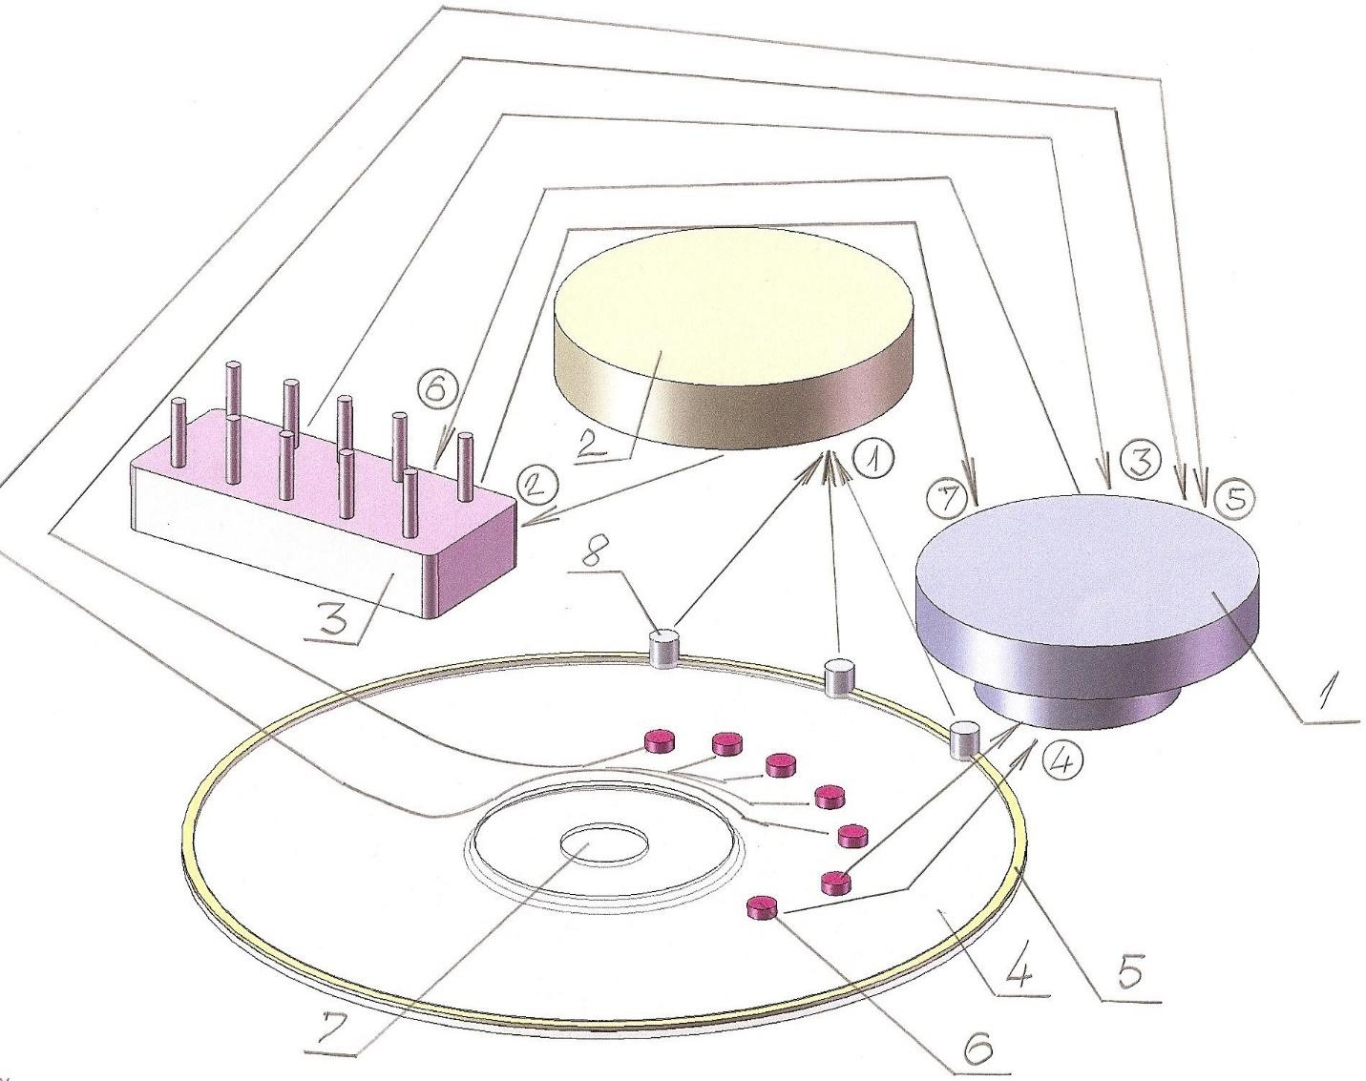
Figure 5. The figure shows a sequence diagram of the interaction of the components of the technical control and monitoring system in real-time for the integrated module of the laser diode and its radio frequency driver in conjunction with a storage medium of significant capacity, with a coding and decoding system for information storage with on-line control of code compliance from 3 synchronous sensors of magnetic and resonance spectroscopy and the corresponding processors of analytical signal processing, combined by elements of artificial intelligence and artificial neural networks simultaneously transmitting the results of analytical processing of the received signals while generating and transmitting control and coordinating signals to all elements and components of the technical and technological super-system.
The numbers in the picture mark:
1 - a complex, including a laser reading head, as well as a local analytical system coordinated using elements of artificial intelligence and artificial neural networks, the configuration of which varies depending on the profile of the tasks and equipment complexity.
2 - an intermediate control and analytical system, functionally connected with the processor included in the supersystem and accumulating signals from three sensors that measure the thickness of the control tape of the information accumulator, confirming the equivalence of the thickness of the control tape to the code and if it fits, allowing the operation that’s next in cycle.
3 - the leading processor, entering and controlling the entire supersystem, including incoming and outgoing information from elements of artificial intelligence and artificial neural networks.
4 - an information accumulator, mainly a multilayer one, possibly having an individual code identification system, expressed in a measurement of a control tape of an information accumulator using magnetic and resonance spectroscopy, usually made of ductile metal or applied by electrochemical method to the periphery of an information accumulator (usually with a diameter of 120 millimeters).
5 - the coding ring on the information accumulator, the coding thickness of which differs by no more than 1 micron allows one to provide many code options and with the help of artificial intelligence elements when interacting with artificial neural networks is able to group signals in real-time and act as a dispatcher when distributing them between the components of the supersystem.
6 - conditional images of pieces of information on the tracks of the information accumulator synchronously transmitted to a complex, including a laser reading head, as well as a local analytical system coordinated using elements of artificial intelligence and artificial neural networks, the configuration of which varies depending on the profile of the tasks and equipment complexity.
7 - center hole of the information accumulator. In the system, the information accumulator can also be presented in the form of a hybrid disk - an information storage device, and in this case, its functions can be significantly transformed, since using the same encoding and decoding method, the degree of protection of the technical supersystem will increase significantly.

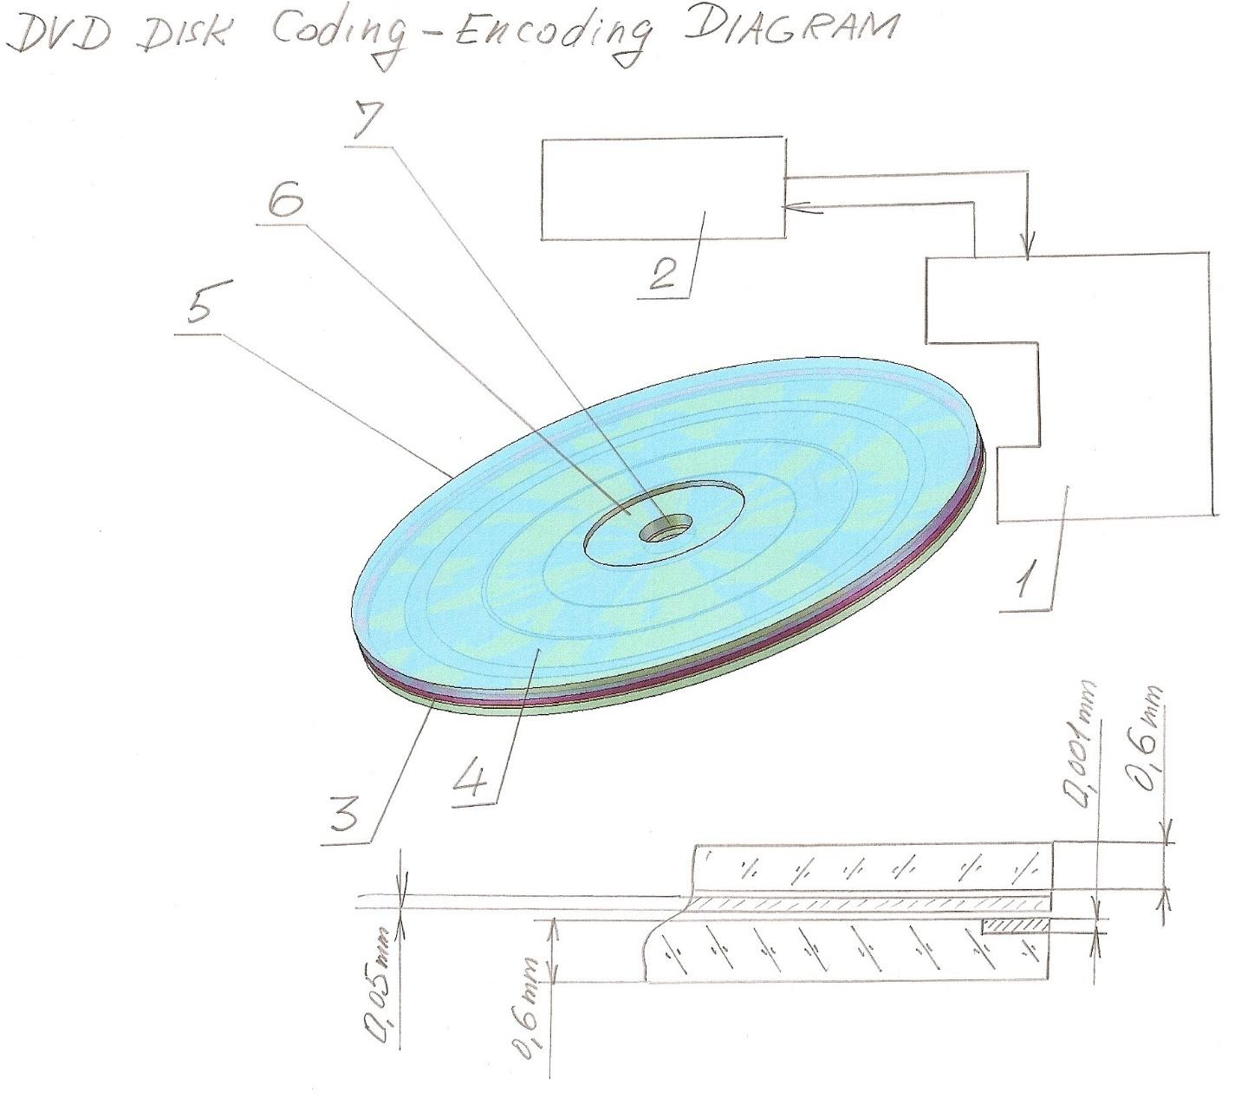
Figure 6. The figure shows the information accumulator with the approximate dimensions of the structural elements that affect the final result and the quality of the information accumulator in the technical supersystem.
The numbers in the picture mark:
1 - radio frequency driver of a technical system
2 - integrated processor for controlling and monitoring the technical system
3- the coding ring
4 - the top panel of the information accumulator's housing
5 - maximum outer diameter of the information accumulator’s disk
6 - centering flange of the top panel of the information accumulator’s housing
7 - centering hole of the top panel of the information accumulator’s housing

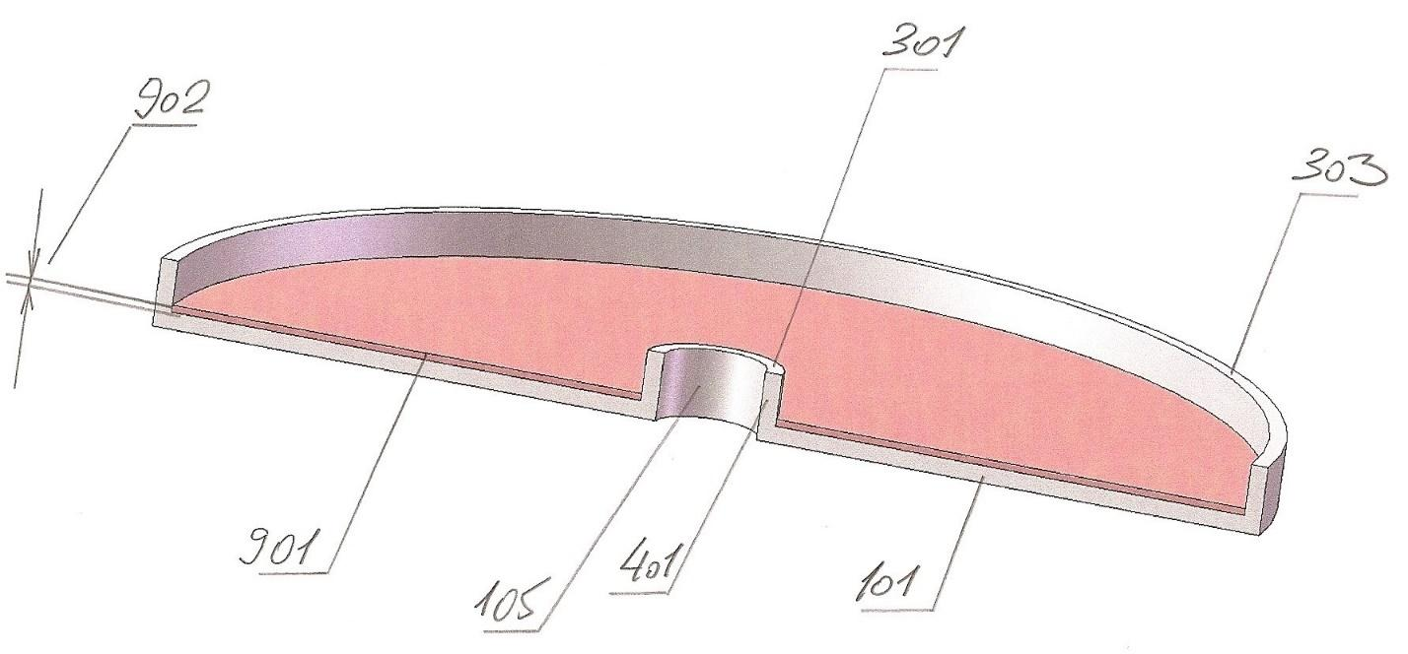
Figure 7. The sectional figure shows the composite structure of a multilayer information storage device, suitable in terms of information volume and speed for operation in technical systems, in the control and monitoring devices with elements of artificial intelligence and artificial neural networks.
The numbers in the picture mark:
101 - bottom of the base of the multilayer information storage (accumulator). The entire drive is made of optically transparent material. From the outside, the load-carrying element of the hard magnetic disk can be attached to the bottom of the base so the whole system will be a hybrid information accumulator
105 - centering hole of the multilayer information storage (accumulator)
301 - the upper face of the sleeve of the centering hole
303 - the upper face of the sleeve of the housing of the information storage (accumulator)
401 - sleeve of the centering hole of the information storage device (accumulator)
901 - one information layer after pouring-in, polymerization, and pressing of the structure of formatted information tracks
902 - the thickness of one information layer is 0.05 mm

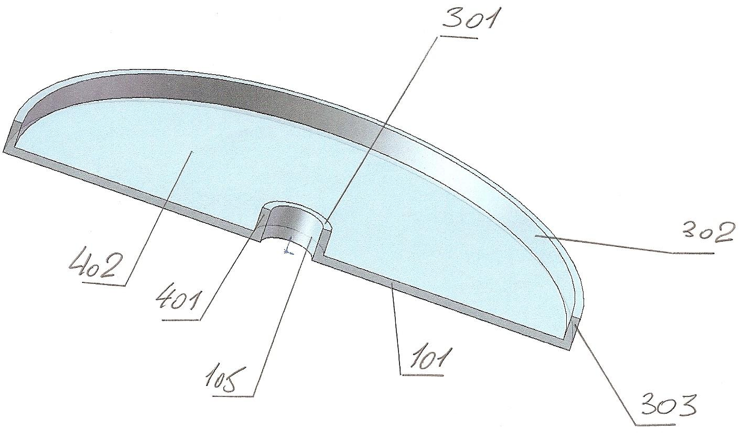
Figure 8. The sectional figure shows the base of a multilayer information storage medium cast from optically transparent plastic. This design also allows the manufacture of this base from an opaque material, such as beryllium, so that it would be possible to modify the information storage device into a hybrid information storage device which combines the functions of a hard magnetic disk and an optical disk.
The numbers in the picture mark:
101 - bottom of the base of the multilayer information storage (accumulator). The entire information storage device can be made of optically transparent material or light metal - like aluminum, or, the technology for manufacturing it from beryllium that is being developed currently. In this case, the information storage device's rotation speed can be significantly increased, which will dramatically increase the efficiency of the multilayer information storage device.
From the outside, the load-carrying element of the hard magnetic disk can be attached to the bottom of the base so the whole system will be a hybrid information accumulator.
105 - centering and orienting hole
301 - the upper face of the base
302 - the outer surface of the base, usually with a diameter of 120 mm
303 - the outer cylindrical surface of the base, the wall thickness is approximately 1 mm
401 - the inner centering sleeve of the base, as a rule, the inner diameter is 15 mm
402 - bottom of the base of the multilayer information storage (accumulator)
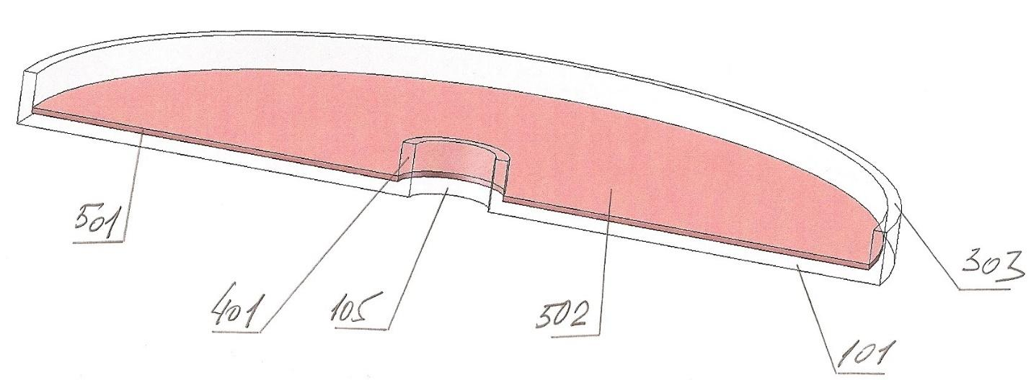
Figure 9. The sectional figure shows the base of an information storage device with the first layer of a multilayer storage’s structure; tracks for recording information there, as a rule, are applied by printing methods rather than optical laser formatting.
This formatting option increases the reliability of information recording and significantly increases the speed of finding and receiving information.
Tested versions of such a storage device can include 100 layers, which increases the capacity of the storage device by more than 1000 times with a significant increase in performance.
This factor allows the use of such information storage devices with elements of artificial intelligence and artificial neural networks.
The numbers in the picture mark:
101 - bottom of the base of the multilayer information storage. The bottom should be strong enough so that in the case of the making of a hybrid information storage device, a hard magnetic disk could be attached to it
105 - the centering hole in the bottom - usually with a diameter of 15 millimeters
303 - the upper end of the outer outline of the base of the multilayer information storage
401 - the central pilot and orientation sleeve of the base of the multilayer information storage
501 - one layer of the multilayer structure of the information storage device - the thickness of a layer after polymerization and printing is 0.05 mm
502 - the surface of the first layer of a multilayer information storage device where formatting marks are applied and the outlines of tracks for information can be pressed after polymerization
Considering that all the described structural elements and the principle of operation of innovative elements and technical subsystems of a multilayer information storage device are equivalent to the use of composite materials, it makes sense to note and analyze the novelty elements of these integrative technical solutions, taking into account all the noted fundamental notable features.
Let's consider an example of an integrative technical system.
Multilayer optical digital information storage device and its production method
Additional information for evaluating the relevance of preparing preliminary patent application materials, planning production and testing of the pilot specimen, as well as preliminary forming the course of manufacturing step in the proposed automatic production line for manufacturing these products in the setting of mass production; the author notes the following:
- for starters, it is necessary to qualify the degree of technological and constructive fundamental novelty of the proposed technical solution.
- since there are several models of this storage device built on the same basic principle, it makes sense to consider the primary versions of the main claims of each model to get a better idea of the degree of reality of the proposed technical solution.

Implementation option - a multilayer optical disk built on a base metal frame

A multilayer optical digital information storage device, mainly based on a two-photon chromophore (a polymer material that is highly sensitive to light radiation), which has the properties, characteristics and capabilities for optical recording and reading under the influence of concentrated, layer-by-layer focused, energetically saturated light beam being subject to complex programmed control, monitored and controlled in connection with elements of artificial intelligence and artificial neural networks, that include:
- hollow, shape-generating, orienting and strengthening frame;
- systemically alternating layers of optically transparent polymer material, sequentially grown in the working annular spaces of the frame, and layers of light-sensitive polymer material located between;
- marking symbols from an optically transparent polymer material of a certain configuration, topology, and microrelief, with particles of a light-sensitive polymer material of the subsequent layer introduced into its micro-spaces, deposited on the upper (relative to the bottom of the frame) side of each layer;
- a boundary layer, which occurred when the polymer of the previous layer was dissolved by the monomer of the subsequent layer at the transition between each of the previous layers to the next;
- information storage layers sequentially recorded on layers of light-sensitive polymer material, before growing subsequent layers off of optically transparent polymer material; moreover, in the process of writing and reading information optical symbols are derived from the marking symbols of each of the previous layers of optically transparent polymeric material.

The base metal frame is supposed to be made of aluminum by impact backward extrusion, bringing the material to a yield state and subsequent prestressing to maintain the correct geometric shapes with a minimum thickness of the walls of the frame and with a minimum weight (mass) of the specified frame.
It is assumed that the thickness of the walls of the frame will be within 0.05 mm; wall height - 1.2 mm. The outer diameter of the frame will be - 120 millimeters, in the center - the fitment hole with a diameter of 15 millimeters.
Concentric to the fitment hole should be an annular space with an outer diameter of 44-45 millimeters. It may be filled with polymer or may be unfilled.
The specified frame must have very accurate dimensions, which are ensured by the accuracy of the stamp for impact extrusion.
It can be assumed that the manufacture of such a frame will not encounter any difficulties since the technology of impact extrusion of aluminum is well established and the technological equipment is not expensive.
On the base of the frame, there is supposed to be a coating of a diamond powder composition with a thickness of 10-15 micrometers.
Such a coating provides:
- a high degree of electrical insulation;
- a high degree of thermal conductivity.
- higher rate of heat dissipation.
- a guarantee of neutralization of static electricity.
- surface safety from scratches and other mechanical damage.

Instead of an aluminum frame, its polymer equivalent may be used.
In both cases, this part of the disk should not cause problems in manufacturing but rather can serve as the basic guarantee of obtaining higher accuracy in the subsequent cultivation of the vertical hierarchy of the operational volume of the disk.
The control technique for the basic geometric and dimensional parameters and ratios for this part of the disk is reduced to a one-time control of technological equipment and periodic control of its degree of wear.

GROWING A LAYERED STRUCTURE OF A VERTICAL DISC HIERARCHY
Monomers of polymer compositions are used as starting material for the process, which:
- undergo a polymerization process when exposed to any thermo-radiation;
- does not require a long period of time for polymerization and curing of the layer during the polymerization process;
- have a viscosity that allows them to be sprayed using metering nozzles.
- have a surface tension coefficient that allows you to hold the film of the specified monomer on the surface of the layer, with a film thickness of 2-5 micrometers.

The specified monomer of a material that is sensitive to light radiation is a solvent for a transparent optical polymer material from which layers that are the boundary for a layer made of a material sensitive to light radiation are made.
The specified boundary layers should be thicker than the layer made of material, sensitive to light radiation, by an amount that ensures the minimum amount of optical distortion of the rays from the light source.

List of reference literature, patent and licensed materials
Annex 1
United States Patent Application | 20020064194
Kind Code | A1
Nagamatsu, Shinya | May 30, 2002

LIGHT SOURCE COMPRISING LASER DIODE MODULE
Abstract
A light source comprising a plurality of laser diode modules, wherein a plurality of high optical power laser diode modules are arranged in high density, each of the plurality of high optical power laser diode modules includes a metal substrate mounting a laser diode chip and an optical instrument thereon; a Peltier device thermally connected to the metal substrate; a heat pipe having a heat absorbing portion and a heat dissipating portion in which the beat absorbing portion is thermally connected to the Peltier device and a heat dissipating fin is provided on the heat dissipating portion; and a heat pipe reinforcing member to hold the heat dissipating fin and reinforce a strength of the heat pipe.
Annex 2
United States Patent Application | 20190067161
Kind Code | A1
Kaifuchi; Yoshikazu | February 28, 2019

SEMICONDUCTOR LASER MODULE AND METHOD FOR MANUFACTURING THE SAME
Abstract
The semiconductor laser module 1 has an electrically conductive heat sink 10, a submount 20 disposed above the heat sink 10, a semiconductor laser device 30 disposed above the submount 20, a lower solder layer 50 disposed between the heat sink 10 and the submount 20, and an upper solder layer 60 electrically connected to the semiconductor laser device 30 and the heat sink 10. This upper solder layer 60 has an electric resistivity lower than an electric resistivity of the submount 20 and extends along surfaces 21 and 22 of the submount 20 to the heat sink 10.
Annex 3
United States Patent Application | 20180191135
Kind Code | A1
YANASE; Atsushi | July 5, 2018

LASER UNIT AND LASER DEVICE
Abstract
The light-concentration density or laser power of a combined laser beam bundle, obtained by combining individual laser beams that are caused to oscillate by and are output from a plurality of single-emitter LDs, is increased efficiently, with high quality. On a bottom plate or a unit base 22 of the laser unit 10, there are disposed: a pair of stacked laser beam creation units 24L, 24R which are arranged with left-right symmetry with respect to a center line N; a single wavelength stabilizing element (VBG) 26 of which an incidence plane vertically intersects the center line N; a pair of primary anamorphic prisms 28L, 28R which are arranged separately on the right and left of the center line N; a mirror-type beam rotation element 30 disposed on the center line N; and a secondary anamorphic prism 32 disposed offset from the beam rotation element 30 in a direction (X-direction) perpendicular to the center line N.
Annex 4
United States Patent Application | 20180292053
Kind Code | A1
Minor; Johannes. et al. | October 11, 2018

MULTIPLE-LASER LIGHT SOURCE
Abstract
A light source includes a plurality of laser diodes or other light emitters. Beams of light from the light emitters are steered to provide n array of parallel beams that illuminate a target area with an array of patches of light. In some embodiments the parallel beams are de-magnified to form the array of patches of light. Such a light source has application in illuminating dynamically-addressable focusing elements such as phase modulators, deformable mirrors and dynamically addressable lenses. Light projectors for a wide variety of applications may combine a light source as described herein with a dynamically-addressable focusing element to project defined patterns of light.
Annex 5
United States Patent Application | 20180316160
Kind Code | A1
Raring; James W.. et al. | November 1, 2018

INTEGRATED WHITE LIGHT SOURCE USING A LASER DIODE AND A PHOSPHOR IN A SURFACE MOUNT DEVICE PACKAGE
Abstract
The embodiments described herein provide a device and method for an integrated white colored electromagnetic radiation source using a combination of laser diode excitation sources based on gallium and nitrogen containing materials and light emitting source based on phosphor materials. A violet, blue, or other wavelength laser diode source based on gallium and nitrogen materials may be closely integrated with phosphor materials, such as yellow phosphors, to form a compact, high-brightness, and highly-efficient, white light source. The phosphor material is provided with a plurality of scattering centers scribed on an excitation surface or inside bulk of a plate to scatter electromagnetic radiation of a laser beam from the excitation source incident on the excitation surface to enhance generation and quality of an emitted light from the phosphor material for outputting a white light emission either in reflection mode or transmission mode.
Annex 6
United States Patent Application | 20190007668
Kind Code | A1
Novotny; Vlad Joseph. et al. | January 3, 2019

LASER LIGHTING HAVING SELECTIVE RESOLUTION
Abstract
In an example, the present invention provides an optical engine apparatus. The apparatus has a laser diode device, the laser diode device characterized by a wavelength ranging from 300 to 2000 nm or any variations thereof. In an example, the apparatus has a lens coupled to an output of the laser diode device and a scanning mirror device operably coupled to the laser diode device. In an example, the apparatus has an un-patterned phosphor plate coupled to the scanning mirror and configured with the laser device; and a spatial image formed on a portion of the un-patterned phosphor plate configured by a modulation of the laser and movement of the scanning mirror device.
Annex 7
United States Patent Application | 20180375279
Kind Code | A1
KAJIWARA; Koji. et al. | December 27, 2018

OPTICAL MODULE AND LIGHT OUTPUT DEVICE
Abstract
An optical module comprising a first optical fiber corresponding to an incidence side for laser light a second optical fiber corresponding to an emission side for the laser light; and a connection protecting portion that is provided and located so as to cover a connection site for optically connecting the first optical fiber and the second optical fiber, wherein the second optical fiber has a larger core diameter than the first optical fiber, the connection site is a site where a core portion of the first optical fiber and a core portion of the second optical fiber are connected to each other in a discontinuous shape, and the connection protecting portion is formed of a thermally conductive protective material and/or a photorefractive protective material includes refractive index that is equal to or higher than that of a clad portion of the first optical fiber.
Annex 8
United States Patent Application | 20190091097
Kind Code | A1
Courtion; Colette. et al. | March 28, 2019

LIGHT-EMITTING DIODE AND MASSAGE DEVICE FOR DELIVERING FOCUSED LIGHT FOR VAGINAL REJUVENATION
Abstract
A rejuvenation and massage device is provided for treating mucosa tissue, such as vaginal tissue, affected by Vaginal Relaxation Syndrome (VRS) or other conditions, through vibration, thermal loading, and light emittance for a duration of time. In one embodiment, the device is an insertable device that includes Low-Level Laser Light (LLLT) therapy to treat the vaginal tissue. The light emittance by one or more light emitters is in a range sufficient to provide therapeutic effects through light radiation. To enhance the therapeutic effects of light radiation provided by the device, the device is configured to provide increased energy density into target tissue of vaginal muscles though a light configuration component (e.g., a focusing component, such as a concave lens assembly, a convex assembly, a pre-lensed light emitter or other focusing optical mechanism) associated with the light emitter that concentrates the light emitted from the light emitter.
Annex 9
United States Patent Application | 20190062222
Kind Code | A1
PEGNA; Joseph. et al. | February 28, 2019

HIGH STRENGTH CERAMIC FIBERS AND METHODS OF FABRICATION
Abstract
A method and apparatus for forming a plurality of fibers from (e.g., CVD) precursors, including a reactor adapted to grow a plurality of individual fibers; and a plurality of independently controllable lasers, each laser of the plurality of lasers growing a respective fiber. A high performance fiber (HPF) structure, including a plurality of fibers arranged in the structure; a matrix disposed between the fibers; wherein a multilayer coating is provided along the surfaces of at least some of the fibers with an inner layer region having a sheet-like strength; and an outer layer region, having a particle-like strength, such that any cracks propagating toward the outer layer from the matrix propagate along the outer layer and back into the matrix, thereby preventing the cracks from approaching the fibers. A method of forming an interphase in a ceramic matrix composite material having a plurality of SiC fibers, which maximizes toughness by minimizing fiber to fiber bridging, including arranging a plurality of SiC fibers into a preform; selectively removing (e.g., etching) silicon out of the surface of the fibers resulting in a porous carbon layer on the fibers; and replacing the porous carbon layer with an interphase layer (e.g., Boron Nitride), which coats the fibers to thereby minimize fiber to fiber bridging in the preform.

Annex 10
United States Patent Application | 20190049676
Kind Code | A1
Kasai; Yohei | February 14, 2019

LIGHT GUIDE DEVICE, LIGHT GUIDE METHOD, AND LD MODULE
Abstract
To increase the reliability of an LD module without decreasing the efficiency of coupling between the laser diode and the optical fiber, an LD module (1) includes a light-guiding device mounted therein that includes (i) a dividing optical system (DM) configured to divide a laser beam so as to generate a partial beam group and (ii) a compositing optical system (RM1, RM2, PRE, PBC) configured to composite the partial beam group so as to generate a partial beam bundle including a plurality of partial beams each having an S axis parallel to a particular spatial axis.
Annex 11
United States Patent Application | 20190020178
Kind Code | A1
OGURI; Atsushi. et al. | January 17, 2019

LASER APPARATUS
Abstract
A laser apparatus includes light source elements outputting laser beams; a wavelength-selecting element disposed in an optical path of each of the laser beams and configured to cause light in a predetermined wavelength band to selectively transmit therethrough; and a partially transmissive-reflector that receives the light transmitted through the wavelength-selecting element, reflects a part of the input light toward the wavelength-selecting element, and causes its remainder to transmit therethrough. The wavelength-selecting element causes a part of the respective laser beams output from the respective light source elements to selectively transmit therethrough, the partially transmissive-reflector reflects a part of the respective transmitted laser beams, and the wavelength-selecting element causes a part of the respective reflected laser beams to transmit to return to the light source elements, and each of the light source elements preferentially oscillates at a wavelength of the laser beam that transmits through the wavelength-selecting element.
Annex 12
United States Patent Application | 20180188458
Kind Code | A1
LAW; Pi-Cheng. et al. | July 5, 2018

OPTICAL COMMUNICATION MODULE CONFIGURED FOR ENHANCING OPTICAL COUPLING EFFICIENCY
Abstract
An optical communication module configured for enhancing optical coupling efficiency, which includes an optical butt joint receptacle and a light emitting body provided on one side of the optical butt joint receptacle. The optical butt joint receptacle has a receptacle body and a through hole provided in the receptacle body for a dual-core optical fiber to extend through. The receptacle body has a light-receiving side and an optical fiber insertion groove corresponding respectively to two ends of the through hole. The light emitting body includes a housing, a laser semiconductor provided in the housing, and an aperture provided in one side of the housing for aligning with the through hole so as that the laser beam emitted by the laser semiconductor is optically coupled to the dual-core optical fiber. The dual-core optical fiber has different core diameters and numerical apertures to enhance the coupling efficiency and reduce the coupling loss in between with the external optical fiber.

Annex 13
United States Patent Application | 20180138664
Kind Code | A1
HUELSEWEDE; Ralf. et al. | May 17, 2018

METHOD FOR PRODUCING A DIODE LASER AND DIODE LASER
Abstract
A method for the production of a diode laser having a laser bar, wherein a metal layer having raised areas is used which is located between the n-side of the laser bar and the cover. The metal layer can be plastically deformed during installation without volume compression in the solid physical state. As a result the laser module can be reliably installed and a slight deviation (smile value) of the emitters from a centre line is achieved.

Annex 14
United States Patent Application | 20180062348
Kind Code | A1
LEE; Won Tae. et al. | March 1, 2018

HIGH-POWER LASER PACKAGING UTILIZING CARBON NANOTUBES
Abstract
In various embodiments, laser devices include a thermal bonding layer featuring an array of carbon nanotubes and at least one metallic thermal bonding material.

