Stability And Operational Safety Of Power Equipment In The Ecosystems Of Smart Integrated Construction Projects
Dyadchenko Sergey Fedorovich
Candidate of Architecture, Associate Professor, Honorary Member of the Union of Architects of Russia
Yuri Gagarin Saratov State Technical University
Saratov, Russian Federation
Abstract
Ensuring the stability and operational safety of power equipment, including cybersecurity aspects, is one of the key challenges in modern construction projects. In most cases, tasks related to operational management, online monitoring, and computer modeling of operating parameters can be effectively addressed using the built-in computational resources of the equipment.
Contemporary energy construction practices are focused on optimizing electricity generation processes, including the use of alternative fuel blends based on diesel fuel and methanol, with the potential increase of methanol content up to 95–100%. Such changes require rapid adaptation of control and monitoring systems, as well as the implementation of specialized software solutions.
Industrial experience demonstrates the necessity of mobile and autonomous solutions capable of ensuring reliable equipment operation without the involvement of additional data storage media. In this context, the integrative inventions and publications of the innovative specialist Artem Aleksanian, dedicated to high-technology ecosystems in the construction industry, are of particular interest.
The developments proposed by Artem Aleksanian collectively ensure compliance with modern technical requirements and form a promising technological direction—high-technology ecosystems and infrastructure in construction projects utilizing magnetic resonance–based contactless monitoring methods and nanoscale measurement techniques.
Keywords: power equipment; methanol; diesel fuel; dynamic mixing; high-technology ecosystems; computer modeling; turbines; equipment operating cycle; turbine fuel system.
Operational Safety and Cybersecurity Challenges
In industrial environments, there is a critical need for protection methods and devices that, without complicating established operational schemes, can provide comprehensive and reliable protection for control and monitoring equipment. At the same time, such solutions should preserve existing circuit, kinematic, and functional elements while introducing new components that do not require modification of the base equipment during adaptation.
Practical experience demonstrates the necessity of mobile and highly simplified systems capable of ensuring autonomous equipment operation without involving additional data carriers.
During the evaluation and analysis of existing protection systems, specialists from power companies concluded that the most cost-effective and efficient approach is the protection of data carriers that does not require significant structural or schematic changes to power-generating equipment.
Leading power companies, utilizing the developments and concepts proposed by Artem Aleksanian, have become pioneers in the use of methanol as an alternative fuel for power-generating gas turbines.
Fuel Mixing Technologies and Thermodynamic Considerations
Gas turbines with capacities of 20–25 MW typically use No. 2 diesel fuel as their primary fuel. One of the original objectives pursued by the developers of the new innovative technology was the utilization of so-called evaporation energy, which is highest in methanol compared to other commonly used liquid fuels.
To implement this and other innovative objectives, various modifications and optimizations of turbine fuel systems were applied. These included both complete replacement of diesel fuel with methanol and innovative solutions involving dynamic mixing of methanol with small proportions of conventional diesel fuel.
This mixing approach helps mitigate certain combustion-related properties of methanol, primarily those associated with its relatively low flame temperature.
Given that hundreds and thousands of turbines with long operational lifespans are currently in service—using heavy diesel fuels such as fuel oil, as well as natural gas, coal dust, and other fuel variants—it is reasonable to focus analytical attention on differences in adaptation systems for dynamic mixing of methanol with these fuels, as well as on the design of the mixing devices themselves.
Experimental testing and qualification trials validated fundamental technical solutions for such devices, with variations depending on fuel type and the number of mixed fuel components.
Despite a high level of unification and standardization in fuel preparation systems, the overall thermodynamic infrastructure remains highly dependent on the mobility and efficiency of control, monitoring, and calibration systems, including real-time adaptive signal processing.
Figures and System Descriptions
Figure 1. Three-dimensional model of a device for dynamic mixing of diesel fuel with methanol.
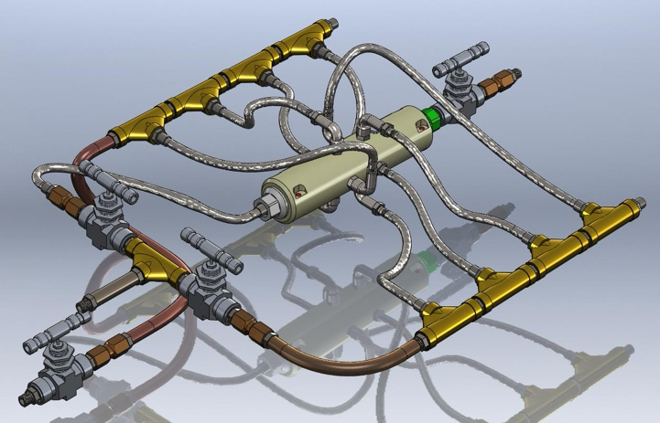
The first image presents a three-dimensional model of a device designed for dynamic mixing of diesel fuel and methanol directly within the fuel line of thermodynamic equipment.
The device is extremely simple and, even in this configuration, can be used in at least two modes: as a static mixer (with no moving parts) or as a static online homogenization device for fuel or fuel mixtures directly within the fuel line.
Due to the unique complexity of power-generating equipment, the introduction of even such a compact and simple device requires appropriate correction of operating characteristics, which in turn necessitates modification of processor software and onboard computing systems.
From a mechanical and hydraulic standpoint, this replacement process is entirely standard and does not present complications. However, from a cybersecurity perspective, the temporary pause required for software modification represents a critical vulnerability window through which malicious software may penetrate control and monitoring systems.
Given the inertial nature of such systems, detection of intrusion may only occur after a significant delay, during which critical equipment components may be compromised.
Figure 2
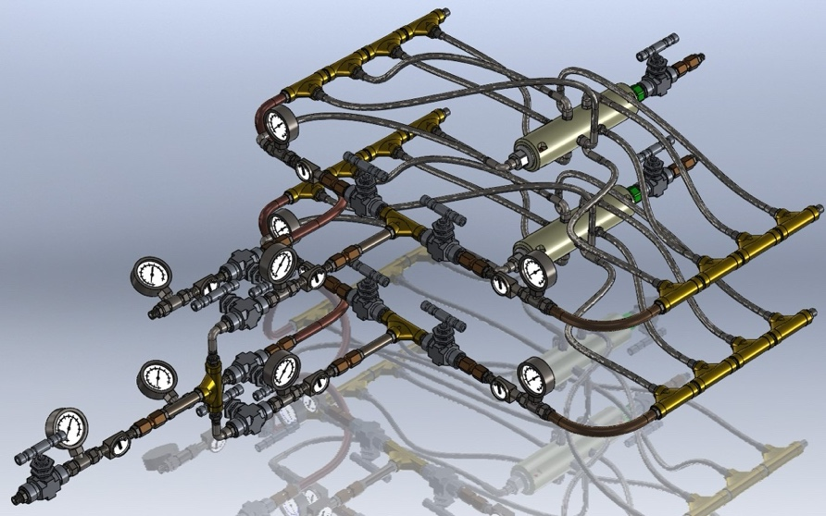

When a dual mixing (figure 2) system is integrated, the corresponding risk nearly doubles. Furthermore, if excess fuel recirculation is present, the number of components potentially affected by malicious software increases severalfold, significantly amplifying modernization risks.
In real-world conditions, significantly higher volumetric or mass fuel flow rates are often required. Since the calorific value of methanol is approximately half that of diesel fuel, modernization efforts must increase fuel consumption by more than twofold.
This further complicates modernization and necessitates a proportional increase in the number of devices, each requiring comprehensive control and monitoring elements. Such systems demand greater processing power and capacity from programmable controllers, confirming the validity of earlier conclusions.
The next image (Figure 3) illustrates a quadruple system consisting of four independent and potentially autonomous units.
Figure 3. System comprising four independent and autonomous units.
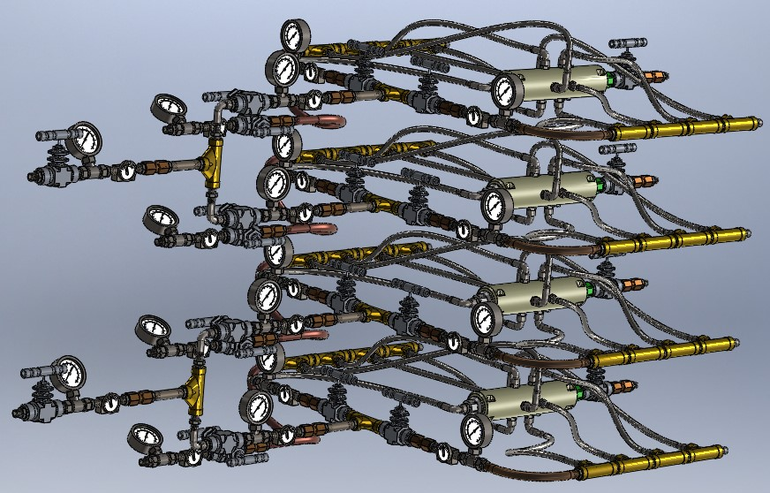
High-Capacity Mixing Systems
Recently, powerful and high-performance systems have emerged that can replace multi-element configurations while maintaining equal or superior thermodynamic performance.
The illustrated system (figure 4) has a capacity of 1,000 liters per hour. Despite having only three external inputs and one output, the complexity of control, monitoring, and hydrodynamic coordination requires extensive control operations and substantial system potential for managing, monitoring, and modeling thermodynamic operating cycles.
Figure 4.
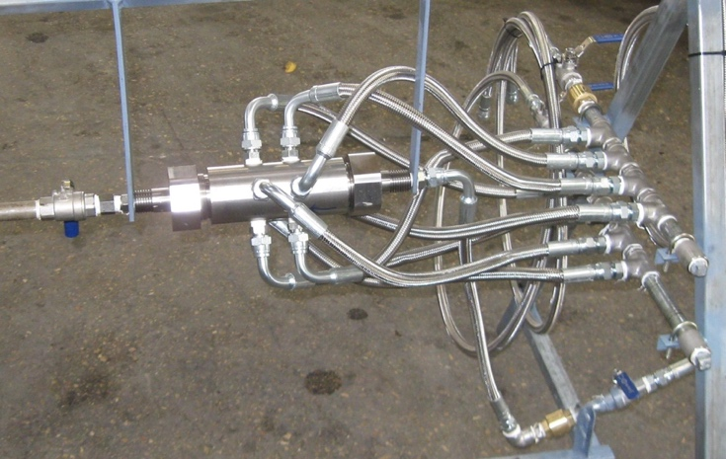
Thus, the importance of reliable and guaranteed protection of operational software loading into control and analytical systems remains critical, regardless of the type or configuration of fuel mixing devices.
Technical Requirements for Secure Data Carriers
Key technical requirements include:
- data carriers must have original system-level protection;
- data carriers must include identification systems equivalent to processor and onboard computer data-reading mechanisms;
- identification codes must be applied without altering standard connector geometry;
- the identification code must contain only one control-measurement parameter;
- identification must be performed without physical contact.
Currently, no mobile data carriers fully satisfy these requirements.
Innovative Contributions and Conclusions
After reviewing the highly innovative developments and publications by Artem Aleksanian, the working group deemed it essential to test data carrier encoding systems based on his proposals.
These developments comprehensively meet all listed technical requirements and introduce a new and promising technological domain—magnetic resonance–based contactless monitoring and nanoscale measurements utilizing artificial intelligence and artificial neural networks.
From the perspective of power equipment operation specialists, widespread adoption of this method among manufacturers and users of specialized computing equipment for power plants and construction projects appears highly effective. Given the scalability of fuel mixing and preparation equipment, this encoding system can be implemented across nearly all energy sectors, including turbines, diesel generators, boilers, combined heat and power plants, and other thermodynamic systems.
The following image presents three-dimensional models of the dynamic mixing device arranged according to dimensional and scale factors, where the smallest systems
can be installed in household appliances, while the largest systems are capable of operating at fuel flow rates of tens of thousands of liters per hour.
Figure 5. Three-dimensional models of dynamic mixing devices scaled from household applications to systems capable of processing tens of thousands of liters of fuel per hour.
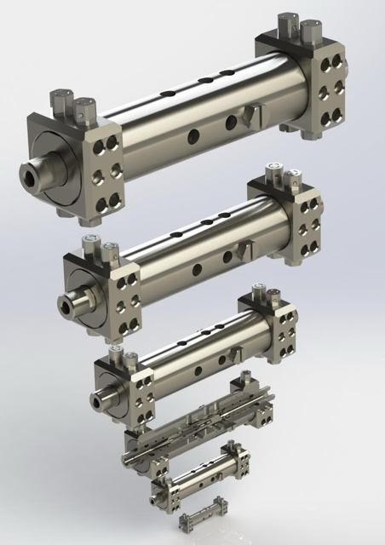
The proposal by Artem Aleksanian enables expanded integration of innovative energy projects within construction ecosystems, yielding annual savings of hundreds of thousands of dollars for a single medium-capacity power station while ensuring maximum protection of control and management systems.
This approach represents a unique and forward-thinking technological and software paradigm that, at relatively low cost, addresses one of the most critical challenges of modern energy systems—ensuring an adequate level of cybersecurity.
References
- Aleksanian, A. A. Methods for control and reliability enhancement of modern battery systems. In: NEW NAMES IN SCIENCE 2025: Proceedings of the International Scientific Research Competition, Penza, November 25, 2025. Penza: Nauka i Prosveshchenie (IP Gulyaev G.Yu.), 2025, pp. 12–14. EDN JEBWUE.
- Aleksanian, A. A. Ecosystem and Infrastructure of a Smart Real Estate Object. ISBN 978-620-9-00047-8.
- Fluid Mixer with Internal Vortex. United States Patent Application US 2011/0069579 A1, published March 24, 2011.
- Method of Dynamic Mixing of Fluids. United States Patent Application US 2010/0243953 A1, published September 30, 2010.
- Dynamic Mixing of Fluids. United States Patent Application US 2010/0281766 A1, published November 11, 2010.
- Micro-Injector and Method of Assembly and Mounting Thereof. United States Patent Application US 2012/0102736 A1, published May 3, 2012.

