Computer Security 2019
Maksym Toporin
Nyvara Software, Ukraine

What are the main problems of secure data storage?
Despite the high development of IT technologies to date, we have not yet encountered and have not realized the whole problem of secure storage or personal and corporate data. In April 2018, Gartner presented a forecast of the world market for public cloud services (Table 1), where we see that the market of cloud services is growing by an average of 20% every year. This means that people, companies and state enterprises are increasingly using and trusting cloud technologies worldwide.
 | 2017 | 2018 | 2019 | 2020 | 2021
Business process cloud services (BPaaS) | 42.6 | 46.4 | 50.1 | 54.1 | 58.4
App infrastructure cloud services (PaaS) | 11.9 | 15 | 18.6 | 22.7 | 27.3
Applied cloud services = cloud apps (SaaS) | 60.2 | 73.6 | 87.2 | 101.9 | 117.1
Administration and security cloud services | 8.7 | 10.5 | 12.3 | 14.1 | 16.1
System infrastructure cloud services (IaaS) | 30 | 40.8 | 52.9 | 67.4 | 83.5
Total market volume: | 153.5 | 186.4 | 221.1 | 260.2 | 302.5

BPaaS = Business processes-as-a-service; IaaS = Infrastructure-as-a-service;
PaaS = Platform-as-a-service; SaaS = Software-as-a-Service
Table. 1. Forecast of the world income of the market of public cloud services (billion US dollars) Source: Gartner (April 2018) [2]
It is also worth noting that the content amount and value is growing. Today, we store a lot of important information on cloud servers such as mail, contacts, photos, videos, documents, credit card numbers, passwords, financial statements, etc. — these are examples of personal use only.
To date, most companies, banks, government agencies store terabytes of important data in the cloud.
For the first time, Amazon Web Services was introduced to the world in 2006 as an infrastructure for cloud web services platforms, and a giant like Google Cloud was launched in 2010, and later iCloud in 2011. It should be noted that even in 2011, the level of consumption and trust in cloud services was quite low. Most people did not store any important information at these services.
But everything changed in 2018, and today the level of trust is extremely high, but the level of security of our information remains approximately at the same level as in 2011. This is the main problem, people are making huge efforts in the development of cloud services, but de too little time to its security. Below I will provide some basic problems of data storage security.
No.1 Using the same password for all accounts
To date, using the same password for all accounts is the most common problem related to the data storage security. Most people have from 5 to 40 accounts in various services or social networks. Examples include Google, Facebook, Twitter, iCloud, Netflix, Amazon, Uber, and, of course, creating and remembering the password for each individual account is difficult and inconvenient. It is for this reason that people use the same password and pair their e-mail address to it which almost always requires the registration of a new account.
Thus, having obtained your password, an attacker can easily read all your correspondence, get access to your phone, credit cards, learn all about your movements, get information on movies you prefer, and inflict irreparable damage to all your personal and working data (photos, documents, contacts and access to social networks). In most cases, this happens when users register at unverified resources such as small forums, third-party applications, websites with suspicious reputation. Typically, these services exist to collect your data, or they are hacked to get access to the data of all registered users.
No.2 Computer Illiteracy
According to the OECD Skills Outlook 2013 study [1], in 33 developed countries, only 5% of the population has a high level of computer knowledge, and only a third of people can perform tasks of medium complexity. Thus, despite the fact that information technologies are developing at a high rate today, more than 65% of the population is not educated enough for the correct and safe use of new technologies. Thus, people often become victims of phishing or computer infecting with a virus that can access personal data.

No.3 Insufficient security
Modern approaches to the personal data security are often inadequate, sometimes even outdated. In my opinion, in 2018, authorization of users through the "Login-Password" system is not enough to reliably protect data from hacking and leakage. The world market lacks new systems of registration and authorization of users, password storage, and protection against hacking. Thus, in the age of information technology, information is under threat.
What are the methods of information security?
Data stored on electronic media and cloud servers, remain exposed to the risk of loss due to malfunction or destruction of equipment, as well as the risk of theft. The following protection methods are recommended and universal for both personal and corporate use.
No.1 Data backup
Duplicating and backing up data is one of the key ways to protect them. Using multiple cloud servers at the same time, as well as storage on removable media will secure your information from loss.
No.2 Using a password manager
A password manager is open-source software for storing and generating passwords with a number of ready-made plug-ins — synchronization, encryption, generation of easily rememberable passwords. This method will help to solve the problem of a single password for all accounts. With this software you can have a unique high-level password for each individual account. Thus, even if one of your passwords is stolen, the remaining accounts will be unavailable to the attacker. The password manager itself is almost impossible to hack because the password database is encrypted with AES-256. This increases the resistance to direct attacks, and you can store the key only in your head.
No.3 Using two-stage authentication
This is a method for controlling access to data where a user shall provide more than one "proof" for authentication to gain access to information. The categories of such proofs include: an SMS code/a call, specialized software, an e-mail code, or more modern methods such as a fingerprint through the "Touch ID" system or face recognition via the "Face ID" system.
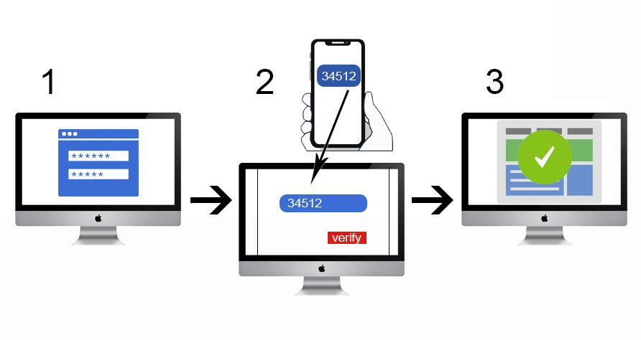
Figure 1 The two-stage authentication scheme.
In Fig. 1, you can see the workflow of the two-stage authentication method, where
1 - Logging in using a personal login and password;
2 - Receiving and entering a password from the system message;
3 - User access to the personal data

No.4 Notification of unauthorized login
If someone logs into the system from an unusual location or from an unknown device, an additional security level will trigger and you will be sent an e-mail and/or SMS notification to the phone. With this method, you will be able to promptly respond to an attempt to attack and steal your data.
No.5 VPN tunneling method
Today, this method is used mainly by private or state companies to protect data. VPN tunneling technology is not a novelty in IT technology, but recently it has become quite popular among many companies due to increased attacks and information leaks. This method provides remote connection to private networks, and also prevents the threat of interception of information on the fly, in way invisible to the recipient. Fig. 2 below shows the scheme of this method.
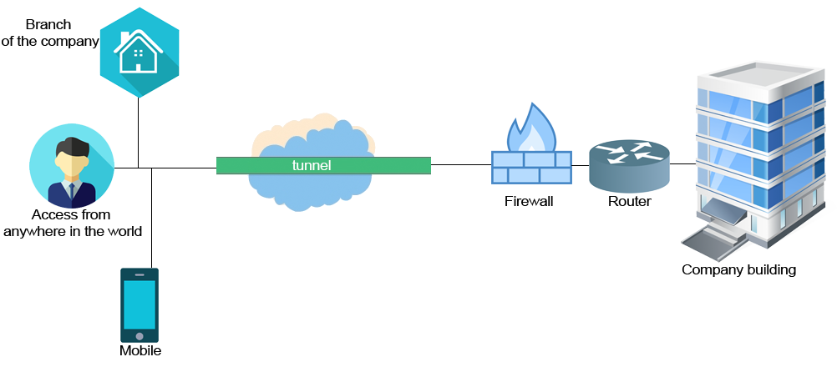
Figure 2 - VPN tunneling scheme

Prospects for the development of new methods of data security
Despite all the problems in this industry, serious efforts to protect information around the world are being developed by young start-ups, corporations and scientists, who create completely new methods and technologies for protecting information. All performance indicators show that every year the information volume becomes bigger, and its value is getting higher. We see rapid technology development, and if 2 years ago the Face ID technology was just a topic for conversation, today it is a full-fledged security system that millions of people around the world use. But the most promising security systems are developments in the field of artificial intelligence and machine learning. Special solutions are designed for automated analysis and detection of threats in order to ensure continuous updating of user facilities as part of an adaptive network security system. This method will significantly increase the effectiveness of protection against new threats.
In conclusion, I would like to say that we live in a century of information that must be protected, because, as Nathan Rothschild said, "Who owns information - owns the world.”

References:
- https://www.oecd-ilibrary.org/education/skills-matter_9789264258051-en
- https://www.gartner.com/newsroom/id/3871416

