ANALYTICAL ALGORITHM FOR MONITORING THE READINESS OF SMART TECHNOLOGIES

Ksenia Kaplieva
Bachelor of Science,
Drexel University, LeBow College of Business,
Philadelphia, USA.

ANNOTATION
In the context of modern smart manufacturing, a patent and licensing strategy is formed as a control analytical algorithm for monitoring the technology's readiness for mass production and integrated marketing.
New smart manufacturing solutions have a positive impact on the development of most production systems and equipment. Their efficiency is enhanced through vertical and horizontal integration.
The proposed technical solutions are based on a method of coding and subsequent identification of the coding element. The method involves applying a special coating (or its technological equivalent) to an object and measuring its thickness. Matching the parameters with the specified code ensures positive identification, while mismatching leads to shutdown or blocking of the equipment or information consumer.
This technology has been repeatedly proven in film thickness control applications in solar energy and semiconductor manufacturing. With the advent of multilayer optical discs and recording formats using blue lasers, its importance has increased. Coding at each recording level enables three-dimensional local encryption of information, making the technology particularly relevant for protecting classified and confidential data. In conclusion, it should be noted that new smart manufacturing technologies have a positive impact on the comprehensive development of virtually any production systems and equipment, as well as on their improvement through vertical and horizontal integration.

Key words: control analytical algorithm for monitoring the readiness of smart technology for mass production and integrated marketing, patent and licensing strategy, innovative technologies, mass-market products, vertical and horizontal integration, implementation of a modification of mobile security coding, external storage media with an innovative coding system, additional features and possibilities of using the technology in new conditions.

Patent and licensing strategy as a control analytical algorithm for monitoring the readiness of smart technology for mass production and integrated marketing

In recent years, several fundamentally new areas of innovative high-tech product development have emerged, confidently becoming products in mass demand.
These include so-called smart products and technologies: smart design, medical technologies and equipment (including devices with mobile apps), smart transportation and logistics, smart manufacturing, and production equipment—from digital CNC machines to modern machining centers and flexible manufacturing modules.
This also includes systems for training and retraining specialists—smart workforce development.
Let's consider this process using the example of implementing modifications to mobile security coding for digital external storage media. The principle of the coding system, the materials used for its construction, and their combinations are also shown in the figure.
This coding and decoding unit solution, while simple, allows for maximum code identification accuracy, as this accuracy is determined by the thickness of the coding or decoding disk. There are at least two methods for manufacturing and installing this disk on the body: the first method involves manufacturing the coding disk from precision foil; The second method is the application of a precision electrochemical coating in a groove made in the housing for the coding disk.

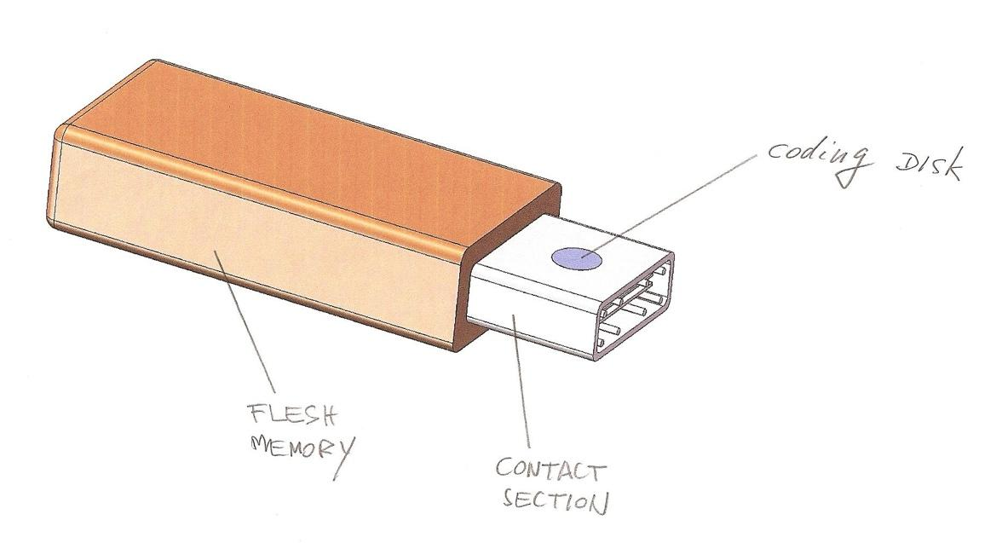
Figure 1. The figure shows an example of an external storage medium modified by an innovative coding system.
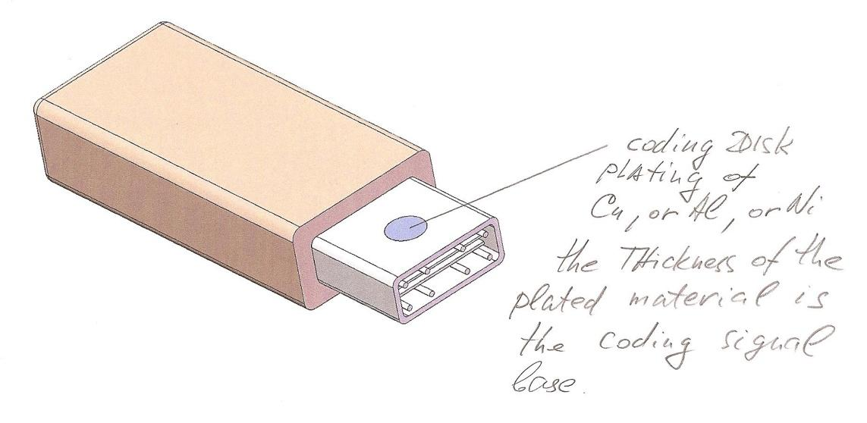
Figure 2. An example of an external storage medium modified by an innovative coding system

General information
All projects in this group of technical solutions are based on a single method of encoding and subsequent identification of the coding element.
The principle consists of applying a coding coating or its technological equivalent to the protected object and then measuring the coating's thickness to determine whether the measurement results match the code.
If the obtained result matches the established one, the coding element is positively identified; if there is a discrepancy, negative identification occurs and the operating cycle of the equipment or information consumer, such as a computer, is stopped or blocked.
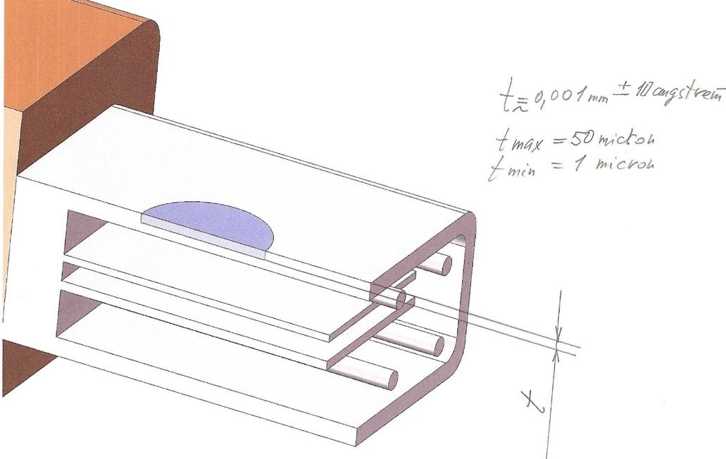

Figure 3. The figure shows an example of such an external storage medium, with technical details modified by an innovative coding system.

The cross-section shows the most critical value determining the encoding or decoding accuracy—the disk thickness (t).
The minimum thickness can be 1 micron, the maximum—50 microns.

Additional technological features
The technological challenges of applying special coatings have been resolved, and this technology has been repeatedly tested in similar applications related to film thickness control on solar panels and in traditional semiconductor manufacturing. Additional features and potential applications of this technology, applied to the new conditions that have emerged in the storage media market over the past year, taking into account new trends in technical solutions and technical systems at all levels, ultimately lead to the synthesis of so-called smart technologies and integrated technical systems with elements of artificial intelligence and artificial neural networks.
With the emergence of new formats for recording and reading optical storage media using blue lasers and the start of production of multilayer optical discs based on this same technology, the proposed principles and technical solutions for security coding have become even more important, as the amount of information recorded on each disc increases, and the lack of protection leads to increasing losses of classified or confidential data. In addition to the information already transmitted, it is necessary to indicate the capabilities for coding each layer in multilayer discs, in which each level of the recording layers is coded, which is a significant improvement in the system of formatting an optical storage medium in three-dimensional terms and is a means of ensuring (for particularly important and secret information) local selective coding of information within a single disc.
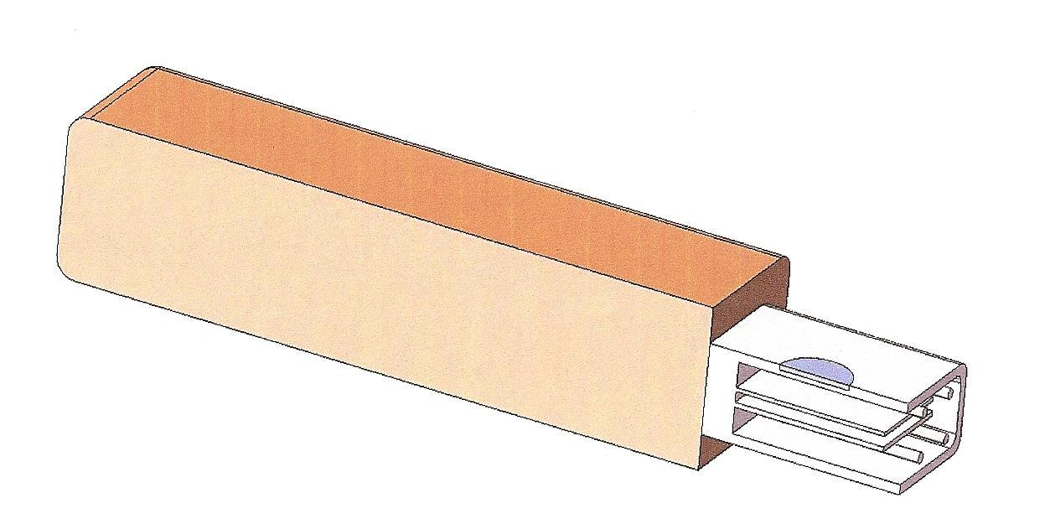

Figure 4. The figure shows a model of a storage medium in axial section.
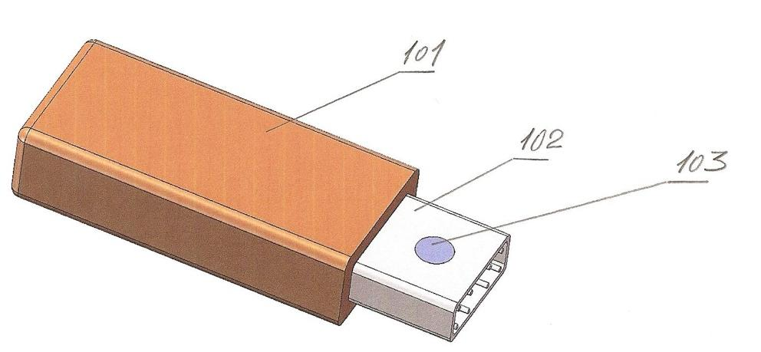

Figure 5. The figure also shows a 3D model of the storage medium.
The numbers in the figure indicate:
101 – Storage medium housing
102 – Flat connector
103 – Coding disk
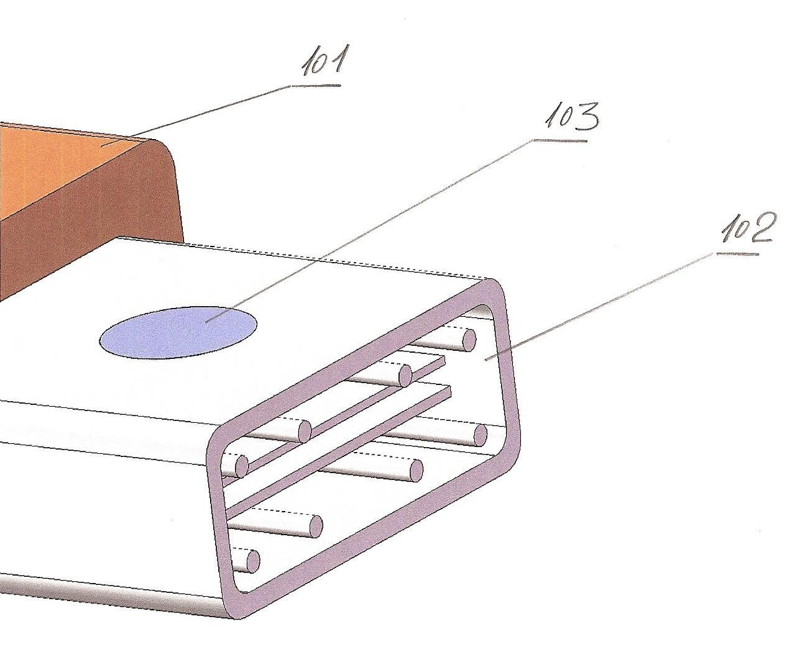

Figure 6. The figure shows a fragment of a 3D model of a storage medium in the area of ​​the flat plug with the encoding and decoding disk.
The numbers in the figure indicate:
101 – Storage medium housing
102 – Flat plug
103 – Coding disk
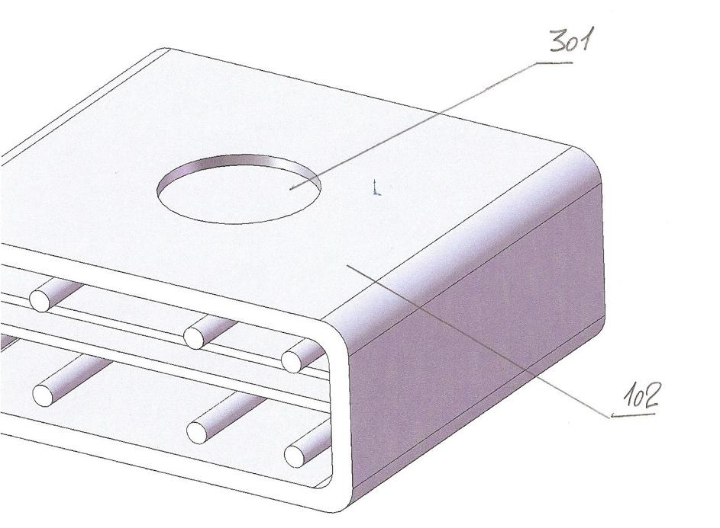
Figure 7. The figure shows a fragment of a 3D model of a storage medium in the area of ​​the flat plug with the encoding and decoding disks before the encoding and decoding disks are installed.
The numbers in the figure indicate:
102 – Flat plug housing
301 – Housing recess for installing the encoding disk in any design variant

As can be seen from all the storage medium models presented in Figures 10, 11, 12, and 13, the encoding and decoding system is quite simple in design, allowing its integration even on storage media designed without such a device and such functions.
This provides an important additional opportunity to use the latest technologies to enhance the marketing potential of a new product. The following technology is an example:
A method for manufacturing a module for installing, cooling, controlling, and monitoring energy-intensive optical and electronic systems, including:
- Steel tape (roll) surface preparation (metal may be specified instead of steel);
- Photoresist application;
- Photoresist development;
- High-speed jet electrochemical coating of nickel in a directed electrolyte flow (2-3 microns thick);
- High-speed jet electrochemical coating of copper in a directed electrolyte flow (25-35 microns thick).

Since this technological phenomenon is the main fundamental difference and forms the package of significant advantages of the proposed innovative method, the author considers it necessary to provide some explanation for this phenomenon.
High-speed jet electrochemical coating is an advanced galvanic process in a selectively oriented directed electrolyte flow with a continuously renewing electrolyte recirculation system, which includes:
- an electrolyte tank with specific electrolyte maintenance parameters, such as nickel and copper concentrations, temperature, acidity or alkalinity, density, and electrical resistance (conductivity); due to the stated advantages of the technology and the materials used, there is no need to use organic additives to the electrolyte (clarifiers);
- a pump with a filter;
- An anode for jet metallization, which has a soluble and insoluble component installed sequentially along the electrolyte flow path. The insoluble component is made of a composite graphite-graphite conductive fabric (such as ETAN) and is positioned parallel to the metallized surface, last along the electrolyte flow path and first before the surface being coated (cathode). Both components are connected to a positive electrical potential and have selective, adjustable hydraulic permeability for the electrolyte. The anode also incorporates a system for uniformly distributing the electrolyte across the soluble component, which is automatically replicated on the insoluble component and, consequently, on the surface being metallized (cathode).
- Photoresist removal;
- Iron etching on one side across half the thickness of the steel tape;
- Removal of etch products from the surface by aerodynamic and then hydrodynamic action;
- Crimping with a flowable polymer composition: monomer filling, subsequent layer-by-layer polymerization, thermal stabilization;
- Iron etching on the other side of the tape (with the same differences);
- Crimping on the second side (with the same differences);
- Applying a protector to the electrically conductive structures;
- Vacuum coating of all thermally conductive structures with a layered system of semiconductor nanoscale structural polycrystalline diamond films.
This technological addition to traditional methods allows for a significant expansion of the scope of new product marketing techniques.

Organization of corporate security systems
The proposed technology, when used to organize a system for protecting information flows within a single corporation, provides protection at multiple system levels, including real-time system tracking of the status and location of each disk within the corporation. Using the proposed encryption methods to protect information on mobile external media is expected to yield the same benefits as when used on optical media and storage devices.

Changes in the structure and scope of use of the product created as a result of the project
Thus, based on similar solutions, at least two projects can be created, each with a large number of applications:
- a project for coding optical storage devices in the form of a disk, including a corresponding analytical and sensor device that can have multiple applications in various fields and industries;
- a project for coding and protecting information on mobile external storage media, including a corresponding mobile or stationary sensor measuring and analytical device, also with multiple applications and design models.

Additional devices and systems that can be created based on the same fundamental technological solutions
At customer request, projects can include a section on additional or specialized devices used to create an entire corporate information security and protection system within a single corporation, group of corporations, or (in the Russian context, state corporations) individual research institutions, academic institutes, and large healthcare institutions.
A specialized product can be developed to protect information not only in the storage area but also in the operational area, transmitting commands and signals within military units and formations, especially in naval environments.
In today's environment, where information is concentrated in relatively small storage devices, potential damage from unauthorized or criminal access can be prevented or localized by creating a dedicated security infrastructure, which can be standardized within the specific context of a given ministry, main department, or structural corporate units and lower-level enterprises.

List of references, patent and licensing information

APPENDIX 1
United States Patent Application 20190281321, Kind Code A1
Author: ZHAO, Xin and others., 12 September 2019
Method and Apparatus for Video Coding
Abstract: A method and apparatus for video coding are provided. In some examples, the apparatus includes a processor circuit that determines an intra-prediction mode for generating a predicted image of the current block, determines one or more primary transforms based on information extracted from the encoded video stream, and determines a secondary transform in accordance with the selected intra-prediction mode and the primary transforms. The apparatus then reconstructs the image of the current block based on the predicted and residual images.
APPENDIX 2
United States Patent Application 20190281270, Kind Code A1
Author: CHEN, Ying, et al., September 12, 2019
Joint Use of Vector Motion in 3D Video Coding
Abstract: Joint coding of depth video and texture video is proposed, wherein a motion vector for a texture video is predicted based on a corresponding motion vector for a depth video, or vice versa. For scalable video coding, depth video is encoded as the base layer and texture video as the enhancement layer(s). Interlayer motion prediction enables motion prediction in texture video based on motion in depth video.
APPENDIX 3
United States Patent Application 20190273948, Kind Code A1
Author: Yin, Hujun, et al., September 5, 2019
Neural Loop Filtering Method and System for Video Coding
Abstract: This method, system, and tool provide neural loop filtering for video coding using multiple alternative neural networks. APPENDIX 4
United States Patent Application 20190273932, Kind Code A1
Author: HAQUE, MUNSI, et al., September 5, 2019
A Video Coding System with Temporal Scalability and Its Method of Operation
Abstract: A method of operation for a video coding system includes: receiving a video stream, extracting video syntax, extracting fixed-syntax HRD, extracting variable-syntax HRD, extracting a temporal layer based on the HRD, and generating the video stream for display on a device.
APPENDIX 5
United States Patent Application 20190268098, Kind Code A1
Author: CHUN, Jinyoung, et al., August 29, 2019
Method and Device for Transmitting Data in a Wireless Communication System
Abstract: A method for transmitting data for multiple users in a wireless local area network includes receiving a DL MU physical protocol block (PPB) from a station, transmitting acknowledgments (ACKs) in response, taking into account frequency, modulation, and coding resource allocation, and the sizes of the allocated resource blocks.
APPENDIX 6
United States Patent Application 20190268016, Kind Code A1
Author: JANSSON TOFTG RD, Tomas, et al., August 29, 2019
Methods and Devices for Segmenting Vectors for Coding
Abstract: A method for segmenting input vectors for coding is proposed. The vector is segmented into an integer number of segments, the relative energy difference between the vector portions is determined at each boundary, and the segments, along with their representations, are fed for individual encoding.
APPENDIX 7
United States Patent Application 20190261010, Kind Code A1
Author: Luo, Ning, et al., August 22, 2019
Video Coding Method and System with Reduced Use of Auxiliary Data Side Buffers
Abstract: Methods, systems, and devices for video coding with reduced use of auxiliary data side buffers are presented.

