Provisional application Inertial Electric Reactor 8 12 18

Provisional (patent) application
Inertial Impulse Electric Thermonuclear Reactor and Method of It.
Patent No: US
Date of Patent:
Inventor: Alexander Alexandrovich Bolonkin abolonkin@gmail.com, 1310 Avenue R, #6-F, Brooklyn, NY 11229, USA:
Current CPC Class: | G21B 3/002 (20130101); G21B 3/006 (20130101); H05H 3/06 (20130101); H05H 2007/007 (20130101)
Current International Class: | G21B 1/15 (20060101); G21B 3/00 (20060101); H05H 7/00 (20060101); H05H 3/06 (20060101)
Field of Search: | ;376/107,113,114,115,116,117
ABSTRACT
The author offers the new small reactor and method for getting a nuclear energy. Main idea is getting a high temperature by new high intensity opposed electric field and two opposed collision jets. Reactor has many innovations and can easy to get the high ignition temperature up 30 keV (350 million K), has enough fuel density (~6×10²⁸ 1/m³) and conformation (10⁻⁶ sec) without the cryogenic, laser or magnetic systems. Author invited a new method for heating of plasma by a direct electric currency, not using laser and laser compressing or heating X-ray or particles beam, not using magnetic field for plasma conformation. No cryogenic temperature. Reactor has Lawson criterion in hundreds of times more than need. The fuel may be liquid, sold, chemical elements and their measures or a compressed gas into ampule. Reactor can work on cheap D+D nuclear fuel (1 gram of deuterium cost only 1$), is very cheap and has a small installation. Author offered the ideas how to easy convert nuclear energy into mechanical energy, electricity, rocket thrust and some chemical elements into the need elements. The main test (getting the thermonuclear reaction) costs only some ten thousand dollars. If test will be successful, we can immediately design the engines for ships, trains, submarines, electric stations, propulsions for rockets and so on.
The method for getting thermonuclear energy comprising the following steps:
using the reactor for getting energy;
making the special fuel capsule;
placing the capsule into said reactor camera with the automatic delivery system;
connecting the capsule to said source energy;
charging the energy source a need energy;
switching the energy source to the capsule;
quick heating said fuel capsule up an ignition thermo-nuclear temperature by direct electric
currency the need voltage, power and ignition energy;
producing thermonuclear energy;
cooling the reactor to acceptable temperature by injecting a cooling agent;
using of thermonuclear energy.
The author has reached and developed the theory of such reactors, made a lot of computations. Invention has a lot of features. He recommends contacting him for details and computations, <abolonkin@gmail.com>.
13 Claims, 5 Figures.
---------------------------------------------------------------------------
Inertial Impulse Electric Thermonuclear Reactor and Method of It.
CROSS-REFERENCR TO RELATED APPLICATIONS
Not applicable
REFERENCE TO A MICROFICHE APPENDIX
Not applicable
BACKGROUND OF THE INVENTION
1. Field of the Invention
This invention proposes new inertial Impulse Thermonuclear Electric reactor and Method for getting the nuclear energy, installations for converting this nuclear energy into mechanic, electric, heat energy, into rocket thrust, using nuclear energy for converting given chemical elements into other need elements. Features of offered reactor are direct heating thermonuclear fuel up ignition by direct electric currency, special fuel capsule, direct converting a kinetic energy of charged particle in electricity or in thrust.
2. Description of related Art.
As it is well-known the thermonuclear reaction occurs when Lawson criterion

L = nTτ >c,

where n is matter (fuel) density, [1/m³]; T is temperature, [KeV], 1 eV = 1.16×10⁴ K; τ is reaction time, [s]; c is constant for given nuclear fuel. For tritium-deuterium fuel (T + D) c ≈ 10²⁰ ÷10²¹ in CI units. The current Inertial Confinement Fusion (ICF) uses the laser compression method (high matter density n) and low temperature T and low reaction time τ. With a compression by 10³, the compressed density will be 200 g/cm³ (T+D), and the compressed radius can be as small as 0.05 mm. For this density (n = 4.8.10³¹ m⁻³ ) and τ = 10⁻⁹ s the Lawson criterion gives a low temperature, which is very few for nuclear reaction. But laser ICF cannot reach this temperature. Trying to warm up the fuel capsule by additional X-rays and other particles have been unsuccessful.
The other method of the current thermonuclear reaction is Magnetic Confinement Fusion (MCF). It uses the other idea – high time reaction (τ = seconds, up minutes) and low plasma density (n = 10²¹m⁻³) and low temperature. That method has a lot of technical problems, is very expensive and also not reaches the stable ignition.
Both current main methods (ICF and MCF) are developed more 60 years by the thousands scientists in all main countries. The governments spent the billions of dollars for their R&D (Research and Development) and are spending hundreds millions dollars every years. But optimist sciences only promise to reach the useful stable nuclear reaction throw 10 – 15 years (after 2016) and build the industrial electric station after the additional 5 – 10 years. The other scientists show: the price of the nuclear energy used tritium fuel (main fuel for current reactors is T+D) will be cost ten times more than in present electric stations using the natural fuel (tritium costs 30,000 $/gram, trend up 100,000 $/gr).

Brief Information and history about Current Thermonuclear Reactors,
Fusion power is useful energy generated by nuclear fusion reactions. In this kind of reaction two light atomic nuclei fuse together to form a heavier nucleus and release energy. The largest current nuclear fusion experiment, JET, has resulted in fusion power production somewhat larger than the power put into the plasma, maintained for a few seconds. In June 2005, the construction of the experimental reactor ITER, designed to produce several times more fusion power than the power into it generating the plasma over many minutes, was announced. The unrealized production of net electrical power from fusion machines is planned for the next generation experiment after R&D ITER.
Unfortunately, this task is not easy, as scientists thought early on. Fusion reactions require a very large amount of energy to initiate in order to overcome the so-called Coulomb barrier or fusion barrier energy. The key to practical fusion power is to select a fuel that requires the minimum amount of energy to start, that is, the lowest barrier energy. The best fuel from this standpoint is a one-to-one mix of deuterium and tritium; both are heavy isotopes of hydrogen. The D-T (Deuterium and Tritium) mix has suitable low barrier energy. In order to create the required conditions, the fuel must be heated to tens of millions of degrees, and/or compressed to immense pressures.
At present, D-T is used by two main methods of fusion: inertial confinement fusion (ICF) and magnetic confinement fusion (MCF)--for example, tokomak device.
In inertial confinement fusion (ICF), nuclear fusion reactions are initiated by heating and compressing a target. The target is a pellet that most often contains deuterium and tritium (often only micro or milligrams). Intense focused laser or ion beams are used for compression of pellets. The beams explosively detonate the outer material layers of the target pellet. That accelerates the underlying target layers inward, sending a shockwave into the center of each pellet’s mass. If the shockwave is powerful enough, and if high enough density at the center is achieved, some of the fuel will be heated enough to cause pellet fusion reactions. In a target which has been heated and compressed to the point of thermonuclear ignition, energy can then heat surrounding fuel to cause it to fuse as well, potentially releasing tremendous amounts of energy.
The thermonuclear reaction depends from production three magnitudes: density (compression of fuel), temperature and time. At present time the scientists use two main methods for attempts to reach efficiency thermonuclear: Inertial Confinement Fusion (ICF) and Magnetic Confinement Fusion (MCF). In ICF the scientists use the high compression (by laser beam), but low time, in MCF they use low compression, but long time.
Laser method. Disadvantages. Thermonuclear reactors and, in particular, Laser methods are have been under development for about 60 years. Governments have already spent tens billions of US dollars, but it is not yet seen as an industrial application of thermonuclear energy for the coming 10-15 years. The laser has very low efficiency (2- 3%), high-pressure acts is every shot time (10⁻⁹– 10⁻¹⁰ s), enough energy is not delivered to the center of the spherical fuel pellet (low temperature), there are many future problems the radioactivity and converting the thermonuclear energy into useful energy.
Data of same current inertial laser installations:
1. NOVA uses laser NIF (USA), has 192 beams, impulse energy up 120 kJ. One reach density
20 g/cm³, speed of cover is up 300 km/s. NIF has failed to reach ignition and is, as of 2013,
generating about 1/3rd of the required energy levels. NIF cost is about $3.5B.
2. YiPER (EU) has impulse energy up 70 kJ.
2. OMEGA (USA) has impulse energy up 60 kJ.
3. Gekko-XII (Japan) has impulse energy up 20 kJ. One reaches density 120 g/cm³.
4. Febus (France) has impulse energy up 20 kJ.
5. Iskra-5 (Russia) has impulse energy up 30 kJ.
There are some small projects. But they do not reach success.
BRIF SUMMARY OF THE INVENTION
The author offers the new reactor and method for getting a nuclear energy (see detail Description). Main idea is getting a high temperature by new high intensity opposed electric field. Reactor can easy to get the high ignition temperature up 30 keV (350 million K), has enough fuel density (~6×10²⁸ 1/m³) and conformation (10⁻⁶ sec). Author invited a new method for heating of plasma by a direct electric currency, not using laser and laser compressing or heating X-ray or particles beam, not using magnetic field for plasma conformation. He reaches a high confinement by internal capsule layer from heavy nucleus and strong massive cover of fuel capsule. No cryogenic temperature. Reactor has Lawson criterion in hundreds of times more than need. The fuel may be liquid, sold, chemical elements and their measures or a compressed gas into ampule. Reactor can work on cheap D+D nuclear fuel (1 gram of deuterium cost only 1$), is very cheap and has a small installation. Author offered the ideas how to easy convert nuclear energy into mechanical energy, electricity, high efficiency rocket thrust and some chemical elements into need elements. The main test (getting the thermonuclear reaction) costs only some ten thousand dollars. If test will be successful, we can immediately design the engines for ships, trains, submarines, electric stations, propulsions for rockets and so on.
BRIF DESCRIPTION OF INVENTION
Outline of the new electric impulse reactor and method.
The some versions of the electric impulse AB thermonuclear reactor is presented in figures 1 – 3.
The new thermonuclear reactor contains:
1) The body of the thermonuclear reactor – sphere 1 diameter 0.3 ÷ 3 m. (Fig.1), the special fuel capsule (Fig.2) and energy source 6 (Fig.1). Reactor has some Versions. In Version 1 the reactor has the additional installations for delivery matter to camera 4 (fig.1) (for example - air) and for converting the nuclear energy into an electric, mechanical energy 5 (fig.1,3) and given chemical element (10 in Fig.1) (located in body) for transforming in others need elements, in Version 2 the reactor converts the thermonuclear energy in a rocket thrust (fig. 4-5). Reactor also has itself source energy.
2) Small special cylindrical thermonuclear fuel capsule (fig.2) (cylindrical fuel ampule, cartridge, granule, beat, pellet and so on) having two cameras, (left and right, Fig.2). Fuel is solid, liquid or compressed gas. Pressure of gas fuel has up 400 ÷1000 atm.
The offered new AB impulse thermo-reactor has some main features. The reactor has the following important differences from all existing and under construction inertial reactors.
1. Thermonuclear fuel is ignited directly electricity. No lasers, particles beams, accelerators or magnetic
systems, which are very expensive and request many energy installations.
2. Original design of fuel capsule (opposed strong electric fields, three circular contacts, internal capsule
layer from heavy nucleus, strong massive capsule cover and so on) which alloys to heat the nuclear fuel
to very hot temperature.
3. Special design of reactor which easy alloys to convert nuclear energy into mechanical, electric, trust
energy and convert given chemical elements in need elements.
BRIEF DESCRIPTION OF THE SEVERAL VIEWS OF THE DRAWINGS
Fig.1. Impulse Inertial Thermonuclear AB Reactor.
Notation: 1 - strong spherical body (shell) of reactor (diameter about 0.3 ÷ 3 m); 2 – the special fuel capsule (it is described in Fig.2); 3 - holder of fuel capsule; 4 – enter of compressed gas (for example-air); 5 – exit of a hot compressed gas after thermonuclear heating; 6 – electric source (for example-capacitor); 7 -mobile deliver of fuel
capsule; 8 – thin conductivity film for absorption the charged particles same sign (option); 9 – conductivity layer for absorption the charged particles of the other sign (option); 10 – chemical elements for converting to other need elements by neutrons.
Fig.2. Principal schema of the special opposed jets fuel (plasma) two camera capsule.
Notation: a – side view; b – forward view. 1 -capsule; 2 – strong non-conductivity cover; 3 -internal non-conductivity layer from heavy elements; 4 - negative internal electric contact; 5 – thermonuclear fuel; 6 – direction of initial acceleration of the positive nucleus; 7 the fuel plasma; 8 – electrons of fuel plasma; 9 – positive contacts; 10 – switch on; 11 – source of energy (for example, capacitor); 12 - thin elastic electric conductivity partition (option). One separated differed type fuel which cannot mixture before heating, for example T+D; 13 – contact.
Fig.3. Final (industrial) work of Impulse Electric AB thermonuclear reactors. Hot compressed gas from sphere runs to the magneto-hydrodynamic generator (MHG) 10 and produces electric energy or runs to gas turbine and produces an useful mechanical energy.
Notation: 1 – strong body of the reactor; 2 – special fuel capsule (it is described in Fig.2); 3 - holder of fuel capsule; 4 – enter of compressed gas (for example-air); 5 – exit of a hot compressed gas after thermonuclear heating; 6 – electric source (for example-capacitor); 7 – injector of cooling liquid; 9 – enter for exhaust gas; 10 – transformer of energy; 11 – mobile deliver of fuel capsule.
Fug.4. Rocket nozzle of Thermonuclear Reactor
Fig.5. Rocket thermonuclear propulsion.
Notation: 1 - three charged electrostatic parabolic nets (reflecting parabolic mirrors) which reflects all charged nuclear particles in one direction for converting kinetic energy of charged particles in trust; 2 – deliver of fuel capsule; 4 – trajectories of charged particles; 5 – holder of fuel capsule; 6 -reactive thrust; 7 – source energy.
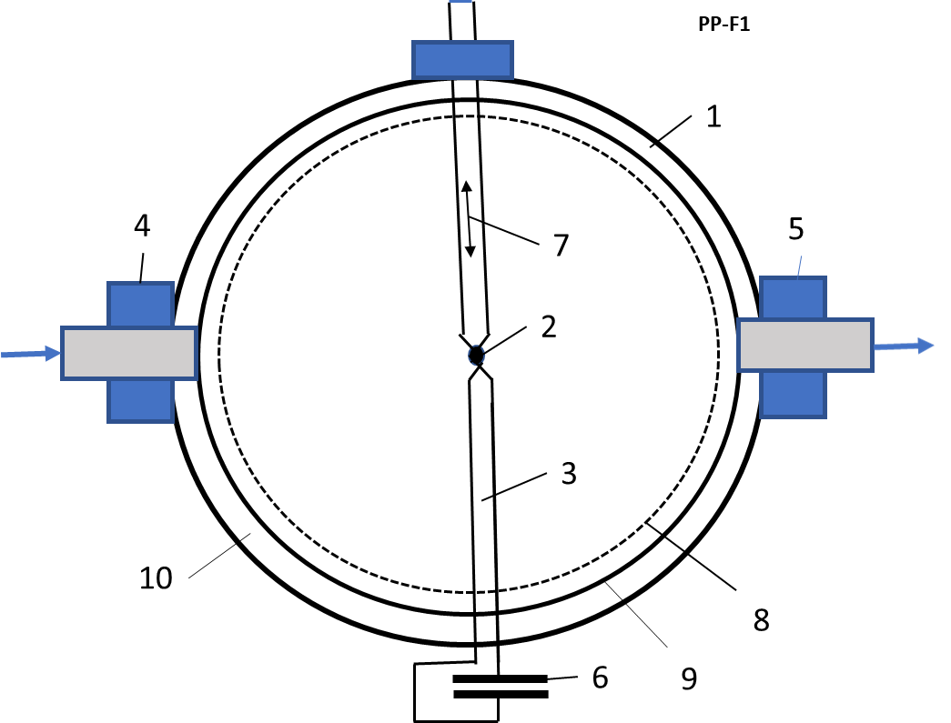
Fig.1. Impulse Inertial Thermonuclear AB Reactor.
Notations: 1 - strong spherical body (shell) of reactor (diameter about 0.3 ÷ 3 m); 2 – the special fuel capsule (it is described in Fig.2); 3 - holder of fuel capsule; 4 – enter of compressed gas (for example-air); 5 – exit of a hot compressed gas after thermonuclear heating; 6 – electric source (for example-capacitor); 7 -mobile deliver of fuel
capsule; 8 – thin conductivity film for absorption the charged particles same sign (option); 9 – conductivity layer for absorption the charged particles the other sign (option); 10 – chemical elements for converting to other need elements by neutrons.
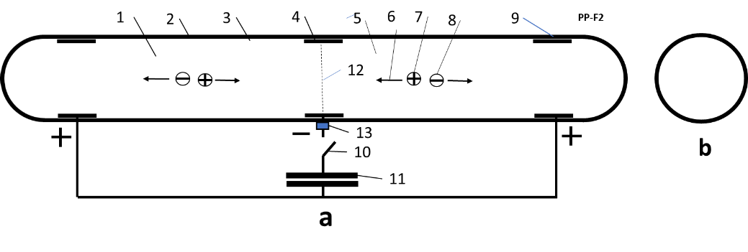
Fig.2. Principal schema of the Special opposed jets fuel two camera capsule.
Notation: a – side view; b – forward view. 1 -capsule; 2 – strong non-conductivity cover; 3 -interne non-conductivity layer from heavy element; 4 - negative internal electric contact; 5 – thermonuclear fuel; 6 – direction of initial acceleration of the positive nucleus 7 the fuel plasma; 8 – electrons of fuel plasma; 9 – positive contacts; 10 – switch on; 11 – source of energy (for example, capacitor); 12 - thin elastic electric conductivity partition (option). One separated differed type fuel which cannot mixture before heating, for example T+D; 13 – contact.
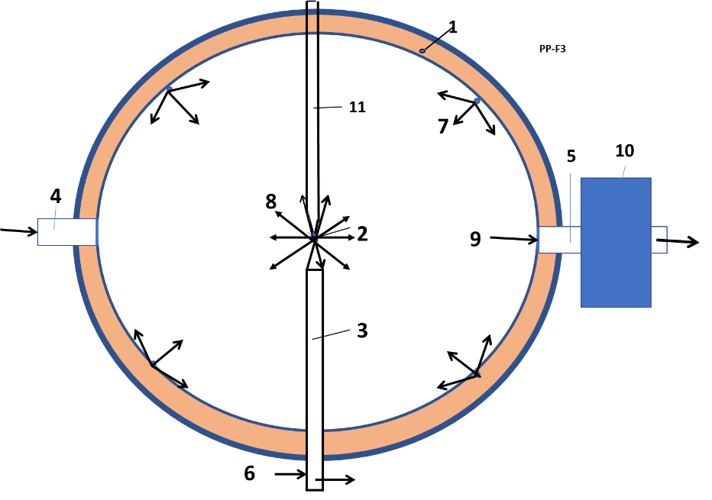
Fig.3. Final (industrial) work of Impulse Electric AB thermonuclear reactors. Hot compressed gas from sphere runs to the magneto-hydrodynamic generator (MHG) 10 and produces electric energy or runs to gas turbine and produces an useful mechanical energy.
Notation: 1 – strong body of the reactor; 2 – special fuel capsule (it is described in Fig.2); 3 - holder of fuel capsule; 4 – enter of compressed gas (for example-air); 5 – exit of a hot compressed gas after thermonuclear heating; 6 – electric source (for example-capacitor); 7 – injector of cooling liquid; 9 – enter for exhaust gas; 10 – transformer of energy; 11 – mobile deliver of fuel capsule.
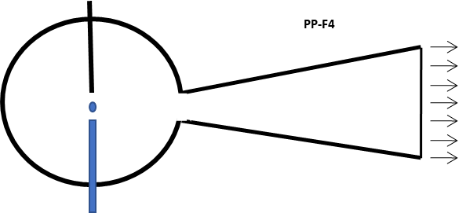
Fug.4. Rocket nozzle of Thermonuclear Reactor
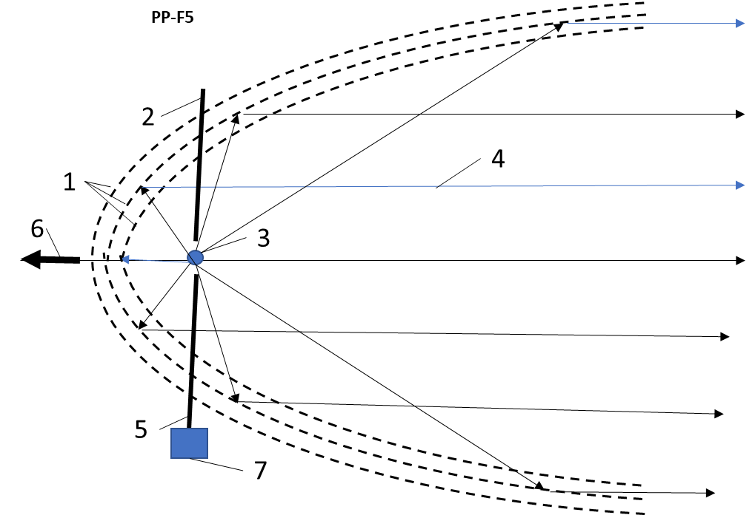
Fig.5. Rocket thermonuclear propulsion.
Notation: 1 - three charged electrostatic parabolic nets (reflecting parabolic mirrors) which reflects all charged nuclear particles in one direction for converting kinetic energy of charged particles in trust; 2 – deliver of fuel capsule; 4 – trajectories of charged particles; 5 – holder of fuel capsule; 6 -reactive thrust; 7 – source energy.
DETAILED DESCRIPTION OF THE INVENTION
Some versions of the electric impulse AB thermonuclear reactors are presented in figures 1 – 5.
The thermonuclear reactor contains:
The nuclear reactor is shown in Fig.1. One contains: strong spherical body (shell) 1 of reactor; the special fuel capsule 2 (It is described in Fig.2); holder (electric conductor) 3 of fuel capsule; enter of compressed gas (for example - air) 4; exit of a hot compressed gas (air) after thermonuclear heating 5; a source of energy (for example, capacitor) 6; mobile deliver of fuel capsule 7.
The reactor (fig.1), which directly converting nuclear energy in electricity, may also contains (option): the 8 – thin conductivity film for absorption the charged particles same sign; 9 – conductivity layer for absorption the charged particles the other sign (option); 10 – chemical elements for converting to other need elements by neutrons.
Reactor has some Versions. In Version 1 the reactor has the additional installations for delivery matter to camera (for example - air) and for converting the nuclear energy into an electric, mechanical energy (fig.1,3) and given chemical element in others need elements. The neutrons produced thermonuclear reaction pass their heat to reactor body, braking, introducing into nucleus and produce the isotopes having a new properties and new reactions. Below some reactions produced by neutrons:
Reactions (Energy in MeV) Cross section, barn
³He + n → ³H + p + 0.764 5400
⁶Li + n → ³H + α + 4.785 945
⁷Be + n → ⁷Li + p + 1.65 51000
¹⁰B + n → ⁷Li + α + 2.791 3837
¹⁴N + n → ¹⁴C + p + 0.626 1.75
¹⁷O + n → ¹⁴C + α + 1.72 0.5
For example, the Litium costs 270 $/kg, the tritium T cost 30,000 $/gr. The conventional Uran-238 costs 35 $/pound, Uran-235 for nuclear weapon costs 1000 $/gr.
Version 2 is shown in Fig.3. One contains: 1 – strong body of the reactor; 2 – special fuel capsule (it is described in Fig.2); 3 - holder of fuel capsule; 4 – enter of compressed gas (for example - air); 5 – exit of a hot compressed gas after thermonuclear heating; 6 – electric source (for example - capacitor); 7 – injector of cooling liquid; 9 – enter for exhaust gas; 10 – transformer of energy; 11 – deliver of fuel capsule.
In Version 3 the reactor converts the thermonuclear energy in a rocket thrust (fig. 4-5). Reactor also has itself source energy. Reactor, which transfers the pressure gas by conventional method, has usual nozzle (Fig. 4). Reactor producing reflected thrust by new method, contains (Fig.5): 1 - three charged electrostatic parabolic nets (reflecting parabolic mirrors) which reflects all charged nuclear particles in one direction for converting kinetic energy of charged particles in trust; 2 – deliver of fuel capsule; 4 – trajectories of charged particles; 5 – holder of fuel capsule; 6 - reactive thrust; 7 – source energy.
Special new small cylindrical thermonuclear fuel capsule (Fig.2) (cylindrical fuel cartridge, ampule, granule, beat, pellet) having two section (left and right cameras) (Fig.2). Thermonuclear fuel may be sold, liquid, gas. Pressure of gas fuel into capsule is up 400 ÷ 1000 atm.
The special fuel capsule has (fig.2): 1 - capsule; 2 – strong non-conductivity cover; 3 -interne non-conductivity layer from heavy element (A ≈ 200, option) ; 4 - negative internal electric contact; 5 – thermonuclear fuel; 6 – direction of initial acceleration of the positive nucleus 7 the fuel plasma; 8 – electrons of fuel plasma; 9 – positive contacts; 10 – switch on; 11 – source of energy (for example, capacitor); 12 - thin elastic electric conductivity partition (option). Partition separates differed type fuel which cannot mixture before heating, for example T+D. Fuel camera has two (left and right section), one negative and two positive electric contacts.
The strong cylindrical shell from non-conductive heavy matter (A ≈ 200). Capsule has minimum two sections: left and right. Thermonuclear fuel in left and right sections may be different.
Power electric capacitor has need energy, voltage and switch speed, small itself electric resistance and inductivity together with were from electric source to capsule.
Brief summary description of the offered Nuclear reactor:
1. An inertial impulse fusion nuclear reactor for getting thermonuclear energy, comprising:
a body (reactor) containing reactor camera and other detail or connected to them;
an installation (system) for automatic delivery a fuel capsule to inter of the body;
an impulse electric source located outer of the body and connected to said body;
an special fuel capsule delivered into the reactor by the delivery system and direct connected
to the electric source.
2. The reactor as recited in point 1 father includes at least one of the from the following systems:
compressor connected to the reactor for pumping a gas (for example, air) into the reactor
camera for power and cooling;
injector connected to the reactor for injecting a liquid (for example, water) into the reactor
camera for power and cooling, for example at least one of the following: nuclear plasma
electric generator, nuclear electrostatic rocket propulsion;
cooling system connected to the reactor for transferring head from the reactor camera;
an Installation connected to the reactor for converting of thermonuclear energy after reaction
to other type of energy;
vacuum pump connected to the reactor for vacuuming the reactor;
an electric cable connects the electric source and the fuel capsule;
a system connected to the reactor for getting a thrust;
said reactor has an elements (matter) which we want to convert in others.
3. The reactor as recited in point 1 father includes at least one of the from the following features:
the special fuel capsule has minimum three electric contacts and linear their disposition;
the special fuel capsule has a strong cover from matter having high electric resistance;
the special fuel capsule has internal layer from heavy elements;
the special fuel capsule is filled at least one of next type of fuel: sold, liquid, compressed gas;
as the fuel may be used at least one from the following chemical elements: p, H, D, T, ³He, ⁶Li,
⁷Li, ¹¹B; hydrides, in which the hydrogen is changed by deuterium, for example
solid ⁶LiD (crystal), B₆H₁₀ (hex borane), liquid D₂O (heavy water);
the electric cable connecting the reactor and their electric source has a small electric
resistance, a small inductivity and a switch-on having a high speed (< 10⁻⁶
sec);
the switch-on may be at least one of the following: electronic, explosive;
the electric source may be at least one of the following: capacitor, impulse electric generator,
explosive electric generator;
the electric cable connecting said reactor and said their electric source may has at least one of a
form: cylinder into cylinder separated by isolator, double twisted isolated wires.
4. The reactor as recited in point 2 includes at least one of the from the following features:
a type of converted energy may be at least one of the following: mechanical, electric, trust,
heating, other chemical elements;
the Installation for converting the nuclear energy after reaction to other type of energy may be:
gas turbine, gas turbine connected with electric generator, magneto-hydrodynamic generator (MHD),
said nuclear plasma electric generator for converting charged particles directly to electricity,
rocket nozzle, electrostatic reflect net for converting charged particles in trust, chemical
elements located in near reactor;
the compressor pumping gas into reactor is at least one of the following: an axis compressor,
direct compressing with flow;
the system for getting a thrust may has at least one of the following: rocket nozzle, electrostatic
reflect net (electrostatic mirror);
as the elements for conversating into others may be at least one of the following, as example:
lithium-6 in tritium, uranium-233 in U-235.
5. The Installation - plasma nuclear electric generator as recited in point 4 add comprising:
conductive thin films located into the reactor camera and collects the electric charges;
conductive layer located out from the film and is separated from the film by non-conductive
environment and collects electric charges of opposed sign;
wires which connect the film and layer to useful electric load.
6. The electrostatic reflect net for converting charged particles in trust as recited in point 4 add
comprising:
three charged electrostatic parabolic nets (reflecting parabolic mirrors) which reflects all charged
nuclear particles in one direction for converting kinetic energy of charged particles in trust;
the thermonuclear fuel capsule located in focus of the parabolic mirrors;
the installation system for automatic delivery a fuel capsule in focus the mirrors;
the energy source connected with the fuel capsule.
7. The reactor as recited in point 4 may father includes at least one of the from the following
features:
the reactor body may contains chemical elements located in reactor body for conversating into
others chemical elements more useful; neutrons produced thermonuclear reaction pass their
head to reactor body, braking, introducing into nucleus and produce the isotopes having a new
properties and new reactions;
as the elements for conversating into others may be at least one of the following, as example:
Reactions (Energy in MeV) Cross section, barn
³He + n → ³H + p + 0.764 5400
⁶Li + n → ³H + α + 4.785 945
⁷Be + n → ⁷Li + p + 1.65 51000
¹⁰B + n → ⁷Li + α + 2.791 3837
¹⁴N + n → ¹⁴C + p + 0.626 1.75
¹⁷O + n → ¹⁴C + α + 1.72 0.5
The offered thermonuclear reactor works the next way (Figs. 1 – 5):
Version 1 for an electric or mechanic energy.
The internal volume of reactor body is filled the atmospheric or compression gas (for example, air) (enter 4 of Fig.1).
The fuel capsule (Fig.2) installs by the deliver 7 to the holder 3 (Fig.1). Turn on the charged (up 50 -500 kV, 30 – 200 kJ, speed 10⁻⁹ sec) electric capacitor 6 (Fig. 1). The electrons from the electric source are ionized the fuel molecules (fig.2) into the left and right sections (cameras) of capsule. In particular, they positive ionize and dissociate the fuel molecules (for example, D and T are contained into cameras of capsule). The positive ionized nucleus of the thermonuclear fuel (having small mass) are quick collectively accelerated up very high temperature (speed) (up 50 – 400 keV) and collide the collectively moving nucleus of opposed camera, which are moving in opposed direction. Partition 8 is burned. The high electric currency (millions A) produces the strong pinch effect and compress the thermonuclear fuel. The cover from heavy molecules (mass A ≈ 200) reflect the light (A ≈ 2÷3) fuel nucleus from capsule walls and increase the fusion (reaction) time of the fuel nucleus. The strong capsule cover also significantly increases the reaction time (in ten-hundred times). In results (as show computation) the fuel nucleus merge and produce ignition of the thermonuclear reaction. The thermonuclear reaction (explosive, high speed nuclear particles) heats the air (gas) into reactor body and bogy. For increasing the efficiency, work mass, decreasing explosive temperature and protection from neutrons, the liquid 7 (for example, water, fig.3) may be injected into reactor.
After thermonuclear explosion the hot gas flow out into the magneto-hydrodynamic generator (MHG) 10 and produces electric energy or runs to the gas, steam turbine and produces the useful work (Fig. 3). Or the hot compressed gas runs to rocket nozzle and produces the rocket trust (fig. 4).
The main difference the offered electric reactor from the published cumulative reactors [2, 7] is type of explosive for getting the temperature, pressure and cumulative effect in fuel. On [2 - 4] author used the chemical explosive. The offered reactor uses the strong electric field for acceleration, getting high temperature and cumulative effect. The electric method leads to practically unlimited cheap power. In [2, 4] the explosive is located into main spherical body 1 (fig.1) (or gun in [2]). In [4] version 1 (fig.2, [4]) the explosive 3 is small and located in the special fuel cartridge (fig.2, [6]). In current version no, special compression explosive. The pressure and high temperature of the fuel are reached the high voltage capacitor. It is easier and it is more comfortable in using.
In the new capsule version, the fuel capsule is filling by the sold, liquid fuel or compressed gas fuel (up 400÷800 atmosphere or more). Reactor not has the explosive for an additional compressing of fuel. The gas fuel is compressed primary and heating only by strong electric charge of a capacitor. The computation shows that is possible. We can also use the conventional pellet with frozen fuel.
AB Reactors are cooled using well-known methods between explosives or by an injection of water into sphere (fig. 3).
Brief summary of offered method:
8. Method for getting thermonuclear energy as recited in point 1 comprising the following steps:
using the reactor for getting energy;
making the special fuel capsule;
placing the capsule into the reactor camera with the automatic delivery system;
connecting the capsule to the source energy;
charging the energy source a need energy;
switching the energy source to the capsule;
quick heating the fuel capsule up an ignition thermo-nuclear temperature by direct electric
currency the need voltage, power and ignition energy;
producing thermonuclear energy;
cooling the reactor to acceptable temperature by injecting a cooling agent;
using of thermonuclear energy.
9. Method for getting thermonuclear energy, as recited in claim 8 comprising at least one of the
following steps:
making a special fuel capsule a cylindrical form having a minimum three alternating contacts
disposed in line;
covering the fuel capsule with strong cover isolator;
creating an internal capsule tine layer from heavy chemical elements;
filling the fuel capsule at least one of next type thermonuclear fuel: compressed gas, liquid, sold fuel;
using as the thermonuclear fuel at least one from the following elements: p, H, D, T, ³He, ⁶Li, ⁷Li,
¹¹B; hydrides, in which the hydrogen is changed by deuterium, for example
solid ⁶LiD (crystal), B₆H₁₀ (hex borane), liquid D₂O (heavy water);
applying the electric cable connecting the reactor and the electric source with electric
cable having a small electric resistance (< 0.1 Ohm), a small inductivity (< 10⁻⁶ F);
a switch-on having a high speed (< 10⁻⁵ sec);
using at least one of the following switch-on: electronic, explosive;
utilizing at least one of the following electric source: capacitor, impulse electric generator,
explosive electric generator;
using as electric cable connecting the reactor and the electric source having at least one a form:
cylinder into cylinder separated by isolator, double twisted isolated wires;
pumping and pressing gas into reactor camera;
heating the gas into reactor with thermonuclear energy;
passing the hot gas into installation which is converting nuclear energy in need form of energy.
10. Method for getting thermonuclear energy, as recited in point 8 comprising at least one of the
following features:
converting thermonuclear energy at least one of the following: mechanical, electric, rocket
trust, heating, other chemical elements;
using for converting thermonuclear energy at least one the following installations: gas turbine,
gas turbine connected with electric generator, magneto-hydrodynamic generator,
the electrostatic thin films located into the reactor camera for converting charged particles
directly to electricity, rocket nozzle, electrostatic reflect net for converting charged particles
in trust, getting a need chemical element;
applying as compressor for pumping gas into reactor at least one of the following devices: an axis
compressor, nozzle which is direct compressing an outer high speed flow;
utilizing the system for getting a thrust at least one of the following ways: rocket nozzle,
electrostatic reflect net;
transforming given chemical elements into others need elements, for example: lithium-6 in
tritium, uranium-233 in 235.
11. Method for getting electric energy as recited in point 10 having the following steps:
placing into reactor body the conductive thin films located into the reactor camera and
collecting same electric charges;
covering into reactor body the conductive layer located out from the film;
separating the layer from the film by non-conductive environment;
collects electric charges of opposed signs in the film and the layer;
connecting the film and the layer by wires to useful electric load.
12. Method for getting rocket thrust by reflecting the charged particles as recited in point 10 having
the following additional steps:
producing three charged electrostatic parabolic nets (reflecting parabolic mirrors) which
reflects all charged nuclear particles in one direction for converting kinetic energy of charged
particles in trust;
connecting the fuel deliver and ignition systems to focus the parabolic mirrors;
placing in focus of the parabolic mirrors the thermonuclear fuel capsule;
switching need voltage in reflecting parabolic mirrors.
13. Method for converting given chemical elements in others as recited in point 10 having the
following steps:
placing in the reactor body given chemical elements for conversating into others chemical
elements more useful; neutrons producing thermonuclear reaction pass their
head to reactor body, braking, introducing into nucleus and produce the isotopes having a new
properties and new reactions; as the elements for conversating into others may be at least one
of the following, as example: lithium-6 in tritium, uranium-233 in U-235.
extracting from reactor body the need elements.
Advantages of the suggested reactors in comparison with ICF Laser method.
The offered reactor and methods have the following advantages in comparison with the conventional ICF laser reactor:
1. Correct design and the high voltage electric capacitor or other power high voltage, high speed source energy
allows reaching the needed thermonuclear temperature.
2. Offered Electric AB-reactors are cheaper by thousands of time because they do not have the gigantic very
expensive laser or magnetic installations (see [1]-[6]).
3. Offered Reactor is small and more efficiency because the laser installation converts only 1 - 2.5% the electric
energy into the light beam. In suggested AB reactors, the all underused energy remains in the spherical reactor
and utilized in MHG or turbine. AB reactors cannot have coefficient Q (used energy) significantly
less 1. Moreover, one has heat efficiency more than conventional heat engines because it has very
high temperature and compression ratio. Reactor can use as the conventional very high-power engine in
civil and military transportation.
4. The offered very important innovation (accelerating of exhaust rocket gas) allows increasing the
top speed of the exhaust mass up very high speed. This makes this method available for thermonuclear rockets.
5. Electric AB-reactors give ignition temperature of the fuel much more than the current ICF laser installations.
6. The compression has longer time (up to 10⁻⁵ – 10⁻⁶ s) than a laser beam pressing is only (10⁻⁹ – 10⁻¹² s),
because molar mass (µ ≈ 200) of heavy molecules (internal layer of the capsule in fig.2) is many times (50 ÷
100) heavier than fuel molar mass (µ = 2 ÷ 3). This pressure is supported by shock wave coming
from moving gas and pinch effect. This pressure increases the temperature, compressing and
probability of thermonuclear reaction.
7. The heavy mass of the cover of capsule (fig.2) (having high nuclear numbers Z ≈ 80 and A ≈ 200)
not allow the nuclear particles easily to fly apart. That increases the reaction time and reactor
efficiency.
8. The suggested AB-thermonuclear reactor is small (body diameter about 0.5÷3 m or less up 0.3 m) light
(mass is about some ton or less up 100 kg) and may be used in the transport vehicles and aviation.
9. The water may protect the material of the sphere from neutrons.
10. It is possible (see computations) the efficiency of AB reactors will be enough for using as fuel only
the deuterium (or others) which is cheaper then tritium in thousands of times (One gram of tritium
costs about 30,000 US dollars. One gram of deuterium costs 1$) (see a fuel cost).
11. The offered AB reactors have high initial temperature. That allows to use the fuels do not give
the neutrons and gamma-radiation. These fuels are safety for humanity and installations.
12. Offered reactor may be used for syntheses elements.
13. Offered reactor allows design the rocket reflect engine (Electrostatic mirror) having specific impulse up
(5 ÷ 10)×10³ km/sec. That in 3000 times more the current chemical impulse 3 km/sec.
Main differences of offered reactor from all current reactors:
1. Correct heating of fuel. As noted above, the nuclear ignition depends from product of three fuel values: density, temperature and time of reaction. In ICF the scientists try to reach the nuclear ignition by the high fuel density, but in short time. They compress the fuel to very high density by laser beam. When this method (after 60 years experiments and spending tens billion of dollars) failed, they added to him heating by X-rays. But they do not reach the need ignition.
In MCF the scientists try to reach reaction in low fuel density but long reaction time. They also fail after 60 years experiments and spending tens billion of US dollars.
Now the scientists promise to get nuclear energy (after 10-15 additional years (after 2016) and after additional funding tens billions of dollars) by reactor, which will produce energy few more then reactor spend for itself (Q > 1). The author is showed in his scientific works, these methods have a dead end [1]. If scientists (using current methods) get the nuclear energy, this energy will be cost in 10 times more expensive than a current gas energy.
Why the scientists do not use the well-known way: heating the nuclear fuel by electricity? The fact is that fuel requests a very high temperature – tens millions of degrees. In the temperature about 10,000K any matter is plasma. Plasma excellent pass the currency and not heat. All heat is released in contacts and heating them. Author invited how to heat plasma. He selected capsule in two sections, made three electrodes which produce two opposed high electric fields having negative contest in middle.
It is known the charged particle go between electrodes having voltage 1 volt and get the energy 1 eV. But 1 eV = 11,600 K (degree). Consequently, if voltage is 10kV, the two opposed jet will have temperature about 116 million K. That is sufficient for ignition most nuclear fuels. The need fuel density easy to reach using the sold or liquid chemical elements or compress gas, which contains elements at room temperature.
Author organize two strong opposed jets. If some particles not collies, they fall (fly) into opposed electric field, brake and accelerate in opposed direction. The heavy layer (A ~ 200) into capsule reflect the easy fuel elements (A ~ 1÷4) from capsule walls. The strong cover of capsule increases the reaction time. As it shows computations that increases Lawson criteria in hundreds of times and alloys to ignites the many good nuclear fuels.
Note we also get rid from huge, very expensive cryogenic, laser and magnetic systems and gigantic building for them. The new small nuclear reactor is suitable for train, ship, aircraft, rockets and the electric station.
Investigation of US Patent Applications
20160155517 Rotating High-Density Fusion Reactor For Aneutronic and Neutronic Fusion (June 2, 2016).
20150117583 Nuclear Fusion Reactor with Power Extraction (April 30, 2015).
20160336079 Fusion Reactor (Nov.17, 2016).
20130294558 FUSION REACTOR (November 7, 2013).
20130089171 Compact Fusion Reactor (April 11, 2013).
20070237278 Inertial fusion reactor device (October 11, 2007)
20170032851 Efficient Compact Fusion Reactor (Feb.2, 2017)
20160155517 Rotating High-Density Fusion Reactor For Aneutronic and Neutronic Fusion
(June 2, 2016).
20050129161 Apparatus and method for fusion reactor (June 16,2005).
20040141578 Nuclear fusion reactor and method (July 22, 2004).
References
[1] Bolonkin A.A., Small Non-Expensive Electric Cumulative Thermonuclear Reactors. LULU, USA.
ISBN 978-1-312-62280-7. 2017.
[2] Bolonkin A.A., Small, Non-Expensive Electric Impulse Thermonuclear Reactor with colliding jets. 7 11 16,
http://viXra.org/abs/1611.0276, https://archive.org/download/ArticleThermonuclearReactorOfCollisingJets10416.
[3] Bolonkin A.A. , Electric Cumulative Thermonuclear Reactors. 7 17 16.
http://vixra.org/abs/1610.0208 , https://archive.org/details/abolonkin_gmail_201610 ,
[4] Bolonkin A.A., “Inexpensive Mini Thermonuclear Reactor”. International Journal of Advanced
Engineering Applications, Vol.1, Iss.6, pp.62-77 (2012). http://viXra.org/abs/1305.0046
http://archive.org/details/InexpensiveMiniThermonuclearReactor,
[5] Bolonkin A.A. , Cumulative Thermonuclear AB-Reactor.. Vixra 7/ 8/2015, http://viXra.org/abs/1507.0053 ,
https://archive.org/details/ArticleCumulativeReactorFinalAfterCathAndOlga7716
[6] Bolonkin A.A., Ultra-Cold Thermonuclear Synthesis: Criterion of Cold Fusion. 7 18 2015.
http://viXra.org/abs/1507.0158, GSJornal: http://gsjournal.net/Science-
Journals/%7B$cat_name%7D/View/6140 .
[7] Bolonkin A.A., Cumulative and Impulse Mini Thermonuclear Reactors. 3 30 16,
http://viXra.org/abs/1605.0309, https://archive.org/download/ImpulseMiniThermonuclearReactors ,
[8] Bolonkin, A.A., “Non Rocket Space Launch and Flight”. Elsevier, 2005. 488 pgs. ISBN-13:
978-0-08044-731-5, ISBN-10: 0-080-44731-7 . http://vixra.org/abs/1504.0011 v4,
[9] Bolonkin, A.A., “New Concepts, Ideas, Innovations in Aerospace, Technology and the Human
Sciences”, NOVA, 2006, 510 pgs. ISBN-13: 978-1-60021-787-6. http://viXra.org/abs/1309.0193,
[9] Bolonkin, A.A., Femtotechnologies and Revolutionary Projects. Lambert, USA, 2011. 538 p. 16 Mb.
ISBN:978-3-8473-0839-0.http://viXra.org/abs/1309.0191,
[11] Bolonkin, A.A., Innovations and New Technologies (v2). Lulu, 2014. 465 pgs. 10.5 Mb, ISBN:
978-1-312-62280-7. https://archive.org/details/Book5InnovationsAndNewTechnologiesv2102014/
[12] Wikipedia. Nuclear reactor.

FORMULA OF INVENTION
I claim:
1. An inertial impulse fusion nuclear reactor for getting thermonuclear energy, comprising:
a body (reactor) containing reactor camera and other detail or connected to them;
an installation (system) for automatic delivery a fuel capsule to inter said body;
an impulse electric source located outer of the body and connected to said body;
an special fuel capsule delivered into said reactor by said delivery system and direct connected
to said electric source.
2. The reactor as recited in claim 1 father includes at least one of the from the following systems:
compressor connected to said reactor for pumping a gas (for example, air) into said reactor
camera for power and cooling;
injector connected to said reactor for injecting a liquid (for example, water) into said reactor
camera for power and cooling, for example at least one of the following: nuclear plasma
electric generator, nuclear electrostatic pocket propulsion;
cooling system connected to said reactor for transferring head from said reactor camera;
an Installation connected to said reactor for converting of thermonuclear energy after reaction
to other type of energy;
vacuum pump connected to said reactor for vacuuming said reactor;
an electric cable connects said electric source and said fuel capsule;
a system connected to said reactor for getting a thrust;
said reactor has an elements (matter) which we want to convert in others.
3. The reactor as recited in claim 1 father includes at least one of the from the following features:
said special fuel capsule has minimum three electric contacts and linear their disposition;
said special fuel capsule has a strong cover from matter having high electric resistance;
said special fuel capsule has internal layer from heavy elements;
said special fuel capsule is filled at least one of next type of fuel: compressed gas, liquid, sold;
as said fuel may be used at least one from the following chemical elements: p, H, D, T, ³He, ⁶Li,
⁷Li, ¹¹B; hydrides, in which the hydrogen is changed by deuterium, for example
solid ⁶LiD (crystal), B₆H₁₀ (hex borane), liquid D₂O (heavy water);
said electric cable connecting said reactor and said their electric source has a small electric
resistance (< 0.1 Ohm), a small inductivity (< 10⁻⁶ F) and a switch-on having a high speed (< 10⁻⁵
sec);
said switch-on may be at least one of the following: electronic, explosive;
said electric source may be at least one of the following: capacitor, impulse electric generator,
explosive electric generator;
said electric cable connecting said reactor and said their electric source may has at least one of a
form: cylinder into cylinder separated by isolator, double twisted isolated wires.
4. The reactor as recited in claim 2 includes at least one of the from the following features:
a type of converted energy may be at least one of the following: mechanical, electric, trust,
heating, other chemical elements;
said Installation for converting said nuclear energy after reaction to other type of energy may be:
gas turbine, gas turbine connected with electric generator, magneto-hydrodynamic generator,
said nuclear plasma electric generator for converting charged particles directly to electricity,
rocket nozzle, electrostatic reflect net for converting charged particles in trust, chemical
elements located in near reactor;
said compressor pumping gas into reactor is at least one of the following: an axis compressor,
direct compressing with flow;
said system for getting a thrust may has at least one of the following: rocket nozzle, electrostatic
reflect net;
as said elements for conversating into others may be at least one of the following, as example:
lithium-6 in tritium, uranium-233 in U-235.
5. The Installation - plasma nuclear electric generator as recited in claim 4 add comprising:
conductive thin films located into said reactor camera and collects same electric
charges;
conductive layer located out from said film and is separated from said film by non-conductive
environment and collects electric charges of opposed sign;
wires which connect said film and layer to useful electric load.
6. Said electrostatic reflect net for converting charged particles in trust as recited in claim 4 add
comprising:
three charged electrostatic parabolic nets (reflecting parabolic mirrors) which reflects all charged
nuclear particles in one direction for converting kinetic energy of charged particles in trust;
said thermonuclear fuel capsule located in focus of said parabolic mirrors;
said installation system for automatic delivery a fuel capsule in focus said mirrors;
said energy source connected with said fuel capsule.
7. The reactor as recited in claim 4 may father includes at least one of the from the following
features:
said reactor body may contains chemical elements located in reactor body for conversating into
others chemical elements more useful; neutrons produced thermonuclear reaction pass their
head to reactor body, braking, introducing into nucleus and produce the isotopes having a new
properties and new reactions;
as said elements for conversating into others may be at least one of the following, as example:
Reactions (Energy in MeV) Cross section, barn
³He + n → ³H + p + 0.764 5400
⁶Li + n → ³H + α + 4.785 945
⁷Be + n → ⁷Li + p + 1.65 51000
¹⁰B + n → ⁷Li + α + 2.791 3837
¹⁴N + n → ¹⁴C + p + 0.626 1.75
¹⁷O + n → ¹⁴C + α + 1.72 0.5
8. Method for getting thermonuclear energy as recited in claim 1 comprising the following steps:
using said reactor for getting energy;
making said special fuel capsule;
placing said capsule into said reactor camera with said automatic delivery system;
connecting said capsule to said source energy;
charging said energy source a need energy;
switching said energy source to said capsule;
quick heating said fuel capsule up an ignition thermo-nuclear temperature by direct electric
currency the need voltage, power and ignition energy;
producing thermonuclear energy;
cooling said reactor to acceptable temperature by injecting a cooling agent;
using of thermonuclear energy.
9. Method for getting thermonuclear energy, as recited in claim 8 comprising at least one of the
following steps:
making a special fuel capsule a cylindrical form having a minimum three alternating contacts
disposed in line;
covering said fuel capsule with strong cover isolator;
creating an internal capsule tine layer from heavy chemical elements;
filling said fuel capsule at least one of next type thermonuclear fuel: compressed gas, liquid, sold
fuel;
using as said thermonuclear fuel at least one from the following elements: p, H, D, T, ³He, ⁶Li, ⁷Li,
¹¹B; hydrides, in which the hydrogen is changed by deuterium, for example
solid ⁶LiD (crystal), B₆H₁₀ (hex borane), liquid D₂O (heavy water);
applying said electric cable connecting said reactor and said electric source with electric
cable having a small electric resistance, a small inductivity; a switch-on having a high speed;
using at least one of the following switch-on: electronic, explosive;
utilizing at least one of the following electric source: capacitor, impulse electric generator,
explosive electric generator;
using as electric cable connecting said reactor and said electric source having at least one a form:
cylinder into cylinder separated by isolator, double twisted isolated wires;
pumping and pressing gas into reactor camera;
heating said gas into reactor with thermonuclear energy;
passing the hot gas into installation which is converting nuclear energy in need form of energy.
10. Method for getting thermonuclear energy, as recited in claim 8 comprising at least one of the
following features:
converting thermonuclear energy at least one of the following: mechanical, electric, rocket
trust, heating, other chemical elements;
using for converting thermonuclear energy at least one the following installations: gas turbine,
gas turbine connected with electric generator, magneto-hydrodynamic generator,
the electrostatic thin films located into said reactor camera for converting charged particles
directly to electricity, rocket nozzle, electrostatic reflect net for converting charged particles
in trust, getting a need chemical element;
applying as compressor for pumping gas into reactor at least one of the following devices: an axis
compressor, nozzle which is direct compressing an outer high speed flow;
utilizing said system for getting a thrust at least one of the following ways: rocket nozzle,
electrostatic reflect net;
transforming given chemical elements into others need elements, for example: lithium-6 in
tritium, uranium-233 in 235.
11. Method for getting electric energy as recited in claim 10 having the following steps:
placing into reactor body said conductive thin films located into said reactor camera and
collecting same electric charges;
covering into reactor body said conductive layer located out from said film;
separating said layer from said film by non-conductive environment;
collects electric charges of opposed signs in said film and said layer;
connecting said film and said layer by wires to useful electric load.
12. Method for getting rocket thrust by reflecting the charged particles as recited in claim 10 having
the following additional steps:
producing three charged electrostatic parabolic nets (reflecting parabolic mirrors) which
reflects all charged nuclear particles in one direction for converting kinetic energy of charged
particles in trust;
connecting said fuel deliver and ignition systems to focus said parabolic mirrors;
placing in focus of said parabolic mirrors said thermonuclear fuel capsule;
switching need voltage in reflecting parabolic mirrors.
13. Method for converting given chemical elements in others as recited in claim 10 having the
following steps:
placing in said reactor body given chemical elements for conversating into others chemical
elements more useful; neutrons producing thermonuclear reaction pass their
head to reactor body, braking, introducing into nucleus and produce the isotopes having a new
properties and new reactions; as said elements for conversating into others may be at least one
of the following, as example: lithium-6 in tritium, uranium-233 in U-235.
extracting from reactor body the need elements.

