Electron Super Speed Hydro Propulsion
by Alexander Bolonkin

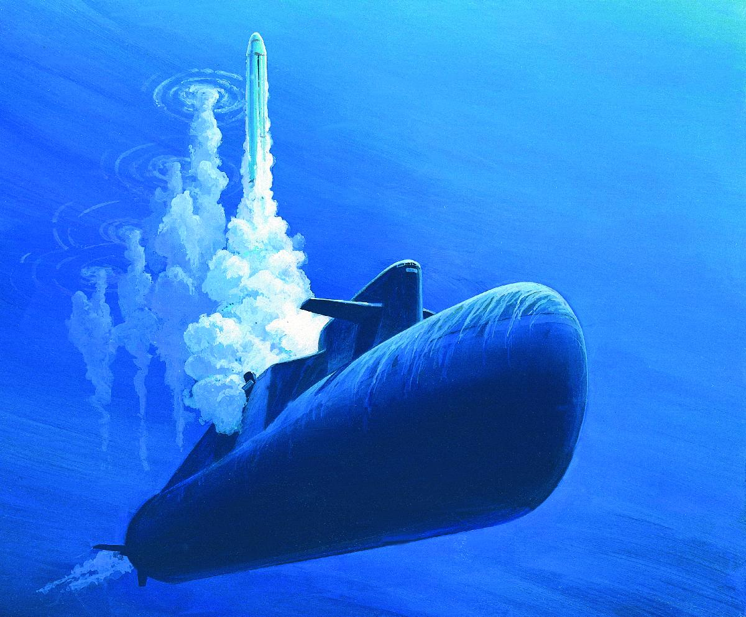

New York USA
June, 2013

Article Electron Hydro Propulsion for Storige 6 23 13
Electron Super Speed Hydro Propulsion
by Alexander Bolonkin
C&R, N.Y., USA. abolonkin@juno.
Abstract. High speed submarines and in particular torpedoes need new propulsion systems which allow the submarine to reach high speeds by cheaper and more efficient methods. Author offers a new propulsion system using electrons for acceleration of the water and having a high efficiency. As this system does not use a water propeller, it does not have the cavitation limitations of conventional water propeller systems. Offered engine can produce a thrust from a zero speed up to high speed. It can work in any liquid planet atmosphere. The system can use apparatus surface for thrust and braking. For energy the system uses high voltage electricity which is not a problem if you have an appropriate electrostatic generator connected with any suitable engine.
-------------------------------------------------------
Key words: Electron propulsion, WABP, super speed hydro propulsion.
1. INTRODUCTION
Currently, propeller propulsion systems are widely used in submarines. Although they are good for slow speeds (<90 km/h), they are worse for middle speed (> 100 km/h) and has tremendous difficulties in achieving very high speed (> 150 km/h). The current designs of super speed hydro propulsion are limited by cavitations, noise and damage of propeller material.
A jet engine is a reaction engine that discharges a fast moving jet which generates thrust by jet propulsion in accordance with Newton's laws of motion. They are widely used in aviation, but not a known method in submarines.
2. INNOVATIONS
One simple version of the offered electronic ramjet hydro propulsion (WABP) is shown in fig.1. Engine contains the tube. The ejectors of electrons 2 are installed in the entrance of the tube. The collector of electrons (grille) 3 is installed in the end of tube. The electric circle having the battery (or electric DC generator) 4 and regulator of voltage 7 connects the ejectors and grille.
The engine works the following way. The ejectors eject the electrons into the tube. The strong electric field between injectors and grill moves them to grill. Electrons push (accelerate) the air to tube exit. When the electrons reach the grill, they enter the grill and close the electric circuit. The accelerated water (water jet) with high speed flows out from engine and creates the thrust. In a correctly designed engine this thrust may be enough for moving the craft.
Fig.1. Electron ramjet engine (WABP). a – side view, b – forward view. Notations: 1 – engine; 2 – injectors of electrons; 3 – collector of electrons; 4 – electric issue; 5 – enter water; 6 – exit water jet; 7 – regulator of an electric voltage (electron regulator); 8 – cover of collector.
The proposed idea of a propulsion engine has many variations. One of them is shown in fig. 2a. That is a conventional submarine (torpedo) body or wing (in fig. 2a it is shown the gross section of the wing). The electron injectors are installed in the beginning of the body (wing) surface. The collectors are installed in the end of the body/wing. The electrons accelerate the water around the apparatus and the electric forces produce the thrust.
Fig.2. Outer Electron ramjet propulsion (WABP). a – side view of the body or a gross-section of wing, b – surface electron engine. Notations: 1 – fuselage or wing; 2 – injector of electrons; 3 – collector of electrons; 4 – electric issue; 5 – enter water; 6 – exit water jet; 7 – electric (electron) regulator; 9 –surface (isolator) of apparatus; 10 – electric plate.
One possible electric schema of the proposed engine, shown in fig. 3, has additional closed loop electric circles which allow extracting the electrons from main electric circle and collecting electrons from water flow to back into main circle.
Fig.3. The electrical circuit of one version WABP engine. Notations are same with figs. 1 – 2. a is side view, b is forward view.
Advantages of the proposed electron propulsion system in comparison with the conventional propeller propulsion systems.
The suggested new propulsion principle has the following advantages in comparison with conventional propeller propulsion systems used at present time.
Advantages:
1. All current water propeller propulsion has low propeller efficiency (about 30% or low for high speed).
The electronic propulsion engine (WABP) has the electric efficiency about 100% which makes it 3
more times efficient.
2. The electron engine does not have the cavitations and can work at any speed. That means it may
be used as an engine of super speed ships.
3. The electronic engine is very simple and cheap.
4. The outer water ship surface may be used as engine. The ship need not have nacelles (propeller-
gondolas). That means a high aerodynamic efficiency of sea apparatus.
5. The outer surface of the electronic engine (fig.2b) may be used for creating the laminar boundary layer.
That means low (minimal) water friction and very high aerodynamic efficiency of sea apparatus.
3. THEORY OF ELECTRON PROPULSION (WABP). COMPUTATION AND
ESTIMATION.
1. Thrust of WABP. The thrust of the jet electron engine is (we use the Law of Impulse):
where T is thrust, N; m is water mass passed through engine in one second, kg/s; V_{f} is an exit speed of water (medium), m/s; V is an entry speed of water (medium), (the speed of the apparatus), m/s; ΔV is increasing of water (medium) speed into engine, m/s; ρ is water (medium) density, kg/m³; S is ender area of engine, m²; T_{s} is specific thrust of engine, N/m².
The energy A_{t} [J] obtained by sea apparatus from thrust is
A_{t} = TVt , (2)
where t is time, sec.
On other hand, energy A_{e} [J] obtained from electric current is
A_{e} = UIt , (3)
where U is voltage between entrance and exit of engine, V; I is electric current, A.
The heat efficiency of the WABP is close to 1, because there is no heating of water into engine (increasing the speed of all water mass is in one direction by electric field).
That way
A_{t} ≈ A_{e} . (4)
From (1) – (4) and I_{s} = I/S we get (V ≠ 0)
(5)
where I_{s} is density of electric currency about apparatus, A/m², ΔV is increasing water (medium) speed into engine, m/s.
Example 1. Let us take the U = 10³ V, I_{s} = 10³ A/m², ship speed V = 50 m/s, ρ = 10³ kg/m³.
Then T_{s} = 4×10⁴ N/m² = 4 tons/m², ΔV = 0.8 m/s.
The same way we can get the required power and getting thrust when the ship speed equals zero:
P_{s} = 0.5m ΔV², m = ρΔV , T_{s} =P_{s}/ΔV , P_{s} = 0.5ρΔV³ , T_{s} = 0.5 ρΔV² , (6)
where P_{s} is electric power for 1 m², W/m²; ΔV is increasing water speed into engine, m/s;
m is water exemption mass passed through engine in one second, kg/s;
Example 2. Let us take the start power P_{s} = 10⁵ W/m². Than the exit speed ΔV = 2.71 m/s, the start thrust is T_{s} = 3.69·10⁴ N/m² = 3.69 tons/m².
2. Efficiency of Electron WABP engine.
Efficiency η of any jet propulsion is production of two values: propulsion efficiency η_{p} and engine (propeller) efficiency η_{e} :
η = η_{p}η_{e} , where η_{p} = V/(V + 0.5 ΔV) . (7)
The propulsion efficiency for propeller and electronic propulsion are same. They depend only on ΔV . But water efficiency of the water propeller is low, about 30 ÷ 40%. In the cavitation regime the propeller efficiency is significantly lower. For high speed over V> 50 m/s the conventional water propeller loses efficiency very quickly. The offered electronic jet engine accelerates water (liquid) by electricity. It has efficiency close to 100% as the only loss of energy is the extraction of the electrons from cathode and ionizations of water molecules. This energy is about some (about 0) electron-volts (eV). The energy spent for acceleration of the water molecules by electrons/ions is hundreds of eV. That means the total efficiency of WABP is 3 times more than conventional air jet propulsion.
The second very important point: efficiency of WABP does not depend upon speed of apparatus.
The other advantages: we can make a very large entrance area of engine, we can use the fuselage and wings, stabilizer and keel of ship as engine.
3. Electron speed. The electron speed about the water, wind, gas (air) jet may be computed by equation:
j_{s} = en₋b₋E + eD₋(dn₋/dx) , (8)
where j_{s} is density of electric currency of jet, A/m²; e = 1.6×10⁻¹⁹ C is charge of single electron, C; n₋ is density of injected electrons (negative charges) in 1 m³; b ₋ is charge mobility of negative charges, m²/sV; E is electric intensity, V/m; D₋ is diffusion coefficient of charges; dn₋/dx is gradient of charges. For our estimation we put dn₋/dx = 0. In this case
j_{s} = en₋b₋E , Q₁ = en , v = bE , j_{s} = Q₁v , (9)
where Q₁ is density of the negative charge in 1 m³; v is speed of the negative charges about stream, m/s.
One liter of sea water has 35 grams of calt NaCl. The Cl (Chlorine) is 1.9% , the Na (Sodium) is 1.05% of water mass . The salt (saline) dissociates in ions Na⁺, Cl⁻ into water. Concentration of ions: Cl⁻ is 0.546 mol/kg, Na⁺ is 0.469 mol/kg.
The charge mobility is:
Cl⁻ is 0.667×10⁻⁷ m²/sV, Na⁺ is 0.450 ×10⁻⁷ m²/sV. (10)
As you see the mobility of ions in water is very small. The applied voltage in water is also small. That means the ion speed is small in comparison with water speed. In many case we can put v = 0.
If v > 0, the electrons accelerate the water (E > 0 and installation expends energy, works as engine). If v < 0, the electrons brake the water (E < 0 and in the correct installation can produce energy, works as electric generator). If v = 0 (electron speed about installation equals water speed V), the electric resistance is zero.
4. Resistance of water. Salt water conducts electric current. This means that part of current will flow back to cathode. The specific electric resistance of water is significantly contingent upon salinity of water. When we have the plates (nets) with both sides (cathode and anode), the specific electric resistance are:
1. Distilled water R ≈ 10⁶ Ωm .
2. Fresh water R = 40 ÷ 200 Ωm (depends from water salinity). (11)
3. Sea water R ≈ 0.2 Ωm .
In our case in one side we have the electron injector (cathode) which has conventionally a small area. In this case the specific electric resistance is:
R_{o} = R/ 4π a , (12)
where a is radius of needle (or cathode), m; this radius conventionally is very small (mm). That means the R_{o} has an electric resistance of hundreds Ohms. Their influence in the installation efficiency is insignificant.
4. The efficiency of installation from back electric current may be estimated by equation:
η ≈ 1/(1+ R_{u}/R_{o}) , (13)
where R_{u} is an useful electric resistance. Ratio R_{u}/R_{o} conventionally is small and η is closed to 1.
4. SUMMARY AND DISCUSSION.
The author proposes a fundamentally unique propulsion system (engine) using the outer medium (water, liquid) and electric energy. It is not comparable to conventional propeller propulsion which uses the mechanical engine for rotation of propeller.
The offered WABP engine is accelerating the water (medium) by a principally new method – by electric field. Its advantages:
1. All current water propeller propulsion have low propeller efficiency (about 30% or low for high speed).
The electronic propulsion engine (WABP) has electric efficiency about 100% which makes it 3
more times efficient.
2. The electron engine does not have cavitations and thus can work at any speed. This means that it may
be used as an engine of super speed ships.
3. The electronic engine is very simple and cheap.
4. The outer water ship surface may be used as engine. The ship need not have nacelles (propeller-
gondolas). That means high aerodynamic efficiency of the sea apparatus.
5. The outer surface electronic engine (fig.2b) may be used for creating the laminar boundary layer.
That means low (minimal) water friction and very high aerodynamic efficiency of sea apparatus.
This engine is also dissimilar to a known propeller or rocket engines (underwater rocket used by super speed torpedo). The rocket engine takes an extracted mass from itself. The WABP does not take the extracted mass, can work only in water and works better if the atmosphere has a high density.
The main disadvantage of the offered engine is the requirement of electricity. For obtaining electricity the conventional internal turbo engine connected with electro-DC generator may be used.
The research papers relating to this topic are presented in [1]-[20].
ACKNOWLEDGEMENT
The author wishes to acknowledge Professor Shmuel Neumann for correcting the English and offering useful advices and suggestions.
- References
[1] A.A.Bolonkin, Electron Air Hypersonic Propulsion. http://viXra.org/abs/1306.0003
http://www.scribd.com/doc/145165015/Electron-Air-Hypersonic-Propulsion
http://www.scribd.com/doc/146179116/Electronic-Air-Hypersonic-Propulsion
[2] A.A.Bolonkin, Electronic Wind Generator. http://viXra.org/abs/1306.0046,
http://www.scribd.com/doc/146177073/
[3] A.A.Bolonkin, Electronic Hydro Electro Generator. 2013.
[4] A.A. Bolonkin, “Bolonkin’s Method Movement of Vehicles and Installation for It”, US Patent 6,494,143
B1, Priority is on 28 June 2001.
[5] A.A. Bolonkin, “Non-Rocket Space Launch and Flight”, Elsevier, 2005, 468 pgs. ISBN-13: 978-0-08044-
731-5, ISBN-10: 0-080-44731-7 .
http://www.archive.org/details/Non-rocketSpaceLaunchAndFlight ,
http://www.scribd.com/doc/24056182
[6]. A.A. Bolonkin, “New Concepts, Ideas, Innovations in Aerospace, Technology and the Human
Sciences”, NOVA, 2006, 510 pgs. ISBN-13: 978-1-60021-787-6. http://www.scribd.com/doc/24057071 ,
http://www.archive.org/details/NewConceptsIfeasAndInnovationsInAerospaceTechnologyAndHumanSciences [7]. A.A. Bolonkin, R. Cathcart, “Macro-Projects: Environments and Technologies”, NOVA, 2007, 536 pgs.
ISBN 978-1-60456-998-8. http://www.scribd.com/doc/24057930 .
http://www.archive.org/details/Macro-projectsEnvironmentsAndTechnologies .
[8]. A.A. Bolonkin, Femtotechnologies and Revolutionary Projects. Lambert, USA, 2011. 538 p., 16 Mb.
ISBN: 978-3-8473-0839-0. http://www.scribd.com/doc/75519828/ ,
http://www.archive.org/details/FemtotechnologiesAndRevolutionaryProjects
[9]. A.A. Bolonkin, LIFE. SCIENCE. FUTURE (Biography notes, researches and innovations). Scribd,
2010, 208 pgs. 16 Mb. ISBN: 978-1-4512-7983-2, http://www.scribd.com/doc/48229884,
http://www.archive.org/details/Life.Science.Future.biographyNotesResearchesAndInnovations
[10]. A.A. Bolonkin, Universe, Human Immortality and Future Human Evaluation. Scribd. 2010г., 4.8 Mb.
http://www.archive.org/details/UniverseHumanImmortalityAndFutureHumanEvaluation,
http://www.scribd.com/doc/52969933/
[12]. A.A.Bolonkin, "Magnetic Space Launcher" has been published online 15 December 2010, in the ASCE,
Journal of Aerospace Engineering (Vol.24, No.1, 2011, pp.124-134). http://www.scribd.com/doc/24051286/
[13]. A.A.Bolonkin, Universe (Part 1). Relations between Time, Matter, Volume, Distance, and Energy.
JOURNAL OF ENERGY STORAGE AND CONVERSION, JESC : JuLy-December 2012, Volume 3, Number 2, pp. 141-154.
http://viXra.org/abs/1207.0075, http://www.scribd.com/doc/100541327/ ,
http://archive.org/details/Universe.RelationsBetweenTimeMatterVolumeDistanceAndEnergy
Universe (Part 2): Rolling of Space (Volume, Distance), Time, and Matter into a Point.
http://www.scribd.com/doc/120693979
http://viXra.org/abs/1207.0075, http://www.scribd.com/doc/100541327/ ,
http://archive.org/details/Universe.RelationsBetweenTimeMatterVolumeDistanceAndEnergy
[14]. A.A.Bolonkin, Lower Current and Plasma Magnetic Railguns. Internet, 2008.
http://www.scribd.com/doc/31090728 ; http://Bolonkin.narod.ru/p65.htm .
[15] A.A.Bolonkin, Electrostatic Climber for Space Elevator and Launcher. Paper AIAA-2007-5838 for 43
Joint Propulsion Conference. Chincinnati, Ohio, USA, 9 – 11 July,2007. See also [10], Ch.4, pp. 65-82.
[16] W.J. Hesse and el. Jet Propulsion for Aerospace Application, Second Edition, Pitman Publishing Corp. NY.
[17] N.I. Koshkin and M.G. Shirkebich, Directory of Elementary Physics, Nauka, Moscow, 1982 (in Russian).
[18] I.K. Kikoin. Table of Physics values. Atomisdat, Moscow, 1976 (in Russian).
[19] Water Encyclopedia. http://www.waterencyclopedia.com/Ge-Hy/Hydroelectric-Power.html
[20] Wikipedia. Submarines.
23 June 2013

