THE CHARACTER OF MODERN TECHNICAL SYSTEMS OF VARYING COMPLEXITY
Sytnik Alexander Alexandrovich
Yuri Gagarin State Technical University of Saratov
Department of “Information and Communication Systems and Software Engineering”
Head of Department, Doctor of Technical Sciences, Professor
Corresponding Member of the Russian Academy of Education, Laureate of the President of the Russian Federation Award, Honored Scientist of the Russian Federation
Abstract
In the modern process of making technical and technological decisions, computer design methods are increasingly applied, particularly the SolidWorks software suite, which can reasonably be regarded as a tool of artificial intelligence. The number of features and factors characterizing a technical solution and its development up to the level of a technical supersystem has become so significant that it requires local compliance with definitions, provisions, and methods of identifying the entire hierarchy of technical solutions—from a local technical solution with unregulated technical and technological connections (subsystems) to a comprehensive conglomerate of local solutions (supersystems).
It should be noted that for the first time in world practice, optimization of the classification of such types of technical solutions was carried out by the modern multidisciplinary specialist Artem Aleksanyan, who possesses both the methodology of classical design and methods of computer program development. In this article, the author sets the task of linking the fundamental conclusions and definitions presented in the publications of Artem Aleksanyan with specific methodology and a system of conceptual decision-making in modern machine design involving elements of artificial intelligence and artificial neural networks.
Keywords: Technical system; Degree of complexity of a technical system; Technical systems of varying complexity; Computer-aided design methods; Varieties of technical solutions; Local character of inventions; Local effect of inventions; Methods and capabilities of the SolidWorks suite; Issues of identifying all types and levels of technical solutions.
Until quite recently, most invention topics were of a relatively local nature, and the positive effect of using inventions could be identified and assessed with relative ease. Today, largely due to the increased capabilities of design and engineering software, the results of the design process allow much more accurate qualification of the originality and novelty of technical systems at any level.
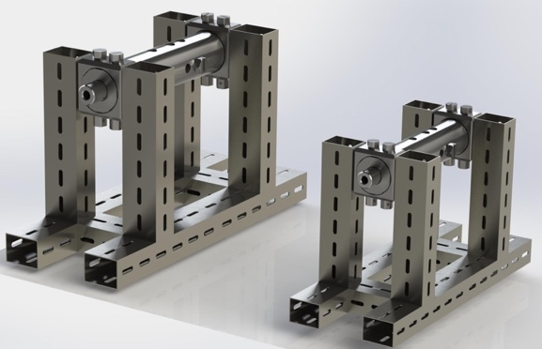
Figure 1. A design concept of a device for real-time homogenization of fuel mixtures is presented.
Using the capabilities of SolidWorks, the design process simulates the properties of structural materials and coatings, as well as generates families of technical systems, which reduces costs and accelerates development. Modern CAD methods, closely associated with elements of artificial intelligence, make it possible to account for numerous features of a technical solution—from local subsystems to supersystems.
The optimization of such classifications was first proposed by Artem Aleksanyan, who combined approaches of classical design and computer programming. His definitions and methodology are applicable in machine design with elements of AI, especially when developing complex and integrative solutions required to achieve the ideal final result.
The identification of levels of technical systems is important for the protection of intellectual property and for effective technological adaptation. However, the development of innovations also faces psychological and technological stereotypes, as well as the limitations of earlier laws of technological progress, formulated before the advent of modern materials, electronics, and laser technologies.
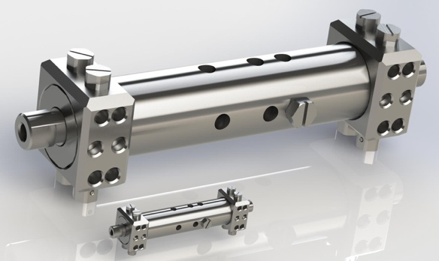
Figure 2. The figure clearly demonstrates the capabilities of computer scaling for obtaining various dimensional types of technical systems within a single design process.
Recognition of a technical solution as an invention differs: in the USA—by four criteria, in other countries—by three. The fourth criterion is associated with subjective evaluation of obviousness, making expert review dependent on the knowledge and competence of patent examiners. Modern innovations are based on the integration of disciplines such as electronics, microelectronics, materials science, fiber optics, and laser technology, requiring collective expert evaluation.
Design software, including SolidWorks, allows the combination of functions for specific design operations, ensuring precise compliance with system requirements. Efficiency depends on the designer’s experience and flexibility, balancing standardization and unification with original design elements to maintain functionality and aesthetic integrity.
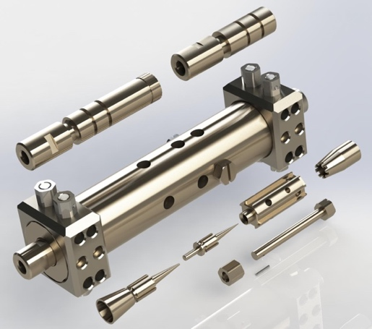
Figure 3. The figure vividly demonstrates a modern design solution for a system of real-time fluid homogenization in pipelines without chemical reagents or stabilizing mixtures.
Modern CAD systems, such as SolidWorks, allow projects to be represented both as assemblies and as detailed components, with appearance and material properties considered. When viewed as a fundamental technical solution for future inventions, implementation must align with TRIZ principles. Originally created in the post-war period, TRIZ long served as a foundation for generating and implementing engineering ideas, but with automation, digital technologies, and composite materials, it required revision and adaptation.
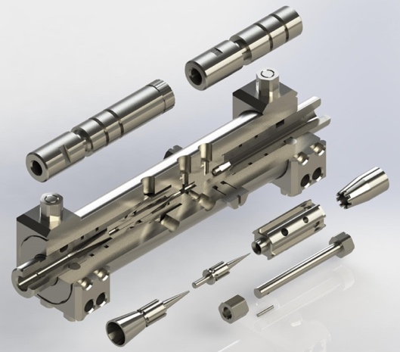
Aleksanyan’s refined definitions and classifications of technical solutions streamlined preparation of key project documents (Technical Conditions, Technical Requirements, Technical Specifications), ensuring compliance with standards. Consideration of component unification and coordination of subsystems with supersystems remains crucial for compatibility and integrity of designs.
Figure 4. The figure shows the same project as Figure 1, with sectional views that clarify the internal structure and geometric requirements of components.
While only part of CAD functionality, combining it with TRIZ methods increases design efficiency and reduces costs. Digital modeling enables idea verification before technical requirements are defined, while TRIZ integration simplifies parameter selection, resolves technical issues, and supports system autonomy. This highlights the value of multidisciplinary methods with digital tools. Regulatory aspects are also affected: U.S. patent reform and AI integration into process control require updates to laws on technical system development.
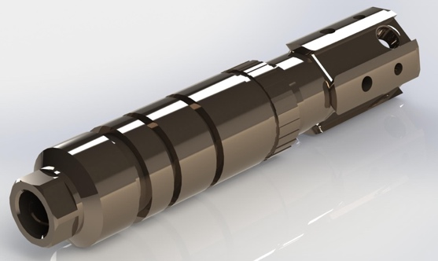
Figure 5. The figure shows the design of a base component of the system from Figures 3 and 4, produced from metal ceramics with high carbon–carbon composite content.
It demonstrates the potential of full design simulation, where appearance and surface quality ensure accurate visualization of the assembly as a supersystem. Modern practice also provides SOLIDWORKS models in supplier catalogs, allowing direct integration into projects. This approach streamlines design by enabling real-time component selection, system-wide integration, and optimization of development paths.
Laws of Development of Technical Systems:
- Law of completeness of system components
- Law of increasing degree of system ideality
- Law of human displacement from the technical system
- Law of coordination of system rhythms
- Law of system energy conductivity
- Law of non-uniform development of system components
- Law of transition from macro to micro level
- Law of increasing degree of material–field interactions
Modified Classification of Technical Systems (by Artem Aleksanyan):
- Technical system
- Local technical system
- Developed technical system
- Global technical system
- Intelligent technical system
System ideality is assessed as the ratio of useful functions to the costs of development, design, production, and operation. Development must comply with standards, technical conditions, and industry regulations, which partially limit designer creativity.
In future publications, it is advisable to return to examples of modern developments with commentary on the laws of technical system development and modified classification definitions.
List of References and Patent Materials
- Tankersley, Nicholas Matthew, et al. Portable control modules in a system for automatic monitoring of machine data. U.S. Patent Application 20170147681, A1, May 25, 2017.
- Lee, Eunjong, et al. Method of transmitting uplink data in a wireless communication system and device for its implementation. U.S. Patent Application 20170188352, A1, June 29, 2017.
- Maheshwari, Sonal, et al. Interface for automatic discovery of services in an IT environment. U.S. Patent Application 20170017368, A1, January 19, 2017.
- Simard, Patrice Y., et al. Completion of functions in human-in-the-loop computer learning. U.S. Patent Application 20160239761, A1, August 18, 2016.
- Azarian Yazdi, Kambiz, et al. Reliability of hybrid automatic repeat request (HARQ) in wireless networks. U.S. Patent Application 20160128090, A1, May 5, 2016.
- Azarian Yazdi, Kambiz, et al. HARQ feedback transmission in wireless networks. U.S. Patent Application 20160128091, A1, May 5, 2016.
- Gao, Jianfeng, et al. Modeling “interestingness” using deep neural networks. U.S. Patent Application 20150363688, A1, December 17, 2015.
- Howard, Kevin D. Method for automatic design extraction from standard source code. U.S. Patent Application 20140304684, A1, October 9, 2014.
- Horn, Bruce L. Computer system for automatic organization, indexing, and viewing of information from multiple sources. U.S. Patent Application 20150120744, A1, April 30, 2015.
- Simard, Patrice Y. Interactive segment extraction in a human-in-the-loop computer learning system. U.S. Patent Application 20150019461, A1, January 15, 2015.

