UDC 514.112.6

Michael Perfileev, math research specialist,
East-Siberian branch of FSUE «VNIIFTRI», Russia, Irkutsk

Dense spiral packing of circles in the plane

Abstract

This paper is devoted to the dense packing of the circles whose radii make up a decreasing geometric progression. It is shown that the solution to the problem of finding the denominator of this progression for such a packing reduces to the solution of the transcendental equation. That is, the problem does not have an exact solution and can only be solved approximately by applying numerical methods and computer software packages. An interesting property of such a package is considered, as well as an example of a dense spiral packing is given and solved for the case of 11 circles

Keywords: packing problems, circle, transcendental equations, numerical methods, geometric progression, Ceva's theorem

Introduction

We consider the problem of m circles tight packing (m is a number of circles and m ≥ 8), whose radii form a geometric progression (note that the circles are on a plane). The denominator x of this progression is less than one, that is, the radius of each subsequent circle is $\frac{1}{x}$times smaller than the radius of the previous circle. Each circle, starting with the second one, touches the central circle and two adjacent circles. The last circle touches the second circle (Figure 1). We call such a packing a dense spiral packing of circles on the plane. The problem converges to finding the denominator x of the decreasing geometric progression, by which it is possible to carry out such a packing for a given number of circles.

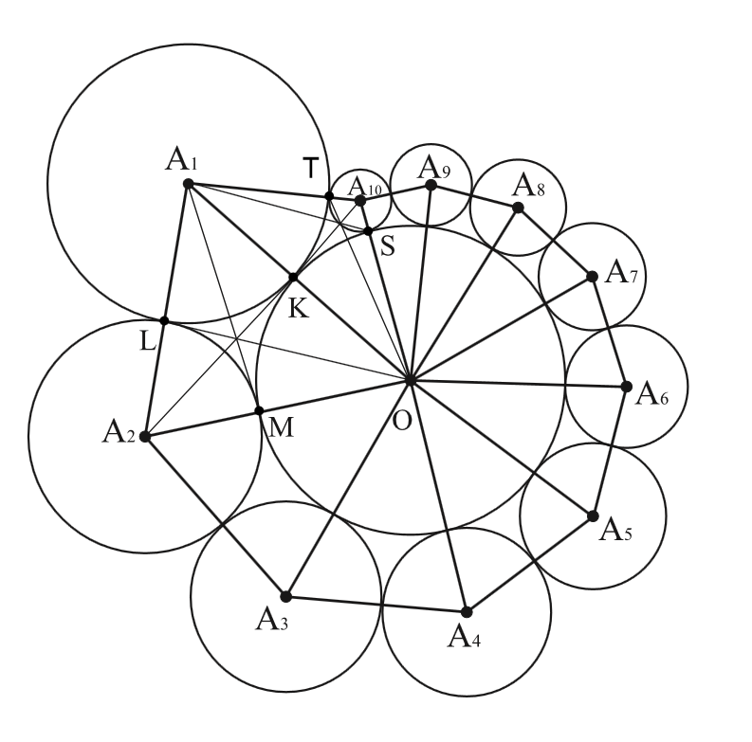
Fig. 1. Dense spiral packing of circles on a plane.

The theorem on the dense spiral packing of circles
We state and prove the following theorem:
The problem of dense spiral packing of circles on a plane is unsolvable in radicals, it does not have an exact solution, and can only be solved approximately.

Proof:
Consider the triangles O$A_{1}A_{2}$, O$A_{2}A_{3}$ , … , O$A_{n-1}A_{n}$, where n = m$-$1, where m is the total number of circles. We suppose that the radius of the central circle equals 1.
The sides of the triangle O$A_{1}A_{2}$ are 1 + x ; x + $x^{2}$ ; 1 + $x^{2}$ ; The sides of triangle O$A_{2}A_{3}$ are equal to 1 + $x^{2}$ ; $x^{2}$ + $x^{3}$ ; 1 + $x^{3}$ ; ……. The sides of the triangle O$A_{n-1}A_{n}$ are equal to 1 + $x^{n-1}$; $x^{n-1}$ + $x^{n}$ ; 1 + $x^{n}$. The last triangle O$A_{n}A_{1}$ has sides 1 + $x^{n}$; $x^{n}$+ x ; 1 + x.
The cosine theorem [1] for the triangles O$A_{1}A_{2}$, O$A_{2}A_{3}$ , … , O$A_{n-1}A_{n}$ will be written in the form:
${\left(x+x^{2}\right)}^{2}= {\left(1+x\right)}^{2}+{\left(1+x^{2}\right)}^{2}-2\left(1+x\right)\left(1+x^{2}\right)cos⁡({A_{1}OA_{2}})$ ;
${\left(x^{2}+x^{3}\right)}^{2}= {\left(1+x^{2}\right)}^{2}+{\left(1+x^{3}\right)}^{2}-2\left(1+x^{2}\right)\left(1+x^{3}\right)\cos{(A_{2}OA_{3}})$; …….
${\left(x^{n-1}+x^{n}\right)}^{2} {=\left(1+x^{n-1}\right)}^{2}+{\left(1+x^{n}\right)}^{2}-2\left(1+x^{n-1}\right)\left(1+x^{n}\right)∙∙cos⁡({A_{n-1}OA_{n}})$
Then the angle $A_{1}OA_{2}$ = arccos$(\frac{{\left(1+x\right)}^{2}+{\left(1+x^{2}\right)}^{2}-{\left(x+x^{2}\right)}^{2}}{2\left(1+x\right)\left(1+x^{2}\right)})$ ;
The angle is $A_{2}OA_{3}$ = arccos$\left(\frac{{\left(1+x^{2}\right)}^{2}+{\left(1+x^{3}\right)}^{2}-{\left(x^{2}+x^{3}\right)}^{2}}{2\left(1+x^{2}\right)\left(1+x^{3}\right)}\right)$; …….
The angle is $A_{n-1}OA_{n}$ = arccos$\left(\frac{{\left(1+x^{n-1}\right)}^{2}+{\left(1+x^{n}\right)}^{2}-{\left(x^{n-1}+x^{n}\right)}^{2}}{2\left(1+x^{n-1}\right)\left(1+x^{n}\right)}\right)$.
Then the sum of the angles
$$A_{1}OA_{2}+A_{2}OA_{3}+…+A_{n-1}OA_{n}=$$
$=\sum_{n=2}^{m-1}{(\arccos\left(\frac{{\left(1+x^{n-1}\right)}^{2}+{\left(1+x^{n}\right)}^{2}-{\left(x^{n-1}+x^{n}\right)}^{2}}{2\left(1+x^{n-1}\right)\left(1+x^{n}\right)}\right))}$ (1)
For the triangle O$A_{n}A_{1}$ by the cosine theorem [1]
${\left(x^{n}+x\right)}^{2}= {\left(1+x^{n}\right)}^{2}+{\left(1+x\right)}^{2}-2\left(1+x^{n}\right)\left(1+x\right)\cos{{(A}_{n}OA_{1}})$,
and therefore the angle
${ A}_{n}OA_{1}$ = arccos$\left(\frac{{\left(1+x^{n}\right)}^{2}+{\left(1+x\right)}^{2}-{\left(x^{n}+x\right)}^{2}}{2\left(1+x^{n}\right)\left(1+x\right)}\right)$ (2)
Adding the expressions (1) and (2), we obtain the sum of all the angles
$A_{1}OA_{2}+A_{2}OA_{3}+…+ A_{n-1}OA_{n}+A_{n}OA_{1}$, which equals to the degree measure of the total circle, that is 2π radians:
$\sum_{n=2}^{m-1}{(\arccos\left(\frac{{\left(1+x^{n-1}\right)}^{2}+{\left(1+x^{n}\right)}^{2}-{\left(x^{n-1}+x^{n}\right)}^{2}}{2\left(1+x^{n-1}\right)\left(1+x^{n}\right)}\right))}$+ arccos$\left(\frac{{\left(1+x^{n}\right)}^{2}+{\left(1+x\right)}^{2}-{\left(x^{n}+x\right)}^{2}}{2\left(1+x^{n}\right)\left(1+x\right)}\right)$ = = 2$π$ (3)
Taking into account that n = m$-$1, the equation (3) takes the following form:
$\sum_{n=2}^{m-1}{(\arccos\left(\frac{{\left(1+x^{n-1}\right)}^{2}+{\left(1+x^{n}\right)}^{2}-{\left(x^{n-1}+x^{n}\right)}^{2}}{2\left(1+x^{n-1}\right)\left(1+x^{n}\right)}\right))}$+ + arccos$\left(\frac{{\left(1+x^{m-1}\right)}^{2}+{\left(1+x\right)}^{2}-{\left(x^{m-1}+x\right)}^{2}}{2\left(1+x^{m-1}\right)\left(1+x\right)}\right)$ = 2$π$ (4)
Performing some trivial algebraic transformations of the expression (4), we obtain a more compact equation:
$\sum_{n=2}^{m-1}{(arccos\left(1 - \frac{2x^{2n-1}}{1+x^{n-1}+x^{n}+x^{2n-1}} \right)})$ + arccos$\left(1- \frac{2x^{m}}{1+x+x^{m-1}+x^{m}}\right)$ = 2$π$ (5)
All the constituent functions of the equation (5) are analytic and not algebraic [2], [3]. Therefore, this equation is transcendental [4], [5], that is, it does not have an exact solution and can be solved only approximately with the help of numerical methods [6].
The theorem is proved.
The equation (5) can be applied in engineering, architecture and computer graphics to calculate the dense spiral packing of circles, balls, and cylinders.
The property of a tight spiral packing of circles on the plane:
In each triangle formed by the centers of pairwise tangent circles, the segments connecting the vertices of the triangle with the points of circles tangency intersect at one point.
Proof:
Consider the triangle OA1A2 (Fig. 1) : OK∙A1L∙A2M = 1∙x∙$x^{2}$ = $x^{3}$ ; KA1∙LA2∙MO = x∙$x^{2}∙1$ = $x^{3}$. Then OK∙A1L∙A2M = KA1∙LA2∙MO, consequently, by Ceva's theorem [7], the segments A1M, A2K and OL intersect at one point, which is what we wanted to prove. For the remaining triangles, except for the last one, the proof is similar. For the last triangle OA10A1 (using the example of a dense spiral packing of 11 circles) OS∙A10T∙A1K = 1∙$x^{10}$∙x = $x^{11}$ ; SA10∙TA1∙KO = $x^{10}$∙x∙1 = $x^{11}$. Hence OS∙A10T∙A1K = SA10∙TA1∙KO and by Ceva's theorem [7] the segments OT, A1S and A10K intersect at one point, which is what we had to prove.

A case of a dense spiral packing with 11 circles

For the case of 11 circles (Figure 1), the problem of their dense spiral packing reduces to the transcendental equation:
$\sum_{n=2}^{10}{(arccos\left(1 - \frac{2x^{2n-1}}{1+x^{n-1}+x^{n}+x^{2n-1}} \right)})$ + arccos$\left(1-\frac{2x^{11}}{1+x+x^{10}+x^{11}}\right)$ = 2$π$ (6)
With the help of a package of applied computer programs, it is possible to obtain an approximate numerical solution of this equation with the required accuracy (for example, 15 decimal places) x$≈0,860266732996342$. That is, with such a denominator of a decreasing geometric progression, the dense spiral packing of 11 circles can be realized. Then the radius of each subsequent circle will be $\frac{1}{x}$ $≈$ 1,162430164557173 times less than the radius of the previous circle. The left-hand side of the equation (6) approximately equals to 6,28318530717957401953, and it differs from the exact value 2π by the value $∆ ≈$ ${10}^{-14}$: 6,28318530717957401953 $-$2$π$ = $-$0,0000000000000124… It is noteworthy that the value $x≈\frac{e}{π}$ : $0,860266732996342-$ $\frac{e}{π}$ = $=-$0,0049892464…, where e and π are Euler's number and Archimedes' constant, respectively [8].
For the case of 8 circles x$≈$0,935652796073189 ; $\frac{1}{x}$ $≈$ 1,068772523522472 ; for the case of 9 circles x$≈$0,898589160388535 ; $\frac{1}{x}$ $≈$ 1,112855623105465 ; for the case of 10 circles x$≈$ 0,875474469382088 ; $\frac{1}{x}$ $≈$1,142237763604691 ; for the case of 1000 circles x$≈$0,823930516998464 ; $\frac{1}{x}$ $≈$1,213694576628801; for 10000 circles x$≈$0,823930516998464 ; for m$→∞$ x$→$0,823930516998464.

Conclusion

Thus, in this paper we have introduced the definition of a dense spiral packing of circles on a plane. The theorem is formulated and proved, according to which such a package is unsolvable in radicals, it does not have an exact solution, and can be solved only approximately by numerical methods. Also, the property of such a package was formulated and proved and an example of a dense spiral packing for 11 circles was shown

Literature
1. Vygodsky M.Ya. Handbook of elementary mathematics. $-$ Moscow:
AST, 2008. $-$ pp.280-282.
2. Taktarov N.G. A handbook on higher mathematics for students. $-$ Moscow: Librocom Publishing House, 2008.$-$ pp.409-411.
3. Ter-Krikorov A.M., Shabunin M.I. Course of mathematical analysis. $-$ Moscow: BINOM. Laboratory of Knowledge, 2015.$-$ pp.98-101.
4. Alexander Gelfond. Transcendental and algebraic numbers. $-$ Moscow: ComKniga, 2006. $–$ pp.83-93.
5. Nesterenko Yu.V. Number theory. Textbook for students of higher educational institutions. $-$ Moscow: Academy, 2008. $-$ pp.266-271.
6. Vladimir Formalev, Dmitry Reviznikov. Numerical methods. $-$ Moscow: FIZMATLIT, 2006.$-$ pp.50-69.
7. Myakishev A.G. Elements of the geometry of a triangle. $-$ Moscow: MCNMO, 2002.$-$ pp.5-8.
8. Steven R. Finch. Mathematical constants. Cambridge, 2003. $-$pp.17-28.

